Use of a Time-based V-slope Method for Determination of Anaerobic Threshold   
  
Hirotaka Nishijima1, Kazuyuki Kominami2, Toko Katsuragawa1, Masatoshi Akino3

1. Kitano Hospital, Sapporo, Japan

6-30 1-jo 1-chome Kitano, Kiyota-ku, Sapporo 004-0861, Japan

1. Aishin Memorial Hospital, Sapporo, Japan

1-15 Kita 27-jo Higashi 1-chome, Higashi-ku, Sapporo 065-0027, Japan

1. Sapporo Kiyota Hospital, Sapporo Japan
   1. 1-jo 1-chome Shinei, Kiyota-ku, Sapporo 004-0831, Japan

email:

corresponding author:

Hirotaka Nishijima: [hnishiji2002@jcom.home.ne.jp](mailto:hnishiji2002@jcom.home.ne.jp)

Current address: 2-5-16 Sakaigawa, Chuoku, Sapporo 064-0943, Japan

Telephone: +81-11-561-8279

Kazuyuki Kominami: [qqae3s4u9@gmail.com](mailto:qqae3s4u9@gmail.com)

Toko Katsuragawa: [cjmdg121@yahoo.co.jp](mailto:cjmdg121@yahoo.co.jp)

Masatoshi Akino: [akimasa-med@hokkaido.med.or.jp](mailto:akimasa-med@hokkaido.med.or.jp)

Running title: Time-based V-slope for Determination of AT

**This is a preprint.**

**An example citation/**

Nishijima H (2025)Use of a Time-based V-slope Method for Determination of Anaerobic Threshold. SportRxiv

Abstract:  
Three methods are commonly used for the determination of anaerobic threshold (AT): v-slope (VS), ventilatory equivalent (VEQ), and end-tidal (ET). For VS, VCO2 is plotted against VO2 (x-axis), and for VEQ and ET, each variable is plotted against elapsed time (x-axis). As these data points do not correspond to the same y-axis, these three methods cannot be directly compared. Purpose: To devise a way to construct a time-based VS graph. Methods: A new index, d, was created by subtracting VO2 from VCO2 and plotting the value against time. The d-AT was determined as the first ascending break point on the d graph. A database of 127 subjects (age: 51±21, 66 healthy subjects, 20 treated for cardiovascular risk factors, and 41 with cardiac disease) who underwent maximal symptom-limited exercise was used to assess the utility of this approach for detecting AT. Each of the four AT methods, employed independently and blinded to each other, were compared. Additionally, the reliability of each method was assessed using Altman’s level of agreement (coefficient of repeatability, CR). Results: The mean AT (mL/min) and its determination rate by d, VS, VEQ, and ET were 857±414 (90%), 939±407 (91%), 946 ±176 (74%), and 862±379 (79%), respectively (d/ET versus VS/VEQ, p<0.001). CR values (mL/min) were 117, 115, 152, and 175, respectively. AT determination by combining all three graphs (d, VEQ, ET) simultaneously did not improve CR but did reveal a delayed or suppressed ventilatory response (VEQ) in 48 subjects. Conclusions: The time-based v-slope, d-AT, was equivalent to v-slope method in AT determination rate and repeatability. One major advantage was that d-AT could graphically delineate different VCO2 and ventilation responses to exercise.

Key Words: cardiopulmonary exercise testing, coefficient of repeatability, d, ventilatory equivalent

Introduction:

Anaerobic threshold (AT, also referred to as the gas exchange threshold (GET), ventilatory threshold (VT) or lactate threshold (LT) is the point during incremental exercise testing at which blood lactate begins to increase above the resting level and an excess amount of CO2 is produced (1). The AT is considered an index of exercise tolerance reached before the symptomatic maximal point (1) and is used as a reference point for exercise intensity during cardiac rehabilitation (2). In exercise physiology, AT is considered the boundary between moderate and severe exercise (3).

Three methods are commonly used to determine AT using respiratory gas analysis: v-slope (VS), ventilatory equivalent (VEQ: VE/VO2 and VE/VCO2), and end-tidal (ET) methods (1). For VS, carbon dioxide production (VCO2) is plotted against oxygen uptake (VO2; x-axis), while for VEQ and ET, each variable is plotted against elapsed time (x-axis). When discrepancies appear among the results obtained using VS compared to VEQ or ET, pinpointing the exact location of this discrepancy is challenging, as the data points do not correspond to the same x-axis of time.

This study aimed to devise a method to construct a time-based VS graph to enable direct comparisons with VEQ and ET graphs.

Methods:

1. Developing a d plot

First, a parameter, d was calculated by simply subtracting VO2 from VCO2 (i.e., d = VCO2 – VO2) and then plotted against time. Figure 1 A-D Case-1 shows a panel in which the d-plot is displayed in the same manner as VEQ and ET plots. On the d-plot, when the respiratory exchange ratio (RER) is >1.0, VCO2 increments are plotted above the y = 0 line (RER = 1), whereas when RER is <1.0, VCO2 increments are plotted below the y = 0 line. The diagonal RER = 1 line on the VS plot becomes a horizontal line of y = 0 on the d-plot. This has an effect of removing VCO2 that changes proportionally (in the 1:1 ratio) to VO2, focusing only on the VCO2 changes against time. The d-AT was identified as the first ascending break point on the d-graph. Figure 1 shows an example of d-AT determination, with the agreement of three break points).

1. Systematically evaluating the utility of d-plot for AT detection

A database of 127 subjects (age, 51 ± 21 years; 93 men; 66 healthy subjects, 20 under treatment for cardiovascular risk factors, and 41 with cardiac disease) who performed maximal symptom-limited exercise was used to assess the utility of the d plot (Table 1). The exercise ramp protocol was 5 W/min (n = 22), 10 W/min (n = 48), 15 W/min (n = 19), 20 W/min (n = 17), 25 W/min (n = 20), or 30 W/min (n = 1). The database was the same as used for our previous study to develop a mathematical derivation of AT (4), except for one case of duplication, which was removed. Cardiopulmonary exercise testing was performed using a stationary bicycle (StrengthErgo 8; Mitsubishi Electric Engineering, Tokyo) and a breath-by-breath gas analyzer (AE-300S; Minato Ikagaku Co., Tokyo). Written informed consent was obtained. The breath-by-breath gas change was transformed into an eight-breath moving average using Excel, and the AT was visually read on the respective Excel graphs.

Each of the four AT detecting methods (VS, d, ET, and VEQ) was applied independently and blinded to the other methods. VS AT was determined by the modified method described by Sue (5). AT determination by d, ET, and VEQ was performed by identifying an ascending break point. All readings were conducted by the same investigator (H.N.). Each AT was also read twice in a random order within a span of 4 months to assess reliability. All AT readings were coded for a level of confidence at the time of each reading as 1: confident, 2: less confident, and 3: unable to detect AT. The last AT reading where the three plots: d, VEQ, and ET plots were simultaneously viewed (Combined) was performed two months after the above, with one week separating two readings. At the time of the Combined reading, differences between break points on the d-plot and VEQ plot were noted and coded as follows: code-0 as VEQ earlier than d, code-1 as VEQ within 1 min of d, code-2 as delayed > 1 min of d, code-3 as delayed until the respiratory compensation point (RCP). Code-4 as no single or detectable break point.

On the VEQ plot, VE/VCO2 is displaced downward by 20 units (see the legend: VE/VCO2 – 20: VE/VCO2 minus 20), to avoid overlapping plots by VE/VO2

Comparison between all five AT detecting methods (VS, d, VEQ, ET, and Combined) was conducted using repeated measures ANOVA. Calculations used the mean of the first and second reading values of each method (AT had to be determined on both occasions). Reliability of the method was assessed by using the limits of agreement (Bland-Altman) and was expressed as the coefficient of repeatability (CR), calculated as 1.96 times the standard deviation of the differences between the two measurements (6).

This study was conducted in accordance with the principles of the Declaration of Helsinki. The research protocol was approved by the institutional review board of Kitano Hospital.

Results

The demographic and clinical information of the study group is summarized in Table 1. The basic cardiopulmonary exercise testing variables are shown in Table 2.

The mean AT and the AT detection rate of each method are presented in Table 3. The mean d-AT was significantly less than either the mean VS or VEQ AT (p < 0.001), but was not significantly different from the mean ET; that is, the d-AT break point appeared earlier than that of either VS or VEQ. The mean AT detected using the Combined method also agreed with d and ET. The detection rate of AT was approximately equal using d and VS (about 90%), but was substantially lower using VEQ and VE (about 80%). The simultaneous combined use of d, VEQ, and ET did not improve the AT detection rate. However, the combined use of all three plots revealed a group of subjects who manifested a delayed or suppressed ventilatory response (d vs. VEQ) in 48 subjects (code 2: n = 35, code 3: n = 11, and code 4: n = 2). An example of code 2 (VEQ-AT delayed >1 min of d-AT) is shown in Fig. 2 A-D Case-2, code 3 (delayed until RCP) in Fig. 2 E-H Case-3, and code 4 (no detectable VEQ-AT) in Fig. 2 I-L Case-4. Those with a delayed response were significantly older than those who did not show this abnormality (56.2 ± 21.6 vs. 46.6 ± 21.6, p < 0.05) and manifested a significantly lower peak VO2 (23.4 ± 9.9 vs. 28.1 ± 10.3 mL/min, p < 0.05). Clinical classification (healthy, risk factors, heart disease) and body weight were not related with this abnormality. In a comparison of d vs. ET, the delayed or suppressed ventilatory response was observed in 21 subjects. The d plot often displayed a more distinct break point than did the VS plot (Fig. 3 A-D Case-5). An example of hyperventilation masquerading as AT on the d plot is shown in Fig 3 E-H Case-6.

The CR was lowest with d (117) and VS (115) and larger with VEQ (152) and ET (175). When the confidence level of AT detection was code 1 (confident), CR decreased markedly in all methods (Table 3).

The combined use of all three graphs suggested a changing trend pattern of VEQ-O2 and ET-O2 against VEQ-CO2 and ET-CO2 as an alternative method of detecting AT (Fig. 3 I-L Case-7). However, this method exhibited poor reliability (for details see SDC).

Discussion

We devised a simple new time-based VS method in which changes of VCO2 are plotted against time. We calculated a new parameter, d as the difference between VCO2 and VO2 and plotted d against time. This enabled a direct comparison of breakpoints and AT derived from using the VS method against ET and VEQ, the other two methods commonly used to detect AT. With the conventional VS method, the y-axis variable, VCO2, is continuously increasing (initially at about 45 degrees to the x-axis), thus to detect AT requires discernment of a further disproportionate rise. In contrast, the d-method requires a simple judgement of an ascending point against the level x-axis.

Traditionally, three methods of AT detection have been employed: VS, ET, and VEQ (1). The VS method plots VCO2 against VO2, whereas the ET and VEQ method plots respective values against time. The lack of a common reference axis makes it visually difficult to assess exactly how a break point on VS corresponds to a break point on ET or VEQ; thus, any existing differences are difficult to pinpoint.

In the past, excess CO2 (calculated either as [VCO22 / VO2 − VCO2] or [VCO2 − 0.75 × VO2], has been used as a time-based measure (7, 8). The value (VCO2 − VO2) / heart rate has also been used (9). We used the reverse term, VO2 − VCO2, to describe the phenomenon of a rightward shift of VS (10). Except for one report, all of the other reports focused on the physiological study of AT. Only Gaskill (7) used excess CO2 to determine individual AT in 185 subjects (athletes, active and sedentary adults) using three methods of AT: VEQ (time-based), excess CO2 (time-based), and VS. He stated that combining all three significantly decreased the CR of AT to about 230 mL/min.

There are instances in the literature where ET and VEQ are plotted against VO2, making the x-axis the same as that used for VS (11). The merits of this method have not been studied systematically. Furthermore, with VO2 as the x-axis, multiple overlapping y-values of ET or VEQ may exist. On the other hand, a time-based method allows only one data point for a time line point on the x-axis, which is more advantageous for pinpointing break points.

The mean d-method AT occurred significantly earlier than that in VS AT. The cause is speculated as follows. The d-method detects the leading edge of a VCO2 increase on the time axis, as ET or VEQ does. With the VS plot, VCO2 data points often overlap in the close vicinity on the same VO2 value. Therefore, the AT break point serves as an approximate average.

The cause for the delay of VEQ-AT (detecting a rising break point of VEQ-O2) is probably related to the fact that it often occurs against the descending limb of VEQ-CO2 (see SDC for detailed discussion).

The group of subjects who show a delayed or suppressed ventilatory response were more clearly identified using the d-method. The pathophysiological significance of this phenomenon is not clear from the present study.

Somewhat surprisingly, the d-method did not result in less error or a higher AT detection rate compared to VS. This was probably because the assessor had more than 10 years of experience of detecting AT primarily using VS, whereas d was developed within the past few years. Reliability in AT detection requires a certain amount of experience (12,13). Considering this factor, the learning curve of the d-method may be much steeper than that of VS. A trade-off exists between the CR and the rate of identified AT. If CR decreases (less error), the detection rate of AT falls. CR of d, VS, ET, VEQ, and Combined were comparable to that of Myers (14).

Limitation of the study: The d-method was tested by one assessor and in one population of subjects. The method needs to be validated by other investigators in various other populations.

In summary, little effort has been exerted to align the three common AT detection plots on the same time axis. We devised a simple new time-based VS representation in which changes of VCO2 are plotted against time. This enabled a direct comparison of break points between the VS and the ET and VEQ, two other methods of AT detection. This new method is expected to make the AT detection easier and more reliable. Furthermore, one major advantage is that d-AT could graphically delineate different VCO2 and ventilation responses to exercise.

Acknowledgements:

All authors declare no conflicts of interest or financial ties to disclose.

The results of the study are presented clearly, honestly, and without fabrication, falsification, or inappropriate data manipulation. The results of the present study do not constitute endorsement by the American College of Sports Medicine. We would like to thank Editage ([www.editage.jp](http://www.editage.jp)) for English language editing. We also thank Sapporo Medical University Scholarly Communication Center Library, Sapporo, Japan for collecting literature.

Data availability statement:

The datasets generated and analyzed during the current study is available on request.

Authors’ Contributions: H.N., K.K., and MA were involved in the planning of the study design and protocol. K.K. and T.K. were involved in the data collection. H.N. interpreted the data. H.N. was responsible for initial writing and drafting of the article. All authors critically revised the manuscript. The final manuscript was approved by all authors.

REFERENCES

1. Wasserman K, Hansen JE, Sue DY, Stringer WW, Sietsema KE, Sun X-G, Whipp BJ. *Principles of Exercise Testing and Interpretation: Including Pathophysiology and Clinical Applications*. 5th ed. Philadelphia: Lippincott Williams & Wilkins; 2012. p. 84-6.
2. Hansen D, Abreu A, Ambrosetti M, Cornelissen V, Gevaert A, Kemps H, Laukkanen JA, Pedretti R, Simonenko M, Wilhelm M, Davos CH, Doehner W, Iliou MC, Kränkel N, Völler H, Piepoli M. Exercise intensity assessment and prescription in cardiovascular rehabilitation and beyond: why and how: a position statement from the Secondary Prevention and Rehabilitation Section of the European Association of Preventive Cardiology. Eur J Prev Cardiol. 2022;29(1):230-45. doi:10.1093/eurjpc/zwab007.
3. Iannetta D, Inglis EC, Anmol T, Fontana FY, Pogliaghi S, Keir DA, Murias JM. A critical evaluation of current methods for exercise prescription in women and men. Med Sci Sports Exerc. 2020;52(2):466-73.　doi:10.1249/MSS.0000000000002147.
4. Nishijima H, Kominami K, Kondo K, Akino M, Sakurai M. New method for the mathematical derivation of the ventilatory anaerobic threshold: a retrospective study. BMC Sports Sci Med Rehabil. 2019;11:10. doi.org/10.1186/s13102-019-0122-z
5. Sue DY, Wasserman K, Moricca RB, Casaburi R. Metabolic acidosis during exercise in patients with chronic obstructive pulmonary disease. Use of the V-slope method for anaerobic threshold determination. Chest. 1988;94(5):931-8. doi:10.1378/chest.94.5.931.
6. Bland JM, Altman DG. Statistical methods for assessing agreement between two methods of clinical measurement. Lancet. 1986;327:307-10.
7. Gaskill SE, Ruby BC, Walker AJ, Sanchez OA, Serfass RC, Leon AS. Validity and reliability of combining three methods to determine ventilatory threshold. Med Sci Sports Exerc. 2001;33(11):1841-8. doi:10.1097/00005768-200111000-00007.
8. Issekutz B Jr, Rodahl K. Respiratory quotient during exercise. J Appl Physiol. 1961;16:606-10. doi:10.1152/jappl.1961.16.4.606.
9. Kisaka T, Cox TA, Dumitrescu D, Wasserman K. CO2 pulse and acid-base status during increasing work rate exercise in health and disease. Respir Physiol Neurobiol. 2015;218:46-56. doi:10.1016/j.resp.2015.07.005.
10. Nishijima H, Kondo K, Yonezawa K, Hashimoto H, Sakurai M. Quantification and physiological significance of the rightward shift of the V-slope during incremental cardiopulmonary exercise testing. BMC Sports Sci Med Rehabil. 2017;9:9. doi:10.1186/s13102-017-0073-1.
11. Clinical exercise testing with reference to lung diseases: indications, standardization and interpretation strategies. ERS Task Force on Standardization of Clinical Exercise Testing. European Respiratory Society. Eur Respir J. 1997;10:2662–89. doi:10.1183/09031936.97.10112662
12. Dolezal BA, Storer TW, Neufeld EV, Smooke S, Tseng CH, Cooper CB. A systematic method to detect the metabolic threshold from gas exchange during incremental exercise. J Sports Sci Med. 2017;16:396-406.
13. Kaczmarek S, Habedank D, Obst A, Dörr M, Völzke H, Gläser S, Ewert R. Interobserver variability of ventilatory anaerobic threshold in asymptomatic volunteers. Multidiscip Respir Med. 2019;14:20. doi:10.1186/s40248-019-0183-6.
14. Myers J, Goldsmith RL, Keteyian SJ, Brawner CA, Brazil DA, Aldred H, Ehrman JK, Burkhoff D. The ventilatory anaerobic threshold in heart failure: a multicenter evaluation of reliability. J Card Fail. 2010;16(1):76-83. doi:10.1016/j.cardfail.2009.08.009.

Figure legends:

1. Fig. 1 (A-D) Case-1. Time aligned plots of d, ET, and VEQ.

Four plots are displayed in the panel: from top to bottom; (1) v-slope, (2) d (VCO2−VO2), (3) end-tidal (ET-O2, ET-CO2), and (4) ventilatory equivalent (VEQ: VE/VO2, VE/VCO2). The arrow “ramp” indicates the start of ramp exercise. On (2) d plot, solid black dots represent d and gray dots represent VO2. On (3) ET and (4) VEQ plots solid black dots represent ET-O2 and VEQ-O2, respectively, and gray dots represent ET-CO2 and VEQ-CO2, respectively. On the VEQ plot, VE/VCO2 is displaced downward by 20 units (represented as VE/VCO2 – 20: VE/VCO2 minus 20), to avoid overlapping plots by VE/VO2..The v-slope plots VCO2 against VO2; d, ET and VEQ are plotted against time (s). The plots (2), (3), and (4) are aligned vertically against time. AT determined using d, ET and VEQ agrees (as shown by a vertical broken line). All subsequent plots follow the same basic design.

1. Fig. 2 (A-D) Case-2. Delayed AT detection using ET and VEQ as compared with d.

The ascending break point (AT-d) is clearly observed on the d plot, whereas it is much less clear on the ET (AT-ET) and VEQ (AT-VEQ) plots, and it is delayed compared to that in the d plot. Two broken lines contrast the difference.

Fig. 2 (E-H) Case-3. No ET or VEQ ascending break points noted until RCP

No clear ascending break points are observed on ET and VEQ plots, until the appearance of the respiratory compensation point (RCP). A broken vertical line contrasts a break point (AT) on d and no break point on ET and VEQ.

Fig. 2D (I-L) Case-4. No AT break point apparent on ET or VEQ plots

The AT break point is difficult to identify on the ET plot, and no identifiable AT break point is discernible on the VEQ plot, despite a clear VCO2 response on the d and V-slope. This suggests an inadequate ventilatory response to CO2. A broken line contrasts the difference.

1. Fig. 3 (A-D) Case-5. Easier identification of a break point on d rather than on v-slope.

The clearly defined AT may be harder to identify on v-slope, whereas it is easier on d, which coincides with those on ET and VEQ (as shown by a broken line).

Fig. 3 (E-H) Case-6. F Hyperventilation

The first ascending break point on d appears to be contaminated by hyperventilation as confirmed by the increase in ET-O2 and the decrease in ET-CO2, and the increases in both VEQ-O2 and VEQ-CO2 (first broken line). However, whether the second break point (potential AT, second broken line) is the true AT is debatable. The true AT may be buried somewhere in the hyperventilation artifact. HV, hyperventilation.

Fig. 3 (I-L) Case-7. Trend pattern changes on ET and VEQ plots

The d break point appears to coincide with the ascending break point on the ET plot; however, on the VEQ plot, it coincides with the junction point where the descending and the plateauing (levelling off) trends meet. The ascending break point occurs much later (see SDC for detailed discussion).

Supplemental Digital Content, SDC.docx

**able 1.** Demographic and clinical characteristics

|  |  |  |  |
| --- | --- | --- | --- |
|  | Healthy  (n = 66) | Those with CV risks  (n = 20) | Patients with cardiac disease  (n = 41) |
| Age, y | 38 ± 21* | 59 ± 11 | 67 ± 9 |
| Sex (male/female) | 47/19 | 20/0 | 26/15 |
| Body weight, kg | 62 ± 10* | 72 ± 7 | 59 ± 9 |
| Height, cm | 167 ± 8 | 167 ± 5 | 160 ± 8 |
| Body mass index, kg/m2 | 22.0 ± 3.1 | 25.8 ± 2.9 | 23.3 ± 3.1 |
| Heart disease etiology: ischemic (%) | NA | NA | 76 |
| Medications (n) | NA |  |  |
| ACE or ARB |  | 9 | 16 |
| Diuretic |  | 2 | 7 |
| Beta-blocker |  | 0 | 17 |
| Inotropics |  | 0 | 0 |
| Ca channel blocker |  | 17 | 7 |
| Anti-lipidemic |  | 3 | 16 |
| Anti-diabetic |  | 2 | 4 |

* P-value was significant (p <0.05) by one-way analysis of variance.

CV, cardiovascular; ACE, angiotensin-converting enzyme inhibitor; ARB, angiotensin II receptor blocker; Ca, calcium.

Table 2. Cardiopulmonary exercise testing

|  |  |  |  |
| --- | --- | --- | --- |
|  | Healthy subjects  (n = 66) | Patients with CV risks (n = 20) | Patients with heart disease (n = 41) |
| Ramp duration, s | 554 ± 141 | 586 ± 136 | 503 ± 150 |
| Peak work rate (W) | 171 ± 65 | 125 ± 37 | 73 ± 29 |
| Borg scale (/20) | 16.7 ± 1.3 | 16.8 ± 1.4 | 15.4 ± 1.6 |
| VO2, mL/min/kg | 33 ± 9 | 22 ± 6 | 16 ± 4 |
| % predicted peak VO2 | 104 ± 19 | 87 ± 15 | 76 ± 18 |
| VO2, mL/min | 2041 ± 731 | 1593 ± 395 | 989 ± 332 |
| VCO2, mL/min | 2396 ± 871 | 1824 ± 478 | 1102 ± 398 |
| R | 1.17 ± 0.10 | 1.14 ± 0.09 | 1.11 ± 0.09 |
| AT (by VS), mL/min | 16.9 ± 3.9 | 12.4 ± 3.3 | 10.6 ± 2.3 |
| AT, % peak VO2 | 54 ± 12 | 54 ± 7 | 66 ± 11 |
| HR, bpm | 164 ± 23 | 136 ± 28 | 117 ± 19 |
| BP-systolic, mmHg | 187 ± 25 | 196 ± 25 | 174 ± 29 |
| Respiration rate, /min | 40 ± 10 | 33 ± 5 | 27 ± 7 |
| Minute ventilation, L/min | 71 ± 24 | 61 ± 14 | 37 ± 13 |
| Tidal volume, mL/min | 1786 ± 436 | 1875 ± 337 | 1398 ± 401 |

Table 3. Five AT detection and reliability methods

|  |  |  |  |  |  |  |  |  |  |  |  |  |  |
| --- | --- | --- | --- | --- | --- | --- | --- | --- | --- | --- | --- | --- | --- |
| All AT readings (confidence code = 1 and 2) | | | | | | | | | |  | Confidence  code = 1 only | | |
|  |
| AT | n | % | mean | d | VS | veq | et | comb | CR |  | n | % | CR |
| d | 114 | 90 | 857 ± 414 | - | * | * |  |  | 117 |  | 91 | 72 | 86 |
| VS | 116 | 91 | 939 ± 407 | * | - |  | * | * | 115 |  | 81 | 64 | 89 |
| VEQ | 94 | 74 | 946 ± 376 | * |  | - | * | * | 152 |  | 80 | 63 | 124 |
| ET | 100 | 79 | 862 ± 379 |  | * | * | - |  | 175 |  | 78 | 61 | 147 |
| Comb | 116 | 91 | 869 ± 414 |  | * | * |  | - | 119 |  | 48 | 38 | 59 |

＊, p<0.05 (Bonferroni, after repeated measures ANOVA)

Figure1

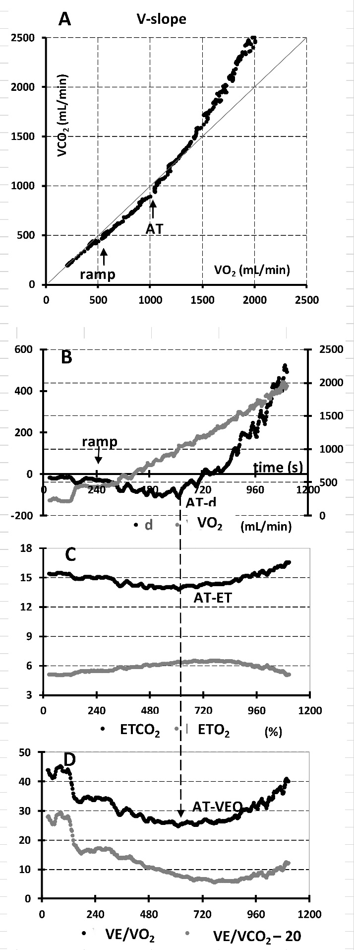

Figure2

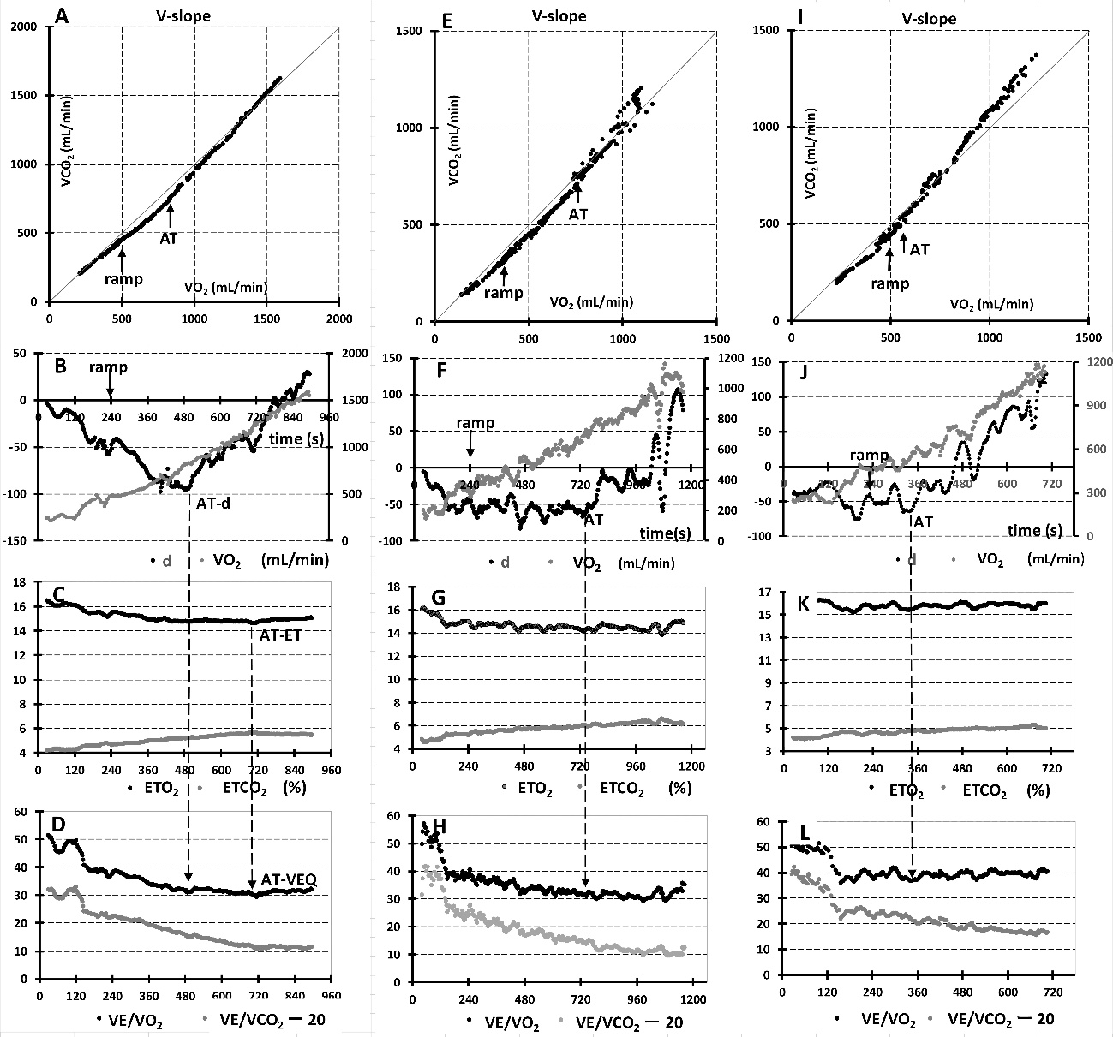

Figure3

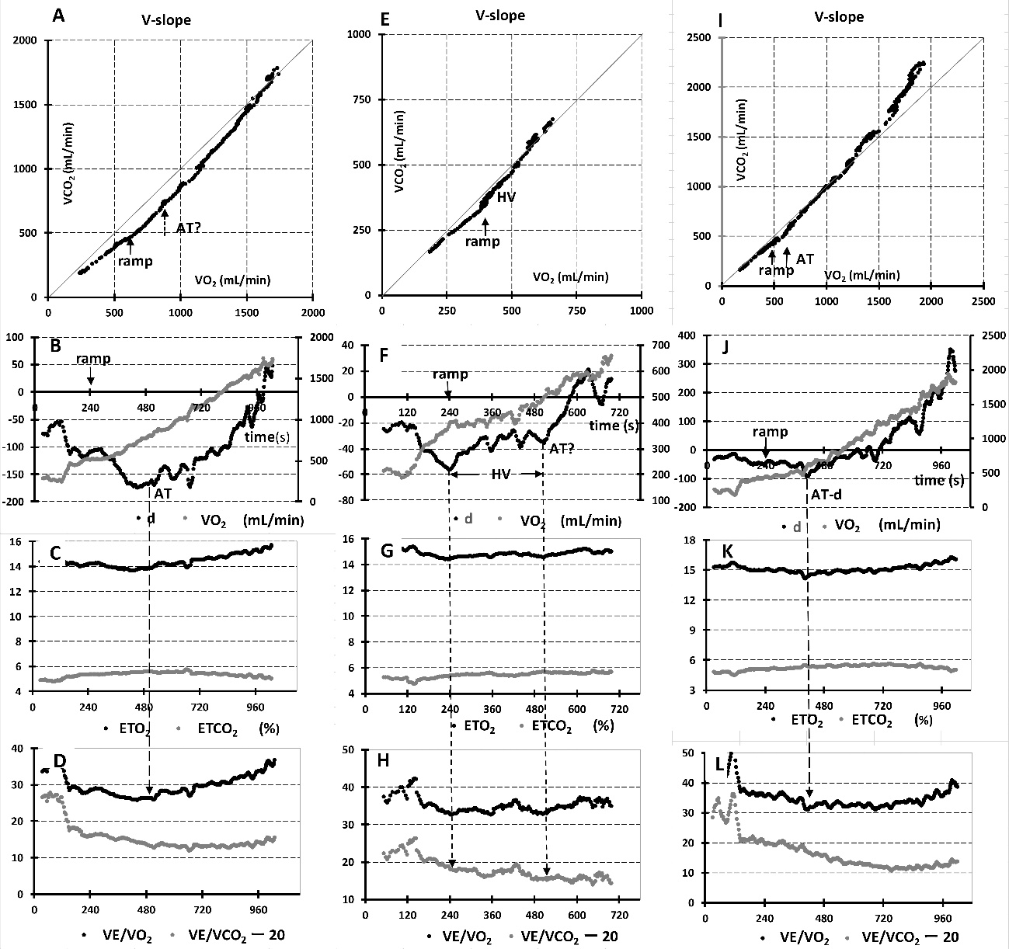

SDC

SDC Table-1. ET- and VEQ-AT read at the point of trend change (ET2, VEQ2)

|  |  |  |  |  |  |  |  |  |  |
| --- | --- | --- | --- | --- | --- | --- | --- | --- | --- |
| AT | n | Detection  (%) | Mean AT  (mL/min) | SD | CR | ET1 | ET2 | VEQ1 | VEQ2 |
| ET1 | 100 | 79 | 871 | 311 | 175 | - | * | * |  |
| ET2 | 112 | 88 | 831 | 303 | 233 | * | - | * |  |
| VEQ1 | 94 | 74 | 973 | 328 | 152 | * | * | - | * |
| VEQ2 | 111 | 87 | 874 | 284 | 241 |  |  | * | - |

*, p<0.05 by Bonferroni procedure (following repeated measures ANOVA)

The trend change pattern.

ET1-AT was read at an ascending BP, as conventionally done. For the reading of ET2-AT, the trend change pattern of ETO2 and ETCO2 was used. The trend change pattern of ETO2 and ETCO2 was defined as follows: in general, during the incremental exercise ETO2 displays a U-shaped pattern and ETCO2, an inverted U (see Fig. 1). As the ETO2 curve descends, the ETCO2 ascends and then they begin to run in parallel (until the ETO2 displays an ascending break point, i.e. AT). If ETO2 begins to plateau while ETCO2 is still ascending, it is defined as the point of trend change or departure and read as AT. For VEQ, both VEQ-02 and VEQ-C02 initially descend and then plateaus running in parallel (until VEQ-O2 displays an ascending break point, i.e. AT). If VEQ-02 plateaus while VEQ-CO2 is still descending, it is considered the point of trend change and read as AT (Fig. 7).

The upward BP of VEQ-02 predominantly occurred against the descending limb of VEQ-CO2, whereas the upward BP of ET-O2 occurred predominantly against ascending limb of ET-CO2 (Fig. 7). Graphically, this would make the appearance of upward BP of ET-O2 easier and that of VEQ-O2 more difficult.

As shown on the Table 1, the mean AT significantly decreased (AT appeared earlier) by adopting the point of trend change approach. However, the coefficient of repeatability (CR) substantially decreased.