**Figure 1**

*Drivers of French National Team Self-Categorization*

Drivers of French National Team Self-Categorization 170 - 2685

Intrapersonal relationship  
72 - 140

Individual-to-staff  
67 - 108

Individual-to-teammates or the team relationship  
169 - 1776

Individual-to-opposing team relationship  
55 - 88

Individual-to-Sport Environment Individuals Relationships, Excluding Teams and Staffs  
32 - 54

Individual-to-Outsiders Relationship  
25 - 33

Contexts  
148 - 477

- Experiencing individual success 48 – 79

- Experiencing individual failure 16 – 21

- Pleasant feeling 14 - 16

- Personal characteristics 9 – 11

- Shared experience 146 – 541

*- Experiencing the Same Occurrences* 127 - 394

*- Group Time* 78 - 125

- Commitment to the group 121 – 277

- Experiencing collective success 103 – 212

- Good relationships with teammates 67 – 78

- Knowing one’s teammates beforehand and during 60 – 92

- Experiencing collective failure 49 – 83

- Good communication 47 – 73

- The team is concerned 47 - 72

- Having shared goals 45 – 63

- Mobilizing the symbols of the French national team 40 – 60

- Having a specific role 35 – 59

- Inherently collective practice situation 29 – 34

- Belonging to the French national team 26 - 35

- Needing everyone to perform 24 - 29

- Discovering the French national team 15 – 17

- Affective experience 13 - 13

- Regarding relationship 42 – 59

*- Good relationship 33 – 46*

*- Bad relationship 10 - 13*

- Regarding performance 34 – 42

- Interacting with the opponent team 41 – 52

- Perception of the opponent team 18 - 27

- Fan presence 24 - 33

- Closed individuals 17 – 18

*- Pleasant relationship 12 – 13*

*- Unpleasant relationship 5 - 5*

- Non-close others 9 - 13

- Context of practice 138 – 403

*- Competition context 100 – 205*

- During the game 95 – 178

• Games 79 – 112

• Time on the Field 35 – 46

- Before the game 14 – 24

*- To be in a selection camp 51 – 58*

*- Selection 47 – 72*

- Succeeding in the selection 43 - 57

- Participating in the selection 9 – 12

*- Training context 43 - 57*

- Off-field life of the French national team 30 – 37

- Deadlines 11 – 13

- COVID influence 9 – 10

**Figure 2**

*Drivers of Individual Level Self-Categorization*

- Feeling 63 – 93

- Experiencing individual success 60 – 107

- Reflection on one’s past performance 60 – 93

- Experiencing individual failure 56 – 93

- Personal goals 51 – 73

- Individual practice situation 45 – 53

- The individual is involved 34 – 53

- Personal journey 27 – 35

- Personal characteristics 24 – 28

- Fan presence 19 - 25

- Interacting with the opponent team 26 – 33

- Perception of the opponent team 10 - 11

- Marked difference with teammates 87 – 160

*- Being cut from the team* 48 - 72

*- Sidelined from the team* 34 - 46

*- Comparison with teammates* 12 – 16

*- Being alienated from the group* 12 - 13

*- Not experiencing the same events* 12 – 12

- Experiencing collective failure 56 – 81

- Special role or position 38 – 58

- Discovering the French national team 35 – 41

- Lack of prior familiarity with teammates 30 – 41

- Commitment to the group 30 – 40

- Experiencing collective success 29 – 36

- Relationship with teammates 22 - 27

- *Bad relationship* 12 - 16

- *Good relationship* 9 – 10

- Joining a group 20 – 26

- Mobilizing the symbols of the French national team 18 – 19

- Shared experience 16 – 19

- *Experiencing the same occurrences* 13 – 16

- Communication 12 – 14

*- Bad communication* 9 – 9

*- Good communication* 3 – 3

- Regarding relationship 31 – 59

*- Bad relationship 18 - 33*

*- Good relationship 16 – 23*

- Regarding performance 28 – 35

- Closed individuals 23 – 35

*- Pleasant relationship 16 – 25*

*- Unpleasant relationship 7 - 9*

- Being special 9 - 9

- Context of practice 135 – 445

*- Competition context 85 – 163*

- During the game 79 – 134

• Time on the Field 54 – 87

• Games 40 – 47

- Before the game 13 – 29

*- Selection 67 – 121*

- Participating in the selection 34 – 47

- Succeeding in the selection 29 - 36

- Failing selection 26 – 35

*- Injury* 40 - 73

*- To be in a selection camp 37 - 45*

*- Training context 33 - 43*

- Off-field life of the French national team 23 - 38

- COVID influence 22 – 27

- Changing club or structure 10 - 11

- Deadlines 9 – 10

Prove one’s skill level  
48 -77

Contexts  
149 - 550

Individual-to-Outsiders Relationship  
31 - 49

Individual-to-Sport Environment Individuals Relationships, Excluding Teams and Staffs  
24 - 35

Individual-to-opposing team relationship  
32 - 49

Individual-to-staff  
48 - 95

Individual-to-teammates or the team relationship  
149 - 580

Intrapersonal relationship  
150 - 649

Drivers of Individual Level Self-Categorization 170 - 2095

**Figure 3**

*Comparison of Themes Driving French National Team or Individual Self-Categorization*

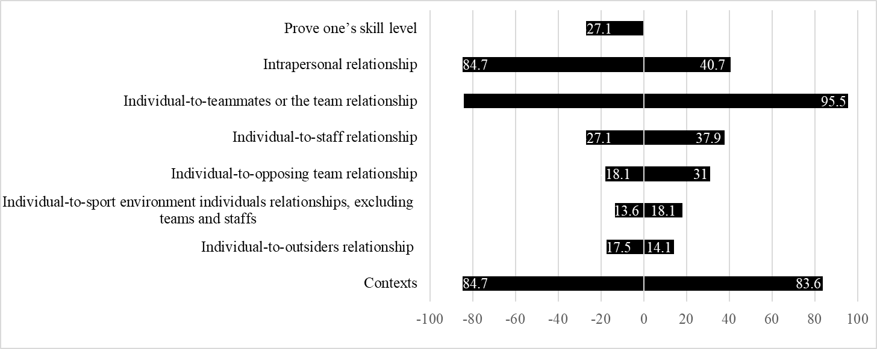

84.2

*Note.* The data labels are expressed as percentages of participants citing the themes.