**Mental practice improves pass accuracy in elite rugby players**

Charlène Truong1*, Julien Pellet2*, Léo Lurquin2, Ariane Tamisier2, Emilie Pété2,3, Quentin Bourgeais4,5, Pierre Gérat2,6, Emmanuelle Lepers2, Alan Guyomarch2,7, Solène Neyret8,9, Julien Ryard10, Jean-Rémy Chardonnet10, Célia Ruffino11, Charalambos Papaxanthis1, Mickael Campo2,12, Florent Lebon1,13

1. INSERM UMR1093-CAPS, Université Bourgogne, UFR des Sciences du Sport, F-21078, Dijon.
2. Psy-DREPI (UR 7458), Faculté des sciences du sport, Université Bourgogne, BP 27 877, 21078 Dijon Cedex, France.
3. Nantes Université, Movement - Interactions - Performance, MIP, UR 4334, F-44000, Nantes, France.
4. University Rouen Normandie, Normandie University, CETAPS UR 3832, F-76000, Rouen, France
5. Université Le Havre Normandie, University Rouen Normandie, INSA Rouen Normandie, Normandie University, LITIS UR 4108, F-76600, Le Havre, France
6. Ligue AURA, Fédération Française de Rugby, Chaponnay, France
7. Centre de Recherche Cerveau & Cognition (CerCo, CNRS UMR-5549), Toulouse, France.
8. Arts et Metiers Institute of Technology, LAMPA, F-53810 Changé, France
9. Icube Laboratory, IGG Team, University of Strasbourg
10. Arts et Metiers Institute of Technology, LISPEN, F-71100 Chalon-sur-Saône, France
11. EA4660, C3S Laboratory, C3S Culture Sport Health Society, Université de Bourgogne, UPFR Sports, 25000, Besançon, France.
12. Sport Psychology Department (Pôle PMAS), Fédération Française de Rugby, France.
13. Institut Universitaire de France (IUF), Paris, France

*Co-first authors

#Corresponding Author: Julien Pellet, [julien.pellet@u-bourgogne.fr](mailto:julien.pellet@u-bourgogne.fr), Université de Bourgogne, UFR STAPS, 3 allée des stades universitaires, 21000 Dijon.

Running head: Imagery and Virtual Reality in Rugby

This document is a preprint

Truong, C., Pellet, J., Lurquin, L., Tamisier, A., Pété, E., Bourgeais, Q., Gérat, P., Lepers, E., Guyomarch, A., Neyret, S., Ryard, J., Chardonnet, J.-R., Ruffino, C., Papaxanthis, C., Campo, M., & Lebon, F. (2024) Mental practice improves pass accuracy in elite rugby players. *SportRxiv.*

**Abstract**

Mental practice has been shown to improve motor performance; however, its effects in elite sports, particularly under constraints, remains underexplored. In this study, we examine the impact of mental practice, preceded by imagined or virtual game scenarios, on pass accuracy in elite rugby players. Seventy-five players from national and regional talent development teams participated in this study. They were divided into three groups: control (CTRL), motor imagery (MI), and virtual reality and motor imagery (VRMI) groups. All players completed pre- and post-tests assessing pass accuracy at three distances (10, 15 and 20 meters) under two conditions (with and without time constraints). Between the tests, the MI and VRMI groups performed three mental practice sessions over three different days. Each session consisted of two blocks of imagined (MI) or virtually observed (VRMI) stressful game scenarios (yellow card or try conceded) followed by imagined passes at each distance. The CTRL group did not engage in any practice during this period. Our results showed that mental practice improved pass accuracy under no constraints, with both MI and VRMI greater than CTRL (p<0.03 in all). Vividness of motor imagery improved over training sessions for MI and VRMI (p=0.01), but VRMI did not further enhance imagery vividness compared to MI alone. Under time constraints, pass accuracy at 20m declined during the pre-test for all groups (p=0.003). However, both mental practice groups failed to counteract this decrease at post-test. In conclusion, three mental practice sessions effectively enhanced pass accuracy under no constraints but did not mitigate the negative effects of time constraints on accuracy. Coaches and practitioners might consider implementing mental practice to further improve motor accuracy and reduce physical workload.

*Keywords*: Motor imagery, motor performance, virtual reality, imagery vividness, elite players, mental training.

**Introduction**

Achieving optimal motor performance in elite sports presents significant challenges. Athletes must consistently extend the limits of their physical capabilities while maintaining their performance precise and consistent, all under various constraints (1). For instance, in crucial moments like the decisive putt in golf, the decisive penalty kick in soccer, or scoring a try under time pressure in rugby, experts may perform below expectations. The pressure created by the high stakes sporting situations (2,3) lead to sub-optimal performance (4–6). Workloads, defined as the cumulative stress from multiple training sessions (7), are crucial to maintain and enhance performance. However, insufficient workloads can impede performance improvements (8), while excessive workloads decrease motor accuracy (9),and in extreme cases induce injuries (10–12). Thus, athletes must effectively balance training and recovery period to optimize performance and minimize risks of injury.

Although physical practice is undeniably fundamental for the improvement and stabilization of motor performance (10,11), complementary methods have also emerged. Mental practice, using motor imagery, offers physical educators and sport coaches alternative methods for improving/maintaining motor performance and reducing physical workload. Motor imagery is defined as the mental simulation of an action without any corresponding motor output (12,13). Numerous investigations have provided robust evidence that executed and imagined movements show overlapped brain activation (14,15) and that mental practice with motor imagery induces neural modulation (16). These neural changes support the behavioral benefits observed after only mentally repeating the movements, such as strength increase (17–19), and movement speed and accuracy improvement (20–24). Additionally, performance improvements have been reported in various motor skills sports such as basketball (25,26), or tennis (27,28).

Despite the cumulated evidence concerning the beneficial effects of mental practice on motor performance, few studies have focused on elite sports (29). Moreover, the effects of mental practice on performance under constraints remain largely unexplored while physical practice under pressure constraint enhance performance in various disciplines, such as soccer (30), basketball and dart (31).

Another alternative to reduce workload and improve motor performance would be virtual reality (VR). VR is a promising tool in sports, which enables the replication of complex game situations that are challenging to simulate in traditional training facilities (32,33). VR is a computerized interactive simulation of a three-dimensional environment, often experienced through a head-mounted display. These environments can range from realistic depictions of real places to entirely imaginary settings (34). Studies have shown that VR immersion can significantly influence the autonomic nervous system, indicated by increased skin conductance (35) and respiratory rate (34), as well as reduced parasympathetic activity (36). These physiological effects are closely linked to the quality of immersion and the sense of presence, leading to engage deeply in the scenery (37). In addition, VR is regarded as one of the most promising methods for inducing emotions akin to those experienced in competitive settings, such as pressure (38). Overall, the opportunity to create immersive and realistic training scenarios by means of VR could present a valuable opportunity for athletes to enhance their performance by mentally simulating situations under constraints. Recent studies showed that the combination of mental practice with VR induced greater performance improvement in comparison to mental practice alone (39,40). Additionally, integrating environment visualization can enhance the focus on the imagined movements (41).

In the current study, we first aimed to explore the influence of mental practice on pass accuracy in elite rugby players. We suggested that three sessions of mental practice would significantly enhance pass accuracy in comparison to no practice. We also investigated whether priming mental practice with imagined or virtually observed scenarios of stressful game situations (yellow card or try conceded) would improve pass accuracy under time constraints. We hypothesized that mental practice associated with VR would further reduce the errors on pass accuracy when players are under time constraints, in comparison to mental practice alone. Finally, we evaluated the positive impact of VR on the vividness of images generated by the players. We hypothesized that exposure to VR scenarios of game situations prior to imagining the passes would help players create more vivid images than those who did not use VR.

**Material and methods**

**Participants**

One hundred and six rugby players (21 females and 85 males), aged between 15 and 30 years old, were included in the study. Twenty-one of them played for the Olympic French rugby Seven team and the others for youth elite development program. They were divided into three groups: (a) Control (CTRL) group who only performed the pre- and post-tests (n = 20), (b) Motor Imagery (MI) group who performed 3 sessions of mental practice between the tests (n = 48), and (c) Virtual Reality and Motor Imagery (VRMI) group who performed 3 sessions of mental practice after using virtual reality (n = 38). Due to incomplete test session or injury, a total of 75 players (8 females and 67 males) was included in data analysis (17, 31, and 27 in the CTRL, MI and VRMI groups, respectively).

**Experimental procedures**

The study complied with the standards set by the Declaration of Helsinki (excluding pre-registration). Informed consent was obtained from all participants. Within one week, we tested pass accuracy in two sessions (pre- and post-test) separated by at least three days. Between the test sessions, participants of the MI and VRMI groups performed three sessions of mental practice, each on separate days. Each session was composed of two blocks of imagined (MI) or virtually observed (VRMI) stressful game scenarios followed by mental practice. The CTRL group received no practice (see Figure 1 for details).

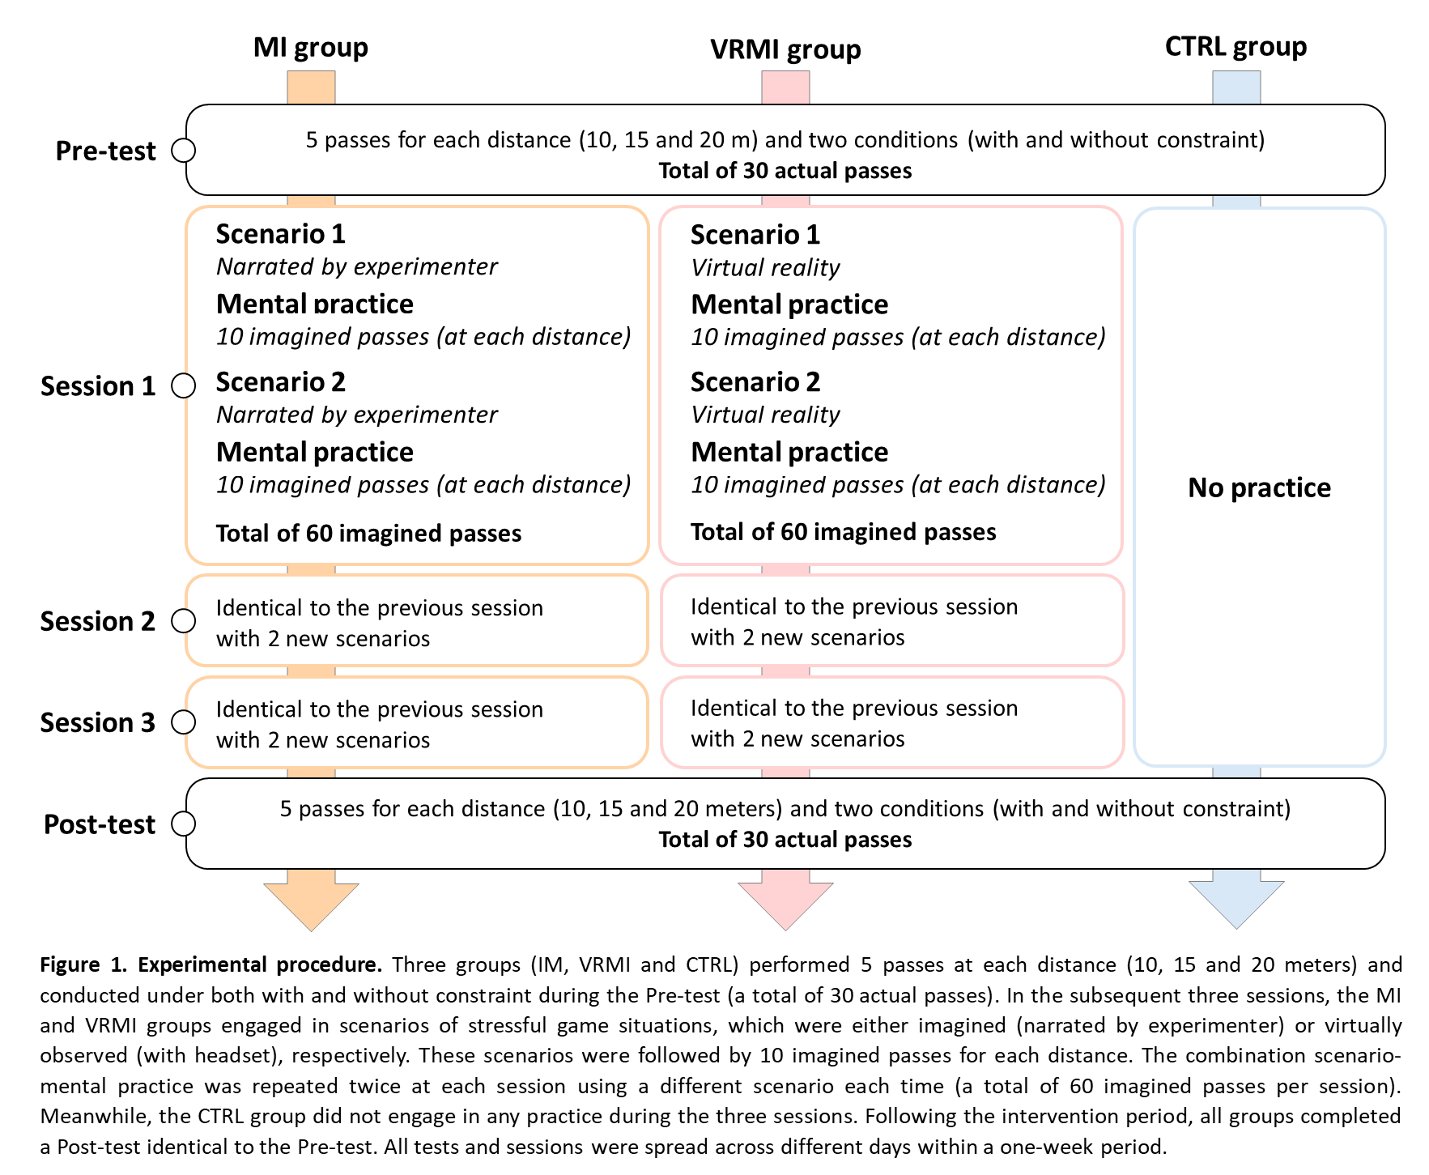

**Pass accuracy measurement**

At pre- and post-tests, we measured pass accuracy for three distances from the target (10, 15 and 20 m, in this order) and two conditions (with and without time constraint, randomized).

The goal was to touch the target (a rugby ball placed on a 103 cm-height pole). The ball to throw was placed on the ground in front of the cone indicating the distance to the target. The cone was positioned so that the participants were slightly in front of the target (to pass backwards; Figure 2A). Under the ‘no time constraint’ condition, the player caught and threw the ball as fast as possible on the Go signal, given by the experimenter. Under the ‘time constraint’ condition, the player did the same task while a second experimenter was running at him/her to catch the ball. This second experimenter started at the Go signal, 5 meters away from the cone.

For each distance and each condition, the players had 5 trials. In total, the players did 30 trials, 15 with no time constraint and 15 with time constraint. Half of the players started with no time constraint, and the other half with time constraint.

To measure the error from the target, we recorded each trial by means of two cameras (SONY DCR-SR35) and analyzed the recordings a posteriori. The lateral camera was positioned to capture a 2D plan, perpendicular to the ground, which included the target in its field of view. The front camera was placed perpendicular to the plan. In order to measure accuracy, we used Kinovea (version 2023.1.2) to synchronize both videos. When the ball crossed the 2D plane (a plane including the ball, the target, and the lateral camera), both synchronized videos were stopped (Figure 2B). We then measured the distance between the ball and the target in centimeters.

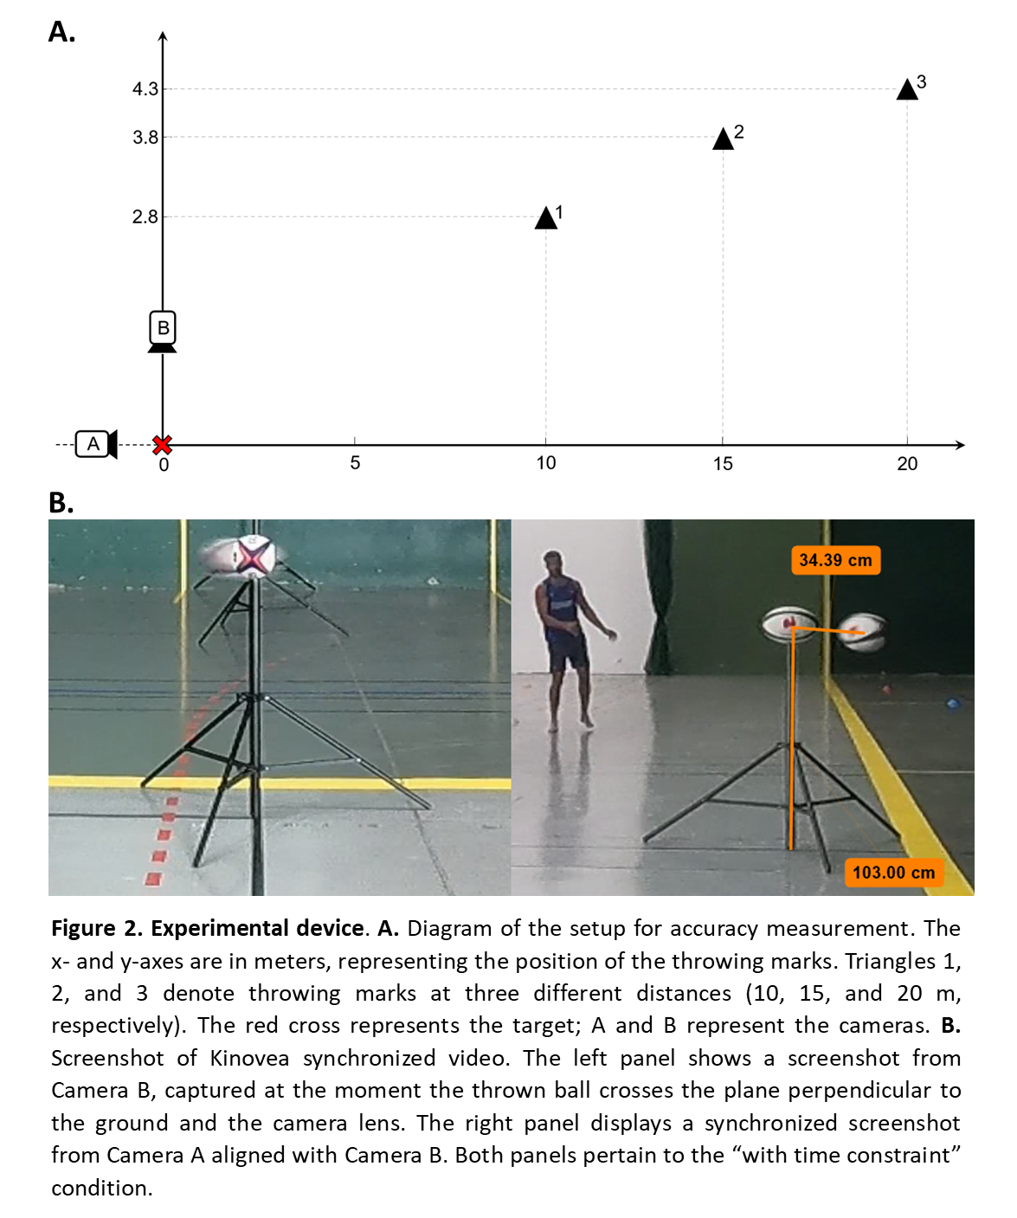

**Scenarios prior to mental practice**

Prior to the mental practice, participants of the VRMI group were immersed, through an HTC Vive head-mounted display, in a virtual environment displaying a scenario. This scenario was also projected on the experimenter’s laptop. Two main scenarios were used, with variations for each training session. Gender and skin color of the avatar were adjusted to fit the participant’s experience. The first scenario immerses the participant in a situation where the French national team has just conceded a try. The participant heard a whistle, and an image appeared, showing him/her positioned within the 22-meter line as teammates ran behind the poles to form a huddle. The participant was then quickly ‘teleported’ into the huddle, where they heard a player leading the team in taking three deep, synchronized breaths with teammates. Next, the team captain’s voice reassured the teammates and suggested focusing on what must be done. The teammates then left the huddle, running to take their positions on the field. Finally, the participant was teleported to a position where they could see the opposing team briefly waiting then running toward them after the kickoff. Figure 3’s left panel displays the huddle. The second scenario immersed the participant in a situation where he/she received a yellow card. The participant heard a whistle, and an image appeared, showing him/her positioned within the opponents' 22-meter area in front of an opponent as the main referee approached. Teammates and opponents acted as though the game was paused, and the referee walked over to speak briefly with another official. The stadium’s large screen displayed ‘TMO.’ After a moment, the main referee turned back toward the participant, approached, reached into his pocket for a yellow card, and raised it while blowing his whistle. The participant was then teleported near the technical area, eventually ending up off the field beside the coach. Table 1 describes the VR setup’s variations. Figure 3’s right panel displays the referee giving a yellow card. While the scenario was played, the experimenter narrated its progress using the screen as a reference (with visual and auditory cues) for the players of the MI group. Contrary to the players of the VRMI group who saw the scenario via the VR headset, the players of the MI group were instructed to mentally recreate, with their eyes closed, the environment narrated by the experiment. The goal of the VR or imagined scenario was to immerse the players in a stressful environment (try conceded or yellow card).

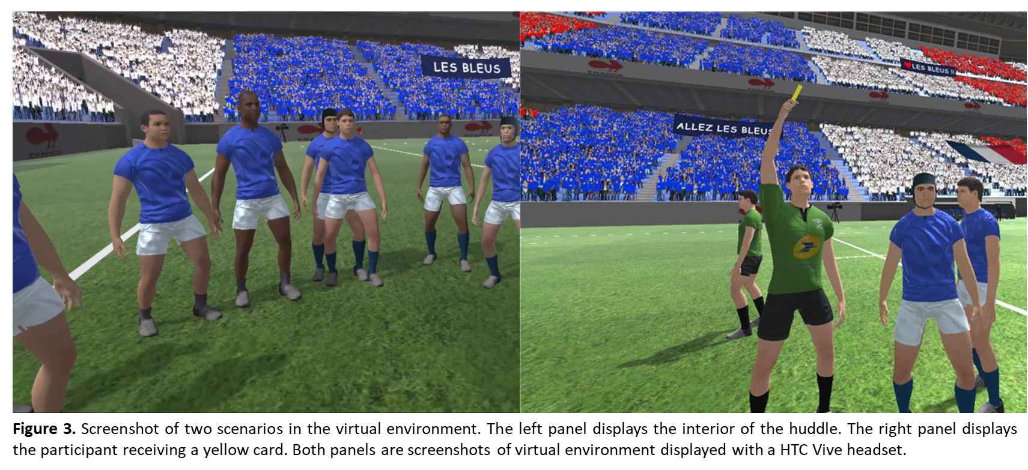

Table 1

*Scenario variations during training sessions*

|  |  |  |  |  |  |  |  |  |
| --- | --- | --- | --- | --- | --- | --- | --- | --- |
| Training session | Scenario | Weather | Time of day | Opponent team | Public | Time clock | Score | Type of situation |
| 1 | 1 | Sunny | Day | England | Exterior | 5’ | 0-0 | Team conceded a try |
|  | 2 | Rainy | Night | England | Exterior | 70’ | 0-10 | Team conceded a try |
| 2 | 1 | Rainy | Day | England | Exterior | 20’ | 12-5 | Team conceded a try |
|  | 2 | Sunny | Day | England | Exterior | 50’ | 12-22 | Yellow card |
| 3 | 1 | Sunny | Day | England | Exterior | 50’ | 10-22 | Yellow card |
|  | 2 | Sunny | Day | England | Exterior | 77’ | 26-22 | Team conceded a try |

*Note*. Left score is always France.

**Mental practice**

After the scenario phase, all players were asked to imagine a situation in the same environment they had just seen (VRMI group) or imagined (MI group), i.e., after the conceded try or when the player was back on the field after the yellow card. Therefore, the mental practice was situated in an imagined context that took place after the scenario they just saw/imagined. Then, the experimenter provided instructions to imagine the action and asked the players to mentally simulate a sequence of 10 passes at three different distances (10, 15, and 20 meters, randomized) without moving their bodies. A non-exhaustive example of situations is: "There’s strong pressure in the ruck, and things are moving fast. The opponents are closing in on your teammate, leaving a gap. Your winger has noticed it too, so you send him a long pass", "The opponent has the ball, offensive tackle, we steal the ball in the ruck, we see a gap, they won’t have time to reset, you send a long pass to your winger who’s ready", or "In front of the poles, you find yourself in the 9’s position after a ruck. You see two opponents coming at you fast, ready to take you down, but you hear your 10 calling for a drop goal from the center. If it goes through, it will lock in the game". After each set of ten passes at a specific distance, participants were asked to rate the clarity of the mental images on a Likert scale from 1 to 7, with 1 being "not vivid at all" and 7 being "perfectly vivid" (42). In total, the players of the MI and VRMI groups imagined 60 passes in different contexts at each session. One mental practice session lasted about 20 minutes. Table 1 outlines the specificities of each scenario and the setting that participants had to first visualize to mentally repeat the task.

**Data analysis and statistics**

For each distance (10m, 15m, and 20m) and condition (with and without time constraint), pre- and post-test pass accuracy was defined as the mean accuracy, excluding the minimum and maximum recorded values. The normality of the data distribution was assessed using the Shapiro-Wilk test. The significance level was fixed at 0.05 (type I error) and power (type II error) was superior to 0.8 for all the statistical analyses.

First, we examined the effects of different practices on pass accuracy without time constraints for each distance. The gain in pass accuracy between pre- and post-tests was calculated for each distance in percentage as follows:

1. Pass accuracy gain = (post – pre) / pre * 100

To measure the effect of mental practice (with or without VR), we first performed a repeated measures (rm) ANOVA using pass accuracy without time constraint as the dependent variable, groups (CTRL, MI, and VRMI) as a between-subject factor and distances (10m, 15m, and 20m) as a within-subject factor. For each group, we compared the gain with the reference value ‘zero’ (0) to determine any improvement between pre- and post-test.

To examine the effect of time constraint on pass accuracy, we first used a three-way rmANOVA to compare pre-test performance across groups (CTRL, MI and VRMI) and distances (10m, 15m, and 20m) as between-subjects factors, and conditions (with and without time constraint) as a within-subjects factor. For distances showing a significant effect of constraint, we calculated the difference in accuracy with and without constraint during the pre-test (Δpre) and the post-test (Δpost) for each group. A rmANOVA was conducted with groups (CTRL, MI and VRMI) as a between-subjects factor and test difference (Δpre and Δpost) as a within-subjects factor.

Finally, to evaluate the evolution of mental images vividness across practice and between groups (with or without VR), we performed a rmANOVA with groups (MI and VRMI) as between-subjects factor and session training (S1, S2 and S3) as a within-subjects factor.

When necessary, we used Newman-Keuls tests for post-hoc analysis. Effect sizes for the ANOVA are reported as partial eta squared (η²), with small (η² < 0.06), moderate (0.06 ≤ η² < 0.14), and large effects (η² ≥ 0.14). In situations where no significant differences were observed, a Bayesian equivalence analysis was conducted using a Region of Practical Equivalence (ROPE) set at [−0.1, 0.1], with a prior Cauchy scale of 0.707 (43). The overlapping hypothesis Bayes factor (BFOH01) and the non-overlapping hypothesis Bayes Factor (BFNOH01) provide the evidence that the data support the null hypothesis versus the alternative hypothesis within the equivalence region, and the extent to which data fall within the region of equivalence rather than the region of non-equivalence, respectively. This analysis quantifies the evidence in favor of the null hypothesis and discriminates the ‘absence of evidence’ and the ‘evidence of absence’, thereby strengthening the reliability of conclusions.

**Results**

**Effect of mental practice with and without virtual reality under no time constraint**

Figure 4 illustrates the average values (+SD) of pass accuracy gain without time constraint for CTRL, MI and VRMI groups according to the distance (10m, 15m, and 20m). We found a significant effect of *group* (F2,72 = 5.43, p = 0.006, η² = 0.13) but no effect of *distance* (F2,144 = 1.97, p = 0.14, η² = 0.03) nor interaction *group x distance* (F4,144 = 1.52, p = 0.20, η² = 0.04). Post hoc analysis on groups revealed a significant difference between CTRL and both MI (p = 0.01) and VRMI (p = 0.003), but no difference between MI and VRMI (p = 0.44, Bayesian equivalence tests: BFOH01 = 4.73 and BFNOH01 = 7.46). Additionally, the comparison of the pass accuracy gains to the reference value (zero) indicated a significant increase of performance at post-test for MI (6.39 ± 28.08%; p = 0.03) and VRMI (9.57 ± 33.88%; p = 0.01), but not for CTRL (-4.53 ± 39.25%; p = 0.41, Bayesian equivalence tests: BFOH01 = 4.62 and BFNOH01 = 7.18). The results showed that mental practice with or without VR enhanced pass accuracy under no time constraint, compared to no practice. However, adding VR prior to mental practice did not result in further improvement compared to mental practice alone.

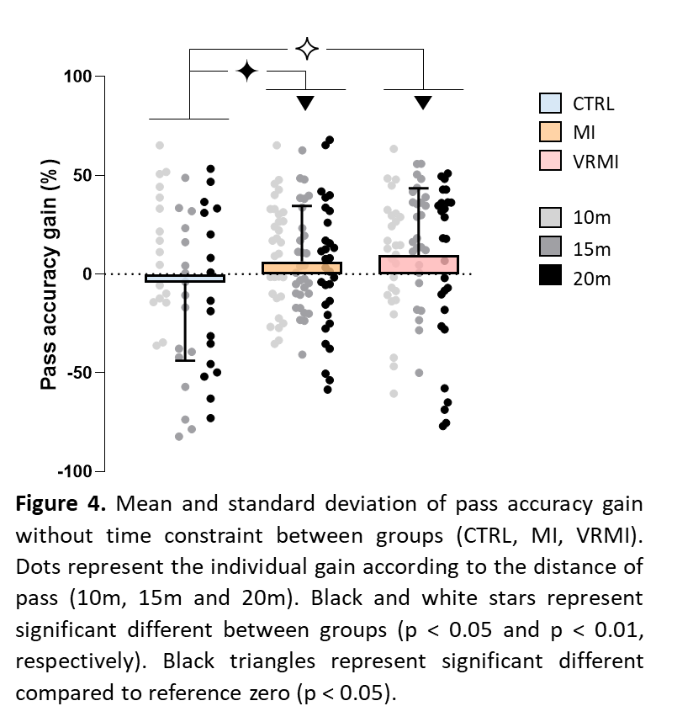

**Effect of mental practice with and without virtual reality under time constraint**

Figure 5A presents the average (+SD) of pass accuracy at pre-test, both without and with time constraints, across groups (CTRL, MI and VRMI) and for different pass distance from the target (10m, 15m, and 20m). We found a significant effect of *distance* (F2,216 = 71.38, p < 0.001, η² = 0.40), and an interaction effect *condition x distance* (F2,216 = 3.85, p = 0.02, η² = 0.04). The post hoc analysis revealed a significant decrease in accuracy with time constraint when the players were 20m away from the target (p = 0.003). However, no significant difference was observed for distances of 10m (p = 0.23, Bayesian equivalence tests: BFOH01 = 1.79 and BFNOH01 = 1.94) and 15m (p = 0.47, Bayesian equivalence tests: BFOH01 = 6.24 and BFNOH01 = 12.87). As the time constraint affects only the accuracy at 20m, we examined the difference effect of practice under time constraint only for this distance.

Figure 5B illustrates the difference with and without constraint for the pre-test (Δpre) and the post-test (Δpost) between groups (MI, VRMI and CTRL) for the 20m distance. We did not find any effect of *group* (F2,72 = 0.08, p = 0.92, η² = 0.002), *test* (F1,72 = 1.31, p = 0.26, η² = 0.02) nor interaction *group x test* (F2,72 = 0.07, p = 0.94, η² = 0.001). Bayesian equivalent tests between Δpre and Δpost per groups supported similar data (BFOH01 > 3.08 and BFNOH01 > 3.87, for all). These results suggest that, although the time constraint reduced pass accuracy at 20m compared to no constraint, mental practice with or without VR did not compensate for this decline.

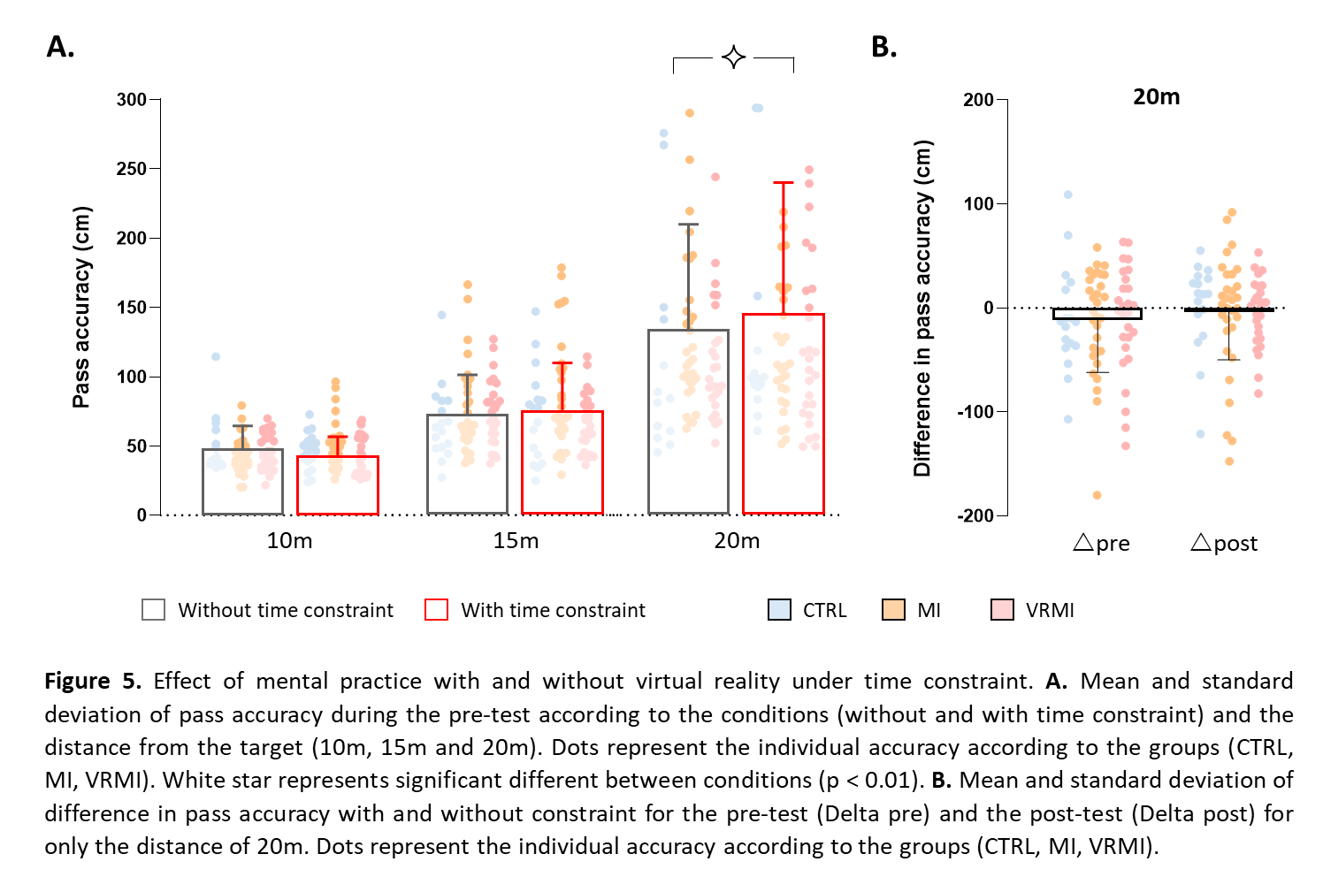

**Vividness of motor imagery**

Figure 6 illustrates the mean score (+SD) of motor imagery vividness during each mental practice session for MI and VRMI groups. We found a significant effect of *session* (F2,112 = 5.22, p = 0.007, η² = 0.09) but no effect of *group* (F1,56 = 0.05, p = 0.82, η² < 0.001) nor interaction effect *session x group* (F2,112 = 0.51, p = 0.60, η² = 0.009). The post hoc analysis showed an increase of imagery vividness between the first training session (Likert scale S1: 4.38 ± 1.13) compared to the two others (Likert scale S2: 4.65 ± 1.13 and S3: 4.69 ± 1.10; p = 0.01, for both). This result suggests that players imagined more vividly across training, but that VR did not further enhance the vividness of motor images.

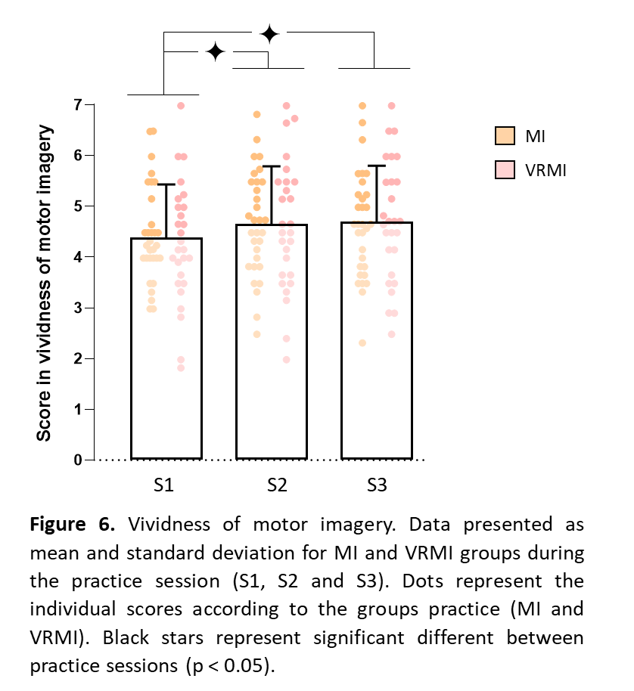

**Discussion**

In this study, we explored the effects of mental practice, preceded either by imagined situations (MI group) or by an immersion in a virtual reality scenario (VRMI group), on pass accuracy in elite rugby players, compared to no practice (CTRL group). Players completed passes at varying distances from the target (10m, 15m, and 20m) under two conditions: with and without time constraint. In the absence of time constraint, mental practice alone improved pass accuracy across all distances, while the addition of virtual reality provided no further improvement. Under time constraint, accuracy decreased only at the longest distance (20m), and mental practice with or without virtual reality did not counteract this decline of accuracy. In addition, the vividness of motor imagery increased over the course of mental practice, without any effect of prior VR.

The elite rugby players exhibited greater accuracy in their physical execution of pass following mental practice. This finding aligns with several previous studies conducted with novice participants (29,44–46), which have shown that mental practice significantly enhances accuracy and speed during simple motor tasks, such as pointing or finger-tapping tasks (21,23,24), as well as in sport, such as golf (47,48) Only a limited number of studies have examined sport-specific motor skills among skilled players, typically combining mental and physical practice (29), such as in tennis (28) and soccer (49). Interestingly, our finding demonstrates the effectiveness of mental practice alone, suggesting it could provide an alternative training approach without adding the physical demands. This result has important implications for training periods where physical practice must be minimized, or workload managed carefully, particularly for elite athletes engaged in high-volume and -intensity training.

Furthermore, the vividness of motor imagery improved across mental practice. Mental practice emerges as a dynamic process: enhancements in imagery ability during practice foster greater performance improvements post-training (42). Greater motor imagery ability exhibits greater activation in the premotor, parietal, and ventrolateral areas, cortical regions known to be involved in the generation of mental images (50).

Interestingly, the concept of internal models offers a theoretical framework for explaining performance enhancement achieved through mental practice (51,52). There is strong evidence supporting that motor predictions are generated by internal forward models - neural networks that simulate the causal relationships of physical processes by predicting future sensorimotor states (e.g., position, velocity) based on the efferent copy of the motor command and the current state (53). A recent study has demonstrated that the forward model may anticipate the sensory consequences of an imagined movement (54). During mental practice, both the initial state of the arm and the efferent copy of the motor command produced by the controller are available to the forward model, which then predicts the arm's future states. These internal predictions, serving as inputs from the forward model to the controller, would enhance the output of controller in the absence of movement-related sensory feedback, thereby improving motor performance in subsequent physical execution.

However, our findings did not show any additional improvement in accuracy nor increase in vividness when VR was prior to mental practice. This is in contrast with our hypothesis. Previous studies supported the use of VR to create realistic simulation environments for athletes during training (55,56). By providing immersive experiences, VR can enhance an athlete's sense of presence (57), and may assist in mentally visualizing the environment, enabling full concentration on mental movement to positively impact the effectiveness of mental practice (41). One potential limitation to explain our result could be the degree of immersion provided by the VR environment. The effectiveness of VR in enhancing mental imagery may depend on how fully immersed an athlete feels in the simulated environment. Previous research suggests that higher levels of immersion can significantly impact the effectiveness of VR training (58–60). The lack of improvement in vividness of mental image may explain why no additional gains in accuracy were observed when VR was used prior to mental practice. If the quality of the mental images generated during practice does not improve, the potential benefits of combining VR with mental practice may be limited. In another study, positive effects of VR were found when used to guide mental practice (40). Therefore, incorporating VR during mental practice may offer a more effective approach, especially in enhancing performance, than using VR prior to mental practice. It is also noteworthy that elite athletes may experience less significant performance gains compared to novice players (61). This could be attributed to the already high level of skill and performance consistency among elite athletes, resulting in diminished room for improvement (62). As such, the marginal gains offered by enhanced mental imagery through VR might not be as pronounced for skilled players. Harris et al. (2020) showed a positive effect of VR for novice, but not skilled, learners in golf putting (61).

Additionally, we showed that accuracy declined with time constraints when the distance from the target was high (20m), i.e., when the difficulty was greater (63). Sport situations, such as the dynamic movement of teammates and opponents for instance, create significant constraints, which can limit the effectiveness of movement (1). Similarly, Kostrna (2022) found fewer successful basketball free throws under time constraint in novice and elite learners (64). This decline in accuracy under constraint may be explained by two theories (65): the distraction (66) and the explicit monitoring theories (3). According to distraction theory, an athlete working memory becomes divided between task-irrelevant distractors and task-relevant performance, especially in stressful situations (67), reducing the cognitive capacity available for executing the motor task (68,69). On the other hand, the explicit monitoring theory posits that pressure amplifies self-awareness, leading to heightened attention toward bodily sensations and motor processes. This focus would reduce movement automatization and hinder execution (70).

Our study did not reveal any significant effect of mental practice, with or without prior VR, on mitigating the decline in accuracy caused by time constraint. Although mental practice enhances motor performance, it appears insufficient to counteract the negative impact of time constraint in this case. This suggests that physical practice under constraint remains a critical element of training for athletes. For instance, training under pressure or implicit learning appear to be relevant for counteracting the pressure-induced performance drops (31,65,71,72). Note that the training duration in our study was limited to one week due to the organizational constraints inherent in the scheduling of elite teams. Further research is needed to determine whether extending the duration of mental training, associated with VR, would optimize performance under constraint.

**Conclusion**

This study highlights the effectiveness of three sessions of mental practice in significantly improving pass accuracy in elite rugby players with no time constraints. However, these short bouts of mental practice (whether combined with VR) were not able to counteract the drop in accuracy under time pressure. This result underscores the challenges of maintaining precision in high-pressure situations. Notably, the addition of VR prior to mental practice did not further enhance performance or imagery vividness, potentially due to the already high skill levels of the players and/or the need for greater immersion in the VR experience. Altogether, our results emphasize the value of mental practice sessions in enhancing motor performance and provide a strong foundation for further exploration in elite sport. To optimize performance under pressure, extending mental training or adopting alternative VR configurations could unlock greater potential for athletes at this elite level.

**Data availability**

The datasets generated during and analyzed during the current study are available at https://osf.io/679h2/

**Author contributions**

**Charlène Truong:** Formal analysis, Writing - Original Draft, Writing - Review & Editing, Visualization**, Julien Pellet:** Methodology, Investigation, Resources**,** Writing - Original Draft, Writing - Review & Editing, Visualization, Project administration**, Léo Lurquin:** Investigation**, Arianne Tamisier:** Formal analysis, Investigation, Visualization**, Emilie Pété:** Investigation**, Pierre Gérat:** Investigation**, Emmanuelle Lepers:** Investigation**, Quentin Bourgeais:** Investigation**, Alan Guyomarch:** Investigation**, Solène Neyret:** Software, Resources**, Julien Ryard:** Software, Resources**, Jean-Rémy Chardonnet:** Software, Resources**, Célia Ruffino:** Conceptualization, Methodology, Writing - Review & Editing**, Charalambos Papaxanthis:** Conceptualization, Writing - Review & Editing, Project administration**, Mickael Campo:** Conceptualization, Methodology, Writing - Review & Editing, Supervision, Project administration, Funding acquisition**, Florent Lebon:** Conceptualization, Methodology, Supervision, Writing - Original Draft, Writing - Review & Editing, Project administration**.**

**Acknowledgement**

This work was supported by the Agence Nationale de la Recherche under Grant PPR STHP n°006.

**Conflict of Interest**

The authors declare that the research was conducted in the absence of any commercial or financial relationship that could be construed as a potential conflict of interest.

The results of the study are presented clearly, honestly, and without fabrication, falsification, or inappropriate data manipulation. In addition, the results of the present study do not constitute endorsement by the American College of Sports Medicine.

**References**

1. Newell KM. Constraints on the Development of Coordination. In: Motor Development in Children: Aspects of Coordination and Control [Internet]. Dordrecht: Springer Netherlands; 1986 [cited 2024 Oct 29]. p. 341–60. Available from: <http://link.springer.com/10.1007/978-94-009-4460-2_19>

2. Beilock SL, Carr TH. On the fragility of skilled performance: What governs choking under pressure? J Exp Psychol Gen [Internet]. 2001 [cited 2024 Oct 29];130(4):701–25. Available from: <https://doi.apa.org/doi/10.1037/0096-3445.130.4.701>

3. Baumeister RF. Choking under pressure: Self-consciousness and paradoxical effects of incentives on skillful performance. J Pers Soc Psychol [Internet]. 1984 [cited 2024 Oct 29];46(3):610–20. Available from: <https://pubmed.ncbi.nlm.nih.gov/6707866/>

4. Dandy J, Brewer N, Tottman R. Self-consciousness and performance decrements within a sporting context. J Soc Psychol [Internet]. 2001 Feb 1 [cited 2024 Oct 29];141(1):150–2. Available from: <https://www.tandfonline.com/doi/abs/10.1080/00224540109600540>

5. Dohmen TJ. Do professionals choke under pressure? J Econ Behav Organ. 2008 Mar 1;65(3–4):636–53.

6. Beilock SL, Gray R. Why Do Athletes Choke Under Pressure? In: Handbook of Sport Psychology [Internet]. Wiley; 2007 [cited 2024 Oct 29]. p. 425–44. Available from: <https://onlinelibrary.wiley.com/doi/10.1002/9781118270011.ch19>

7. Gabbett TJ, Whyte DG, Hartwig TB, Wescombe H, Naughton GA. The Relationship Between Workloads, Physical Performance, Injury and Illness in Adolescent Male Football Players. Sports Medicine [Internet]. 2014 Jul 9 [cited 2024 Oct 29];44(7):989–1003. Available from: <https://pubmed.ncbi.nlm.nih.gov/24715614/>

8. Windt J, Gabbett TJ. How do training and competition workloads relate to injury? The workload—injury aetiology model. Br J Sports Med [Internet]. 2017 Mar 1 [cited 2024 Oct 29];51(5):428–35. Available from: <https://pubmed.ncbi.nlm.nih.gov/27418321/>

9. Maly T, Sugimoto D, Izovska J, Zahalka F, Mala L. Effect of Muscular Strength, Asymmetries and Fatigue on Kicking Performance in Soccer Players. Int J Sports Med [Internet]. 2018 Apr 5 [cited 2024 Oct 29];39(04):297–303. Available from: <https://pubmed.ncbi.nlm.nih.gov/29506307/>

10. Krakauer JW, Hadjiosif AM, Xu J, Wong AL, Haith AM. Motor Learning. In: Comprehensive Physiology [Internet]. Wiley; 2019. p. 613–63. Available from: <https://onlinelibrary.wiley.com/doi/10.1002/cphy.c170043>

11. Dayan E, Cohen LG. Neuroplasticity Subserving Motor Skill Learning. Neuron [Internet]. 2011 Nov 3 [cited 2021 Aug 17];72(3):443–54. Available from: <https://linkinghub.elsevier.com/retrieve/pii/S0896627311009184>

12. Jeannerod M, Decety J. Mental motor imagery: a window into the representational stages of action. Curr Opin Neurobiol [Internet]. 1995 Dec [cited 2023 Apr 18];5(6):727–32. Available from: <https://pubmed.ncbi.nlm.nih.gov/8805419/>

13. Lotze M, Halsband U. Motor imagery. Journal of Physiology-Paris [Internet]. 2006 Jun 1 [cited 2024 Oct 29];99(4–6):386–95. Available from: <https://linkinghub.elsevier.com/retrieve/pii/S0928425706000210>

14. Hétu S, Grégoire M, Saimpont A, Coll MP, Eugène F, Michon PE, et al. The neural network of motor imagery: An ALE meta-analysis [Internet]. Vol. 37, Neuroscience and Biobehavioral Reviews. Neurosci Biobehav Rev; 2013 [cited 2021 Jul 4]. p. 930–49. Available from: <https://pubmed.ncbi.nlm.nih.gov/23583615/>

15. Hardwick RM, Caspers S, Eickhoff SB, Swinnen SP. Neural correlates of action: Comparing meta-analyses of imagery, observation, and execution. Neurosci Biobehav Rev [Internet]. 2018 Nov 1 [cited 2023 Apr 24];94:31–44. Available from: <https://linkinghub.elsevier.com/retrieve/pii/S0149763417309284>

16. Ruffino C, Papaxanthis C, Lebon F. Neural plasticity during motor learning with motor imagery practice: Review and perspectives. Neuroscience [Internet]. 2017 Jan 26 [cited 2023 Apr 20];341(November):61–78. Available from: <http://dx.doi.org/10.1016/j.neuroscience.2016.11.023>

17. Yue G, Cole KJ. Strength increases from the motor program: comparison of training with maximal voluntary and imagined muscle contractions. J Neurophysiol [Internet]. 1992 May 1;67(5):1114–23. Available from: <https://www.physiology.org/doi/10.1152/jn.1992.67.5.1114>

18. Lebon F, Collet C, Guillot A. Benefits of Motor Imagery Training on Muscle Strength. J Strength Cond Res [Internet]. 2010 Jun [cited 2021 Jul 4];24(6):1680–7. Available from: <https://pubmed.ncbi.nlm.nih.gov/20508474/>

19. Grosprêtre S, Jacquet T, Lebon F, Papaxanthis C, Martin A. Neural mechanisms of strength increase after one-week motor imagery training. Eur J Sport Sci [Internet]. 2018 Feb 7 [cited 2021 Jul 4];18(2):209–18. Available from: <https://pubmed.ncbi.nlm.nih.gov/29249176/>

20. Allami N, Paulignan Y, Brovelli A, Boussaoud D. Visuo-motor learning with combination of different rates of motor imagery and physical practice. Exp Brain Res [Internet]. 2008 Jan [cited 2021 Jul 4];184(1):105–13. Available from: <https://pubmed.ncbi.nlm.nih.gov/17849109/>

21. Gentili R, Han CE, Schweighofer N, Papaxanthis C. Motor Learning Without Doing: Trial-by-Trial Improvement in Motor Performance During Mental Training. J Neurophysiol [Internet]. 2010 Aug;104(2):774–83. Available from: <https://www.physiology.org/doi/10.1152/jn.00257.2010>

22. Ruffino C, Rannaud Monany D, Papaxanthis C, Hilt PM, Gaveau J, Lebon F. Smoothness Discriminates Physical from Motor Imagery Practice of Arm Reaching Movements. Neuroscience [Internet]. 2022 Feb 10 [cited 2023 Apr 24];483:24–31. Available from: <https://linkinghub.elsevier.com/retrieve/pii/S0306452221006461>

23. Ruffino C, Truong C, Dupont W, Bouguila F, Michel C, Lebon F, et al. Acquisition and consolidation processes following motor imagery practice. Sci Rep [Internet]. 2021 Dec 27;11(1):2295. Available from: <https://doi.org/10.1038/s41598-021-81994-y>

24. Truong C, Hilt PM, Bouguila F, Bove M, Lebon F, Papaxanthis C, et al. Time-of-day effects on skill acquisition and consolidation after physical and mental practices. Sci Rep [Internet]. 2022 Apr 8 [cited 2022 Jun 1];12(1):5933–5933. Available from: <https://europepmc.org/articles/PMC8993858>

25. Fazel F, Morris T, Watt A, Maher R. The effects of different types of imagery delivery on basketball free-throw shooting performance and self-efficacy. Psychol Sport Exerc [Internet]. 2018 Nov 1 [cited 2024 Oct 29];39:29–37. Available from: <https://linkinghub.elsevier.com/retrieve/pii/S1469029217306532>

26. Ziegler SG. Comparison of Imagery Styles and Past Experience in Skills Performance. Percept Mot Skills [Internet]. 1987 Apr 1 [cited 2024 Oct 29];64(2):579–86. Available from: <https://journals.sagepub.com/doi/10.2466/pms.1987.64.2.579>

27. Guillot A, Genevois C, Desliens S, Saieb S, Rogowski I. Motor imagery and ‘placebo-racket effects’ in tennis serve performance. Psychol Sport Exerc [Internet]. 2012 Sep 1 [cited 2024 Oct 29];13(5):533–40. Available from: <https://linkinghub.elsevier.com/retrieve/pii/S1469029212000325>

28. Robin N, Dominique L, Toussaint L, Blandin Y, Guillot A, Her M Le. Effects of motor imagery training on service return accuracy in tennis: The role of imagery ability. Int J Sport Exerc Psychol [Internet]. 2007 Jan [cited 2024 Oct 29];5(2):175–86. Available from: <https://www.tandfonline.com/doi/abs/10.1080/1612197X.2007.9671818>

29. Lindsay RS, Larkin P, Kittel A, Spittle M. Mental imagery training programs for developing sport-specific motor skills: a systematic review and meta-analysis. Phys Educ Sport Pedagogy [Internet]. 2023 Jul 4;28(4):444–65. Available from: <https://doi.org/10.1080/17408989.2021.1991297>

30. Reeves JL, Tenenbaum G, Lidor R. Choking in front of the Goal: The effects of self‐consciousness training. Int J Sport Exerc Psychol [Internet]. 2007 Jan [cited 2024 Oct 29];5(3):240–54. Available from: <https://www.tandfonline.com/doi/abs/10.1080/1612197X.2007.9671834>

31. Oudejans RRD, Pijpers JR. Training with anxiety has a positive effect on expert perceptual–motor performance under pressure. Quarterly Journal of Experimental Psychology [Internet]. 2009 Aug 1 [cited 2024 Oct 29];62(8):1631–47. Available from: <https://journals.sagepub.com/doi/abs/10.1080/17470210802557702>

32. Farley ORL, Spencer K, Baudinet L. Virtual reality in sports coaching, skill acquisition and application to surfing: A review. Journal of Human Sport and Exercise. 2019;15(3):535–48.

33. Faure C, Limballe A, Bideau B, Kulpa R. Virtual reality to assess and train team ball sports performance: A scoping review. J Sports Sci [Internet]. 2020 Jan 17 [cited 2024 Oct 29];38(2):192–205. Available from: <https://www.tandfonline.com/doi/abs/10.1080/02640414.2019.1689807>

34. Fadeev KA, Smirnov AS, Zhigalova OP, Bazhina PS, Tumialis A V., Golokhvast KS. Too Real to Be Virtual: Autonomic and EEG Responses to Extreme Stress Scenarios in Virtual Reality. Behavioural Neurology [Internet]. 2020 Jan 1 [cited 2024 Oct 29];2020(1):5758038. Available from: <https://onlinelibrary.wiley.com/doi/full/10.1155/2020/5758038>

35. Liu Q, Zhang W. Sex differences in stress reactivity to the trier social stress test in virtual reality. Psychol Res Behav Manag [Internet]. 2020 [cited 2024 Oct 29];13:859–69. Available from: <https://www.tandfonline.com/action/journalInformation?journalCode=dprb20>

36. Rodrigues J, Studer E, Streuber S, Sandi C. IMVEST, an immersive multimodal virtual environment stress test for humans that adjusts challenge to individual’s performance. Neurobiol Stress. 2021 Nov 1;15:100382.

37. Servotte JC, Goosse M, Campbell SH, Dardenne N, Pilote B, Simoneau IL, et al. Virtual Reality Experience: Immersion, Sense of Presence, and Cybersickness. Clin Simul Nurs. 2020 Jan 1;38:35–43.

38. Jackson II T. Immersive Virtual Reality in Sports. In 2021. p. 135–50. Available from: <http://services.igi-global.com/resolvedoi/resolve.aspx?doi=10.4018/978-1-7998-4222-4.ch008>

39. Choi JW, Kim BH, Huh S, Jo S. Observing Actions Through Immersive Virtual Reality Enhances Motor Imagery Training. IEEE Transactions on Neural Systems and Rehabilitation Engineering [Internet]. 2020 Jul;28(7):1614–22. Available from: <https://ieeexplore.ieee.org/document/9103109/>

40. Im H, Ku J, Kim HJ, Kang YJ. Virtual Reality-Guided Motor Imagery Increases Corticomotor Excitability in Healthy Volunteers and Stroke Patients. Ann Rehabil Med [Internet]. 2016 [cited 2024 Oct 29];40(3):420–31. Available from: <https://synapse.koreamed.org/articles/1150106>

41. Bedir D, Erhan SE. The Effect of Virtual Reality Technology on the Imagery Skills and Performance of Target-Based Sports Athletes. Front Psychol [Internet]. 2021 Jan 22 [cited 2024 Oct 29];11. Available from: <https://pubmed.ncbi.nlm.nih.gov/33551887/>

42. Ruffino C, Papaxanthis C, Lebon F. The influence of imagery capacity in motor performance improvement. Exp Brain Res [Internet]. 2017 Oct 1 [cited 2024 Oct 29];235(10):3049–57. Available from: <https://link.springer.com/article/10.1007/s00221-017-5039-8>

43. Morey RD, Rouder JN. Bayes factor approaches for testing interval null hypotheses. Psychol Methods [Internet]. 2011 Dec [cited 2022 Aug 6];16(4):406–19. Available from: <https://pubmed-ncbi-nlm-nih-gov.proxy.insermbiblio.inist.fr/21787084/>

44. Driskell JE, Copper C, Moran A. Does mental practice enhance performance? Journal of Applied Psychology [Internet]. 1994 Aug [cited 2024 Oct 29];79(4):481–92. Available from: <http://doi.apa.org/getdoi.cfm?doi=10.1037/0021-9010.79.4.481>

45. Simonsmeier BA, Andronie M, Buecker S, Frank C. The effects of imagery interventions in sports: a meta-analysis. Int Rev Sport Exerc Psychol [Internet]. 2021 Jan 1 [cited 2024 Oct 29];14(1):186–207. Available from: <https://www.tandfonline.com/doi/full/10.1080/1750984X.2020.1780627>

46. Toth AJ, McNeill E, Hayes K, Moran AP, Campbell M. Does mental practice still enhance performance? A 24 Year follow-up and meta-analytic replication and extension. Psychol Sport Exerc [Internet]. 2020 May 1 [cited 2024 Oct 29];48:101672. Available from: <https://linkinghub.elsevier.com/retrieve/pii/S1469029219301530>

47. Kim T, Frank C, Schack T. A Systematic Investigation of the Effect of Action Observation Training and Motor Imagery Training on the Development of Mental Representation Structure and Skill Performance. Front Hum Neurosci [Internet]. 2017 Oct 17 [cited 2024 Oct 29];11. Available from: <https://pubmed.ncbi.nlm.nih.gov/29089881/>

48. Frank C, Land WM, Popp C, Schack T. Mental Representation and Mental Practice: Experimental Investigation on the Functional Links between Motor Memory and Motor Imagery. Urgesi C, editor. PLoS One [Internet]. 2014 Apr 17 [cited 2024 Oct 29];9(4):e95175. Available from: <https://journals.plos.org/plosone/article?id=10.1371/journal.pone.0095175>

49. Ramsey R, Cumming J, Edwards MG, Williams S, Brunning C. Examining the emotion aspect of PETTLEP-based imagery and penalty taking performance in soccer. J Sport Behav [Internet]. 2010 [cited 2024 Oct 29];33(3):295–314. Available from: <https://researchers.mq.edu.au/en/publications/examining-the-emotion-aspect-of-pettlep-based-imagery-and-penalty>

50. Guillot A, Collet C, Nguyen VA, Malouin F, Richards C, Doyon J. Functional neuroanatomical networks associated with expertise in motor imagery. Neuroimage. 2008 Jul;41(4):1471–83.

51. Miall RC, Wolpert DM. Forward Models for Physiological Motor Control. Neural Networks [Internet]. 1996 Nov [cited 2021 Feb 19];9(8):1265–79. Available from: <https://pubmed-ncbi-nlm-nih-gov.proxy.insermbiblio.inist.fr/12662535/>

52. Wolpert DM, Diedrichsen J, Flanagan JR. Principles of sensorimotor learning. Nat Rev Neurosci [Internet]. 2011 Dec 27 [cited 2021 Feb 19];12(12):739–51. Available from: <https://pubmed-ncbi-nlm-nih-gov.proxy.insermbiblio.inist.fr/22033537/>

53. Wolpert DM, Flanagan JR. Motor prediction. Current Biology. 2001;11(18):729–32.

54. Kilteni K, Andersson BJ, Houborg C, Ehrsson HH. Motor imagery involves predicting the sensory consequences of the imagined movement. Nat Commun [Internet]. 2018 Dec 24 [cited 2021 Jul 4];9(1):1617. Available from: <https://pubmed.ncbi.nlm.nih.gov/29691389/>

55. Michalski SC, Szpak A, Loetscher T. Using Virtual Environments to Improve Real-World Motor Skills in Sports: A Systematic Review. Front Psychol [Internet]. 2019 Sep 20 [cited 2024 Oct 29];10(SEP):2159. Available from: <https://pubmed.ncbi.nlm.nih.gov/31620063/>

56. Akbaş A, Marszałek W, Kamieniarz A, Polechoński J, Słomka KJ, Juras G. Application of Virtual Reality in Competitive Athletes – A Review. J Hum Kinet [Internet]. 2019 Oct 18 [cited 2024 Oct 29];69(1):5–16. Available from: <https://pubmed.ncbi.nlm.nih.gov/31666884/>

57. Miles HC, Pop SR, Watt SJ, Lawrence GP, John NW. A review of virtual environments for training in ball sports. Comput Graph. 2012 Oct 1;36(6):714–26.

58. Gray R. Virtual environments and their role in developing perceptual-cognitive skills in sports. In: Anticipation and Decision Making in Sport [Internet]. New York, NY: Routledge, 2019.: Routledge; 2019 [cited 2024 Oct 29]. p. 342–58. Available from: <https://www.taylorfrancis.com/chapters/edit/10.4324/9781315146270-19/virtual-environments-role-developing-perceptual-cognitive-skills-sports-rob-gray>

59. Wood G, Wright DJ, Harris D, Pal A, Franklin ZC, Vine SJ. Testing the construct validity of a soccer-specific virtual reality simulator using novice, academy, and professional soccer players. Virtual Real [Internet]. 2021 Mar 1 [cited 2024 Oct 29];25(1):43–51. Available from: <https://link.springer.com/article/10.1007/s10055-020-00441-x>

60. Richlan F, Weiß M, Kastner P, Braid J. Virtual training, real effects: a narrative review on sports performance enhancement through interventions in virtual reality. Front Psychol. 2023 Oct 19;14:1240790.

61. Harris DJ, Buckingham G, Wilson MR, Brookes J, Mushtaq F, Mon-Williams M, et al. The effect of a virtual reality environment on gaze behaviour and motor skill learning. Psychol Sport Exerc [Internet]. 2020 Sep 17 [cited 2024 Oct 29];50:101721. Available from: <https://pubmed.ncbi.nlm.nih.gov/21682867/>

62. Spittle M. Motor learning and skill acquisition: Applications for physical education and sport. Blomsburry Publishing; 2021.

63. Fitts PM. The information capacity of the human motor system in controlling the amplitude of movement. J Exp Psychol [Internet]. 1954 Jun [cited 2022 Nov 8];47(6):381–91. Available from: /record/1955-02059-001

64. Kostrna J. Effects of Time Constraints and Goal Setting on Basketball Shooting. Front Psychol [Internet]. 2022 Jun 29 [cited 2024 Oct 29];13. Available from: <https://pubmed.ncbi.nlm.nih.gov/35846670/>

65. Gröpel P, Mesagno C. Choking interventions in sports: A systematic review. Int Rev Sport Exerc Psychol [Internet]. 2019 Jan 1 [cited 2024 Oct 29];12(1):176–201. Available from: <https://www.tandfonline.com/doi/abs/10.1080/1750984X.2017.1408134>

66. Carver CS, Scheier MF. Attention and Self-Regulation. Attention and Self-Regulation. 1981;

67. Beilock SL, Kulp CA, Holt LE, Carr TH. More on the Fragility of Performance: Choking Under Pressure in Mathematical Problem Solving. J Exp Psychol Gen [Internet]. 2004 Dec [cited 2024 Oct 29];133(4):584–600. Available from: <https://doi.apa.org/doi/10.1037/0096-3445.133.4.584>

68. Englert C, Oudejans RRD. Is Choking under Pressure a Consequence of Skill-Focus or Increased Distractibility? Results from a Tennis Serve Task. Psychology [Internet]. 2014 Jul 11 [cited 2024 Oct 29];05(09):1035–43. Available from: <https://www.scirp.org/journal/paperinformation?paperid=47964>

69. Masaki H, Maruo Y, Meyer A, Hajcak G. Neural Correlates of Choking Under Pressure: Athletes High in Sports Anxiety Monitor Errors More When Performance Is Being Evaluated. Dev Neuropsychol [Internet]. 2017 Feb 17 [cited 2024 Oct 29];42(2):104–12. Available from: <https://pubmed.ncbi.nlm.nih.gov/28452597/>

70. Lee TG, Acuña DE, Kording KP, Grafton ST. Limiting motor skill knowledge via incidental training protects against choking under pressure. Psychon Bull Rev [Internet]. 2019 Feb 18 [cited 2024 Oct 29];26(1):279–90. Available from: <https://pubmed.ncbi.nlm.nih.gov/29777527/>

71. Beaumont C, Maynard IW, Butt J. Effective Ways to Develop and Maintain Robust Sport-Confidence: Strategies Advocated by Sport Psychology Consultants. J Appl Sport Psychol [Internet]. 2015 Jul 3 [cited 2024 Oct 29];27(3):301–18. Available from: <https://www.tandfonline.com/doi/abs/10.1080/10413200.2014.996302>

72. Bell JJ, Hardy L, Beattie S. Enhancing mental toughness and performance under pressure in elite young cricketers: A 2-year longitudinal intervention. Sport Exerc Perform Psychol [Internet]. 2013 Nov [cited 2024 Oct 29];2(4):281–97. Available from: <http://doi.apa.org/getdoi.cfm?doi=10.1037/a0033129>

**Figure legends**

**Figure 1.** Experimental procedure. Three groups (IM, VRMI and CTRL) performed 5 passes at each distance (10, 15 and 20 meters) and conducted under both with and without constraint during the Pre-test (a total of 30 actual passes). In the subsequent three sessions, the MI and VRMI groups engaged in scenarios of stressful game situations, which were either imagined (narrated by experimenter) or virtually observed (with headset), respectively. These scenarios were followed by 10 imagined passes for each distance. The combination scenario-mental practice was repeated twice at each session using a different scenario each time (a total of 60 imagined passes per session). Meanwhile, the CTRL group did not engage in any practice during the three sessions. Following the intervention period, all groups completed a Post-test identical to the Pre-test. All tests and sessions were spread across different days within a one-week period.

**Figure 2**. Experimental device. **A.** Diagram of the setup for accuracy measurement. The x- and y-axes are in meters, representing the position of the throwing marks. Triangles 1, 2, and 3 denote throwing marks at three different distances (10, 15, and 20 m, respectively). The red cross represents the target; A and B represent the cameras. **B.** Screenshot of Kinovea synchronized video. The left panel shows a screenshot from Camera B, captured at the moment the thrown ball crosses the plane perpendicular to the ground and the camera lens. The right panel displays a synchronized screenshot from Camera A aligned with Camera B. Both panels pertain to the “with time constraint” condition.

**Figure 3.** Screenshot of two scenarios in the virtual environment. The left panel displays the interior of the huddle. The right panel displays the participant receiving a yellow card. Both panels are screenshots of virtual environment displayed with a HTC Vive headset.

**Figure 4.** Mean and standard deviation of pass accuracy gain without time constraint between groups (CTRL, MI, VRMI). Dots represent the individual gain according to the distance of pass (10m, 15m and 20m). Black and white stars represent significant different between groups (p < 0.05 and p < 0.01, respectively). Black triangles represent significant different compared to reference zero (p < 0.05).

**Figure 5.** Effect of mental practice with and without virtual reality under time constraint. **A.** Mean and standard deviation of pass accuracy during the pre-test according to the conditions (without and with time constraint) and the distance from the target (10m, 15m and 20m). Dots represent the individual accuracy according to the groups (CTRL, MI, VRMI). White star represents significant different between conditions (p < 0.01). **B.** Mean and standard deviation of difference in pass accuracy with and without constraint for the pre-test (Delta pre) and the post-test (Delta post) for only the distance of 20m. Dots represent the individual accuracy according to the groups (CTRL, MI, VRMI).

**Figure 6**. Vividness of motor imagery. Data presented as mean and standard deviation for MI and VRMI groups during the practice session (S1, S2 and S3). Dots represent the individual scores according to the groups practice (MI and VRMI). Black stars represent significant different between practice sessions (p < 0.05).