**The practice behaviours of expert League of Legends players: An exploratory study**

Kyle J.M. Bennett a*, Dylan R Poulus a, & Andrew R Novak b

*a Physical Activity, Sport and Exercise Research Theme, Faculty of Health, Southern Cross University, Coffs Harbour, Australia. b Human Performance Research Centre, School of Sport, Exercise, and Rehabilitation, Faculty of Health, University of Technology Sydney, Moore Park, Australia.*

*Corresponding author:

Kyle J.M. Bennett. Southern Cross University. Hogbin Drive, Coffs Harbour, NSW, 2450.  
[Kyle.Bennett@scu.edu.au](mailto:Kyle.Bennett@scu.edu.au)

Please cite this article as Bennett, K.J.M., Poulus, D.R., & Novak, A.R. (2024). The practice behaviours of expert League of Legends players: An exploratory study. *Sportrxiv*.

**Acknowledgements**

We thank Riot Games for providing us access to their application programming interface.

# Abstract

Esports has garnered substantial academic interest in the last decade as an expertise domain and professional pursuit; however, scientific investigations exploring players' practice behaviours in different esports genres and games are still scarce. Therefore, the current exploratory study aimed to address this knowledge gap. We sourced data from Riot Game's Application Programming Interface. The sample included randomly selected League of Legends players (n = 913) from four tiers (i.e. Challenger, Grandmaster, Master, and Emerald I) and eight servers (relatively large = North America, Korea, Europe West, and Vietnam; relatively small = Brazil, Japan, Russia, and Singapore, Malaysia, and Indonesia). We extracted the time and date of players' last 100 matches, which we used to derive additional practice behaviour metrics. Overall, Challenger players had more matches per day, less variability in their total hours, went the fewest days without a match, and had the greatest number of matches in three- and seven-day practice blocks than other tiers. Servers with larger player pools tended to have more daily practice than comparatively smaller servers. We devised several hypotheses, including: (1) the volume of solo/due ranked practice is associated with expertise, (2) more effective stress-coping strategies explain the lower variability in daily practice hours between tiers, (3) there is an interrelationship between player pool size, competitiveness, and practice behaviours, and (4) there are distinct patterns of practice that promote sustained participation and prolonged disengagement. Future research using confirmatory methods should test our hypotheses to improve our understanding of esports practice behaviours.

**Keywords**

Esports, Video Gaming, Ranked, Skilled.

# Introduction

Esports, the playing of competitive video games (Pedraza-Ramirez et al., 2020), has attracted increased scientific attention in recent years (Poulus, Sharpe, et al., 2024; Reitman et al., 2020), possibly due to its immense popularity among young people and increased professionalisation in a competitive sense. Esports has moved far beyond small gatherings in niche gaming communities, evolving into a global phenomenon, with numerous major international tournaments, such as the Esports World Cup. The competitive domain has developed so far that an Olympic Esports Games is possible in the foreseeable future (International Olympics Committee, 2024). While esports was largely a self-directed recreational pursuit in the past, players now have facilities, schedules, and support comparable to traditional athletes. In many instances, esports players will engage in hours of team and individual practice, planning and video review sessions, team-building activities, and personal development (Pedraza-Ramirez et al., 2020; Poulus et al., 2022a). They also have performance facilities for their training and support staff working with them, including coaches, analysts, sports psychologists, and sometimes strength and conditioning specialists (Zalamea, 2022). Consequently, innovation in performance optimisation, talent identification, and expertise development is now at the forefront of professional organisations looking to succeed at domestic and international levels.

Among the esports titles, League of Legends (Riot Games, California, USA) stands out as one of the most competitive at domestic and international levels, featuring numerous tournament seasons in each domestic region, culminating in major international tournaments attended by the highest performing teams in each region – Mid-Season Invitational and World Championships. Established regions (i.e., major regions), such as Korea and China, have historically dominated these international tournaments, winning all but one of the titles at the Mid-Season Invitational and 85% of the World Championships (Stewart, 2024). In contrast, teams from emerging regions (i.e., minor regions), which include areas with less developed esports infrastructure and/or smaller populations like Oceania, often struggle to qualify, are allocated fewer positions, and rarely progress far in these competitions. For example, Oceania's League of Legends Professional competition has been replaced or refreshed twice. In 2020, Riot Games announced that the Oceanic Pro League (2015 – 2022) would be dissolved due to operational costs and replaced by the League of Legends Circuit Oceania. In 2024, the same competition folded due to similar resourcing issues (Taifalos, 2024). A likely contributor to this disparity is the size and depth of the player participation pool. This pool extends beyond the professional environment into publicly accessible ranked match play, where any player with access to the game can compete to climb skill-based ladders and achieve higher ranks via winning matches. In this environment, millions of players practice to become more skilled, serving as the primary talent pool for professional organisations to recruit future players.

Unlike traditional sports, where much of a player's development occurs in academy systems (Burgess & Naughton, 2010), most esports players learn in a primarily unstructured and self-regulated environment (Bubna et al., 2023). In other words, the players themselves are responsible for devising strategies for improvement, albeit some do seek mentorship from other skilled players or amateur coaches. While semi-professional academy programs exist in some regions, these typically cater to relatively few players when compared with traditional sports programs that may include structured training programs and coaching for hundreds of athletes. For this reason, the esports learning environment offers a novel context in which to study expertise development and performance. While research has begun to explore this area (Pluss et al., 2020; Pluss et al., 2021, 2022), a substantial evidence gap remains, particularly concerning the practice behaviours that contribute to expertise in esports. In contrast, scientific investigations in traditional sports are more abundant, offering insights into the volume and type of practice activities that might lead to world-class performance (Rees et al., 2016). Many of these studies use retrospective recall techniques, where athletes document or discuss their developmental histories through questionnaires or interviews (e.g., Ford et al., 2009; Güllich, 2014). While adopting a similar study design in esports might address the evidence gap, methodological limitations, such as estimation errors or misremembering of milestones, impact the ability of researchers to collect accurate data with which to draw inferences and offer practical implications (Howard, 2011).

An alternative approach researchers can use in esports is accessing and analysing data repositories available through the game developer (Deng et al., 2024). For example, Riot Games – the developer of League of Legends – provides an extensive application programming interface (API) containing practice (e.g. frequency and duration of matches) and performance (e.g. kills, deaths, and assists) data for all players engaged in ranked matchmaking play. Utilising such data offers the opportunity to improve reporting accuracy, mitigating recall biases and providing real-time insights into player development patterns. Therefore, the current study will implement an exploratory design to analyse the practice behaviours of esports players in League of Legends by leveraging the game's data repository. Specifically, we will focus on players who are relative experts across established and emerging regions. We opted not to conduct explicit hypothesis testing due to the exploratory nature of our approach. Instead, we concentrated on generating preliminary insights that can inform future confirmatory research and practice applications in talent identification and development within the esports industry.

# Methods

## Context

League of Legends is a team-based multiplayer online battle arena video game. It involves teams of five players controlling a champion (i.e. assassin, fighter, mage, marksman, support, tank) with unique abilities. The player uses this champion to defeat minions and enemy players, rewarding them with gold and experience, which allows their champion to get progressively stronger by levelling up. The player can use the gold to buy items, boosting the champion's power so they can do more damage. Throughout the game, the team can defeat neutral objectives, providing them with a buff and temporarily increasing their power. The game ends when the team destroys the opposition's base. See Novak et al. (2020) and Novak et al. (2019) for additional details about League of Legends matchplay.

League of Legends has an in-built matchmaking system based on relative skill levels (akin to the Elo rating system used in chess and sports), with ten tiers of competition, progressing from least to most skilful (i.e. Iron, Bronze, Silver, Gold, Platinum, Emerald, Diamond, Master, Grandmaster, and Challenger). These tiers have four sub-divisions, except for Master, Grandmaster, and Challenger, which only have one. Players progress up the competitive ladder by winning matches, which earns them League Points. Once they have achieved 100 League Points within a division, they move to the subsequent division. Once they reach the top division within a tier (e.g., Gold I), they advance to the lowest level of the next tier (i.e., Platinum IV). The matchmaking system has several game modes, with the ranked option relevant to the current study. We specifically focused on the Solo/Duo queue as it reflected independent practice. In contrast, Flex Queue requires a party of three or more players and may be more indicative of team-based practice.

## Sample Characteristics

We designed the sample characteristics for this exploratory study using our domain knowledge (all authors have League of Legends playing experience and have worked with professional teams) and pragmatic decisions (the API restricts requests to 100 every two minutes and subsequent data processing limitations). The target sample for the present study was 30 players from each of four tiers across eight servers (i.e., 30 × 4 × 8 = 960 total players. Specifically, the sample was League of Legends players who had achieved the Challenger, Grandmaster, Master, or Emerald I tiers of the matchmaking ladder. It is difficult to provide the exact distribution of these players as thousands of games are being played at any one time, and the distributions shift dynamically; however, Challenger is in approximately the top 0.025% of players in a region, Grandmaster is 0.025 – 0.075%, and Master is 0.075 – 0.85% (League of Graphs, 2024). Comparatively, Emerald I players are approximately the top 6 – 7%, representing skilled players with less relative expertise than the top three tiers.

Given the API rate limits and data processing times, we sampled two servers from each of the four regions as defined by the Riot Games API documentation (Americas, Europe, Asia, and Southeast Asia). The sampling approach aimed to approximate a representative sample of high-tier players across diverse regions and server sizes. Therefore, within each region, we included one server with a relatively high number of total players across all tiers and one with a relatively low number of total players across all tiers. The servers in the relatively large category were North America, Korea, Europe West, and Vietnam. The servers in the relatively small sample were Brazil, Japan, Russia, and Singapore, Malaysia, and Indonesia (a combined server). We implemented a randomised sampling approach via R statistical software from each server to select 30 random players ranked in each tier from a list of queried players returned by the API. However, not all servers had 30 players within each tier when the data were collected, possibly due to the recent beginning of a new League of Legends season, which resets the player rankings. We included all available players from the tier when fewer than 30 were present; therefore, the sample represents a disproportionate stratified random sampling approach as the small cohorts of highest performing players are of interest when studying expertise.

The Southern Cross University Human Research Ethics Committee approved the current study (approval number: 2024/043).

### **Data processing procedures**

We queried data from the Riot Games API using an approved development API key. We used R statistical programming to access the last 100 completed matches of each player within the sample. Although the API stores up to 1000 games of data per player, it was not feasible to query such a high volume of data for 913 players (913,000 total queries) at a rate limit of 100 queries per two minutes. Parallel processing was implemented to improve processing time (concurrent queries running per server), although at most, this can improve processing by four times, given that API limits are at the region level. In some cases, matches were unavailable for some players, so players were only included in the final analysis if their most recent 100 completed matches were returned by the API. See Table 1 for the final count of players per tier and server for which the most recent 100 completed matches were retrieved. We did not conduct a formal power analysis due to the exploratory nature of the study. Instead, we focused on gathering sufficient data to identify preliminary patterns and generate hypotheses for future research.

Table 1.

*The sample size per server and tier.*

|  |  |  |  |  |  |  |  |  |  |
| --- | --- | --- | --- | --- | --- | --- | --- | --- | --- |
|  | **Relatively Small** | | | | **Relatively Large** | | | |  |
| **Tier** | **BR1** | **JP1** | **RU** | **SG2** | **NA** | **KR** | **EUW1** | **VN2** | **Total** |
| Challenger | 30 | 30 | 27 | 20 | 30 | 30 | 30 | 30 | 227 |
| Grandmaster | 30 | 30 | 25 | 20 | 30 | 30 | 30 | 30 | 225 |
| Master | 30 | 30 | 30 | 25 | 30 | 30 | 30 | 27 | 232 |
| Emerald I | 30 | 30 | 30 | 19 | 30 | 30 | 30 | 30 | 229 |
| **Total** | 120 | 120 | 112 | 84 | 120 | 120 | 120 | 117 | 913 |
| **Note:** Brazil, NA1 = North America, JP1 = Japan, KR = Republic of Korea, EUW1 = Europe West, RU = Russia, SG2 = Singapore, Malaysia, and Indonesia, VN2 = Vietnam | | | | | | | | | |

The variables of interest for our analysis included the date and time of each match, as well as the match duration. From these contextual factors, we calculated additional, such as the number of games per day, number of days in which at least one game was played, number of days played in a row, number of days without play in a row, most games played in one day, most games played in a three-day period, and the ratio of days played vs. not played.

## Statistical Analysis

We conducted all data extraction and preliminary processing using R (v4.1.2, R Core Team, Vienna, Austria) in R Studio (v2021.09.2, R Studio Team, Boston, MA). Data for all players were combined into a single file, which we imported into Tableau and Excel to generate summary statistics and data visualisations, while we used R for further modelling.

### **Exploring differences in practice behaviour between servers and tiers**

To explore differences in practice behaviour between groups (i.e. servers and tiers, including interaction effects), we used the continuous variable *hours per day* as the dependent variable. We identified outliers using a labelling rule of 1.5 x interquartile range. We labelled 32 observations as outliers, although we retained them in further analysis as they appear to be realistic values, and removal had little effect on model outputs. We plotted the *hours per day* variable for each level of grouping and inspected the QQ plots. Some groups had a non-normal distribution, and the residuals of fitted models displayed deviation from homoscedasticity, so we tested rank and log transformations in two-way ANOVA models via the stats package in R (v3.6.2, R Core Team). Log transformation produced the best distribution of residuals as viewed in the residual distribution plot, QQ plot and a Shapiro-Wilk test of residuals, so we retained this as the final model for this exploratory analysis. Following this, pairwise Wilcoxon tests were used to compare individual tiers and servers. An alpha level of 0.05 was set to identify potential differences between groups, and we applied a Bonferroni correction to multiple comparisons.

### **Identifying different types of practice behaviours**

To identify different practice behaviours, we conducted a hierarchical cluster analysis on four metrics, which we found to be not multicollinear (r < 0.80), including 1) *the ratio of days with practice to days without practice; 2) the most number of games played in a one-day period; 3) the most number of games played across a three-day period; and 4) the most days without practice in a row*. We scaled all variables to a range between 0 and 1 before clustering. We conducted the analysis via the stats package in R (v3.6.2, R Core Team) using the Euclidean distance and Ward's minimum distance to minimise increases in the within-cluster variance. We used visual inspection of the clustering tree and the distribution of variables within each group to identify practice behaviour types that could be easily interpreted.

# Results

## Descriptive data

### **Number and duration of matches per day**

Challenger players (highest tier) across all servers (except Europe West) tended to have the greatest number of ranked solo/due queue matches per day, whereas Emerald I players (lowest tier) had the least (excluding Japan and Vietnam). The average number of matches per tier when pooling these data was 4.7 ± 2.1, 4.3 ± 2.4, 3.4 ± 2.2, and 3.1 ± 1.84 for Challenger, Grandmaster, Master, and Emerald tiers, respectively. The relatively large servers had an average of 0.6 more matches per day than the relatively small ones (4.1 ± 2.3 vs. 3.5 ± 2.1). The Korean server had the highest combined average for the number of matches per day of any other region (Figure 1a).

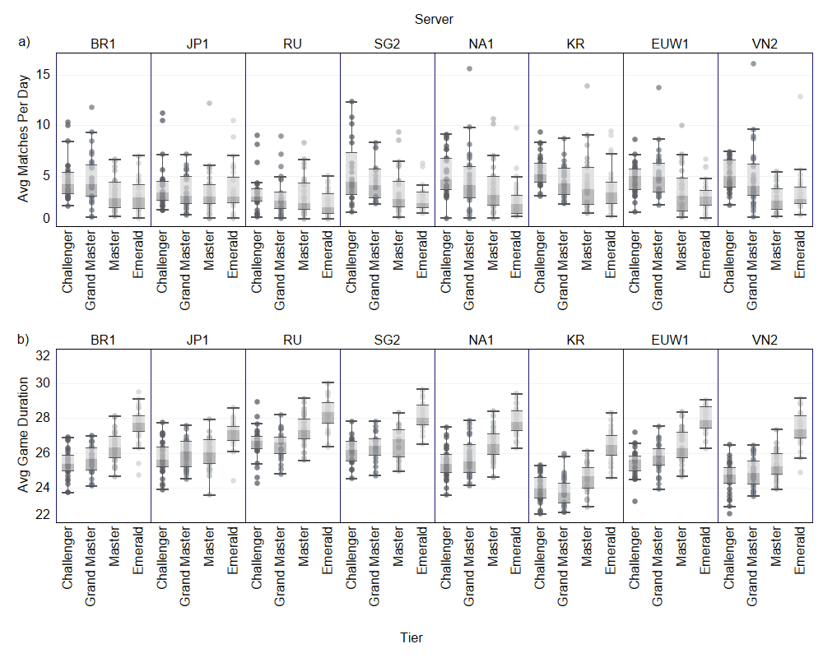

Figure .

*The a) average number and b) duration of matches per day according to server and tier.*

*Note.* BR1 = Brazil, JP1 = Japan, RU = Russia, SG2 = Singapore, Malaysia, and Indonesia, NA1 = North America, KR = Korea, EUW1 = Europe West, VN2 = Vietnam.

When removing the days when players had no matches, the average number of ranked solo/due queue matches per day increased by 2.0 ± 1.2. The average number of daily matches was as high as 7.6 among Korean Challenger players (Table 2).

Table 2.

*The mean number of matches per day (removing days without play) based on server and tier.*

|  |  |  |  |  |
| --- | --- | --- | --- | --- |
|  | **Tier** | | | |
| **Servers** | **Challenger** | **Grandmaster** | **Master** | **Emerald 1** |
| BR1 | 5.9 ± 1.9 | 6.3 ± 2.3 | 5.1 ± 1.2 | 4.9 ± 1.9 |
| JP1 | 6.7 ± 2.4 | 5.8 ± 1.8 | 5.5 ± 2.0 | 5.6 ± 2.2 |
| RU | 5.4 ± 1.7 | 4.9 ± 1.8 | 5.0 ± 1.9 | 4.9 ± 1.8 |
| SG2 | 7.0 ± 2.7 | 6.2 ± 2.1 | 5.4 ± 2.2 | 5.0 ± 1.9 |
| NA1 | 7.0 ± 2.4 | 6.5 ± 2.8 | 5.5 ± 2.6 | 4.3 ± 1.4 |
| KR | 7.6 ± 2.0 | 6.7 ± 2.5 | 6.7 ± 2.7 | 6.3 ± 2.3 |
| EUW1 | 5.9 ± 1.8 | 6.9 ± 2.2 | 5.4 ± 2.2 | 4.9 ± 1.3 |
| VN2 | 7.0 ± 1.9 | 6.9 ± 3.1 | 5.0 ± 1.4 | 4.8 ± 1.8 |
| **Note:** Brazil, NA1 = North America, JP1 = Japan, KR = Republic of Korea, EUW1 = Europe West, RU = Russia, SG2 = Singapore, Malaysia, and Indonesia, VN2 = Vietnam | | | | |

The average ranked solo/duo queue match was at least 20 minutes, irrespective of the player's tier or server (Figure 1b). Average match durations were similar across tiers, with slightly shorter durations in the Challenger tier (25.4 ± 1.2 min vs. 25.5 ± 1.2, 26.1 ± 1.2, 27.5 ± 1.1 mins, for Grandmaster, Master, and Emerald tiers, respectively). The average match durations were somewhat longer in relatively small (26.6 ± 1.2 mins) than in relatively large (25.7 ± 1.5 mins) servers.

### **Total practice hours**

Challenger players had the highest volume of practice in six out of the eight servers (Figure 2a). The average total practice hours for Challenger, Grandmaster, Master, and Emerald I players were 1.98 ± 0.88, 1.83 ± 1.00, 1.48 ± 0.93, and 1.40 ± 0.83 h, respectively. The average total practice hours per day was slightly longer in relatively large than small servers (1.77 ± 0.95 vs. 1.56 ± Y 0.92 h).

There was substantial variability within ranked practice hours per day (Figure 2b). Generally, Challenger players had the lowest variability in ranked practice, with a pooled coefficient of variation of 44.6%. This was lower than Grandmaster (54.6%), Master (62.9%), and Emerald I (59.3%). The variability was comparable between relatively large (54.1%) and small (58.8%) servers. The lowest variability existed in the Korean Challenger players group.

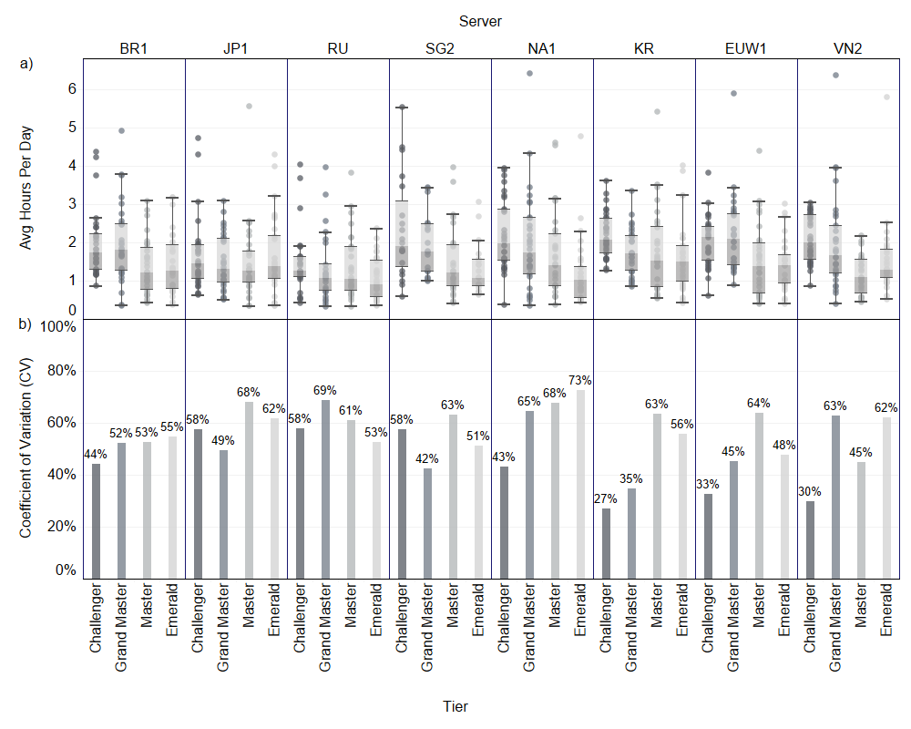

Figure .

*The a) average ranked solo/duo queue practice hours per day and the b) associated variability based on server and tier.*

*Note.* BR1 = Brazil, JP1 = Japan, RU = Russia, SG2 = Singapore, Malaysia, and Indonesia, NA1 = North America, KR = Korea, EUW1 = Europe West, VN2 = Vietnam.

### **Practice behaviours**

Most players within the sample spent approximately two weeks playing at least one ranked solo/due queue match per day (Table 3). In some instances, the number of days with at least one game reached 25 in North American players. The greatest number of days without a match was comparatively lower, with an average value ranging between 3.1 and 6.1 across servers and tiers. The average of most days without a match increased as tier decreased (Challenger = 4.0 ± 2.0, Grandmaster = 4.4 ± 2.1, Master = 5.2 ± 2.0, Emerald I = 5.3 ± 1.9). The average of most days without a match was similar between relatively large and small servers (4.5 ± 2.0 vs. 4.9 ± 2.1).

When analysing the matches across three- and seven-day blocks, the total number of matches reached 34.9 (Japan) and 58.4 (Singapore, Malaysia, and Indonesia), respectively. Challenger players tended to have the most matches in a three-day (32.1 ± 9.7) and seven-day (53.7 ± 15.1) block, and Emerald I players had the least (25.4 ± 8.7 and 42.0 ± 14.2, respectively). Three-day and seven-day blocks were slightly higher in relatively large compared with relatively small servers (29.2 ± 9.8 and 48.5 ± 15.8 vs. 28.4 ± 9.9 and 46.8 ± 16.9, respectively).

Table 3.

*The practice behaviours of League of Legends players across servers and tiers.*

|  |  |  |  |  |  |
| --- | --- | --- | --- | --- | --- |
| **Server** | **Tier** | **Days with at least one match** | **Most Days without a match** | **Most matches in three days** | **Most matches in seven days** |
| BR1 | Challenger | 18.7 ± 5.9 | 3.5 ± 2.0 | 29.5 ± 10.1 | 51.1 ± 15.4 |
|  | Grandmaster | 17.8 ± 5.8 | 3.8 ± 2.4 | 30.9 ± 9.8 | 50.4 ± 16.6 |
|  | Master | 20.8 ± 5.0 | 5.0 ± 2.2 | 26.8 ± 6.9 | 45.1 ± 14.1 |
|  | Emerald I | 22.7 ± 7.8 | 5.1 ± 1.9 | 24.5 ± 8.0 | 41.2 ± 14.6 |
| JP1 | Challenger | 17.0 ± 6.0 | 5.5 ± 1.7 | 34.9 ± 12.0 | 57.1 ± 18.0 |
|  | Grandmaster | 19.1 ± 6.9 | 5.3 ± 1.9 | 29.0 ± 11.8 | 47.3 ± 16.2 |
|  | Master | 20.2 ± 6.7 | 5.2 ± 2.1 | 28.7 ± 7.8 | 47.2 ± 15.4 |
|  | Emerald I | 20.7 ± 8.0 | 4.8 ± 2.0 | 26.4 ± 10.3 | 43.4 ± 15.4 |
| RU | Challenger | 20.3 ± 6.7 | 5.3 ± 2.1 | 29.9 ± 8.8 | 47.3 ± 11.8 |
|  | Grandmaster | 23.2 ± 8.5 | 5.3 ± 2.2 | 25.7 ± 9.5 | 40.9 ± 12.3 |
|  | Master | 22.8 ± 8.0 | 5.6 ± 1.7 | 26.8 ± 9.5 | 42.3 ± 15.2 |
|  | Emerald I | 22.8 ± 7.1 | 6.1 ± 1.6 | 25.3 ± 10.1 | 43.3 ± 17.3 |
| SG2 | Challenger | 16.6 ± 6.6 | 3.3 ± 2.5 | 34.8 ± 8.1 | 58.4 ± 19.9 |
|  | Grandmaster | 18.1 ± 6.3 | 4.2 ± 2.0 | 31.2 ± 10.8 | 51.7 ± 16.4 |
|  | Master | 21.2 ± 7.3 | 5.2 ± 2.1 | 27.0 ± 9.3 | 44.2 ± 16.8 |
|  | Emerald I | 23.3 ± 9.4 | 5.4 ± 2.0 | 24.9 ± 7.3 | 38.4 ± 11.0 |
| NA1 | Challenger | 15.9 ± 5.0 | 3.5 ± 2.0 | 32.6 ± 9.5 | 55.1 ± 4.1 |
|  | Grandmaster | 17.8 ± 6.7 | 4.0 ± 2.1 | 30.8 ± 10.2 | 49.9 ± 14.5 |
|  | Master | 22.0 ± 10.1 | 4.7 ± 2.4 | 27.3 ± 10.7 | 45.1 ± 17.9 |
|  | Emerald I | 25.0 ± 7.0 | 5.6 ± 2.0 | 22.8 ± 6.3 | 38.6 ± 12.0 |
| KR | Challenger | 13.9 ± 3.6 | 3.8 ± 1.5 | 33.0 ± 7.2 | 56.4 ± 13.5 |
|  | Grandmaster | 16.8 ± 5.4 | 4.4 ± 1.7 | 31.3 ± 10.8 | 49.6 ± 14.4 |
|  | Master | 17.4 ± 6.8 | 5.0 ± 2.0 | 30.3 ± 10.2 | 53.2 ± 21.1 |
|  | Emerald I | 17.9 ± 6.7 | 5.3 ± 1.8 | 30.0 ± 10.1 | 47.0 ± 15.4 |
| EUW1 | Challenger | 18.3 ± 5.6 | 3.1 ± 1.3 | 28.4 ± 8.5 | 49.9 ± 12.2 |
|  | Grandmaster | 15.6 ± 4.2 | 3.7 ± 1.8 | 30.9 ± 9.0 | 52.9 ± 16.5 |
|  | Master | 21.0 ± 7.1 | 5.1 ± 2.1 | 26.9 ± 8.7 | 44.5 ± 15.7 |
|  | Emerald I | 21.7 ± 5.4 | 5.2 ± 2.0 | 25.5 ± 7.4 | 41.6 ± 11.3 |
| VN2 | Challenger | 15.3 ± 4.2 | 4.0 ± 1.9 | 34.8 ± 10.7 | 54.9 ± 12.9 |
|  | Grandmaster | 17.2 ± 7.4 | 4.4 ± 2.2 | 31.6 ± 11.5 | 52.3 ± 17.6 |
|  | Master | 21.9 ± 7.2 | 5.8 ± 1.5 | 27.5 ± 10.2 | 43.8 ± 14.4 |
|  | Emerald I | 22.8 ± 6.6 | 4.7 ± 2.0 | 23.8 ± 7.9 | 41.4 ± 14.3 |
| **Note:** Brazil, NA1 = North America, JP1 = Japan, KR = Republic of Korea, EUW1 = Europe West, RU = Russia, SG2 = Singapore, Malaysia, and Indonesia, VN2 = Vietnam | | | | | |

## Statistical Analysis

### **Practice hours per day between servers and tiers**

The interaction between server and tier explained little variance for these data (*F* (21,881) = 1.408, *p* = 0.105). However, there are differences between servers (*F* (7,881) = 5.942, *p* < 0.001) and tiers (*F* (3,881) = 29.289, *p* < 0.001) in the total ranked practice hours per day. Specifically, all servers, except Japan, practised more than Russia (*p* < 0.001 – *p* = 0.035). Also, players in the Korean server practice more than those in the Japanese server (*p* = 0.035). When considering the tier of players, Challenger players tended to practice more hours of solo/duo queue than Master (*p* < 0.001) and Emerald I (*p* < 0.001) players. Grandmaster players also had more hours per day of practice than the Master (*p* < 0.001) and Emerald I (*p* < 0.001) players.

## *3.3. Cluster Analysis*

### **Identification of Practice Behaviours**

We interpreted the results of the hierarchical cluster analyses and selected four clusters for reporting. These demonstrated easily interpretable patterns of practice using the four metrics. Cluster 1 included larger blocks of practice in relatively short periods and minimal days without play (See Table 4 for specific median and interquartile range values). Cluster 2 displayed shorter blocks of practice than Cluster 1 but with more days without play, resulting in a lower ratio of days practised to not practised. Cluster 3 had occasional very large one and three-day blocks, but the player may go many days without practice. Lastly, Cluster 4 included small single and multi-day practice blocks, but somewhat more consistency than Cluster 3.

Table 4.

*The practice characteristics of each cluster (median and interquartile range)*

|  |  |  |  |  |
| --- | --- | --- | --- | --- |
| **Cluster** | **One day Practice Block** | **Three-Day Practice Block** | **Days without Practising** | **Practice:No Practice Ratio** |
| 1 | 16 (14 – 20) | 38 (30 – 44) | 2 (1 – 2) | 7.5 (4.6 – 10.0) |
| 2 | 13 (11 – 15) | 28 (24 – 32) | 3 (3 – 4) | 3.8 (2.9 – 5.0) |
| 3 | 16 (14 – 18) | 32 (27 – 38) | 7 (6 – 7) | 1.0 (0.6 – 1.5) |
| 4 | 10 (9 – 11) | 20 (17 – 23) | 6 (5 – 7) | 1.4 (0.8 – 2.3) |

The proportion of players in each cluster varied depending on the server and tier. Figure 3 displays the breakdown.

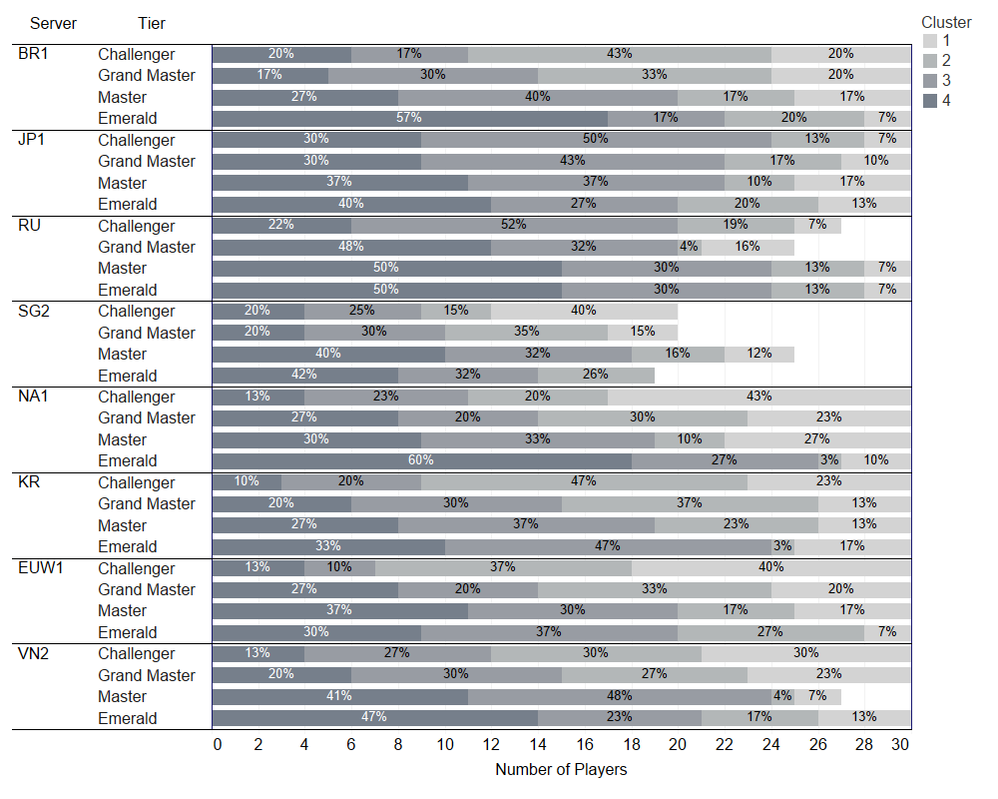

Figure .

*The distribution of practice clusters according to server and tier.*

*Note.* BR1 = Brazil, JP1 = Japan, RU = Russia, SG2 = Singapore, Malaysia, and Indonesia, NA1 = North America, KR = Korea, EUW1 = Europe West, VN2 = Vietnam.

# Discussion

The current exploratory study analysed preliminary patterns in expert League of Legends players' ranked (solo/duo queue) practice behaviours according to their tier and server. Overall, it appears that greater expertise might be associated with more frequent and consistent daily and weekly practice. Specifically, Challenger players had more matches per day, less variability in daily practice hours, and shorter game durations than other tiers. They also went the fewest days without competing in a match and had the highest number of matches in three- and seven-day blocks than any other tier. The above trends were similar for servers. Those with larger player pools had more daily practice than those with smaller ones. Readers should interpret our findings cautiously as they are based largely on a descriptive analysis. We recommend that future research employ confirmatory methods to explore the relationship between expertise and practice behaviours using the hypotheses from this paper.

## Quantity of practice

The first hypothesis derived from our analyses is that the volume of solo/due ranked practice is likely associated with expertise. We have centred this hypothesis on the observation that the Challenger and Grandmaster players had significantly more daily solo/duo ranked practice than Master and Emerald I players. Furthermore, Challenger players had the most matches in three- and seven-day blocks. Our finding aligns with previous work in esports. Namely, Pluss et al. (2022) reported that professional Counter-Strike: Global Offensive players had more hours of total and competitive practice than those at a semi-professional level. Some researchers have also observed similar findings in traditional sports. For example, the time spent in team practice was the most consistent discriminator between elite and sub-elite soccer players (Ward et al., 2007). Likewise, experts in team ball sports accumulated more hours of sport-specific practice than non-experts after childhood (Baker et al., 2003). Despite this, we note that practice only sometimes discriminates between expertise groups. Ford et al. (2009) observed soccer play activities (not practice) during childhood to differentiate between elite players who attained a professional status and those who did not. Consequently, more research is necessary to better understand the relationship between practice volume and expertise in esports.

## Practice hours variability

A second observation was that the Challenger players had less variability in the total daily practice hours. We hypothesise that this may be due to more effective stress-coping strategies, as previous research has indicated that esports players frequently experience competitive stressors (Leis et al., 2024; Poulus et al., 2022). Higher-skilled players in our sample may have developed more adaptive coping strategies, allowing them to be less affected by negative emotions (e.g., anger and frustration) that could lead to disengagement from the game. For example, Poulus et al. (2020) found that higher in-game ranks were associated with higher mental toughness levels and higher mental toughness levels were associated with more adaptive use of stress-coping strategies. It is also possible that the higher-skilled players, such as those in the Challenger tier, were members of professional organisations with access to psychological support and training, as it is common for these individuals to use ranked practice to complement their team training (Poulus et al., 2022a; Poulus et al., 2022b). Finally, it might be that Challenger players have better communication skills, thus overcoming some common team-related stressors, such as communication issues, unfavourable plays, and intra-team conflict (Leis et al., 2024). Future research could build on our findings by examining the factors related to disengagement patterns.

## Practice behaviour and player pool size

Our third hypothesis is that there is an interrelationship between player pool size, competitiveness, and practice behaviours. Within our sample, players from relatively large servers had more daily practice hours than those on relatively small servers. We would expect differences in practice behaviours based on server size, as larger servers have more players contesting ladder positioning within a tier. Hence, players will likely need more high-quality practice to outperform their peers, increasing the competitiveness of the server. It could also be that relatively large servers are situated in major regions with an established professional environment, better financial and logistical infrastructure, and higher-quality coaching and support services. These influences would trickle down into ranked match play as the professional players incorporate the game mode into their practice schedules. In other words, more investment into the development of players would make them more skilful, meaning that amateur players participating in ranked matches have tougher competition, thus improving their own skill levels. Future research could relate the number of players within a tier to the performance required to 'climb' the competitive ladder.

## Patterns in practice behaviour

Our final hypothesis is that there are distinct patterns of practice that promote sustained participation and prolonged disengagement; however, these might not be related to expertise, as there was considerable variability in the relative distribution of each cluster. We suggest that characteristics of Cluster 2 might represent the healthiest engagement with League of Legends solo/due ranked practice because it was characterised by the most consistent participation with limited blocks of excessive hours. It also may not compromise performance (albeit this was not assessed), with nearly half of Korean challenger players displaying this pattern. As we have previously noted, Korea has historically been one of the most successful regions in the professional scene. In contrast, there were two types of practice behaviour (i.e. Cluster 1 and 3) that might lead to negative outcomes. Burnout might be most likely in players who display the practice patterns of Cluster 1, with previous research highlighting a relationship between higher volumes of practice and burnout dimensions (Poulus et al., 2024a; Poulus et al., 2024b). Furthermore, players in Cluster 3 demonstrated binge-like behaviours. In other words, they would practice excessively for a short period, then disengage for several days before repeating the pattern. Finally, while Cluster 4 might also feature a pattern of healthy engagement, it might compromise performance due to a lower learning stimulus than Cluster 2. According to our findings, there are several avenues for future research. These include examining the relationship between the practice behaviours of Cluster 2, health, and performance; investigating the link between excessive practice and burnout; and determining the association between binge-like practice and prolonged disengagement.

## Strengths and Limitations

To our knowledge, the present study is one of the first to action recommendations for research to use a game developer's data repository to explore expertise in esports (Campbell et al., 2018; Pluss et al., 2019). One strength of our study was that we could analyse players' practice histories using objective data that the game client records while a match takes place instead of relying on retrospective recall techniques. As such, we could reduce the chance of biases and estimation errors within our dataset. However, we note that we had to assume that these objective data were error-free or that the errors were randomly distributed, as we were not involved with collecting these data. A second strength of our study was that we analysed a representative sample of highly skilled esport players, accessing data across four tiers and eight servers. This approach allowed us to hypothesise about the relationship between expertise and practice more confidently. Notwithstanding the strengths of our investigation, there are some noted limitations. First, as we have alluded to throughout this manuscript, the analyses were primarily descriptive, meaning we could only document the patterns within these data. Second, the query limits associated with the API restricted the total sample size and the amount of data we could reasonably access per player. Accordingly, we only sampled a maximum of 30 players per tier and retrieved approximately 10% of their available matches. A third limitation is that we only examined the trends in players' ranked solo/duo practice behaviours. As such, the values recorded in the current manuscript are unlikely to represent to total practice volume, as players might engage in other game modes (e.g., quickplay normal, draft normal, ranked flex, ARAM, etc.). Readers should consider these limitations when drawing conclusions from our manuscript.

# Conclusion

Despite the descriptive nature of our investigation, our study is among the first to provide preliminary evidence to support the notion that expertise is associated with practice behaviours in esports. We identified distinct patterns in the ranked practice profiles of highly skilled players, revealing more frequent, consistent, and efficient practice routines. Specifically, players in higher tiers engaged in more daily practice with less variability in their total hours and experienced shorter game durations. Additionally, we suggest that players on servers with larger participation pools may require more practice to achieve higher ranks due to greater competitiveness. Finally, we proposed that there are some practice patterns that promote positive engagement with League of Legends and others that may lead to disengagement. While our study was exploratory, it highlights the need for future confirmatory research to test our hypotheses. By analysing additional data within the repository or employing longitudinal methods, subsequent studies may validate or expand upon our findings.

# References

Baker, J., Cote, J., & Abernethy, B. (2003). Sport-Specific Practice and the Development of Expert Decision-Making in Team Ball Sports. *Journal of Applied Sport Psychology*, *15*(1), 12–25. https://doi.org/10.1080/10413200305400

Bubna, K., Trotter, M. G., Watson, M., & Polman, R. (2023). Coaching and talent development in esports: A theoretical framework and suggestions for future research. *Frontiers in Psychology*, *14*. https://doi.org/10.3389/fpsyg.2023.1191801

Burgess, D. J., & Naughton, G. A. (2010). Talent Development in Adolescent Team Sports: A Review. *International Journal of Sports Physiology and Performance*, *5*(1), 103–116. https://doi.org/10.1123/ijspp.5.1.103

Campbell, M. J., Toth, A. J., Moran, A. P., Kowal, M., & Exton, C. (2018). Chapter 10 - eSports: A new window on neurocognitive expertise? *Progress in Brain Research*, *240*, 161–174. https://doi.org/10.1016/bs.pbr.2018.09.006

Deng, D., Trepanowski, R., Li, M., Zhang, Y., Bujić, M., & Hamari, J. (2024). Streaks and Coping: Decoding Player Performance in League of Legends Using Big Data from Top Players' Matches. *Companion Proceedings of the 2024 Annual Symposium on Computer-Human Interaction in Play*, 50–55. https://doi.org/10.1145/3665463.3678787

Ford, P. R., Ward, P., Hodges, N. J., & Williams, A. M. (2009). The role of deliberate practice and play in career progression in sport: The early engagement hypothesis. *High Ability Studies*. https://doi.org/10.1080/13598130902860721

Güllich, A. (2014). Many roads lead to Rome—Developmental paths to Olympic gold in men's field hockey. *European Journal of Sport Science*, *14*(8), 763–771. https://doi.org/10.1080/17461391.2014.905983

Howard, R. W. (2011). Testing the accuracy of the retrospective recall method used in expertise research. *Behavior Research Methods*, *43*(4), 931–941. https://doi.org/10.3758/s13428-011-0120-x

International Olympics Committee. (2024, July 12). *IOC announces Olympic Esports Games to be hosted in the Kingdom of Saudi Arabia*. Olympics.Com. https://olympics.com/ioc/news/ioc-announces-olympic-esports-games-to-be-hosted-in-the-kingdom-of-saudi-arabia

League of Graphs. (2024). *Rank distribution—League of Legends*. League of Graphs. https://www.leagueofgraphs.com/rankings/rank-distribution

Leis, O., Sharpe, B. T., Pelikan, V., Fritsch, J., Nicholls, A. R., & Poulus, D. (2024). Stressors and coping strategies in esports: A systematic review. *International Review of Sport and Exercise Psychology*, *0*(0), 1–31. https://doi.org/10.1080/1750984X.2024.2386528

Novak, A. R., Bennett, K. J. M., Pluss, M. A., & Fransen, J. (2019). Performance analysis in esports: Part 1 - the validity and reliability of match statistics and notational analysis in League of Legends. *Sportrxiv*. https://doi.org/10.31236/osf.io/sm3nj

Novak, A. R., Bennett, K. J., Pluss, M. A., & Fransen, J. (2020). Performance analysis in esports: Modelling performance at the 2018 League of Legends World Championship. *International Journal of Sports Science & Coaching*, *15*(5–6), 809–817. https://doi.org/10.1177/1747954120932853

Pedraza-Ramirez, I., Musculus, L., Raab, M., & Laborde, S. (2020). Setting the scientific stage for esports psychology: A systematic review. *International Review of Sport and Exercise Psychology*, *0*(0), 1–34. https://doi.org/10.1080/1750984X.2020.1723122

Pluss, M. A., Bennett, K. J. M., Novak, A. R., Panchuk, D., Coutts, A. J., & Fransen, J. (2019). Esports: The Chess of the 21st Century. *Frontiers in Psychology*, *10*. https://doi.org/10.3389/fpsyg.2019.00156

Pluss, M. A., Novak, A. R., Bennett, K. J. M., McBride, I., Panchuk, D., Coutts, A. J., & Fransen, J. (2022). Examining the game-specific practice behaviors of professional and semi-professional esports players: A 52-week longitudinal study. *Computers in Human Behavior*, *137*, 107421. https://doi.org/10.1016/j.chb.2022.107421

Pluss, M. A., Novak, A. R., Bennett, K. J. M., Panchuk, D., Coutts, A. J., & Fransen, J. (2021). The relationship between the quantity of practice and in-game performance during practice with tournament performance in esports: An eight-week study. *The Journal of Sport & Exercise Science*, *5*(1), 69–76.

Pluss, M., Novak, A. R., Bennett, K. J. M., Panchuk, D., Coutts, A. J., Fransen, J., & Pluss, M. (2020). Perceptual-motor Abilities Underlying Expertise in Esports. *Journal of Expertise*, *3*(2), 133–143.

Poulus, D., Coulter, T. J., Trotter, M. G., & Polman, R. (2020). Stress and Coping in Esports and the Influence of Mental Toughness. *Frontiers in Psychology*, *11*. https://doi.org/10.3389/fpsyg.2020.00628

Poulus, D., Coulter, T., Trotter, M., & Polman, R. (2022). Perceived Stressors Experienced by Competitive Esports Athletes. *International Journal of Esports*, *1*(1), Article 1.

Poulus, D. R., Coulter, T. J., Trotter, M. G., & Polman, R. (2022a). A qualitative analysis of the perceived determinants of success in elite esports athletes. *Journal of Sports Sciences*, *40*(7), 742–753. https://doi.org/10.1080/02640414.2021.2015916

Poulus, D. R., Coulter, T. J., Trotter, M. G., & Polman, R. (2022b). Longitudinal analysis of stressors, stress, coping and coping effectiveness in elite esports athletes. *Psychology of Sport and Exercise*, *60*, 102093. https://doi.org/10.1016/j.psychsport.2021.102093

Poulus, D. R., Sargeant, J., Zarate, D., Griffiths, M. D., & Stavropoulos, V. (2024a). Burnout profiles among esports players: Associations with mental toughness and resilience. *Journal of Sports Sciences*, *0*(0), 1–10. https://doi.org/10.1080/02640414.2024.2405794

Poulus, D. R., Sargeant, J., Zarate, D., Griffiths, M. D., & Stavropoulos, V. (2024b). Burnout, resilience, and coping among esports players: A network analysis approach. *Computers in Human Behavior*, *153*, 108139. https://doi.org/10.1016/j.chb.2024.108139

Poulus, D. R., Sharpe, B. T., Jackman, P. C., Swann, C., & Bennett, K. J. M. (2024). Defining elite esports athletes: A scoping review. *International Review of Sport and Exercise Psychology*, *0*(0), 1–36. https://doi.org/10.1080/1750984X.2024.2386531

Rees, T., Hardy, L., Güllich, A., Abernethy, B., Côté, J., Woodman, T., Montgomery, H., Laing, S., & Warr, C. (2016). The Great British Medalists Project: A Review of Current Knowledge on the Development of the World's Best Sporting Talent. *Sports Medicine*, *46*(8), 1041–1058. https://doi.org/10.1007/s40279-016-0476-2

Reitman, J. G., Anderson-Coto, M. J., Wu, M., Lee, J. S., & Steinkuehler, C. (2020). Esports Research: A Literature Review. *Games and Culture*, *15*(1), 32–50. https://doi.org/10.1177/1555412019840892

Stewart, J. (2024, May 1). *Why LoL's World Championships is the esports event you can't afford to miss*. Red Bull. https://www.redbull.com/au-en/league-of-legends-history-of-worlds

Taifalos, N. (2024). *Riot "exploring solutions" for new LoL circuit in Oceania just 4 years after last revamp*. Dot Esports. https://dotesports.com/league-of-legends/news/riot-exploring-solutions-for-new-lol-circuit-in-oceania-just-4-years-after-last-revamp

Ward, P., Hodges, N. J., Starkes, J. L., & Williams, M. A. (2007). The road to excellence: Deliberate practice and the development of expertise. *High Ability Studies*, *18*(2), 119–153. https://doi.org/10.1080/13598130701709715

Zalamea, N. (2022, February 10). *This US$50M TSM esports performance center is the most expensive in the world | ONE Esports*. One Esports. https://www.oneesports.gg/gaming/tsm-esports-performance-center-expensive/