**Kinarm Approach Avoidance Task: A robot-based reaching task to assess automatic attitudes towards visual stimuli**

Kayne Park1*, Matthieu P. Boisgontier1,2*

1School of Rehabilitation Sciences, Faculty of Health Sciences, University of Ottawa, Canada

2Perley Health Centre of Excellence in Frailty-Informed Care, Ottawa, Canada

*Corresponding authors:

apark2@uOttawa.ca (Park K.)

matthieu.boisgontier@uOttawa.ca (Boisgontier M.P.)

**Abstract**

The investigation of automatic approach-avoidance attitudes has traditionally been conducted using computer-based technologies. These devices can characterize important measures of psychological function such as reaction time and error rates. However, they are unable to accurately quantify other crucial measures of human behaviour such as hand speed and movement direction. Novel robotic devices have been developed to allow highly quantitative measures of human motion. The Kinarm is an augmented reality device which can track a participant’s upper limb movement while they interact in novel environments. Here, we describe the adaptation of the commonly used Approach-Avoidance Task on the Kinarm Endpoint Laboratory. This variant of the task can assess movements of both arms and across many directions of reach. In addition, the Kinarm can provide resistive loads which can investigate the role of metabolic cost during approach or avoidance or be used for rehabilitation protocols.

**Keywords**

Approach-Avoidance, Robotics, Reaction time, Speed, Automatic tendencies

**Preprint statement**

This manuscript has been prepared as a preprint to be published on sportrxiv.

Citation: Park K., Boisgontier M.P. (2024). *Kinarm Approach Avoidance Task: A robot-based reaching task to assess automatic attitudes towards visual stimuli*. sportrxiv.

**1. Introduction**

How we move and interact with our environment can be guided by our automatic tendencies (Marteau et al., 2012). Studies have demonstrated that individuals approach images of physical activity faster than sedentary activities (Cheval et al., 2014, 2018, 2020; Farajzadeh et al., 2023, 2024). This bias in approaching and avoiding certain stimulus has been demonstrated across many contexts such as food (Kemps et al., 2013; Lender et al., 2018), object ownership status (Barton et al., 2021; Roy et al., 2023), and facial expressions (Marsh et al., 2005). Further, these approach-avoidance tendencies have been associated with behaviours that are harmful for health such as physical inactivity, smoking addiction, overeating, and alcoholism (Cheval et al., 2020; Spruyt et al., 2013; Wiers et al., 2010; Wittekind et al., 2015, 2021).

A common method for assessing an individual’s approach-avoidance tendencies is through the Approach-Avoidance Task (AAT) (Phaf et al., 2014; Solarz, 1960). A variant of this task has been previously used to examine individual’s attitudes towards physical inactivity using images of physical and sedentary activities (Cheval et al., 2018; Farajzadeh et al., 2023, 2024). They found an automatic bias in participants responses as approach responses were faster for images of physical rather than sedentary activity whereas avoidance responses were faster for sedentary rather than physical activity, irrespective of age. Importantly, this version of the task used neutral stimuli to account for potential bias to certain actions (i.e., faster avoidance than approach responses, irrespective of stimuli).

The AAT has commonly used interfaces such as joysticks, mouse, or keyboards to characterize performance measures (Krieglmeyer & Deutsch, 2010; Phaf et al., 2014; Wittekind et al., 2021). These devices commonly quantify performance using measures such as reaction time and error rate, but there is evidence to suggest that other measures (kinematic), such as hand speed, may be crucial for understanding approach-avoidance tendencies. Barton and colleagues used the AAT to examine potential bias toward self-owned properties (Barton et al., 2021). They found that individuals displayed bias towards images of self-owned objects for both the reaction time and speed of responses. Interestingly, although both measures identified a self-bias effect using the AAT, this effect was dependent on the mapping between approach/avoid and object ownership status. Therefore, it is imperative to examine various aspects of movement to provide greater characterization of the influence that potential biases can have on our behaviours.

The Kinarm Endpoint laboratory is a system that has been used to quantify upper limb movements using augmented reality environments (Scott, 1999). The robotic device is comprised of two mechanical linkages with handles that participants can grasp and move along the horizontal plane. In conjunction, a screen is positioned above the handles provide to participants with information on their hand position along the same horizontal plane. Participants’ movements can be tracked by motors providing highly sensitive kinematic data of upper limb motion. This interface provides greater degrees of freedom for participants than joystick, mouse, or keyboard interfaces can offer.

A key feature of the Kinarm laboratory is the ability to develop custom tasks that allow participants to interact in novel environments to assess cognitive function. One task is the Object Hit and Avoid Task where participants use both hands to intercept certain shapes (i.e., circles and triangles) moving towards them while avoiding other shapes (squares and ovals) examining an individual’s ability to make rapid decisions based on visual stimulus shape (Bourke et al., 2016). Other Kinarm tasks have been used to quantify cognitive function in ‘healthy’ human participants and to identify cognitive impairments across various diseases groups such as stroke, Parkinsons, kidney disease, and epilepsy (Gaprielian et al., 2022; Lowrey et al., 2022; Simmatis et al., 2020; Vanderlinden et al., 2022). Thus, the Kinarm robotic device has proven to be an effective tool for quantifying cognitive function.

Here, we describe the Kinarm Approach Avoidance Task (KAAT) as an adaptation of the AAT on the Kinarm robotic laboratory. The KAAT has been developed for the Kinarm Endpoint system to provide a wealth of kinematic data to characterize an individual’s approach-avoidance tendencies. This variant of the AAT is a 12-target center-out reaching task that examines upper limb movements in response to the appearance of a visual stimulus. The stimuli used for the KAAT can be chosen according to the object of study (e.g., smoking-related images, alcohol-related images, high- vs. low calorie food pictures, gambling-related images). Here, for the sake of illustration, we used stimuli depicting physical activities (e.g., running, swimming) and sedentary behaviours (lounging in a hammock, watching TV). In the KAAT, participants are given instructions to either quickly reach towards (‘Approach’) or reach in the opposite direction (‘Avoid’) of the stimuli location. To characterize many aspects of upper limb behaviour, the KAAT assesses both arms to control for performance bias using the dominant or nondominant arm and quantifies centre-out reaching across 12 different directions to dissociate the bias between movement direction and approach-avoidance tendencies (Cacioppo et al., 1993; Wittekind et al., 2021). In addition, the Kinarm can apply resistive loads during reaches toward certain visual stimulus. These loads can be used to investigate novel approach-avoidance tendencies such as increasing the metabolic cost for reaching towards certain visual stimulus or they can be used as training for rehabilitation (Marteau et al., 2012).

**2. Task Layout**

The KAAT has been developed on MATLAB (The MathWorks, Inc., version 2019b) and has been tested on Dexerit-E software (version 3.10, Kinarm, Kingston, Ontario). The current version of the KAAT is comprised of 24 different types of visual stimulus (Condition 1: 6 Active and 6 Sedentary images; Condition 2: 6 Circle and 6 Square images), two different Movements (Approach (reach towards); Avoid (reach to the open circle in the opposite direction)) and both arms are assessed in a single session (Figure 1). The Active images are shown in Figure 2¸ the Sedentary images are shown in Figure 3, the Circle images are shown in Figure 4, and the Square images are shown in Figure 5.

Instruction images are shown to participants at the start of each block indicating the Movement-Condition pairing. The Instruction images for Circle/Square Conditions are shown in Figure 6 and Active/Sedentary Conditions are shown in Figure 7.

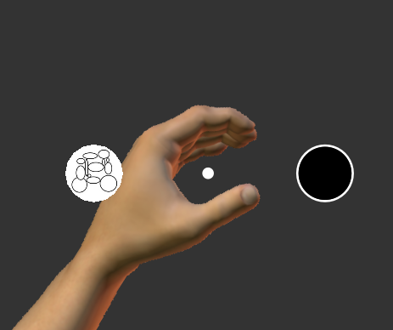

**Figure 1.** Stimulus appearing for the left arm. A trial in the Circle/Square Condition with a Circle stimulus appearing in the West direction and the Avoid stimulus (open circle) appearing in the East direction. The dashed circles are not visible to the participant and are didactics to highlight possible locations for the targets. The image of the hands and arms are not shown to participants.

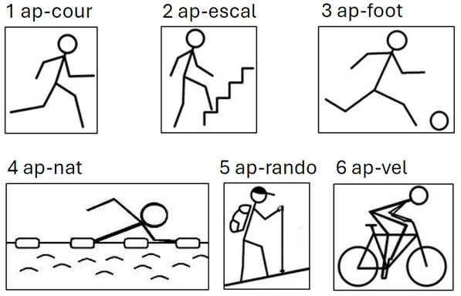  
**Figure 2.** The six pictures used for the ’Active’ Condition. Each picture label corresponds to the filename. Each picture number corresponds to the Trial Protocol (TP) used in the Kinarm associated software, Dexterit-E version 3.10.

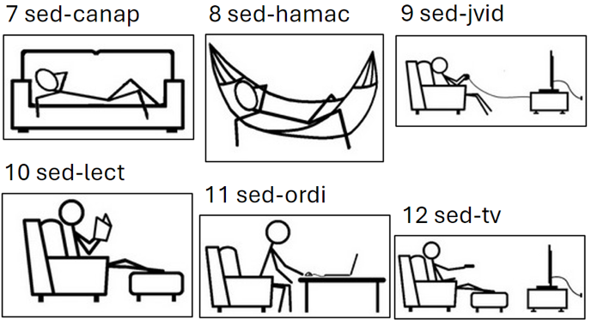  
**Figure 3.** The six pictures used for the ’Sedentary’ Condition.

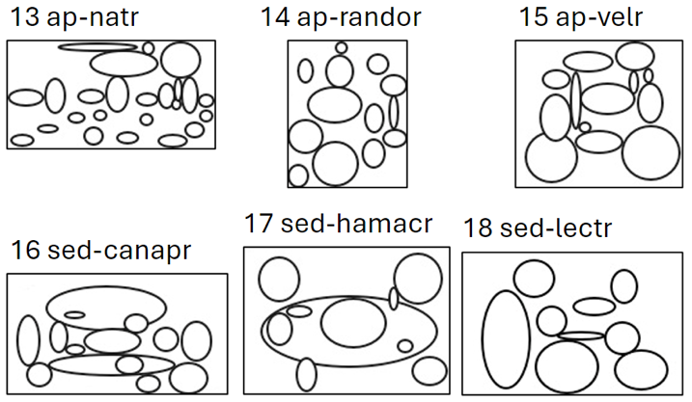  
**Figure 4.** The six pictures used for the ’Circle’ Condition.

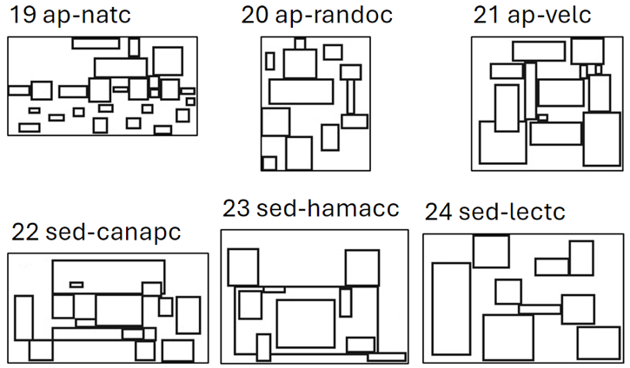  
**Figure 5.** The six pictures used for the ’Square’ Condition.

A

B

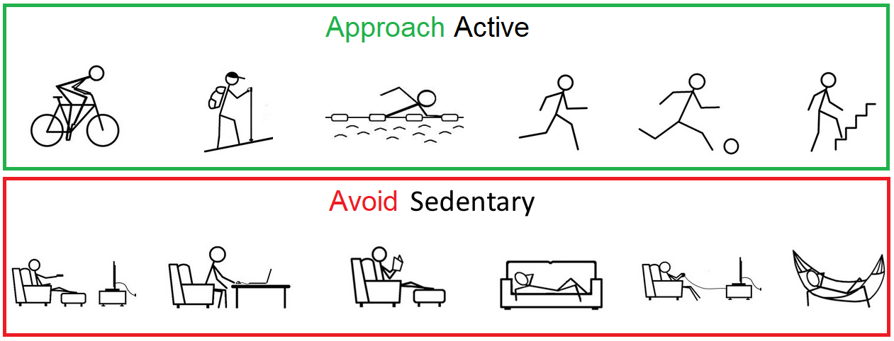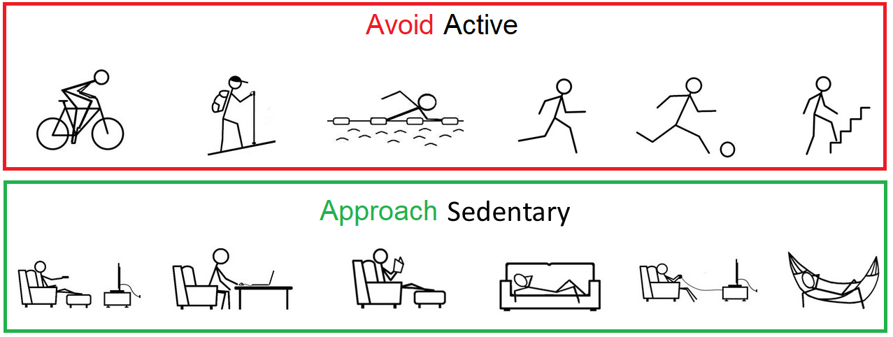

Approach Active

Approach Sedentary

Avoid Sedentary

Avoid Active

**Figure 6.** Instruction images shown for the Active/Sedentary Condition. A) Approach-Active Movement-Condition pairing: Active images should be approached, and Sedentary images should be avoided. B) Approach-Sedentary pairing: Active images should be avoided, and Sedentary images should be approached.

**Figure 7.** Instruction images shown for the Circle/Square Condition. A) Approach-Circle Movement-Condition pairing: Participants should approach Circle images and avoid Square images. B) Approach-Square pairing: Participants should approach Square images and avoid Circle images.

**3. Task operation**

3.1. Starting a block

The task must be run with the ‘Arm to be assessed’ as ‘Right’. After starting the task, participants are shown 1 out of 4 Instruction images informing them of the Movement-Condition pairing for the block (Figure 8). Once the participant places either cursor (represented by a white circle of 0.5 cm radius) into the green circle (1 cm radius) at the center of the workspace under the text “Place either hand in the circle to start”, the block begins.

**Figure 8.** Image taken at the start of a block. This block displays the Approach-Circle (Avoid-Square) instruction with a green circle available for participants to move the cursor of either hand in to begin.

3.2. Starting a trial

At the start of each trial, a blue Start target (circle 1 cm radius) appears on the left or right side of the workspace (equal probability) (Figure 9). After the participant has placed the corresponding cursor (left workspace requires left hand cursor) in the Start target to begin the trial and holds this position for 500-750 ms (randomized time), a peripheral target (circle 2.5 cm radius) appears in 1 of 12 locations located 10 cm away from the Start target. Location 1 is east of the Start target and the location number for each subsequent target increases counterclockwise from this location (Location 4 is north, 7 is west, 10 is south). If participants do not hold the Start target for the 500-750 ms, they must reenter the Start target and hold for the entire duration for the peripheral target to appear. If participants do not reach the Start target within 3000 ms, the trial is marked as Timed Out, yellow text ‘Too slow’ is displayed (Figure 10), and the trial ends.

**Figure 9.** Start of a trial. This trial displays the blue Start target in the left side of the workspace for the participant to place their left arm into to begin the trial.

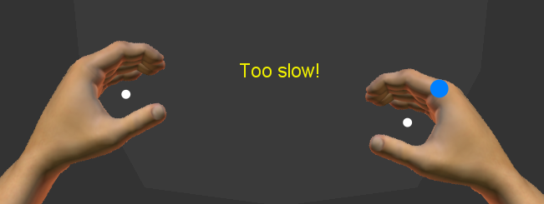

**Figure 10.** Timed Out trial. The participant was unable to place their right arm in the Start target within the allotted time resulting in the yellow ‘Too slow!’ text.

3.3. Reaching

A successful Approach is counted when the cursor is placed in any portion of the peripheral target. A successful Avoid is counted when the participant’s cursor moves into any portion of the open circle target. On a correctly completed trial, the peripheral targets disappear, no text is shown to participants, and the next trial begins (Figure 11).

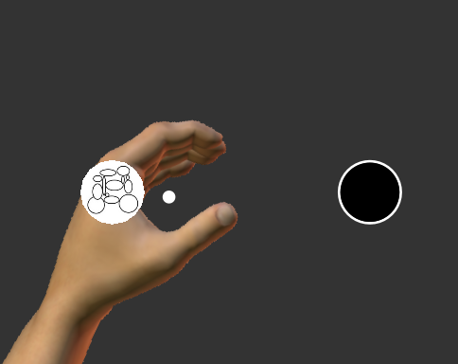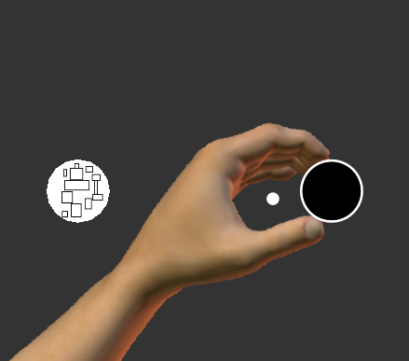

A

B

**Figure 11.** Illustration of 2 trials of an Approach-Circle block. A) The left arm correctly approaching the Circle image (white arrow, not shown to participants) towards the target. B) The left arm correctly avoiding the Square image by reaching towards the Avoid target.

On an incorrect trial (e.g., cursor inside a Square image on a Approach-Circle block), the red text ‘Incorrect!’ appears in the middle of the workspace (Figure 12A). If the participant is unable to reach to one of the peripheral targets within 3000 ms, the yellow text ‘Too slow!’ appears (Figure 12B). 1100 ms after a correct trial or 1500 ms after an incorrect trial, a new Start target appears for the next trial to begin.

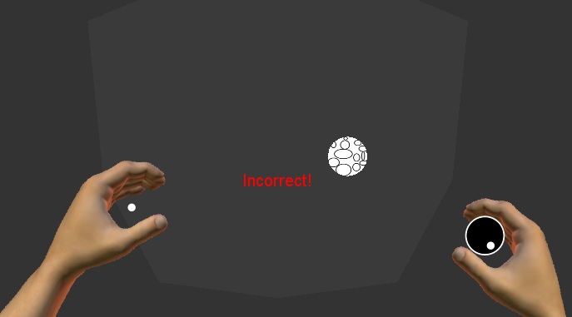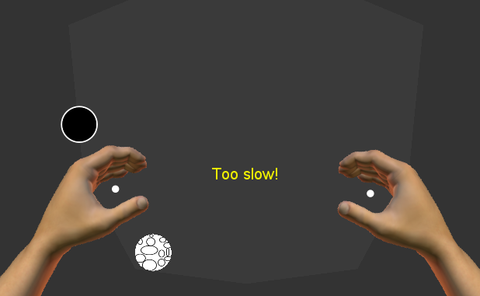

A

B

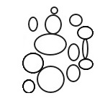

**Figure 12.** Image of two error trials during an Approach-Circle block. A) An incorrect reach to the Avoid target resulting in an ‘Incorrect!’ text. B) No reach towards any target resulting in a ‘Too slow!’ text.

In addition, the task features a function to apply a mechanical force to the arm if the cursor is near a certain distance from a specified stimulus. For example, the robot can apply a resistive load (1 N) originating from the Square image if the participant’s cursor is within 9 cm radius of this target (Figure 13).

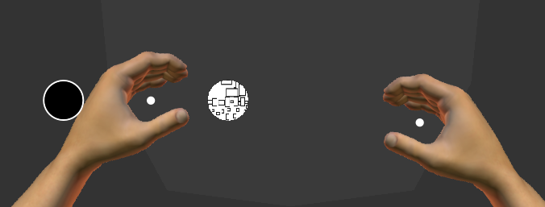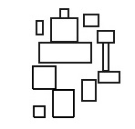

**Figure 13.** Didactic illustration of the direction of the force applied to the hand (white arrows) if the participant moves their cursor within 9 cm radius of the Square image (dashed circle). The arrows and dashed circle are not shown to the participant.

3.4. End of a block

After 48 trials, the block ends and a new block and Instruction image appears for the participant to be informed of the next Movement-Condition pairing.

**4. Task specifications**

4.1. General tab

In the General tab (Figure 14), the “Customized instructions” in the “Task instructions” has an explanation of the task for the participant that will display on the examiner’s screen after pressing the play button. In the “General protocol information” section, the Code is set to KAA (Kinarm Approach Avoidance). “Hand feedback behaviour” should be set to Both hands. “Pause/unpause behaviour” should be set to Pause at next trial. “Advanced options” should have both Use repeat trial flag and Use random seed checked on.

**Figure 14.** Screenshot of the General tab in the sandwichOrder.dtp file.

4.2. Target Table tab

In the Target Table tab (Figure 15 and Figure 16), we assign all the relevant targets and labels used in the task.

*4.2.1. Target assignment:*

Target 1 is a circle used for the Start target.

Target 2 is a circle used for the Avoid target.

Target 3 is a circle used to start a block.

Target 4 is a label used to display text.

Target 5 is a rectangle that displays the Instruction image.

Targets 6-11 are circles that display Active image targets.

Targets 12-17 are circles that display Sedentary image targets.

Targets 18-23 are circles that display Circle image targets.

Targets 24-29 are circles that display Square image targets.

*4.2.2. Target specifications*

Targets 1-3, 6-29 use Visual Radius for their circle size.

Targets 2 and 3 use Next Colour for their outline colour.

Target 4 uses Initial Colour, Next Colour, and Third Colour for label colours.

Target 5 is the Instruction image target that can display 1 of 4 images found in Initial Colour (Approach-Active), Next Colour (Approach-Sedentary), Third Colour (Approach-Circle), and Fourth Colour (Approach-Square).  
Targets 1, 6-29 use Initial Colour to display their images/colours.

The X column is left empty as we manually assign this value in the Task Wide Parameters tab (see below). The Visual Radius only applies to circle targets. The Target X Length and Target Y Length only apply to rectangle targets.

**Figure 15.** Screenshot of the Target Table tab displaying columns used to set target properties.

**Figure 16.** Another screenshot of the Target Table tab displaying columns used to set target properties.

5.3. Trial Protocol (TP) Table tab

The Trial Protocol (TP) Table (Figure 17) assigns the targets used for the task and specifies which stimulus has a forcefield around them (Toggle Field). The first five columns each point to a single target that is consistent for all TP. The Approach Target column points to Targets 6-29 to display the different Conditions. The CS or AS column is set to 0 to identify which TP are Circle and Square images or 1 to identify the Active and Sedentary images. The Toggle Field column can be set to either 0 to apply no forcefield or 1 to apply a forcefield to the targets listed in the Approach Target column. In the current KAAT, the forcefield is applied to Sedentary and Square images.

**Figure 17.** Screenshot of the TP Table identifying the targets to use for specific columns.

5.4. Task Wide Params tab

The task parameters set in the Task Wide Parameters tab (Figure 18) dictate the layout and flow of the task.

* Avoid Distance Adjustment scales the distance needed to move to the Avoid target (0-100%).
* Distance From Midline adjusts the distance (cm) that the Start target and peripheral targets appear relative to the midline (middle of workspace is 0 cm).
* Error Delay is the amount of time (ms) that the ‘incorrect’ or ‘timed out’ labels appear.
* Hold Delay is the amount of time (ms) needed to hold the cursor at the Start target to display a peripheral target.
* Maximum Force is the strength of the forcefield (N).
* Maximum Background Force is the strength of background forces that push the hands towards the midline (N). No background load is currently used.
* Ramp Duration is the time (ms) given for forcefields to ramp up and down to the Maximum Force (half the duration is ramp up and half is ramp down).
* Reach Time is the maximum allotted time (ms) for reaching the peripheral target.
* Starting Delay is a random value from 0 to the value in Start Delay (ms) added to Hold Delay.
* Success Delay is the time (ms) the peripheral target is shown after a trial.
* Target Distance is the distance (cm) from the centre of the Start Target to the centre of the peripheral or the avoid target. Avoid Distance Adjustment scales this value for the avoid target.
* Trial Time is the time (ms) allowed to reach the Start target before timing out.

**Figure 18.** Screenshot of the Task Wide Params tab.

5.5. Block Table tab

The Block Table (Figure 19) must follow strict guidelines. First, a single block must contain the same Condition (only TP 13-24 (Circle/Square) or only TP 1-12 (Active/Sedentary)). Second, the TP list must contain 12 values. Last, the value for List Reps must be 4 and Block Reps must be 1 and ‘Randomized’ must be checked on (Figure 19).

To assess all Movement-Condition pairings, each Condition must be run twice. The Movement-Condition pairings are assigned as follows: 1) The first instance of a Condition will be randomly assigned one of the two Movements (50% chance for Approach or Avoid), 2) The next block of the same Condition will have the opposite Movement. An example of a task sequence for four blocks can be as follows: Block 1 is Approach-Circle, Block 2 is Approach-Active, Block 3 is Approach-Sedentary, and Block 4 is Approach-Square.

**Figure 19.** Screenshot of the Block Table highlighting the TP List, List Reps, Randomized, and Block Reps.

**6. Declarations**

6.1. Material and code sharing

Following good research practices (Boisgontier, 2022), the material and code for the KAAT are freely available on Github (<https://github.com/Boisgontier-Lab/KinarmApproachAvoidTask>).

6.2. Contributions

Based on the Contributor Roles Taxonomy (CRediT) (Allen et al., 2019), individual author contributions to this work are as follows:

* Kayne Park: Methodology, Software, Visualization, Writing – Original Draft.
* Matthieu P. Boisgontier: Conceptualization, Writing – Review and Editing, Supervision, Funding Acquisition.

6.3. Funding

Matthieu P. Boisgontier is supported by the Canada Foundation for Innovation (CFI 43661) and the Natural Sciences and Engineering Research Council of Canada (NSERC) (RGPIN-2021-03153).

**7. References**

Allen, L., O’Connell, A., & Kiermer, V. (2019). How can we ensure visibility and diversity in research contributions? How the Contributor Role Taxonomy (CRediT) is helping the shift from authorship to contributorship. *Learned Publishing*, *32*(1), 71–74. https://doi.org/10.1002/leap.1210

Barton, T., Constable, M. D., Sparks, S., & Kritikos, A. (2021). Self-bias effect: Movement initiation to self-owned property is speeded for both approach and avoidance actions. *Psychological Research*, *85*(4), 1391–1406. https://doi.org/10.1007/s00426-020-01325-0

Boisgontier, M. (2022). Research integrity requires to be aware of good and questionable research practices. *European Rehabilitation Journal*, *2*(1), Article 1. https://doi.org/10.52057/erj.v2i1.24

Bourke, T. C., Lowrey, C. R., Dukelow, S. P., Bagg, S. D., Norman, K. E., & Scott, S. H. (2016). A robot-based behavioural task to quantify impairments in rapid motor decisions and actions after stroke. *Journal of NeuroEngineering and Rehabilitation*, *13*, 91. https://doi.org/10.1186/s12984-016-0201-2

Cacioppo, J. T., Priester, J. R., & Berntson, G. G. (1993). Rudimentary determinants of attitudes: II. Arm flexion and extension have differential effects on attitudes. *Journal of Personality and Social Psychology*, *65*(1), 5–17. https://doi.org/10.1037/0022-3514.65.1.5

Cheval, B., Daou, M., Cabral, D. A. R., Bacelar, M. F. B., Parma, J. O., Forestier, C., Orsholits, D., Sander, D., Boisgontier, M. P., & Miller, M. W. (2020). Higher inhibitory control is required to escape the innate attraction to effort minimization. *Psychology of Sport and Exercise*, *51*, 101781. https://doi.org/10.1016/j.psychsport.2020.101781

Cheval, B., Sarrazin, P., & Pelletier, L. (2014). Impulsive Approach Tendencies towards Physical Activity and Sedentary Behaviors, but Not Reflective Intentions, Prospectively Predict Non-Exercise Activity Thermogenesis. *PLOS ONE*, *9*(12), e115238. https://doi.org/10.1371/journal.pone.0115238

Cheval, B., Tipura, E., Burra, N., Frossard, J., Chanal, J., Orsholits, D., Radel, R., & Boisgontier, M. P. (2018). Avoiding sedentary behaviors requires more cortical resources than avoiding physical activity: An EEG study. *Neuropsychologia*, *119*, 68–80. https://doi.org/10.1016/j.neuropsychologia.2018.07.029

Farajzadeh, A., Dionne, N., Benoit, N., Bezeau, O., Bourgie, T., Gerro, B., Ouimet, J., & Boisgontier, M. P. (2024). *Apathy, Intentions, and Affective Attitudes in Physical Activity Behavior* (p. 2024.07.16.24310493). medRxiv. https://doi.org/10.1101/2024.07.16.24310493

Farajzadeh, A., Goubran, M., Beehler, A., Cherkaoui, N., Morrison, P., de Chanaleilles, M., Maltagliati, S., Cheval, B., Miller, M. W., Sheehy, L., Bilodeau, M., Orsholits, D., & Boisgontier, M. P. (2023). Automatic approach-avoidance tendency toward physical activity, sedentary, and neutral stimuli as a function of age, explicit affective attitude, and intention to be active. *Peer Community Journal*, *3*. https://doi.org/10.24072/pcjournal.246

Gaprielian, P., Scott, S. H., & Levy, R. (2022). Reverse Visually Guided Reaching in Patients with Parkinson’s Disease. *Parkinson’s Disease*, *2022*(1), 8132923. https://doi.org/10.1155/2022/8132923

Kemps, E., Tiggemann, M., Martin, R., & Elliott, M. (2013). Implicit approach–avoidance associations for craved food cues. *Journal of Experimental Psychology: Applied*, *19*(1), 30–38. https://doi.org/10.1037/a0031626

Krieglmeyer, R., & Deutsch, R. (2010). Comparing measures of approach–avoidance behaviour: The manikin task vs. two versions of the joystick task. *Cognition and Emotion*, *24*(5), 810–828. https://doi.org/10.1080/02699930903047298

Lender, A., Meule, A., Rinck, M., Brockmeyer, T., & Blechert, J. (2018). Measurement of food-related approach-avoidance biases: Larger biases when food stimuli are task relevant. *Appetite*, *125*, 42–47. https://doi.org/10.1016/j.appet.2018.01.032

Lowrey, C. R., Dukelow, S. P., Bagg, S. D., Ritsma, B., & Scott, S. H. (2022). Impairments in Cognitive Control Using a Reverse Visually Guided Reaching Task Following Stroke. *Neurorehabilitation and Neural Repair*, *36*(7), 449–460. https://doi.org/10.1177/15459683221100510

Marsh, A. A., Ambady, N., & Kleck, R. E. (2005). The Effects of Fear and Anger Facial Expressions on Approach- and Avoidance-Related Behaviors. *Emotion*, *5*(1), 119–124. https://doi.org/10.1037/1528-3542.5.1.119

Marteau, T. M., Hollands, G. J., & Fletcher, P. C. (2012). Changing Human Behavior to Prevent Disease: The Importance of Targeting Automatic Processes. *Science*, *337*(6101), 1492–1495. https://doi.org/10.1126/science.1226918

Phaf, R. H., Mohr, S. E., Rotteveel, M., & Wicherts, J. M. (2014). Approach, avoidance, and affect: A meta-analysis of approach-avoidance tendencies in manual reaction time tasks. *Frontiers in Psychology*, *5*. https://doi.org/10.3389/fpsyg.2014.00378

Roy, N., Karnick, H., & Verma, A. (2023). Towards the self and away from the others: Evidence for self-prioritization observed in an approach avoidance task. *Frontiers in Psychology*, *14*, 1041157. https://doi.org/10.3389/fpsyg.2023.1041157

Scott, S. H. (1999). Apparatus for measuring and perturbing shoulder and elbow joint positions and torques during reaching. *Journal of Neuroscience Methods*, *89*(2), 119–127. https://doi.org/10.1016/S0165-0270(99)00053-9

Simmatis, L. E. R., Jin, A. Y., Keiski, M., Lomax, L. B., Scott, S. H., & Winston, G. P. (2020). Assessing various sensorimotor and cognitive functions in people with epilepsy is feasible with robotics. *Epilepsy & Behavior: E&B*, *103*(Pt A), 106859. https://doi.org/10.1016/j.yebeh.2019.106859

Solarz, A. K. (1960). Latency of instrumental responses as a function of compatibility with the meaning of eliciting verbal signs. *Journal of Experimental Psychology*, *59*(4), 239–245. https://doi.org/10.1037/h0047274

Spruyt, A., De Houwer, J., Tibboel, H., Verschuere, B., Crombez, G., Verbanck, P., Hanak, C., Brevers, D., & Noël, X. (2013). On the predictive validity of automatically activated approach/avoidance tendencies in abstaining alcohol-dependent patients. *Drug and Alcohol Dependence*, *127*(1), 81–86. https://doi.org/10.1016/j.drugalcdep.2012.06.019

Vanderlinden, J. A., Semrau, J. S., Silver, S. A., Holden, R. M., Scott, S. H., & Boyd, J. G. (2022). Acute kidney injury is associated with subtle but quantifiable neurocognitive impairments. *Nephrology Dialysis Transplantation*, *37*(2), 285–297. https://doi.org/10.1093/ndt/gfab161

Wiers, R. W., Rinck, M., Kordts, R., Houben, K., & Strack, F. (2010). Retraining automatic action-tendencies to approach alcohol in hazardous drinkers. *Addiction*, *105*(2), 279–287. https://doi.org/10.1111/j.1360-0443.2009.02775.x

Wittekind, C. E., Blechert, J., Schiebel, T., Lender, A., Kahveci, S., & Kühn, S. (2021). Comparison of different response devices to assess behavioral tendencies towards chocolate in the approach-avoidance task. *Appetite*, *165*, 105294. https://doi.org/10.1016/j.appet.2021.105294

Wittekind, C. E., Feist, A., Schneider, B. C., Moritz, S., & Fritzsche, A. (2015). The approach-avoidance task as an online intervention in cigarette smoking: A pilot study. *Journal of Behavior Therapy and Experimental Psychiatry*, *46*, 115–120. https://doi.org/10.1016/j.jbtep.2014.08.006