Eccentric muscle actions do not promote superior hypertrophy compared with concentric actions: a systematic review and meta-analysis
Leonardo Santos Lopes da Silva^{1*}; Leonardo da Silva Gonçalves¹; Pedro Henrique Alves Campos²; Cícero Jonas Rodrigues Benjamim¹; Marcio Fernando Tasinafo Júnior¹; Leonardo Coelho Rabello de Lima²; Carlos Roberto Bueno Júnior^{1,2,3}; Charles Phillipe de Lucena Alves⁴

¹Department of Internal Medicine, Ribeirão Preto Medical School, University of São Paulo, Ribeirão Preto, Brazil
²School of Physical Education and Sport of Ribeirão Preto (EEFERP/USP), University of São Paulo, Ribeirão Preto, Brazil.
³Ribeirao Preto College of Nursing, University of São Paulo (EERP/USP), Ribeirão Preto, SP, Brazil
⁴Graduate Program in Epidemiology at Federal University of Pelotas, Pelotas, Rio Grande do Sul, Brazil

*Corresponding author: Leonardo Santos Lopes da Silva (leonardosls@usp.br) Bandeirantes Avenue nº 3900, University Campus - Monte Alegre, Ribeirao Preto-SP, Brazil. Zip code: 14030-680.

ABSTRACT
Different physiological mechanisms of sarcomere activity during eccentric (ECC) and concentric (CON) muscle actions led to investigations into muscle hypertrophy outcomes, but conclusions remain elusive. We aimed to investigate the effects of ECC vs. CON muscle actions on muscle hypertrophy in apparently healthy adults through a systematic review with meta-analysis. The searches were conducted on EMBASE, MedLine, Cochrane Library, Web of Science, Scopus, and SPORTSDiscus databases. Eligibility criteria: blinded and unblinded randomized controlled trials that investigated the effects of CON versus ECC resistance training programs in apparently healthy adults (≥18 years old). These studies should have performed hypertrophy measurements in outcomes using cross-sectional area, muscle thickness, or muscle volume assessed by imaging methods. 15778 studies were identified, and twenty-six (682 participants included in the meta-analysis) achieved the inclusion criteria. The main findings indicate that: there was no difference between ECC vs. CON on hypertrophy measurements (0.285 [95%CI: -0.131 to 0.701]; p= 0.179; I²: 84.4%; GRADE: Very low). Subgroup meta-analysis analyzing possible hypertrophy outcome moderators as age (18 to 59 years old and ≥60 years old) and weeks of intervention duration (≤8 weeks and >8 weeks) did not reveal differences between ECC vs. CON. Sub-group analysis revealed a very limited but significant effect for ECC on the upper limb muscles (1.44 [95%CI: 0.179 to 2692]; p= 0.025; I²: 91%; GRADE: Low). Our findings suggest there was no evidence of a difference in hypertrophy between ECC and CON muscle action in apparently healthy adults.

Keywords:
Muscle growth, strength training, lengthening, shortening.

INTRODUCTION
Eccentric (ECC) and concentric (CON) are two types of muscle actions that are prioritized in resistance training aiming to promote muscle hypertrophy (42). ECC muscle actions involve the active lengthening of sarcomeres, while CON muscle actions involve the shortening of sarcomeres to overcome external resistance (20). Per se, these distinct biomechanical and physiological characteristics of ECC and CON muscle actions have motivated researchers to investigate and compare their acute and chronic impact on muscle properties, especially in muscle hypertrophy (46).
The load used during both traditional and CON-based resistance training depends on the maximal CON strength (i.e., based on one repetition maximum - 1RM) (11). On the other hand, ECC-based training allows for the use of supramaximal loads (i.e., greater than CON 1RM), thus enhancing the mechanical stimuli applied to the muscle (32). Furthermore, ECC muscle actions demand less energy and muscle activation for similar torque production, making their application possible for individuals with a variety of age and/or medical-related conditions (muscle atrophy, weakness, and physical dysfunction) (30,42). Therefore, it is speculated that the effects of ECC training are superior to CON training for hypertrophy (14,28).
Despite decades of research dedicated to elucidating the effects of ECC vs. CON muscle actions on muscle hypertrophy, conclusions remain elusive. For instance, a previous meta-analysis from Schoenfeld et al. (2017) (46) showed a very small effect but superior muscle growth for ECC- compared to CON-based resistance training. However, a small effect, methodological limitations (without certainty of evidence analysis), and variability in participant characteristics (young and older adults), training protocols, and hypertrophy measures (biopsy, DXA, ultrasound, etc.) in their meta-analysis have limited the interpretation of real-world application of ECC muscle actions to promote muscle growth. Therefore, we aimed to investigate the effects of ECC vs. CON muscle actions on muscle hypertrophy in apparently healthy adults. through a systematic review with meta-analysis.

METHOD
Research question
Which type of muscle action (ECC or CON) is more effective for promoting muscle hypertrophy in apparently healthy adults?

Registration
This systematic review was included in the PROSPERO database (registration number: CRD42023452583). This systematic review was reported according to the Preferred Reporting Items for Systematic Reviews and Meta-Analyses (PRISMA) (37) with an extension for Exercise, Rehabilitation, Sports Medicine, and Sports Science (PERSiST) (Supplementary Table 1) (1).

Search Strategy and Study Selection
The search was conducted in six databases: MEDLINE (via PubMed), EMBASE, Cochrane Library, Web of Science, SCOPUS, and SPORTDiscus. We performed the searches on November 4th (2023), and an updated search on January 29th (2024). The search strategy considered was composed of the following keywords: “Resistance training” OR “resistance exercise” OR “strength training” OR “strength exercise” OR “weightlifting” OR “weight exercise” OR “weight training” AND “Muscle action” OR “concentric” OR “eccentric” OR “contraction” OR “contractile properties” OR “shortening” OR “lengthening” AND “Muscle tissue” OR “hypertrophy” OR “muscle thickness” OR “cross-sectional area” OR “CSA” OR “fascicle length” OR “pennation angle” OR “muscle strength” OR “strength”. Detailed searches in each database are presented in Supplementary Table 2.
All obtained articles were exported to the Rayyan QCRI program (Qatar Computing Research Institute, Qatar) to exclude duplicates. The studies were screened in the Rayyan program by two independent reviewers (LSG and LSLS), who read the titles and abstracts (phase 1). The eligibility stage (phase 2) was carried out by the same reviewers through reading the articles in full. The reviewers discussed the issue to find a consensus when disagreements occurred. Furthermore, the lists of references cited in the selected studies in phase 2 were analyzed to identify other eligible studies that could also be included in this review (snowball method).

Inclusion criteria
To be included, the studies should meet the following inclusion criteria: (1) population: apparently healthy adults (≥18 years); (2) training status: trained and untrained subjects; (3) study design: randomized clinical trial with different settings and at least 4 weeks of intervention. The following designs were considered: between-subject or crossover clinical trials and direct comparison between ECC vs. CON muscle actions; (4) hypertrophy measurements: cross-sectional area, muscle thickness, or muscle volume assessed by imaging methods (i.e., magnetic resonance imaging, computed tomography, or ultrasonography).

Data Extraction
The following information was extracted: authors (last name), year of publication, study design, sample size in each group, sex, age, characteristics of the intervention, hypertrophy assessment method, and main results. The data extraction performed by one reviewer was cross-validated by another (LSLS and LSG).
We extracted the reporting of muscle hypertrophy presented in tables or graphs at baseline and the end of the resistance training intervention. The Web Plot Digitizer® application was used to extract data presented in graphs. We adopted the criteria of extracting the data of delta (%) and their respective standard deviation (SD). Values accessible with “standard error” or “confidence intervals” (CI) in the studies were converted to mean and SD. To enhance the transparency of the meta-analysis, Supplementary Table 3 presents the information on where the data was extracted in each selected article.

Assessment of the methodological quality of the studies
The methodological quality of the studies was assessed with the Tool for the assEssment of Study qualiTy and reporting in EXercise (TESTEX), a 15-point scale (5 points for study quality and 10 points for reporting) (52). The process was conducted by two authors (LSLS and LSG).
The Grades of Recommendation, Assessment, Development, and Evaluation (GRADE) Working Group was used to evaluate the level of evidence, study quality, and its limitations (33).

Qualitative Analysis
A narrative synthesis was performed to provide detailed methodological information of each included study. These results were plotted in tabular and graph form.

Meta-analysis
The meta-analysis was calculated based on the comparison between ECC vs. CON muscle actions. The comparison of hypertrophy was assessed based on pre-post changes, considering the mean and standard deviations. To calculate the standard deviation, we used the formula established by the Cochrane Handbook Chapter 6.5.2.8 (25). This formula is composed of the standard deviation change pre-posttest and the correlations between the pre and post-measurements. When the included studies did not report information about pre-posttest correlation, we fixed the correlation value at 0.5, to provide a conservative estimate of our outcomes (40). Critical targeted subgroup analyses were performed when a specific group was represented by at least two of the included studies. The subgroup analyses were carried out considering: 1) different ages from studies, in this line sub-group analysis were performed with young (18 to 59 years old) and older adults (>60 years old); 2) anatomic location of the muscles analyzed, where we sub-group analyzed lower and upper limb muscles; 3) training duration, where sub-groups were defined for studies with <8 weeks of intervention and >8 weeks of intervention.
The effect size was calculated through the difference of the pre-posttest change of eccentric vs. concentric groups divided by the pooled standard deviation (25). The Standard Error of the effect size was calculated using the formula proposed by the What Works Clearinghouse Handbook version 4.1 (59). Model parameters were estimated by the method of restricted maximum likelihood. We applied Egger's test with a visual inspection of funnel plots to assess the potential risk of publication bias. This meta-analysis considered both fixed and random models. Sensitivity analyses and subgroup analyses were conducted when heterogeneity was present. All analyses were conducted using JASP (version 0.17.1).

Results
Figure 1 presents details of the search process and selection of articles in the PRISMA flowchart. Our initial search identified 15778 articles, and after removal of duplicates (n= 6155), 9623 articles were screened by title and abstract. For phase 2, the studies included in the meta-analysis of Schoenfeld et al. (46) (n= 15) were included. In this sense, 93 articles were considered eligible for full-text reading, and 26 (2–4,7,8,10,13,15–18,23,26,27,29,31,34,39,41,44,45,47,50,55,57,58) were included in the systematic review and meta-analysis.

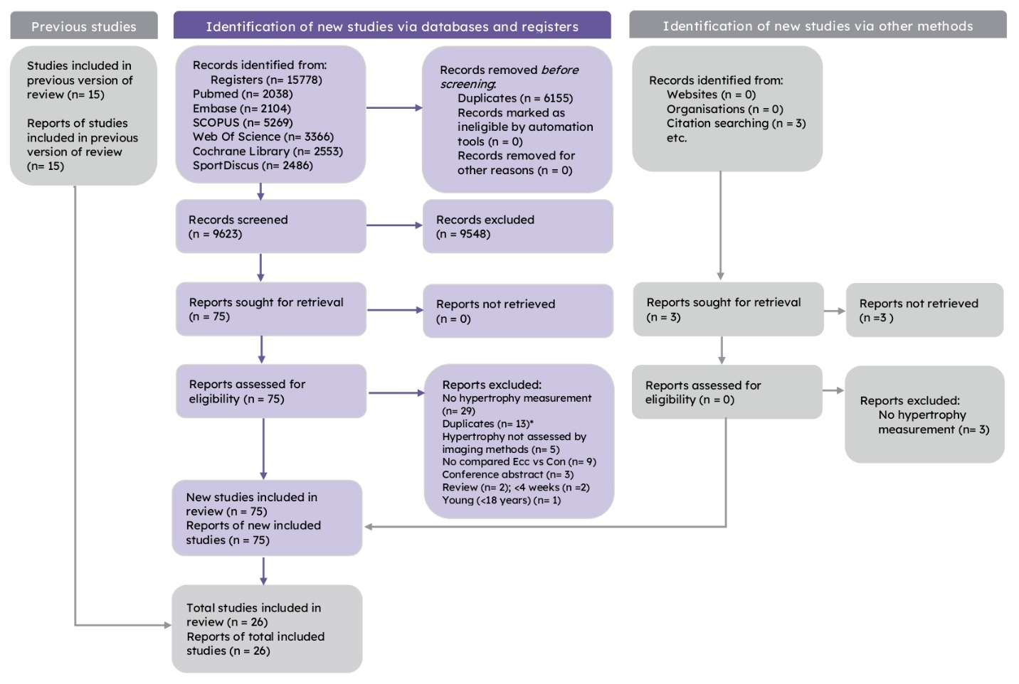
Figure 1. PRISMA flowchart.

Narrative synthesis of the studies
Table 1 shows the data (subjects, training status, study design, resistance training duration, training mode, hypertrophy measurement, and findings) extracted from each of the included articles. The total number of subjects included in the studies was 749. Fifteen of the studies included only men (57.7%) (2,3,7,13,16,17,31,34,39,41,47,50,55,57,58), three studies (11.5%) included only women (10,18,23) and eight (30.7%) included both sexes (4,8,27,29,44,45). Only two studies (7.7%) include older adults (2,39). Regarding training status, one study (3.8%) did not provide information (2) and another (3.8%) used inactive subjects (7). The other studies included recreationally active subjects without previous practice in resistance training before the intervention or in the previous few months.
Regarding training protocols, 13 studies (50%) used an isokinetic dynamometer (3,4,8,15,18,23,27,29,31,34,41,47,55), 10 used machines and exercises common in clinical settings (e.g, leg extension machine, squat, etc) (2,7,10,13,16,44,45,50,57,58) and three studies used specific machines or variable resistance training (17,26,39). 18 (69.2%) studies involved lower-limb training (2–4,7,8,10,13,16,17,23,26,31,39,41,47,50,55,57) and the other upper limb (15,18,27,29,34,44,45,58). Eight studies (30.7%) that investigated isokinetic training enrolled lower limbs (3,4,8,23,31,41,47,55), while this was also the case for seven of the studies using exercises/machines common in clinical (2,7,10,13,16,50,57), and three studies with specialized machines (17,26,39). Training frequency ranged from one to seven sessions per week between studies and the duration of the interventions ranged from 4 to 20 weeks, while the volume ranged from 2 to 12 sets per session. The intensity in studies using an isokinetic dynamometer was determined by angular velocities of 30°/s-' to 180°/s-', while other studies prescribed this variable by repetition zone, percentage of maximal repetition, or MVIC. Two studies matched the workload between muscle actions, both prescribing the training in isokinetic equipment; one investigating elbow extension (31) and the other, elbow flexion (34).
The instrument used more often to assess muscle size was ultrasound, which was used in fifteen studies (2–4,7,8,10,13,15,18,27,29,41,44,45,55), followed by magnetic resonance imaging (4,16,17,23,31,39,47,50,57) and computerized tomography (26,34,58). One study used ultrasound and magnetic resonance imaging to assess lower limb muscles (4). The most frequently assessed body segment was the lower limbs (2–4,7,8,10,13,16,17,23,26,31,39,41,47,50,55,57). 10 of the included studies performed regional measurements of muscle size (3,4,15–17,23,45,47,50,58), with seven performing regional measures of lower limbs (3,4,16,17,23,47,50) and three in upper limbs (specifically elbow flexors) (15,45,58).
Regarding the training outcomes, 13 studies found no difference between muscle actions (2,4,8,10,13,16,26,29,34,39,41,50,57), four reported regional differences between muscle actions (3,17,18,23), eight showed greater responses for ECC (7,15,31,39,44,45,47,58) and two did not find any training effects (27,55). Among the studies that found advantages for ECC training, the study of Quílan et al (2021) found no difference between muscle actions in male adults, but greater effects of ECC training in older males.
The different regional changes in muscle size between muscle actions were noted in studies with lower and upper limbs. The studies of Benford et al (2021) and Franchi et al (2014) analyzed lower limbs and reported no difference between the efficacy of different muscle actions in increasing muscle volume, with CON showing a greater effect than ECC at mid-distance, while ECC showed greater changes at the distal region of vastus lateralis ACSA and CSA, respectively. Higbie et al. (1996) found that both muscle actions promoted increases in muscle size, with greater increases in all measure sites and the sum of them for ECC. On the other hand, the study of Häkkinen et al. (2022) showed similar changes in muscle size of the pectoralis major and the lateral head of the triceps brachii for both contraction modes, while the long head of the triceps brachii showed a greater increase following ECC training.

Table 1. Description of the characteristics of included studies by author and year, subjects, training status, study design, resistance training duration, training mode, hypertrophy measurement, and main findings.
Study | Subjects | Training Status | Study design | RT duration (weeks) | Training mode | Hypertrophy  measurement | Main findings
Baptista et al 2016 | 23 older male subjects | n.i | Intra-subject | 12 | The training was carried out unilaterally in a knee extensor machine twice a week. In the ECC leg, they performed two sets of 10 eccentrical repetitions with 80% of 5RM within 3 seconds, while in the CON leg they performed the same number of sets, repetitions and cadence. The range of motion was 90° of knee flexion to full extension. Rest interval between sets was 1 minute. Assistants move the arm' machine for participants only performing the specific contraction. | Muscle thickness by ultrasound method on vastus lateralis at 50% distance between the  anterior superior iliac spine and the lateral femur epicondyle | Both training regiments promote  similar changes in MT.
Benford et al 2021 | 16 healthy males | Physically active (> 60 minutes per day,  minimum 3 days per week) | Intra-subject | 5 | Training was carried unilaterally in an isokinetic dynamometer for knee extension twice weekly. Both legs performed 4 sets of 8 continuous maximal knee extension repetitions at 30°/s-'. The range of motion was the maximal for each participant. Rest interval between sets as 1 minute and a minimum of 48 hours between sessions. The return of the machine arm was performed passively for specific contraction. | Muscle volume and regional ACSA by ultrasound method of vastus lateralis. The measures of ACSA was performed at 50% and 70% of muscle length as mid and distal point, respectively | Both training regimens showed gains on muscle volume  without differences between them, whilst they improved the measures of  ACSA, but the CON leg showed better changes than ECC leg  at mid-point, while the ECC leg showed greater changes at distal point.
Blazevich et al 2007 | 33 adults | Recreationally active,  had not performed RT | Randomized trial | 10 | Training was carried in a isokinetic dynamometer for knee extension three times per week. The number of sets increases from 4 to 6 sets across the intervention and the intensity ranged from 50% to 100% of maximum. The participants were instructed to move the machine arm "as fast as hard possible", despite the machine was set to move at 30°/s-'. CON group initiated your sets from maximal knee flexion to maximal knee extension followed by a small knee flexion for next repetition, while the ECC group initiated the sets with a small knee extension before to maximally extend the joint resisting to the arm's machine downward.  Rest between sets was 1 minute and the sessions were separated at least 1 day. | Muscle volume and anatomic regional (proximal and distal) and physiological CSA by MRI  of whole quadriceps and your muscles. Muscle thickness of vastus lateralis and vastus medialis by ultrasound | Both training regimen improves increases in muscle volume of quadriceps and vastus lateralis and medialis. Muscle thickness of vastus lateralis and medialis increases similarly between the training programs.
Buker et al 2021 | 60 males | Inactive | RCT | 8 | Training was performed with unilateral squat exercise seven days per week. They performed 3 sets of 10 repetitions in moderate intensity. Also groups performed exercise in a 25°decline board. The CON group initiated the sets with the knee in 70° flexion and performed effort to fully extended this joint, returning to start point with non-dominant limb, while the ECC group initiated the sets with the knee fully extended and performed effort to break the move of joint to achieve 70° of flexion, returning to the initial point with a non-dominant limb. Rest interval between sets was 2 minutes. | Quadriceps, rectus femoris and vastus lateralis muscle thickness by ultrasound. Rectus femoris and vastus lateralis measures were obtained at midpoint of tight (lateral condyle of the femur to the central palpable point of the greater trochanter). Quadriceps measure was obtained between the proximal musculotendinous part and the most proximal part of the patellar insertion | Both interventions improved the muscle measures,  but the ECC group showed a greater effect of percentage changes
Cadore et al 2014 | 22 healthy adults | Physically active, with RT experience but without engagement in training in the last year | RCT | 6 | Training was carried in an isokinetic from knee extension or flexion twice weekly. They performed 2-5 sets of 10-12 repetitions along the intervention. The angular velocity was 60°·s−1 and the range of motion traveled from 0° to 90°. The subjects were advised to perform maximal effort during all of the sets. | Muscle thickness  by ultrasound method on vastus lateralis were taken midway between the lateral condyle of the femur and greater trochanter | Both groups improve the muscle size, without  differences between them.
Coratella et al 2022 | 60 healthy women of  university-based population | Not engaged RT program on last 6 months,  but practice one-to-three sports | RCT | 8 | Training was carried out in a knee extension machine unilaterally, with one session in the first week and two in remaining weeks. Volume-load was matched between groups. The CON group performed 6 sets of 7 repetitions at 85% of 1RM, while the ECC group performed 5 sets of 6 repetitions at 120% of 1RM. Each set was separated by 3 minutes of rest and the sessions by at least 3 days. Assistants move the arm' machine for participants only performing the specific contraction. | Muscle thickness by ultrasound method on vastus lateralis at the midpoint between the greater trochanter and the lateral condyle of the femur | Both groups improve the muscle size, without  differences between them.
Duhig et al 2019 | 30 males | Recreationally active | Randomized trial | 5 | The CON group performed prone leg curl machine within 3 seconds with only concentric phase, starting starting at knee extended and finished with knee flexion (90°), and the ECC group performed nordic hamstring exercise with only lowering phase (eccentric phase) with their arms at the chest, initiating the set with the hip extended lowered your body slowly as possible into a prone position. In ECC group, overload occurs initiating with only body mass and adding external load when the subjects were able to stop the movement at 10° from knee extension. The frequency was 2 sessions per week for the first 4 weeks, but only one session in last week. The groups performed 2-5 sets of 6 repetitions. The sessions were separated by 48 h. | Muscle thickness by ultrasound method on biceps femoris long head at distance between the superficial and intermediate aponeuroses of the muscle | Both groups improve the muscle size, without  differences between them.
Farthing et al 2003 | 34 young adults | Little strength training experience | RCT | 8 | Groups performed elbow flexion in an isokinetic dynamometer three times per week. The program consisted of 2-6 sets of 8 maximal repetitions. Groups were different in cadence. The CON and ECC group who trained with fast velocity performed the repetitions in a [180s-1(3.14 rad s-1)]. On other hand, the CON and ECC group who trained with slow velocity performed the repetitions in a [30s-1(0.52 rad s-1)] | Muscle thickness by ultrasound  method on elbow flexors. The mid point was measured at two-thirds of the distance  down from the acromion process to the olecranon process, with the proximal and distal point  3 cm above and below, respectively | The ECC arm showed a greater proximal changes than CON arm, despite  the velocity. The ECC showed greater changes in the mid and distal site compared to CON, despite the velocity. The ECC promoted better changes than CON in the combined site.
Farup et al 2014 | 22 healthy young men | Recreationally active | Intra-subject | 12 | Training was carried on a leg extension machine three times per week. The volume and intensity was progressive increase and ranged, respectively, from 6-12 sets and 6-15RM. The load of the ECC leg was 120% of the CON leg load. Each repetition was performed into 2 seconds of duration and recovery time between sets was 2 minutes.  The CON leg extended performed the concentric phase lifting a load and the eccentric phase without a load. The ECC leg performed the eccentric phase against a load after performing the concentric phase without a load. | Quadriceps CSA by MRI in distal, mid and proximal point by MRI in 1/3, 1/2, and 2/3 of the femur length,  respectively. But they analyzed only mid and ∑CSA (the sum between proximal, mid and  distal points) | Both training regiments promotes  similar changes in muscle size.
Franchi et al 2014 | 12 young men | Not engaged on RT program | Randomized trial | 10 | Training was carried three times per week unilaterally in a leg-press machine modified to enable only ECC or CON contraction.  The intensity was 80% of 1RMcon for CON group and 80%1RMecc for ECC group. They performed 4 sets of 8-10 repetitions. The CON group performed the contraction in 2 seconds, while the ECC group leads 3 seconds on each repetition. The rest interval was 1 minute. | They used MRI for assessed the regionally vastus lateralis CSA (proximal, mid  and distal) and VL volume. Proximal sites were when muscle was visible starting from the hip/knee joint.  Midpoint around the peak of CSA. | The vastus lateralis change in the midpoint was greater for CON group, while in distal the site was great for the ECC group. Both training regimens lead to similar increases in vastus lateralis volume.
Higbie et al 1996 | 60 women in good health and free  of right knee pathology | Unfamiliar with the Kin-Com dynamometer  and without engagement in RT program  in last 6 months | RCT | 10 | Training was carried in a Kin-Com dynamometer for knee extension according to the group who was assigned three times per week. They performed 3 sets of 10 repetitions with 3 minutes of rest between sets. The speed was controlled by a Kin-Com dynamometer. | CSA of quadriceps at 20, 30, 40, 50, 60, 70, and  80% of the femur length by MRI | Both groups changed the quadriceps CSA in all sites and the sum of  them. At the 40, 50, 60, and 70% levels and in the sum of the seven levels the changes were greater in the ECC group.
Jones et al 1987 | 12 healthy adults | Without previous participation in RT program | RCT | 12 | Training was carried in a variable-resistance leg-extension machine three times per week. with 4 sets of 6 repetitions. The weight was ~80%1RM and the weight of the ECC leg was ~145% of the CON leg weight. The knee angle ranges from 45° to 180°. The duration of contraction was 2-3 seconds, and the six repetitions were carried out within 30 seconds. One minute of rest was given between sets. The repetition was performed with the help of a researcher. | Quadriceps CSA was measured by CT at midway between greater trochanter and tibial femoral joint | Both training regiments increases the muscle size, without  differences between them.
Häkkinen et al 2022 | 23 young women | Some experience in strength training, especially the bench press exercise for only their own recreational (but not for competitive or athletic purposes) | Randomized trial | 10 | Training was carried in an isokinetic bench press twice weekly. The number of sets ranged from 2-4 sets and the reps ranged from 3-4. At the start of each set, subjects first produced their maximal isometric force. Depending on their group, they continued to produce their maximal force throughout the following ECC or CON action depending on their group. The velocity used in two groups is 0.2m/s. The rest between repetitions was 2 seconds. After isokinetic, they performed under supervision exercises at moderate load and low volume training for the legs and trunk muscles to maintain strength and mass of these muscle groups. | Anatomical CSA of triceps brachii (long and lateral head) and muscle thickness of pectoralis major by ultrasound. The triceps measure the midpoint between the medial epicondyle and the acromion. The sum of triceps and pectoralis also was calculated. | The CSA of triceps brachii long head increase in both groups with greater changes for the ECC group, while for lateral head the increase was similar for both groups. The size of pectoralis major increases for both groups. The sum of muscles increases similarly between groups, without difference between groups.
Kidgel et al 2015 | 27 young adults | Had not participated in strength training  for at least 12 months | RCT | 4 | Training was performed in an isokinetic dynamometer three times per week on non consecutive days, performed by wrist flexors. Volume was 4 sets of 6-8 maximal repetitions with 3 minutes of rest. Repetitions were performed at 20°/s. | Muscle thickness of wrist flexors was measured by ultrasound at 5 cm distal to olecranon | The interventions did not promote effects on muscle size
Kim et al 2015 | 14 adults | Recreationally active | Randomized trial | 8 | Training was carried in a isokinetic dynamometer performing shoulder abduction in a scapular plane with the right arm. Volume and intensity ranged along the training, varying to 4-6 sets and 6-8 repetitions at 60°/s in a maximal effort. One minute of rest was provided between sets for both training regiments. Each participant was securely strapped to avoid compensatory movements. | Three different images of supraspinatus were obtained by ultrasound: relaxed 0° abduction, relaxed 60° abduction (arm supported by a pillow) and contracted (isometric) 60° abduction. Sagittal scans taken at the  midpoint of the muscle belly were used to capture muscle thickness | Both groups increase muscle thickness, without difference between them.
Maeo et al 2018 | 12 healthy males | Physically active, but not competitive  athletes or engaged on a RT program in  the past 12 months | Intra-subject | 10 | Training was carried in a isokinetic dynamometer for knee extension twice weekly. The volume increases from 3 to 6 sets of 10 repetitions at 180°/s-'. Eight-second rests were taken in between repetitions, during which the leg was passively (automatically) returned to the start position by the dynamometer at 20°/s-1(~5s) followed by a static rest (~3 s). Two-minutes of rest were taken in between sets, during which participants rested statically with the knee joint angle at approximately the middle of the range. The leg who initiated the training session was switched between sessions and the total volume work per set and leg was matched. | The ACSA and whole muscle volume of quadriceps was assessed by MRI | They observed a tendency of increases in ACSA for ECC compared to CON from pre to post-training. The muscle volume increases only in a ECC training and the %Δmuscle volume was greater for this contraction mode.
Moore et al 2012 | 9 healthy young men | Recreationally active, without no more  than 4 hours per week of engagement on physical  active or RT for upper body in the past 6 months | Intra-subject | 9 | Training was performed in an isokinetic dynamometer twice weekly with elbow flexion. The ECC arm resisted the machine at an angular velocity of 0.79 rad/s, while the elbow angle progressed from 100° to 10°. The CON arm performed a equivalent volume of external work - the number of repetitions was greater because the difference of strength  between contraction mode. The volume increases from 2 to 6 sets along the intervention from the ECC arm with 10 repetitions. In the final week, ECC arm performed only 2 sets to avoid residual fatigue for the study measures. Sessions were separated for at least 2 days. | CSA of biceps brachii at half the distance between the antecubital and axilla areas of the upper arm by hQCT. | Both training regiments increases the muscle size, without  differences between them.
Ünlu et al 2020 | 42 male college students | Recreationally active, with previous  experience in RT, but not engagement on  the last 12 months | Randomized trial | 12 | Participants performed the exercise in a knee extension machine in three high-intensity RT sessions per week on non consecutive days. The volume was 3 sets to failure. The groups were different in the velocity of movement, with slow CON and ECC training with 30°/s-' and fast CON and ECC with 180°/s-'. Assistants move the arm' machine  participants only performed the specific contraction. | Muscle volume of quadriceps by MRI and the  images were obtained from the great trochanter to the proximal end of the patella | Both training regiments increases the muscle size, without  differences between them.
Quílan et al 2021 | 37 healthy young and older males | Recreationally active | Randomized trial | 8 | The training was performed three times per week in a specialized leg-press machine. Each group trained with 60% 1RM of your maximal weight in their specific contraction mode. The program consisted of 4 sets of 15 repetitions, and the duration of each repetition was 3 seconds in the specific contraction mode. In week 5, the exercise became performed unilaterally, in the same training structure - the intensity was 60% of unilateral 1RM of the contraction mode assigned. | Quadriceps volume was assessed by MRI | All training regiments increase muscle volume. In the older men, the ECC promoted greater responses in %Δ muscle volume to CON.
Ruas et al 2019 | 40 healthy men | Participation in sports and recreational  activities, but not engagement in RT or endurance  training in the last three months prior to  study intervention | RCT  Respectively to Q/H:  CON/CON  ECC/ECC  CON/ECC | 6 | Training was performed with non-dominant limb in a knee extension/flexion isokinetic dynamometer, twice weekly with 48h of interval between them. The CON/CON group started the first week of training by performing 1 set of 10 maximal repetitions at 210°/s for quadriceps and hamstrings. The ECC/ECC group started the first week of training by performing 1 set of 10 maximal repetitions at 60°/s for quadriceps and hamstrings. The CON/ECC group started the first week of training by performing 1 set of 10 maximal CON repetitions at 210°/s for quadriceps and 1 set of 10 maximal ECC repetitions at 60°/s for hamstrings. The training intensity was increased every week by increasing the isokinetic angular velocity for eccentric and decreasing it for concentric in 30°/s increments. Additionally, training volume was increased by adding 1 set every week. They were verbally encouraged to perform the maximal effort within the range of motion predetermined (0° = full extension to 90° of knee flexion). | Muscle thickness of rectus femoris, vastus lateralis, vastus intermedius, vastus medialis,  biceps femoris long head, semitendinosus and semimembranosus was  assessed by ultrasound. The vastus lateralis MT was assessed in the 30% of distance  between the greater trochanter and the lateral condyle of the femur, while the others muscles  MT was assessed at 50% of the same distance. The MT of quadriceps is the average of our  muscles, and for hamstrings the same. | All training group increases muscle size
Sato et al 2021 | 31 healthy university students | Not performed RT or competitive sports in  the past 6 months | RCT | 5 | The training was carried twice weekly in a preacher curl (45° of shoulder flexion). The number of sets was 6 in each session with five repetitions, and the load increased from 10% to 100% of MVIC torque of  trained arm. In the ECC group the ROM ranged 90° of elbow flexion into 0°, while in the CON group the move initiated in 5° of elbow flexion to 90°. The rest between repetitions was 15 seconds and 2 minutes between sets. When the participants had difficulty controlling the dumbbell in higher loads (> 80% MVIC torque) an assistant helped them in hardest moments of range. | Muscle thickness of biceps brachii plus brachial was assessed by ultrasound at 60%  of distance between the lateral epicondyle of the humerus from the acromion | Only ECC intervention showed increases in muscle size
Sato et al 2022 | 53 healthy university students | Not performed RT in the past 6 months | RCT | 5 | Training was performed by dominant-arm in a preacher curl, with the shoulder in 45° flexion and the forearm supinated to hold a dumbbell. The intensity was progressively increased along the intervention from 10% to 100% of MVC-ISO torque at 50°. Each session consisted of 3 sets of 10 repetitions of the specific contraction, with the repetition tempo controlled by a metronome (2 seconds for each repetition). After each repetition, an assistant moves the weight to the initial position (0° for CON and 50° for ECC) and the range of motion was between 0° to 50° of elbow flexion. When the participants had difficulty controlling the dumbbell at higher loads (> 80% MVIC torque) and an assistant helped them during the hardest moments of the range. Rest interval between sets was 3 minutes. | A total of biceps brachii and brachialis MT were assessed by ultrasound at 50%, 60% and 70% of distance between the lateral epicondyle of the humerus from the acromion | Only ECC intervention showed increases in muscle size
Seger et al 1998 | 10 male students of physical education | Moderately trained. None of them participated  in RT program before | RCT | 20 | Training was carried out in an isokinetic dynamometer three times per week. During the first 10 weeks, the left leg was trained and in the remaining weeks the right leg was trained. Each session was consisted  by 4 sets of 10 maximal knee extensor contractions. Subjects were instructed to exert maximally across the whole range of motion (85°). The velocity was 90°/s-' , so each contraction lasted 1s with 1s of passive  recovery positioning for the next contraction. Rest interval between sets was 2 minutes. | CSA of quadriceps were obtained by MRI in half femur length (midpoint) and the other 12cm distally from that point (distal point) | Increases were found to ECC leg only in distal-point
Shibata et al 2021 | 22 university male soccer player | Not engaged in RT program after intervention | Randomized trial  CON2s/ECC2s  CON2s/ECC4s | 6 | They performed parallel back-squat with intensity of 75% 1RM in 3 sets until momentary failure. The duration tempo of repetition in each group was controlled by a metronome, with one group performing each phase in 2 seconds, and another group with CON in 2 seconds and ECC in 4 seconds. Rest interval was 3 minutes. | CSA of right thigh (dominant for all subjects) was measured by MRI at 30%, 50% and  70% of distance between the greater trochanter upper end and the lateral condyle of femur. | An increase in all regions was observed, with the greatest changes in CSA70% than other regions. No differences were observed between groups.
Timmins et al 2016 | 28 males | Recreationally active | Randomized trial | 6 | Training was carried out in an isokinetic dynamometer with maximal unilateral knee flexion exercise. The was initially twice weekly and increased tor three times per week from the second week. Training volume increased from 4 to 6 sets and the repetitions per set from 6 to 8 across intervention. The velocity of repetitions was 180°/s-'. The CON group started the sets with knee fully extended and performed maximal  effort to flexed this joint into 90°, while the ECC group initiated the set with knee flexed in 90° and efforted to flexed this joint to achieve full extension. Rest interval between sets was 30 seconds and the sessions were separated by 48 hours. The assistants move the isokinetic arm to the initial position in each group for the participants only performing your assigned contraction mode. | Muscle thickness of biceps femoris long head was determined by ultrasound at halfway point between the ischial tuberosity and the popliteal crease, along the line of the muscle | No changes in muscle size were observed.
Vikne et al 2006 | 17 healthy men | Resistance-trained (within the sample some were  recreationally RT practitioners and others were  athletes on track and field or powerlifting | Randomized trial | 12 | Training was carried 2-3 times per week with a flexion elbow exercise with the shoulder flexed. The volume ranged from 3-5 and the load ranged from maximal (4-8RM) or medium loads (85% of maximal loads). The CON group started the set at an angle of 160° with end position of approximately 70 in the elbow joint, while the ECC group started at 70° and ended at 160° of this joint's range. Rest intervals range from 3 to 6 minutes. Assistants move the weight to ensure who participants performed only their assigned contraction mode. | ACSA of elbow flexors was assessed by CT. Four images of these muscles was obtained  at one, two, three and four-eighths of the humerus length and the mean of them  was taken to mean flexor area. | Only ECC intervention showed increases in muscle size for all site measures and in mean flexor area
Notes: RCT: Randomized controlled trial; CSA: Cross-sectional area; ACSA: Anatomical cross-sectional area; MT: muscle thickness; CT: computerized tomography.; hQCT: high resolution peripheral quantitative computerized tomography; RT: resistance training; MVIC: maximal voluntary isometric contraction; RM = repetition maximum.

Analysis of the methodological quality
The TESTEX analysis is reported in Table 2. Within these studies, one scored 11 points (8), six of them scored 10 points (2,10,13,18,55,58), seven scored 9 points (16,17,29,31,34,50,57), while eleven studies obtained 8 points (3,4,15,23,26,27,39,41,44,45,47) and only one study scored 5 points (7). None of the studies scored in Randomization specified and in Activity monitoring in control groups. Conversely, all studies scored in the Relative exercise intensity remained constant, and Exercise volume and energy expenditure criteria referring to training protocols.

Table 2. Tool for the assEssment of Study qualiTy and reporting in EXercise (TESTEX) methodological quality of the studies included.
Study | Eligibility Criteria Specified | Randomization specified | Allocation concealment | Groups similar at baseline | Blinding of assessor (for at least one key outcome) | Outcome measures assessed in 85% of patients | Intention-to-treat analysis | Between-group statistical comparisons reported | Point measures and measures of variability for all reported outcome measures | Activity monitoring in control groups | Relative exercise intensity remained constant | Exercise volume and energy expenditure | Overall TESTEX score
Baptista et al | Yes | Unclear | Unclear | Yes | Yes | Yes (1) | Yes | Yes | Yes | No | Yes | Yes | 10/15
Benford et al | Yes | Unclear | Unclear | Yes | No | Yes (1) | Yes | Yes | Yes | No | Yes | Yes | 8/15
Blazevich et al | Yes | Unclear | Unclear | Yes | Unclear | Yes (1) | Yes | Yes | Yes | No | Yes | Yes | 8/15
Buker et al 2021 | Yes | Unclear | Unclear | No | No | No | No | Yes | Yes | Unclear | Yes | Yes | 5/15
Cadore et al 2014 | Yes | Unclear | Yes | Yes | Yes | Yes (2) | Yes | Yes | Yes | Unclear | Yes | Yes | 11/15
Coratella et al 2022 | Yes | Unclear | Unclear | Yes | Unclear | Yes (2) | Yes | Yes | Yes | Unclear | Yes | Yes | 10/15
Duhig et al 2019 | Yes | Unclear | Unclear | Yes | Yes | Yes (2) | Yes | Yes | Yes | No | Yes | Yes | 10/15
Farthing et al 2003 | Yes | Unclear | Unclear | Yes | Unclear | Yes (1) | Yes | Yes | Yes | Unclear | Yes | Yes | 8/15
Farup et al 2014 | Yes | Unclear | Unclear | Yes | Yes | Yes (1) | Yes | Yes | Yes | No | Yes | Yes | 9/15
Franchi et al 2014 | Yes | Unclear | Yes | Yes | Unclear | Yes (1) | Yes | Yes | Yes | No | Yes | Yes | 9/15
Higbie et al 1996 | Yes | Unclear | Unclear | Yes | Unclear | Yes (1) | Yes | Yes | Yes | No | Yes | Yes | 8/15
Jones et al 1987 | Yes | Unclear | Unclear | Yes | Unclear | Yes (1) | Yes | Yes | Yes | Unclear | Yes | Yes | 8/15
Häkkinen et al 2022 | Yes | Unclear | Yes | Yes | Yes | Yes (1) | Yes | Yes | Yes | No | Yes | Yes | 10/15
Kidgel et al 2015 | Yes | Unclear | Unclear | Yes | Unclear | Yes (1) | Yes | Yes | Yes | No | Yes | Yes | 8/15
Kim et al 2015 | Yes | Unclear | Unclear | Yes | Yes | Yes (1) | Yes | Yes | Yes | No | Yes | Yes | 9/15
Maeo et al 2018 | Yes | Unclear | No | Yes | Yes | Yes (1) | Yes | Yes | Yes | No | Yes | Yes | 9/15
Moore et al 2012 | Yes | Unclear | Unclear | Yes | Yes | Yes (1) | Yes | Yes | Yes | No | Yes | Yes | 9/15
Ünlu et al 2020 | Yes | Unclear | No | Yes | Yes | Yes (1) | Yes | Yes | Yes | Unclear | Yes | Yes | 9/15
Quílan et al 2021 | Yes | Unclear | No | Yes | Unclear | Yes (1) | Yes | Yes | Yes | No | Yes | Yes | 8/15
Ruas et al 2019 | Yes | Unclear | No | Yes | Unclear | Yes (1) | Yes | Yes | Yes | No | Yes | Yes | 8/15
Sato et al 2021 | Yes | Unclear | Unclear | Yes | Unclear | Yes (1) | Yes | Yes | Yes | Unclear | Yes | Yes | 8/15
Sato et al 2022 | Yes | Unclear | Unclear | Yes | Unclear | Yes (1) | Yes | Yes | Yes | Unclear | Yes | Yes | 8/15
Seger et al 1998 | Yes | Unclear | No | Yes | Unclear | Yes (1) | Yes | Yes | Yes | No | Yes | Yes | 8/15
Shibata et al 2021 | Yes | Unclear | No | Yes | Unclear | Yes (2) | Yes | Yes | Yes | No | Yes | Yes | 9/15
Timmins et al 2016 | Yes | Unclear | No | Yes | Yes | Yes (2) | Yes | Yes | Yes | No | Yes | Yes | 10/15
Vikne et al 2006 | Yes | Unclear | No | Yes | Yes | Yes (2) | Yes | Yes | Yes | No | Yes | Yes | 10/15

Comparison between eccentric vs. concentric training for hypertrophy
Figure 2 shows the meta-analysis of the comparison between ECC vs. CON for hypertrophy. The main analysis suggests that there was no difference between muscle actions, with large heterogeneity (ES: 0.285 [95%CI: -0.131 to 0.701]; p=0.179; I2: 84.4%; GRADE: ⨁◯◯◯ Very low). In the subgroup analysis (Table 3), only the upper limb muscles favored the ECC training (p=0.025), but with low certainty of evidence (GRADE: ⨁⨁◯◯ Low).
The sensitivity analysis is reported in the Supplementary Table 4. The only difference for hypertrophy occurred when removing the study of Franchi et al. (17) (ES: 0.367 [95% CI: 0.004 to 0.731]; p=0.048; I² = 80%), which favors ECC training. The other analysis remained without difference (p>0.05).
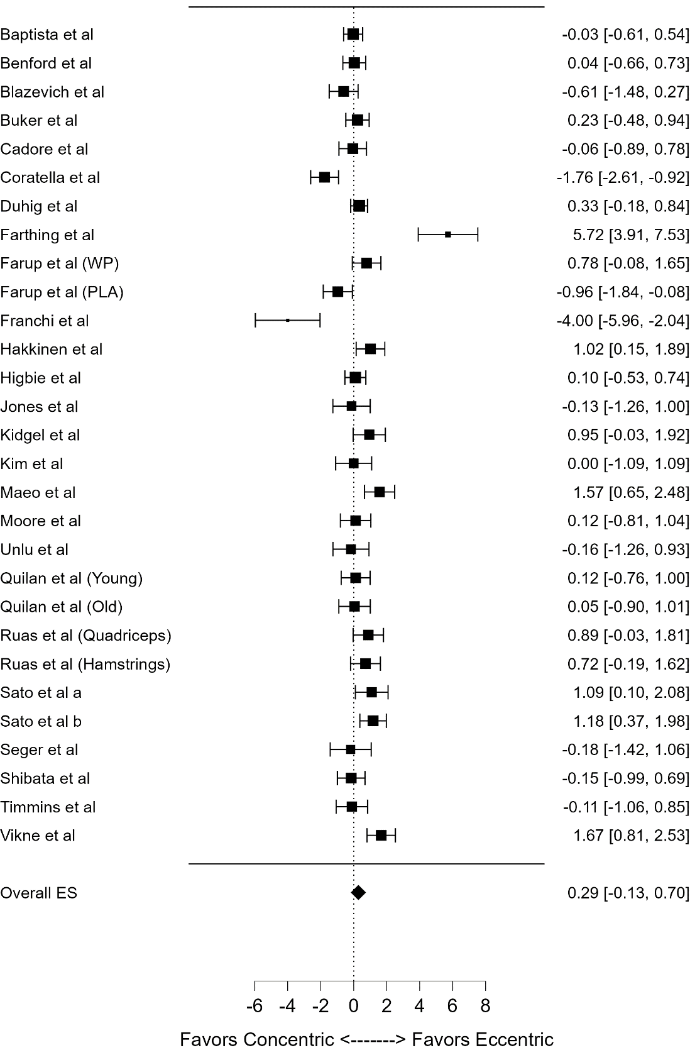
Figure 2. Forest plot results comparing concentric vs eccentric muscle actions on muscle hypertrophy.
Table 3. Subgroup analysis regarding the comparison of concentric (CON) vs. eccentric (ECC) training on muscle hypertrophy.
Subgroup analysis | Studies (n) | Size (n) (CON / ECC) | Effect Size (95% CI) | I² (%) | P value | Certainty of evidence
Age
Adults (18-59 years) | 25 | 312 / 307 | 0.308 (-0.150 to 0.766) | 86 | 0.188 | ⨁◯◯◯ (Very low)
Older adults (≥60 years) | 2 | 31 / 32 | -0.011 (-0.505 to 0.483) | 0 | 0.966 | ⨁◯◯◯ (Very low)
Muscles analyzed
Upper limb muscles | 7 | 77 / 75 | 1.436 (0.179 to 2.692) | 91 | 0.025 | ⨁⨁◯◯ (Low)
Lower limb muscles | 20 | 266 / 264 | -0.005 (-0.339 to 0.330) | 70 | 0.978 | ⨁◯◯◯ (Very low)
Training duration
≤8 weeks of intervention | 14 | 199 / 194 | 0.472 (-0.122 to 1.065) | 87 | 0.119 | ⨁◯◯◯ (Very low)
>8 weeks of intervention | 13 | 144 / 145 | 0.066 (-0.544 to 0.677) | 83 | 0.831 | ⨁◯◯◯ (Very low)

Publication bias
Figure 3 shows the funnel plot regarding the risk of publication bias. The Egger’s test reveals no funnel-plot asymmetry (z= 0.294; p=0.769), meaning that there was no tendency for bias in the results provided by the meta-analysis.

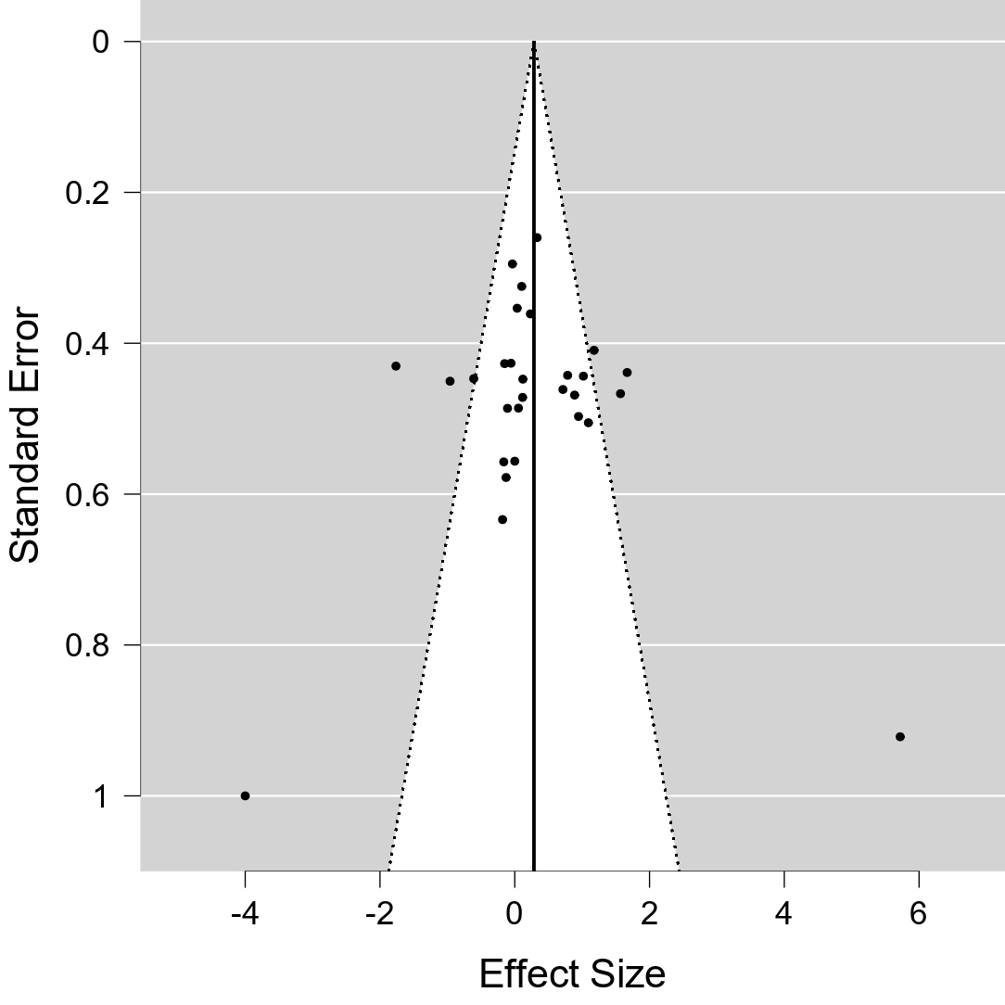
Figure 3. Funnel plot of the meta-analysis.

Discussion
This systematic review aimed to investigate the effects of ECC vs. CON muscle actions on muscle hypertrophy in apparently healthy adults. Our main findings indicate that: a) there was no difference between ECC vs. CON on hypertrophy measurements.; b) Subgroup analyses revealed that upper limb muscles benefit from an advantage conferred by ECC training, but this effect is largely heterogeneous with low certainty of evidence. c) Other subgroups (age, lower limb muscles, and intervention duration) did not present superior hypertrophy in ECC training. In this sense, our study contrasts with the previous meta-analysis of Schoenfeld et al. (46), which differs in the number of studies included (n=15), inclusion criteria (especially regarding hypertrophy measures), subgroup/sensitivity analysis, and the main effects (ES: -0.27 [95%CI: -0.57 to -0.01]; p<0.05). Therefore, our review did not support a superior promotion of muscular hypertrophy for ECC compared to CON training, adding some interesting aspects to discuss with the literature.
Both ECC and CON muscle actions promote distinct muscular morphological adaptations, and depending on whether one or the other type of contraction is prioritized during a resistance training program, these adaptations may be more evident. During CON muscle actions, the length of the muscle fascicle decreases as the muscle contracts (29). This phenomenon results from the sliding of cross-bridges formed between actin and myosin filaments, shortening the sarcomere and consequently the muscle as a whole, causing this decrease in fascicle length (4,13,55). Moreover, following CON training there is a tendency for the addition of sarcomeres in parallel (60). This characteristic is common in muscles that perform short amplitude and high-speed movements, favoring increased force generation capacity and improvement in muscle power (9). Therefore, hypertrophic changes appear to be achieved through a specific adaptation with CON training, providing distinct structural adaptations than ECC (60).
On the other hand, during ECC muscle actions, the length of the muscle fascicle increases as the muscle elongates (4). This occurs because the cross-bridges between actin and myosin filaments are stretched while controlling the downward movement or deceleration, promoting this type of adaptation during interventions that prioritize this action. The pennation angle tends to increase during ECC contraction, as muscle fibers move away from each other during muscle stretching, which generates adaptations to muscular architecture (48). For example, leading to adaptations favoring the development of sarcomeres in series, as stretching aligns fibers in a longitudinal direction (54). Furthermore, ECC muscle actions appear to induce unique adaptations compared to traditional CON-ECC resistance training protocols. Brandenburg & Docherty (2002) (5) showed that when using ECC loads greater than maximal concentric force (i.e., > 1RM), exclusively ECC training seems to promote greater increases in overall strength (i.e., combined CON, isometric, and CON strength) compared to CON-based and traditional training (i.e., alternating CON-ECC muscle actions). Therefore, ECC muscle actions are particularly effective for overall and specific strength gains.
The distinct mechanisms of muscular force production during ECC and CON muscle actions result in significant differences in force/power generation capacity, energy cost, and fatigue (41,53,56). A recent meta-analysis estimated that the maximal ECC force is approximately 40% greater than the maximal CON force (35). Furthermore, Souron et al. (2018) (53) demonstrated that to achieve the same level of fatigue observed in CON muscle actions (i.e., 40% reduction in maximal isometric force), a 28.8% greater volume of contractions (134 vs 104) was required when the exercise was performed eccentrically. When the same external resistances are used (i.e., 70-95%RM), CON-ECC muscle action protocols to failure resulted in substantially greater volume (64 to 152%) (51).
One of the adaptations of ECC contraction stems from titin, a protein with considerable molecular extension, which regulates muscle contraction (21). Its filamentous structure spans significant longitudinal extensions within the sarcomere, connecting the Z lines to the myosin filaments at the sarcomere's center. This central position grants titin the ability to regulate sarcomere length during muscle contraction, enabling elongation while maintaining structural integrity and elasticity. Its primary function is to provide passive elasticity to muscles, enabling them to return to their resting length after contraction or stretching. Additionally, titin interacts directly with contractile filaments, acting as a sort of "molecular spring" that influences contraction force and relaxation speed (22). Storing potential elastic energy during the muscle stretching process amplifies the muscle's capacity to generate force when this energy is released in the subsequent contraction (6,21). Finally, the interaction with titin implies that the enhanced residual force could result in specific adaptations, such as longitudinal muscle hypertrophy, during ECC exercise, driven by the peak fascicle force during muscle-tendon unity stretch and the muscle's final stretched length (54).
The elastic property of titin optimizes muscle contractile performance during ECC muscle actions, allowing for effective utilization of stored energy to produce contractions supporting higher intensity (21). Conversely, during CON muscle action, titin regulates sarcomere length and interacts with contractile filaments. However, its capacity to store and release energy is relatively lower compared to ECC contraction, resulting in a lesser contribution of titin to force generation during CON contractions. In addition to its biomechanical functions, titin also participates in cellular signaling within muscles (21). It may be involved in transducing mechanical and biochemical signals that regulate processes such as muscle growth, exercise adaptation, and response to muscle injuries (20). Therefore, the role of titin may be one of the mechanistic explanations for adaptations through ECC muscle actions.

Limitations
Despite the strengths of a meta-analysis, our review has several limitations. First, the use of an isokinetic dynamometer for participant training across the most analyzed studies. While isokinetic dynamometry provides precise control over ECC contraction (36), enhancing experimental rigor, it may limit the ecological validity of the findings. The nearly isolated principle of isokinetic exercises may not fully replicate the dynamic and multifaceted conditions encountered in real-world resistance training settings. Consequently, the outcomes of our analysis may not be entirely representative of the diverse stimuli encountered during more conventional forms of resistance training, potentially limiting the generalizability of our findings to practical applications. Future research should incorporate a wide range of resistance training modalities to ensure a more comprehensive understanding of the eccentric-concentric dichotomy in muscle hypertrophy under ecologically valid conditions.
We included only regional imaging methods to measure muscle hypertrophy (i.e., MRI, ultrasound, and computed tomography). Muscle biopsies and skeletal muscle estimation (through equations) are also adequate to measure muscle hypertrophy (19). However, analyzing studies with different methods of measuring muscular hypertrophy may introduce a bias and true differences in effects may be obscured (24).
Another limitation is the choice of one regional measure of muscle hypertrophy for meta-analysis. Some studies measured different regions of a muscle group (e.g., 30%, 50%, and 70% of total quadriceps). In this case, we standardized the data extracted from 50% of the muscle to avoid double-counting in the meta-analysis (49).
Finally, another limitation is the heterogeneity of defining training status across studies. Most studies used a criterion to categorize the training status, such as previous experience (in years) with resistance training. However, some studies defined the participants as physically/recreationally active or did not inform the training status. Furthermore, previous experience with resistance training is not the only criterion to define training status (43). strength level, current uninterrupted training time, time of detraining, previous training experience, and exercise technique (43) are also used. Therefore, based on these limitations, we chose not to carry out a subgroup analysis considering the training status.

Practical applications
Since our study showed no superior hypertrophy of ECC compared to CON training, some practical applications should be considered. For instance, some ECC predominance exercises such as the Nordic hamstring also offer advantages in terms of skeletal muscle adaptations (i.e., pennation angle, fascicle length, and muscle thickness) (38). Adding these exercises to strength training regimens may benefit the resistance training prescription, particularly for individuals aiming to optimize muscle growth. Athletes or individuals rehabilitating from injuries may also benefit from emphasizing ECC training to enhance muscle architecture parameters and promote joint stability (4,12). Additionally, Strength and Conditioning Coaches may design resistance training routines based on individual preferences and specific muscle goals. Therefore, our findings elucidate the possibility of considering ECC training, but not to the detriment of CON training due to its non-superiority in hypertrophy.

Conclusion
There was no evidence of superior hypertrophy between eccentric and concentric, in addition to greater heterogeneity and a low level of recommendations (GRADE). Therefore, parsimony should be considered when implementing eccentric muscle actions in resistance training programs.

Funding
The present work received financial support from the Coordination for the Improvement of Higher Education Personnel (CAPES; finance code 001).

Competing interests
The authors declare that they have no competing interests.

Data availability statement
The raw data supporting the conclusions of this article will be made available by the authors, without undue reservation.

Author contributions
LSLS and LSG performed the conducted experiments, performed the statistical analysis, and wrote the introduction, methods, results, and discussion sections. PHAC, CJRB, MFTJ, and LCRL improved interpretation analysis and reviewed the manuscript. CRBJ and CPLA supervised the study, drafted the manuscript, and gave final approval for the version submitted for publication. All authors contributed to the article and approved the submitted version.

REFERENCES
1. Ardern, CL, Büttner, F, Andrade, R, et al. Implementing the 27 PRISMA 2020 Statement items for systematic reviews in the sport and exercise medicine, musculoskeletal rehabilitation and sports science fields: the PERSiST (implementing Prisma in Exercise, Rehabilitation, Sport medicine and SporTs science) guidance. Br J Sports Med 56: 175–195, 2022.
2. Baptista, R, Onzi, E, Goulart, N, et al. Effects of Concentric Versus Eccentric Strength Training on the Elderly’s Knee Extensor Structure and Function. Journal of Exercise Physiology Online 19: 120–132, 2016.
3. Benford, J, Hughes, J, Waldron, M, and Theis, N. Concentric versus eccentric training: Effect on muscle strength, regional morphology, and architecture. Translational Sports Medicine 4: 46–55, 2021.
4. Blazevich, AJ, Cannavan, D, Coleman, DR, and Horne, S. Influence of concentric and eccentric resistance training on architectural adaptation in human quadriceps muscles. Journal of Applied Physiology 103: 1565–1575, 2007.
5. Brandenburg, JP and Docherty, D. The effects of accentuated eccentric loading on strength, muscle hypertrophy, and neural adaptations in trained individuals. J Strength Cond Res 16: 25–32, 2002.
6. Brynnel, A, Hernandez, Y, Kiss, B, et al. Downsizing the molecular spring of the giant protein titin reveals that skeletal muscle titin determines passive stiffness and drives longitudinal hypertrophy. eLife 7: e40532, 2018.
7. Buker, N, Savkin, R, Suzer, A, and Akkaya, N. Effect of eccentric and concentric squat exercise on quadriceps thickness and lower extremity performance in healthy young males. ACTA GYMNICA 51, 2021.
8. Cadore, EL, González-Izal, M, Pallarés, JG, et al. Muscle conduction velocity, strength, neural activity, and morphological changes after eccentric and concentric training. Scandinavian Journal of Medicine and Science in Sports 24: e343–e352, 2014.
9. Caserotti, P, Aagaard, P, and Puggaard, L. Changes in power and force generation during coupled eccentric-concentric versus concentric muscle contraction with training and aging. Eur J Appl Physiol 103: 151–161, 2008.
10. Coratella, G, Beato, M, Bertinato, L, et al. Including the Eccentric Phase in Resistance Training to Counteract the Effects of Detraining in Women: A Randomized Controlled Trial. Journal of strength and conditioning research 36: 3023–3031, 2022.
11. Coratella, G and Schena, F. Eccentric resistance training increases and retains maximal strength, muscle endurance, and hypertrophy in trained men. Appl Physiol Nutr Metab 41: 1184–1189, 2016.
12. Douglas, J, Pearson, S, Ross, A, and McGuigan, M. Chronic Adaptations to Eccentric Training: A Systematic Review. Sports Med 47: 917–941, 2017.
13. Duhig, SJ, Bourne, MN, Buhmann, RL, et al. Effect of concentric and eccentric hamstring training on sprint recovery, strength and muscle architecture in inexperienced athletes. Journal of Science and Medicine in Sport 22: 769–774, 2019.
14. Fang, Y, Siemionow, V, Sahgal, V, Xiong, F, and Yue, GH. Distinct brain activation patterns for human maximal voluntary eccentric and concentric muscle actions. Brain Research 1023: 200–212, 2004.
15. Farthing, JP and Chilibeck, PD. The effects of eccentric and concentric training at different velocities on muscle hypertrophy. European Journal of Applied Physiology 89: 578–586, 2003.
16. Farup, J, Rahbek, S, Vendelbo, M, et al. Whey protein hydrolysate augments tendon and muscle hypertrophy independent of resistance exercise contraction mode. Scandinavian journal of medicine & science in sports 24: 788–798, 2014.
17. Franchi, MV, Atherton, PJ, Reeves, ND, et al. Architectural, functional and molecular responses to concentric and eccentric loading in human skeletal muscle. ACTA PHYSIOLOGICA 210: 642–654, 2014.
18. Häkkinen, K, Newton, RU, Walker, S, et al. Effects of Upper Body Eccentric versus Concentric Strength Training and Detraining on Maximal Force, Muscle Activation, Hypertrophy and Serum Hormones in Women. Journal of Sports Science & Medicine 21: 200–213, 2022.
19. Haun, CT, Vann, CG, Roberts, BM, et al. A Critical Evaluation of the Biological Construct Skeletal Muscle Hypertrophy: Size Matters but So Does the Measurement. Front Physiol 10: 247, 2019.
20. Herzog, W. The mysteries of eccentric muscle action. J Sport Health Sci 7: 253–254, 2018.
21. Herzog, W. The multiple roles of titin in muscle contraction and force production. Biophys Rev 10: 1187–1199, 2018.
22. Herzog, W, Schappacher, G, DuVall, M, Leonard, TR, and Herzog, JA. Residual Force Enhancement Following Eccentric Contractions: A New Mechanism Involving Titin. Physiology 31: 300–312, 2016.
23. Higbie, EJ, Cureton, KJ, Warren III, GL, and Prior, BM. Effects of concentric and eccentric training on muscle strength, cross-sectional area, and neural activation. Journal of applied physiology 81: 2173–2181, 1996.
24. Higgins, J, Thomas, J, Chandler, J, et al. Cochrane Handbook for Systematic Reviews of Interventions. Cochrane Handbook for Systematic Reviews of Interventions , 2019.
25. Higgins, JP, Li, T, and Deeks, J. Choosing effect measures and computing estimates of effect. In: Cochrane Handbook for Systematic Reviews of Interventions version 6.3.Cochrane, 2022.Available from: http://www.training.cochrane.org/handbook
26. Jones, D and Rutherford, O. Human muscle strength training: the effects of three different regimens and the nature of the resultant changes. The Journal of physiology 391: 1–11, 1987.
27. Kidgell, DJ, Frazer, AK, Rantalainen, T, et al. Increased cross-education of muscle strength and reduced corticospinal inhibition following eccentric strength training. Neuroscience 300: 566–575, 2015.
28. Kim, DY, Oh, SL, and Lim, J-Y. Applications of Eccentric Exercise to Improve Muscle and Mobility Function in Older Adults. Ann Geriatr Med Res 26: 4–15, 2022.
29. Kim, SY, Ko, JB, Farthing, JP, and Butcher, SJ. Investigation of supraspinatus muscle architecture following concentric and eccentric training. Journal of science and medicine in sport 18: 378–382, 2015.
30. LaStayo, P, Marcus, R, Dibble, L, Frajacomo, F, and Lindstedt, S. Eccentric exercise in rehabilitation: safety, feasibility, and application. Journal of Applied Physiology 116: 1426–1434, 2014.
31. Maeo, S, Shan, X, Otsuka, S, Kanehisa, H, and Kawakami, Y. Neuromuscular adaptations to work-matched maximal eccentric versus concentric training. Medicine and Science in Sports and Exercise 50: 1629–1640, 2018.
32. Maroto-Izquierdo, S, Martín-Rivera, F, Nosaka, K, et al. Effects of submaximal and supramaximal accentuated eccentric loading on mass and function. Front Physiol 14: 1176835, 2023.
33. Meader, N, King, K, Llewellyn, A, et al. A checklist designed to aid consistency and reproducibility of GRADE assessments: development and pilot validation. Syst Rev 3: 82, 2014.
34. Moore, DR, Young, M, and Phillips, SM. Similar increases in muscle size and strength in young men after training with maximal shortening or lengthening contractions when matched for total work. European Journal of Applied Physiology 112: 1587–1592, 2012.
35. Nuzzo, JL, Pinto, MD, Nosaka, K, and Steele, J. The Eccentric:Concentric Strength Ratio of Human Skeletal Muscle In Vivo: Meta-analysis of the Influences of Sex, Age, Joint Action, and Velocity. Sports Med 53: 1125–1136, 2023.
36. Osternig, LR. Isokinetic dynamometry: implications for muscle testing and rehabilitation. Exerc Sport Sci Rev 14: 45–80, 1986.
37. Page, MJ, McKenzie, JE, Bossuyt, PM, et al. The PRISMA 2020 statement: an updated guideline for reporting systematic reviews. BMJ 372: n71, 2021.
38. Pollard, CW, Opar, DA, Williams, MD, Bourne, MN, and Timmins, RG. Razor hamstring curl and Nordic hamstring exercise architectural adaptations: Impact of exercise selection and intensity. Scand J Med Sci Sports 29: 706–715, 2019.
39. Quinlan, JI, Franchi, MV, Gharahdaghi, N, et al. Muscle and tendon adaptations to moderate load eccentric vs. concentric resistance exercise in young and older males. GeroScience 43: 1567–1584, 2021.
40. Rosenthal, R. Meta-Analytic Procedures for Social Research. 2455 Teller Road, Thousand Oaks California 91320 United States of America: SAGE Publications, Inc., 1991 [cited 2023 Jan 2].Available from: https://methods.sagepub.com/book/meta-analytic-procedures-for-social-research
41. Ruas, CV, Pinto, RS, Haff, GG, Lima, CD, and Brown, LE. Article effects of different combinations of concentric and eccentric resistance training programs on traditional and alternative hamstrings-to-quadriceps ratios. Sports 7, 2019.Available from: https://www.scopus.com/inward/record.uri?eid=2-s2.0-85097025614&doi=10.3390%2fsports7100221&partnerID=40&md5=aebda53c4af33a618811192bee4e2de7
42. Ryschon, TW, Fowler, MD, Wysong, RE, Anthony, A-R, and Balaban, RS. Efficiency of human skeletal muscle in vivo: comparison of isometric, concentric, and eccentric muscle action. Journal of Applied Physiology 83: 867–874, 1997.
43. Santos Junior, ERT, de Salles, BF, Dias, I, et al. Classification and Determination Model of Resistance Training Status. Strength & Conditioning Journal 43: 77, 2021.
44. Sato, S, Yoshida, R, Kiyono, R, et al. Cross-education and detraining effects of eccentric vs. concentric resistance training of the elbow flexors. BMC Sports Science, Medicine and Rehabilitation 13, 2021.Available from: https://www.embase.com/search/results?subaction=viewrecord&id=L2013619945&from=export http://dx.doi.org/10.1186/s13102-021-00298-w
45. Sato, S, Yoshida, R, Murakoshi, F, et al. Comparison between concentric-only, eccentric-only, and concentric–eccentric resistance training of the elbow flexors for their effects on muscle strength and hypertrophy. European Journal of Applied Physiology 122: 2607–2614, 2022.
46. Schoenfeld, BJ, Ogborn, DI, Vigotsky, AD, Franchi, MV, and Krieger, JW. Hypertrophic Effects of Concentric vs. Eccentric Muscle Actions: A Systematic Review and Meta-analysis. J Strength Cond Res 31: 2599–2608, 2017.
47. Seger, JY, Arvidsson, B, Thorstensson, A, and Seger, JY. Specific effects of eccentric and concentric training on muscle strength and morphology in humans. European journal of applied physiology and occupational physiology 79: 49–57, 1998.
48. Şenışık, SÇ, Akova, B, Şekir, U, and Gür, H. Effects of Muscle Architecture on Eccentric Exercise Induced Muscle Damage Responses. J Sports Sci Med 20: 655–664, 2021.
49. Senn, SJ. Overstating the evidence – double counting in meta-analysis and related problems. BMC Med Res Methodol 9: 10, 2009.
50. Shibata, K, Takizawa, K, Nosaka, K, and Mizuno, M. Effects of Prolonging Eccentric Phase Duration in Parallel Back-Squat Training to Momentary Failure on Muscle Cross-Sectional Area, Squat One Repetition Maximum, and Performance Tests in University Soccer Players. Journal of Strength and Conditioning Research 35: 668–674, 2021.
51. Shibata, K, Yamaguchi, T, Takizawa, K, and Nosaka, K. Comparison in Repetitions to Failure Between Concentric-Only and Eccentric-Only Dumbbell Arm Curl Exercise at Four Different Relative Intensities. J Strength Cond Res 37: 1754–1760, 2023.
52. Smart, NA, Waldron, M, Ismail, H, et al. Validation of a new tool for the assessment of study quality and reporting in exercise training studies: TESTEX. Int J Evid Based Healthc 13: 9–18, 2015.
53. Souron, R, Nosaka, K, and Jubeau, M. Changes in central and peripheral neuromuscular fatigue indices after concentric versus eccentric contractions of the knee extensors. Eur J Appl Physiol 118: 805–816, 2018.
54. Tecchio, P, Raiteri, BJ, and Hahn, D. Eccentric exercise ≠ eccentric contraction. J Appl Physiol (1985) 136: 954–965, 2024.
55. Timmins, RG, Ruddy, JD, Presland, J, Maniar, N, and Williams, M. Architectural changes of the biceps femoris long head after concentric or eccentric training. Medicine and science in sports and exercise 48: 499–508, 2015.
56. Tomalka, A. Eccentric muscle contractions: from single muscle fibre to whole muscle mechanics. Pflugers Arch 475: 421–435, 2023.
57. Ünlü, G, Çevikol, C, and Melekoğlu, T. Comparison of the Effects of Eccentric, Concentric, and Eccentric-Concentric Isotonic Resistance Training at Two Velocities on Strength and Muscle Hypertrophy. Journal of strength and conditioning research 34: 337–344, 2020.
58. Vikne, H, Refsnes, PE, Ekmark, M, et al. Muscular performance after concentric and eccentric exercise in trained men. Medicine and Science in Sports and Exercise 38: 1770–1781, 2006.
59. What Works Clearinghouse, I of ES. What Works Clearinghouse procedures handbook, version 4.1. , 2020.Available from: https://ies.ed.gov/ncee/wwc/Handbooks
60. Wisdom, KM, Delp, SL, and Kuhl, E. Review. Use it or lose it: Multiscale skeletal muscle adaptation to mechanical stimuli. Biomech Model Mechanobiol 14: 195–215, 2015.

