Title: Performance kinetics during repeated sprints is influenced by knowledge of task endpoint and associated peripheral fatigue

Authors: François Billaut¹, Marie Rousseau-Demers¹, and Andrew Hibbert²

Affiliation: ¹Département de kinésiologie, Université Laval, Québec, QC, CANADA; ² Institute for Health & Sport, Victoria University, Melbourne, VIC, AUSTRALIA

PREPRINT not peer reviewed

Please cite as: Billaut F, Rousseau-Demers M, Hibbert A (2023). Performance kinetics during repeated sprints is influenced by knowledge of task endpoint and associated peripheral fatigue. SportRxiv

ABSTRACT
The regulation of exercise intensity allows an athlete to perform an exercise in the fastest possible time while avoiding debilitating neuromuscular fatigue development. This phenomenon is less studied during intermittent activities. To investigate anticipatory and real-time regulation of motor output and neuromuscular fatigue during repeated-sprint exercise, twelve males randomly performed one (S1), two (S2), four (S4) and six (S6) sets of five 5-s cycling sprints. Mechanical work and electromyographic activity were assessed during sprints. Potentiated quadriceps twitch force (ΔQ_{tw,pot}) and central activation ratio (Q_{CAR}) were quantified from response to supra-maximal magnetic femoral nerve stimulation pre- vs post-exercise. Compared with S1, mechanical work developed in the first sprint and in the entire first set was reduced in S6 (–7.8% and –5.1%, respectively, P<0.05). Work developed in the last set was similar in S4 and S6 (P=0.82). Similar results were observed for EMG activity. The Q_{CAR} was also more reduced in S4 (–5.8%, P<0.05) and S6 (–8.3%, P<0.05) than in S1. However, ΔQ_{tw,pot} was not significantly different across all trials (–33.1% to –41.9%, P=0.46). Perceived exhaustion increased across sprints to reach a maximal and similar level in S2, S4 and S6 (all 19.2, P<0.01 vs S1). These results suggest that the regulation of performance, exerted at the beginning and continuously during repeated sprints, is based on the task endpoint, presumably to avoid excessive peripheral muscle and associated conscious overwhelming sensations.

KEY WORDS: anticipation; pacing; central motor output; peripheral fatigue; intermittent sprints

INTRODUCTION

In contemporary exercise physiology, it is well accepted that the reduction in exercise intensity does not occur without brain involvement, and that all voluntary activity is likely to be paced by the brain based on individualised priorities and knowledge of personal capabilities (11,18,22). Pacing is the continuous regulation of performance by the brain, via manipulations of motor unit recruitment, to enable the athlete to perform the exercise in the fastest possible time or with the highest mean power output, without excessively stressing physiological systems, thus preventing premature termination of exercise (11,22).

The selection of exercise intensity by the central nervous system (CNS) is established pre-exercise, based upon the expected exercise duration and previous experience of similar bouts of exercise (3,19). Furthermore, a participant will also rely on metabolic perturbations occurring within active skeletal muscles to adjust their intensity in real time during exercise, and, therefore, any pacing strategy is influenced by the development of peripheral muscle fatigue and the conscious (often overwhelming) sensations of fatigue. In fact, it has been robustly demonstrated that power output and muscle recruitment (assessed via electromyography, EMG) during a cycling time trial are continuously adjusted to limit the development of peripheral muscle fatigue to an individual critical threshold (1,2). While extensive research has explored continuous exercise, evidence of pacing during intermittent activities is still limited.

Anticipatory regulation was first demonstrated during repeated-sprint exercise when participants consciously or subconsciously altered their power output and lower-limb muscle recruitment during a series of 5-s sprints depending upon their knowledge of the number of sprints to perform beforehand (7). Since the number of efforts contributes to exacerbate muscle fatigue (6,14), the different regulation of performance when knowing or not knowing the sprint number probably related, at least partly, to the expected development of fatigue in active skeletal muscles. This hypothesis was later confirmed by measuring changes in quadriceps twitch torque and voluntary brain activation, and showing that, like in endurance exercise, the peripheral fatigue that developed during 10-s repeated sprints reached a constant level despite manipulation of pre-existing fatigue (16) or exercise duration (15). However, the a-priori open-loop design used by Billaut et al. (deception trial, anticipation) allowed pacing to take place, whereas Hureau and colleagues reported no presence of pacing in their closed-loop designs. Thus, whether pacing occurs during repeated-sprints exercise in relation to locomotor muscle fatigue is yet to be explored. Furthermore, these findings are limited to very short protocols (i.e., up to ten sprints), and extending our knowledge of pacing or avoidance strategies involved during longer protocols would be relevant to better comprehend and act on the (sub)conscious decisions made by players on the field (4,9).

Therefore, we investigated anticipatory and real-time feed-forward regulation of motor output during sessions involving different numbers of sets of all-out, repeated sprints. We hypothesised that i) the session involving the most sets would display the greatest anticipation and real-time, feed-forward regulation of motor output, and ii) exercise intensity would gradually decrease to be set to a level where locomotor muscle fatigue and associated conscious sensations are maintained despite more sprints being performed.

Methods

Participants
Twelve healthy participants from the university and local sports clubs (soccer, Australian Rules football & basketball) volunteered for the study (mean ± SD: age 24.67 ± 3.87 y, height 182.22 ± 6.46 cm, body mass 81.93 ± 10.43 kg, physical activity 5.6 ± 2.05 h.week⁻¹). After being fully informed of the requirements, benefits, and risks associated with participation, each participant gave a written informed consent. Ethical approval for the study was obtained from the Victoria University Human Subject Research Committee and the Laval University Human Subject Research Committee. This research was carried out in accordance with the ethical standards of the International Journal of Exercise Science (21).
Experimental design
Athletes visited the laboratory five times (one familiarisation and four experimental sessions). During the first session, stature and body mass were recorded. Then, athletes were familiarised with sprint cycling until fully confident of producing an all-out effort from a stationary start, and with the technique of magnetic stimulation superimposed onto a maximal isometric voluntary knee extension.

Following the familiarisation session, participants were randomised in a crossover design, and asked to perform one (S1), two (S2), four (S4) and six (S6) sets of repeated sprints in subsequent separated visits. These experimental sessions were conducted at the same time of day for every participant and were separated by a minimum of 4 days. Temperature and humidity were maintained constant throughout all testing at 20.6 ± 0.4°C and 46.4 ± 4.5%.

Repeated-sprint exercise
Testing was performed on an electronically-braked cycle ergometer (Excalibur, Lode, Groningen, the Netherlands) set in isokinetic mode. The pedalling rate was the same for every sprint in all sessions so that exercise-induced changes in physiological responses and mechanical output would not be influenced by changes in pedalling rate between trials. The selected pedalling rate (120 rpm) has been demonstrated to be optimal for the development of maximal mechanical output (5). The software provided instantaneous, average and peak values for power (watts), and time at 4 Hz. Mechanical work performed (kJ) was calculated by integrating the power curve over the entire duration of the sprint for every sprint. Total and mean work (kJ) was calculated as the total and average, respectively, of all sprint mechanical work values within every session.

Participants were instrumented with necessary electrodes and, after a 7-min self-paced warm-up (~60–120 watts cycling and two 5-s warm-up sprints separated by 1 min), they rested for another 1 min, and the exercise (sets of five 5-s sprints with 25 s and 120 s of rest between sprints and sets, respectively) was initiated. Sprints were initiated with the dominant lower limb, from the same position (crank arm located 45° forward to the vertical axis). Participants were instructed to cycle as “hard as you can go” from the start of every sprint and were verbally encouraged throughout each sprint to promote a conscious/voluntary maximal effort. Participants remained seated during every sprint and recovery period. The handlebars and seat were individually adjusted to each athlete’s characteristics, which was replicated for all three trials, and their feet were secured to the pedals using straps. Participants had no performance feedback during any sprint.

Electrophysiological and perceptual responses to exercise
Surface electromyography (EMG) acquisition and analysis. This procedure has been fully described elsewhere (7,8). Briefly, the EMG signals of the vastus lateralis, vastus medialis and rectus femoris were recorded from the dominant lower limb via surface electrodes (DE-2.1 single differential electrodes, DelSys Inc., Boston, MA). Electrode location was measured and then marked with a waterproof felt-tip pen to ensure reliable electrode replacement in subsequent testing sessions. Raw EMG signals were pre-amplified (gain = 1000) and sampled at 2 kHz (Bagnoli EMG system, DelSys Inc., Boston, MA). During post-processing, the EMG signals were rectified and filtered (bandwidth frequency = 12–500 Hz) to minimise extraneous noise and movement artefacts in the low-frequency region and to eliminate aliasing and other artefacts in the high-frequency region. The root mean square (RMS) of each muscle signal was calculated across 5 consecutive crank cycles in every sprint. Then, total EMG activity was calculated by summing the RMS values across the three muscles (7,8) for the first (RMS_{first}) and last sprint (RMS_{last}) as well as last set (RMS_{lastset}). Mean EMG activity across every session was also calculated (RMS_{mean}).

The surface EMG electrodes were also used to assess the magnetically-evoked compound muscle action potentials (M-waves) for the quadriceps muscles to evaluate changes in M-wave properties pre- versus post-exercise. Membrane excitability was assessed before and immediately after exercise using M-wave properties evoked by supramaximal magnetic stimuli (see procedure below). The peak-to-peak amplitude and duration were measured, and the values for the three muscles were averaged. During each maximal voluntary contraction (MVC), EMG signals of the three muscles were quantified by using RMS calculated over a 1-s period after the torque had reached a plateau. The RMS_{MVC} was then normalized to the corresponding M-wave amplitude (M_{amp}) by using the ratio RMS_{MVC}/M_{amp}, and the values for the three muscles were averaged. A reduction in the RMS_{MVC} without a reduction in M_{amp} may be interpreted as a central activation failure (8,13).

Peripheral magnetic stimulation. Athletes lay supine on a custom-made bench with the right lower-limb knee joint angle set at 90° of flexion (0° = knee fully extended) and the arms folded across the chest. A magnetic stimulator (Magstim RAPID²; JLM Accutek Healthcare, Homebush, NSW) and a double 70-mm coil (producing two overlapping circular fields) were used to stimulate the quadriceps muscle and femoral nerve. The quadriceps force responses were obtained at 1 kHz from a calibrated load cell (Extran 2kN “S” beam, model SW1, Applied Measurement, Melbourne, Australia) connected to a non-compliant strap, which was attached around the subject’s leg just superior to the malleoli of the ankle. Care was taken to ensure that the knee angle did not change, the ankle strap and load cell were parallel to the floor, and the ankle strap position remained constant throughout the experiment. The area of stimulation associated with the largest quadriceps twitch (Q_{tw}) and M-wave amplitudes was determined by positioning the coil head high onto the thigh, between the quadriceps muscle and the femoral triangle (1,8). This position was kept the same for all sessions. To ensure supramaximality of stimulation during magnetic stimulation of the femoral nerve, the plateau in evoked-twitch forces, obtained every 30 seconds, at 70, 80, 85, 90, 95 and 100% of maximal stimulator output, was also evaluated (1,8,16).

With the stimulus power set at 100% of maximum, single stimuli were delivered. Three potentiated Q_{tw} (Q_{tw,pot}) were obtained 5 s after a 4-s MVC of the quadriceps. This procedure was performed two times at baseline (60 s of rest in between) such that six Q_{tw,pot} values are obtained, but was only performed once at end-exercise to reduce post-exercise assessment time and limit recovery as much as possible (8,12). The Q_{tw,pot} were averaged and analysed for peak force, contraction time, maximal rate of force development, one-half relaxation time, and maximal relaxation rate. The area between the quadriceps and femoral nerve was also stimulated during the MVCs (superimposed single stimuli) to determine the completeness of muscle activation (1,8,16). The quadriceps central activation ratio (Q_{CAR}) was calculated as the percentage of voluntary force obtained during the superimposed contraction, that is, Q_{CAR} = MVC ÷ (MVC + stimulated force) (17). The entire neuromuscular assessment procedure was performed ~5 min before and immediately after the last sprint (between 20 to 40 s, depending on the subject capacity to move quickly from the cycle ergometer to the bench; this time was kept constant for each subject between sessions).

Rating of perceived exertion (RPE). As an index of overall feeling of subjective perceived exertion, the RPE was assessed with the Borg 15-point scale. RPE readings were taken at rest and immediately after every set.

Statistical analysis
Analyses were performed using SPSS Statistics for Windows (version 21.0, IBM Corp., Armonk, NY). One-way ANOVAs (set) were used to compare the following dependent variables between sessions: mechanical work performed in the first and last sprints, mean mechanical work performed across all sprints, percent decline in mechanical work, EMG activity in the first and last sprints, mean EMG activity across all sprints, changes in twitch measures, RMS_{MVC}/M_{amp}, Q_{CAR}, MVC and RPE. Finally, two-way, repeated measures ANOVAs (set x sprint) were used to compare mechanical work and RMS between sessions and across sprint repetitions. Fisher’s LSD post-hoc analyses were used to locate differences among pairs of means when ANOVAs revealed significant F-ratio for main or interaction effects. The level of significance was set at 0.05. Differences between sessions were also assessed using Cohen’s d effect sizes (ES) (10), and effects were considered small (>0.2), moderate (>0.5) or large (>0.8). Data are reported as mean ± SD.

RESULTS

Cycling mechanical measurements
Mechanical variables are displayed in Figures 1A, 2 and 3. There was no significant interaction effect for any of the mechanical variables. However, compared with S1 (i.e., when participants performed only five sprints), mechanical work developed in the first sprint of the session was significantly lower when participants expected to perform 30 sprints (i.e., S6) (–7.8%, P<0.05, ES: –0.50). Furthermore, total mechanical work developed in the first set (i.e., sum of the first five sprints) was lower in S6 than in S1 (–5.1%, P<0.05, ES: –0.36) and S2 (–6.8%, P<0.05, ES: –0.42), and lower in S4 than in S2 (–3.2%, P<0.05, ES: –0.30). Work averaged over all sets in each session was also lower in S4 (–9.1%, P<0.05, ES: –0.47) and S6 (–11.8%, P<0.01, ES: –0.61) compared to S1. Towards the end of the exercise, however, there was no difference in total work done (P=0.82) in the last set between S4 (i.e., sprints 15 to 20) and S6 (i.e., sprints 25 to 30). A further sub-analysis of mechanical work values for the S4 and S6 sessions indicated that, from set 3, mechanical work did not vary significantly (P=0.51) until the end of the exercise.

Figure 1. Mechanical work (panel A) and sum electromyograms (RMS_{sum}) of vastus lateralis, vastus medialis, rectus femoris and biceps femoris (panel B) during one, two, four and six sets of five all-out sprints. Standard deviations are removed for clarity. Both the work developed and RMS_{sum} in the first sprint were lower (P<0.05) in S6 than in S1 and S2 (*). Both the work developed and RMS_{sum} in the last sprint were lower (P<0.05) in S4 and S6 than in S1 and S2 (†).

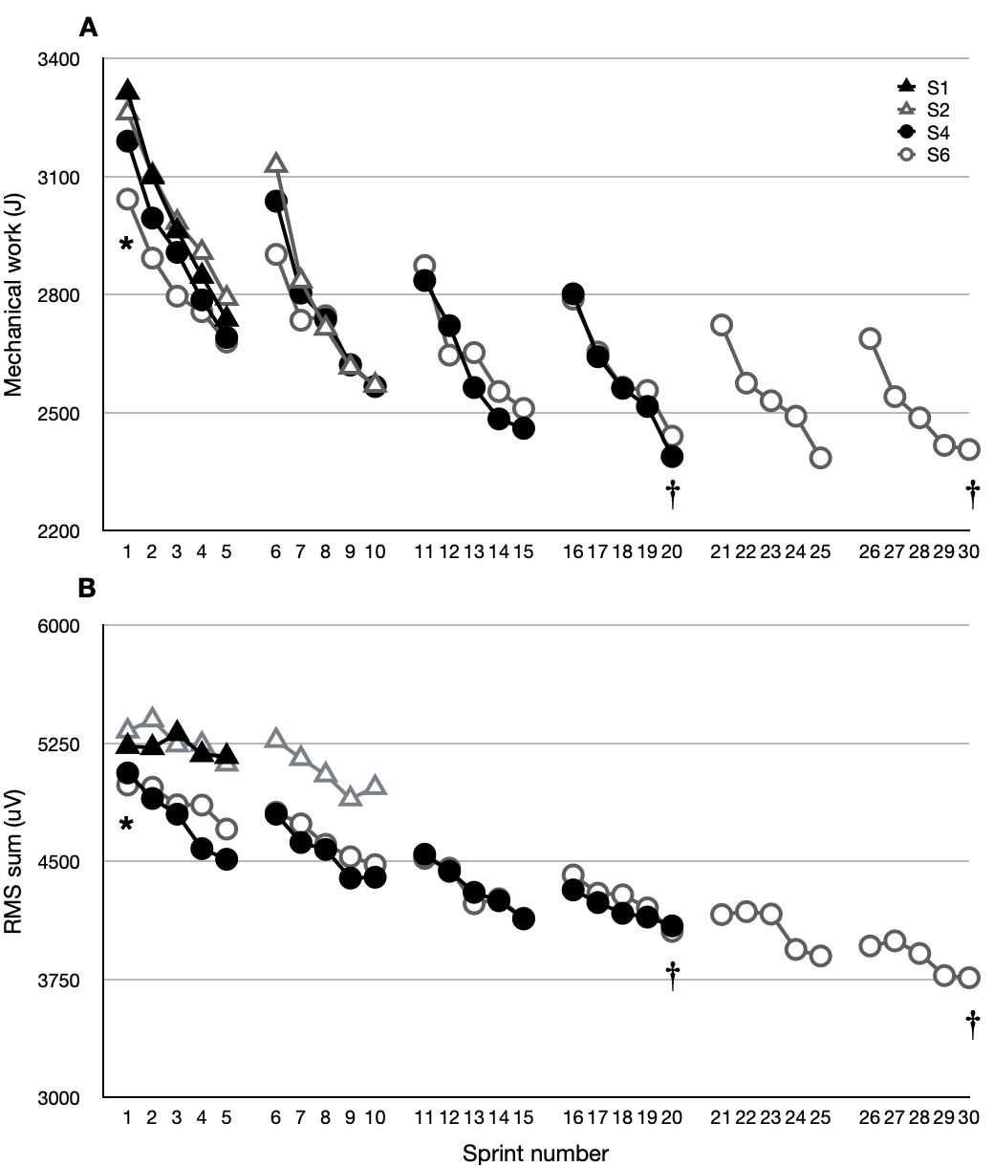

Figure 2. Mechanical work summed over every set during one, two, four and six sets of five all-out sprints. Work developed during the first set was lower (P<0.05) in S6 than in S1 and S2 (*). Work developed during the first set was lower (P<0.05) in S4 than in S2 (†). Work developed during the last set was lower (P<0.05) in S2, S4 and S6 than in S1 (‡). Work developed during the last set was lower (P<0.05) in S4 and S6 than in S2 (§).

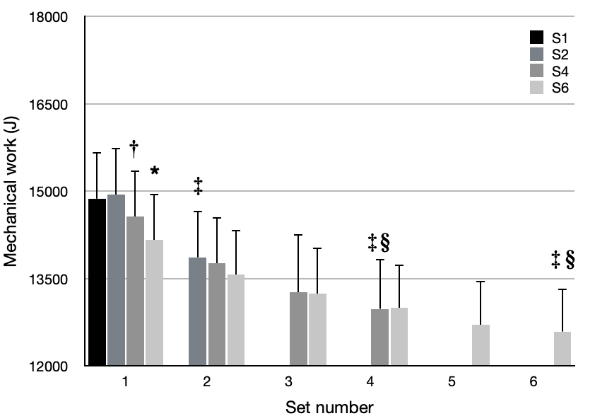

Cycling electromyographic measurements
The EMG activity during sprints is displayed in Figure 1B. As for mechanical work, the RMS_{sum} recorded in the first sprint was significantly lower in S6 (4.9 ± 1.0 mV) than in S1 (5.2 ± 0.8 mV, P<0.05) and S2 (5.4 ± 1.1 mV, P<0.05). Similar results were observed when cumulating RMS_{sum} over the first set (S1: 26.4 ± 9.4 mV and S2: 26.5 ± 10.1 mV vs S6: 24.6 ± 11.2 mV, P<0.05). Furthermore, the cumulative value of RMS_{sum} over the last set was significantly lower in S4 (20.9 ± 8.3 mV, P<0.05) and S6 (19.4 ± 12.1 mV, P<0.01), compared to S1 (26.4 ± 9.4 mV). As for mechanical work, the EMG activity did not significantly decline further from set 3 until the end of the exercise (P=0.70).

Voluntary force, muscle contractile function and central activation ratio
Pre- to post-exercise reduction in MVC of the quadriceps muscles revealed significant differences between protocols (Table 1). The MVC reduction was larger in S2 (–16.2 ± 3.4%, P<0.05, ES: –0.46), S4 (–18.8 ± 4.0%, P<0.05, ES: –0.51) and S6 (–19.1 ± 3.8%, P<0.05, ES: –0.52) than in S1 (–2.2 ± 1.5%).

The Q_{CAR} was more reduced in S2 (–4.6%, P<0.05), S4 (–5.8%, P<0.05) and S6 (–8.3%, P<0.05) than in S1.

Post-exercise Q_{tw,pot} was reduced from pre-exercise baseline in all sessions (Table 1 and Figure 3). However, there was no statistical difference between sessions (P=0.66). No significant differences were observed for within-twitch measurements (MRFD, MRR, CT and RT0.5) from baseline to immediately post-exercise.

Table 1. Pre- to post-exercise changes in neuromuscular function parameters after one, two, four and six sets of five all-out sprints.

 | S1 | S2 | S4 | S6
MVC (N) | -48.3 ± 8.6* | -89.1 ± 9.9*† | -125.2 ± 11.8*† | -128.5 ± 11.6*†
Qtw, pot (N) | -55.9 ± 10.6* | -69.0 ± 11.3* | -72.6 ± 10.2* | -73.7 ± 11.0*
CT (ms) | 2.0 ± 5.5 | 2.1 ± 5.6 | -2.5 ± 4.7 | -1.9 ± 4.9
MRFD (N.s⁻¹) | -29.3 ± 9.0* | -37.1 ± 11.6* | -41.6 ± 12.0* | -40.7 ± 11.9*
MRR (N.s⁻¹) | 50.4 ± 9.9 | 54.7 ± 14.3 | 55.8 ± 16.8 | 51.0 ± 21.8
RT0.5 (ms) | -1.8 ± 13.5 | 2.7 ± 14.5 | 4.6 ± 14.7 | 5.9 ± 11.1
M-wave amp (mV) | 3.1 ± 0.5 | -1.1 ± 1.5 | -0.9 ± 2.0 | -0.9 ± 1.9
M-wave dur (ms) | 1.4 ± 6.3 | 1.5 ± 4.5 | 1.9 ± 5.2 | -1.7 ± 6.0

Note. MVC: maximal voluntary contraction; Q_{tw,pot}: 1 Hz potentiated twitch; MRFD: maximal rate of force development; CT: contraction time; MRFD: maximal rate of force development; MRR: maximal rate of relaxation; RT_{0.5}, half-relaxation time. (*) significant difference from pre in the same session (P<0.05); (†) significant difference from S1 (P<0.05).

Cycling perceptual responses
No significant difference was observed between sessions for RPE scores recorded after the first set (all 16.3 ± 0.5, P>0.05). However, RPE recorded after the last set was significantly higher in S2, S4 and S6 (all 19.2 ± 0.7, P<0.01), compared to S1 (17.1 ± 0.8).

Figure 3. Average mechanical work over the entire session of repeated sprints (black histograms) and pre- to post-exercise mean changes in potentiated quadriceps twitch force (grey histograms). Mechanical work was lower (P<0.05) in S4 and S6 than in S1 (*). However, there was no effect of set number on the reduction in Q_{tw,pot} (P=0.66) following the repeated sprints.

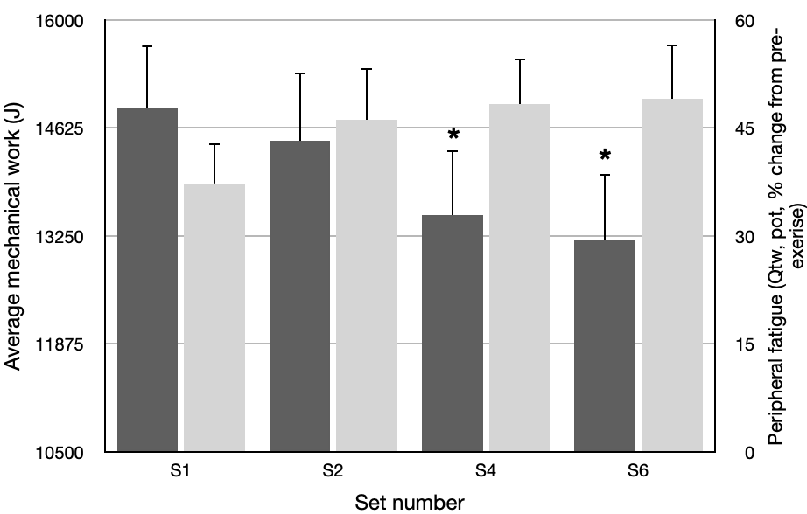

DISCUSSION

This study examined the kinetics of performance from 1 to 30 repeated sprints and its interaction with the development of both locomotor muscle and central fatigue. Our results confirm that pacing occurs during all-out sprints despite strong verbal encouragements, and that the selected pacing strategy depends on the task endpoint (i.e., the number of sprints to be performed). Our results also extend current knowledge by showing that mechanical output is relatively rapidly (within 5 sprints) down regulated to progressively reach a “minimum” level that does not incur greater development of peripheral muscle fatigue nor greater conscious sensations of discomfort during exercise despite more efforts being performed.

Pacing strategies during intermittent activities have been demonstrated, despite researchers’ instructions to participants to perform all-out efforts and verbal encouragements, through study designs altering the number (7) and duration (27) of sprints. In these studies, participants down regulated the magnitude of the central motor drive and performance when the task was perceived as more challenging (i.e., involved more sprints than expected or longer sprints). Whether this strategy is conscious or subconscious is extremely difficult to ascertain from such research designs, and the two schools of thought coexist in the current literature (11,18). Whatever the case, the present data confirmed that pacing occurs in anticipation of exercise since the first sprint performance and associated muscle recruitment were lower when participants expected to perform 30 vs 5 sprints (Figure 1). It has been proposed that humans, like all other animals, are endowed with regulatory capabilities that evolved through the necessity of protection against environmental stressors (25). In this paradigm of anticipatory regulation, it is postulated that the brain calculates the anticipated duration of the exercise that can be safely sustained with “maximal” voluntary effort without causing harmful physical consequences or projecting sensations of system failure, so that the organism is able to complete its objective within its physiological capacity (11,18,23). In the present study, an “excessive” power output developed in the first sprint during S4 and S6 would probably have caused too much fatigue and overwhelming negative cues early in the trial and performance would have been hampered prematurely. This confirms that cognitive and motivational factors contribute to regulate performance, in addition to metabolic reserve and energy turnover, during efforts as short as a few seconds (7).

This session-specific kinetics of performance and muscle recruitment carried over the first set, as both EMG activity and mechanical work were lower in the longest vs the shortest protocols (Figure 2). The expectation of performing 20 to 30 sprints altered the mechanical output during the first 5 sprints. As demonstrated before (7), when participants expect to perform more efforts, they may adopt a strategy that is more economical, and the work rate is adjusted to the exercise end point. Interestingly, however, we could not replicate exactly the findings of Billaut and colleagues where participants adopted a different pacing strategy between a trial with 5 sprints and a trial with 10 sprints, as motor output in the first set for S1 and S2 was not statistically different. This apparent discrepancy may be due to the presence of a 120-s recovery period between sets in the present study, whereas participants in the former study had to perform 10 consecutive sprints interspersed with 24 s. This aligns with the current opinion that the characteristics of the task may significantly alter the expectations of effort and fatigue, at least strongly enough to alter performance kinetics (11,18,23). In fact, the number of sprints, the duration of every sprint as well as the recovery duration influence metabolic disturbances and the development of muscle fatigue during intermittent activities (6,14).

In our study, signs of pacing were only apparent from S4. Not only did participants display an early lower motor output in S4 and S6 compared to shorter sessions, but another striking finding was that both muscle recruitment and performance tended to reach a nadir in set 3 (i.e., sprints 11 to 15) and remained at a seemingly constant level until the end of the exercise. Such a plateau in performance has been observed on several occasions during repeated-sprint protocols (6,14), but also in other exercise physiology settings where participants can maintain performance for a relatively long time during endurance exercise (e.g., critical power (24,26)) or isolated dynamic contractions (e.g., intensity/duration relationship (20)). Collectively, these observations may be interpreted as proof that the system is exercising at a sustainable level of intensity after the initial adjustments made at the beginning of the task. In fact, it may be argued that the performance kinetics during repeated-sprint protocols resembles a hyperbolic relationship with a sharp decline in power occurring at the beginning of the task and the remaining power plateau resembling the asymptote known as critical power in endurance exercise (24,26). Whether a similar concept of sustainable metabolic rate or power can be applied to repeated sprints, and how it compares to that measured during endurance tasks, is certainly very intriguing and requires more investigation.

A period of lag time has been identified at the onset of exercise, during which afferent feedback is yet to be fully integrated by the conscious brain (11,25). As participants repeated the first few sprints, the severity of these negative sensory cues bombarding the brain reached such intensity as to trigger a conscious aware attempt/behaviour to regulate pace. The rate of perceived exhaustion reached 17.1 after the first set, which is considered very high, and a common finding in repeated-sprint protocols (7,8,15,16). This is related to the metabolic disturbances and rapid development of fatigue within the active skeletal muscles. After that initial sharp increase, RPE scores increased a little more to reach “maximal” values of 19.2 in all the remaining sets without changing from S2 to S6, indicating maximal sense of conscious effort. In concomitance with this conscious level of awareness, we measured a significant decline in Q_{tw,pot} from rest after the first set, and others have even reported declines in quadriceps twitch after only 1 to 4 repetitions (15,16). But more importantly, the decline in Q_{tw,pot} remained relatively constant from the first to the sixth set of sprints (Figure 3), which depicts a constant threshold of locomotor muscle fatigue despite more work accumulating with every subsequent sprint. In other words, performing work at that intensity did not induce more muscle fatigue. Furthermore, Figure 3 highlights that the average mechanical work performed per set (or per sprint) was reduced as sets were added to the session, probably to account for the additional work done in every additional sprint. The regulation of performance based on the development of muscle fatigue during repeated sprints was first reported in the literature by using a hypoxia paradigm (8). Authors hypothesised that the brain could regulate motor output in every sprint in order to not surpass an individual threshold of muscle fatigue, which was found to be similar in normoxia and hypoxia, despite greater work done in normoxia. These data were later confirmed using a pre-fatigue paradigm (16) and by manipulating the number of sprints to perform (15). Interpreted collectively, these data suggests that it may take a few sprint repetitions for afferent feedback to set in fully and adjust the pace, after which there does not seem to be any change in the pattern of activation. We postulate that the optimal pacing strategy is fully in place within 4 to 5 sprints.

These results suggest that the kinetics of performance during repeated sprints is controlled in anticipation of the task and continuously during the task with every additional repetition adding critical information to the conscious mind about muscle metabolic state and associated overwhelming sensations to achieve the best possible outcome.

ACKNOWLEDGEMENTS

No source funding was used in this project.

REFERENCES

1. Amann M, Dempsey J a. Locomotor muscle fatigue modifies central motor drive in healthy humans and imposes a limitation to exercise performance. The Journal of Physiology 586(1): 161–73, 2008.
2. Amann M, Venturelli M, Ives SJ, McDaniel J, Layec G, Rossman MJ, et al. Peripheral fatigue limits endurance exercise via a sensory feedback-mediated reduction in spinal motoneuronal output. Journal of applied physiology 115(3): 355–64, 2013.
3. Ansley L, Robson PJ, Gibson ASC, Noakes TD. Anticipatory Pacing Strategies during Supramaximal Exercise Lasting Longer than 30 s. Medicine Sci Sports Exerc 36(2): 309–14, 2004.
4. Aughey RJ. Australian football player work rate: evidence of fatigue and pacing? International journal of sports physiology and performance 5(3): 394–405, 2010.
5. Barratt PR, Korff T, Elmer SJ, Martin JC. Effect of crank length on joint-specific power during maximal cycling. Medicine and science in sports and exercise 43(9): 1689–97, 2011.
6. Billaut F, Bishop D. Muscle fatigue in males and females during multiple-sprint exercise. Sports medicine (Auckland, NZ) 39(4): 257–78, 2009.
7. Billaut F, Bishop DJ, Schaerz S, Noakes TD. Influence of knowledge of sprint number on pacing during repeated-sprint exercise. Medicine and science in sports and exercise 43(4): 665–72, 2011.
8. Billaut F, Kerris JP, Rodriguez RF, Martin DT, Gore CJ, Bishop DJ. Interaction of central and peripheral factors during repeated sprints at different levels of arterial O2 saturation. PloS one 8(10): e77297, 2013.
9. Bradley PS, Noakes TD. Match running performance fluctuations in elite soccer: Indicative of fatigue, pacing or situational influences? J Sport Sci 31(15): 1627–38, 2013.
10. Cohen J. Statistical Power Analysis for the Behavioral Sciences (2nd ed.). 2nd ed. Hillsdale, NJ: Lawrence Erlbaum Associates, 1988.
11. Edwards AM, Polman RCJ. Pacing and Awareness: Brain Regulation of Physical Activity. Sports medicine (Auckland, NZ) 43(11): 1057–64, 2013.
12. Froyd C, Millet GY, Noakes TD. The development of peripheral fatigue and short-term recovery during self-paced high-intensity exercise. The Journal of Physiology 591(5): 1339–46, 2013.
13. Girard O, Lattier G, Maffiuletti N a, Micallef JP, Millet GP. Neuromuscular fatigue during a prolonged intermittent exercise: Application to tennis. Journal of electromyography and kinesiology : official journal of the International Society of Electrophysiological Kinesiology 18(6): 1038–46, 2008.
14. Glaister M. Multiple-sprint work: methodological, physiological, and experimental issues. Int J Sport Physiol 3(1): 107–12, 2008.
15. Hureau TJ, Ducrocq GP, Blain GM. Peripheral and Central Fatigue Development during All-Out Repeated Cycling Sprints. Medicine Sci Sports Exerc 48(3): 391–401, 2016.
16. Hureau TJ, Olivier N, Millet GY, Meste O, Blain GM. Exercise performance is regulated during repeated sprints to limit the development of peripheral fatigue beyond a critical threshold. Exp Physiol 99(7): 951–63, 2014.
17. Kent-Braun JA. Central and peripheral contributions to muscle fatigue in humans during sustained maximal effort. European journal of applied physiology 80: 57–63, 1999.
18. Marino FE. If only I were paramecium too! A case for the complex, intelligent system of anticipatory regulation in fatigue. Fatigue: Biomedicine, Health & Behavior 2(4): 185–201, 2014.
19. Micklewright D, Papadopoulou E, Swart J, Noakes T. Previous experience influences pacing during 20 km time trial cycling. Brit J Sport Med 44(13): 952, 2010.
20. Monod H, Scherrer J. The work capacity of a synergic muscular group. Ergonomics 38(3): 329–38, 1965.
21. Navalta JW, Stone WJ, Lyons S. Ethical Issues Relating to Scientific Discovery in Exercise Science. International Journal of Exercise Science 12(1): 1–8, 2019.
22. Noakes TD. Time to move beyond a brainless exercise physiology: the evidence for complex regulation of human exercise performance. 35(January): 23–35, 2011.
23. Noakes TD. Fatigue is a brain-derived emotion that regulates the exercise behavior to ensure the protection of whole body homeostasis. 3(April): 1–13, 2012.
24. Poole DC, Burnley M, Vanhatalo A, Rossiter HB, Jones AM. Critical power: an important fatigue threshold in exercise physiology. Medicine Sci Sports Exerc 48(11): 2320–34, 2016.
25. Ulmer HV. Concept of an extracellular regulation of muscular metabolic rate during heavy exercise in humans by psychophysiological feedback. Experientia 52(5): 416–20, 1996.
26. Vanhatalo A, Jones AM, Burnley M. Application of critical power in sport. International journal of sports physiology and performance 6(1): 128–36, 2011.
27. Wittekind AL, Micklewright D, Beneke R. Teleoanticipation in all-out short-duration cycling. British journal of sports medicine 45(2): 114–9, 2011.

