Appendix 2. Results of the confirmatory factor analysis of the ARSS for the total sample and subsamples.
 | Model | χ² | df | GFI | CFI | RMSEA | SRMR
Recovery Dimension
Total sample (N = 385) | First-order model | 304.77 | 84 | .91 | .92 | .08 | .06
 | Hierarchical model | 335.53 | 100 | .90 | .92 | .08 | .06
 | Bifactor model | 194.37 | 75 | .94 | .96 | .06 | .04
 | Final model | 289.87 | 83 | .92 | .93 | .08 | .06
Female sample (n = 213) | Final model | 172.37 | 83 | .91 | .95 | .07 | .07
Male sample (n = 170) | Final model | 209.16 | 83 | .87 | .88 | .09 | .07
Team sports athletes’ sample (n = 188) | Final model | 216.17 | 83 | .88 | .90 | .09 | .06
Individual sports athletes’ sample (n = 195) | Final model | 191.53 | 83 | .89 | .93 | .08 | .07
Stress Dimension
Total sample (n = 385) | First-order model | 359.81 | 98 | .89 | .92 | .08 | .06
 | Hierarchical model | 502.81 | 100 | .86 | .87 | .10 | .10
 | Bifactor model | - | - | - | - | - | -
 | Final model | 29.51 | 95 | .92 | .94 | .07 | .06
Female sample (n = 213) | Final model | 251.66 | 95 | .87 | .92 | .09 | .07
Male sample (n = 170) | Final model | 168.08 | 95 | .90 | .94 | .07 | .06
Team sports athletes’ sample (n = 188) | Final model | 198.35 | 95 | .89 | .93 | .08 | .06
Individual sports athletes’ sample (n = 195) | Final model | 216.16 | 95 | .88 | .93 | .08 | .07
Note. ARSS = Acute Recovery and Stress Scale, GFI = goodness-of-fit index, CFI = Comparative Fit Index, RMSEA = Root Mean Square Error of Approximation, SRMR = Standardized Root Mean Square Residual, BIC = Bayesian Information Criteria

Note: Replication of the analysis by Kolling et al. (2020)

We applied CFA, according to the steps presented by Kölling et al. (2020) (Figure 1).¹⁹ The results of the CFA are presented in Table 2. For the Recovery dimension, satisfactory results were obtained for all the three models; therefore, the final model was retained. The bifactor model did not converge for the stress dimension, and the final model was retained. For both final models of Recovery and Stress dimensions, all goodness-of-fit statistics except for RMSEA reached the cut-off values as described in the study by Kolling et al. (2020)¹⁹ (GFI ≥ .90, CFI ≈ .95, RMSEA ≤ .05, SRMR ≤ .08).
a.
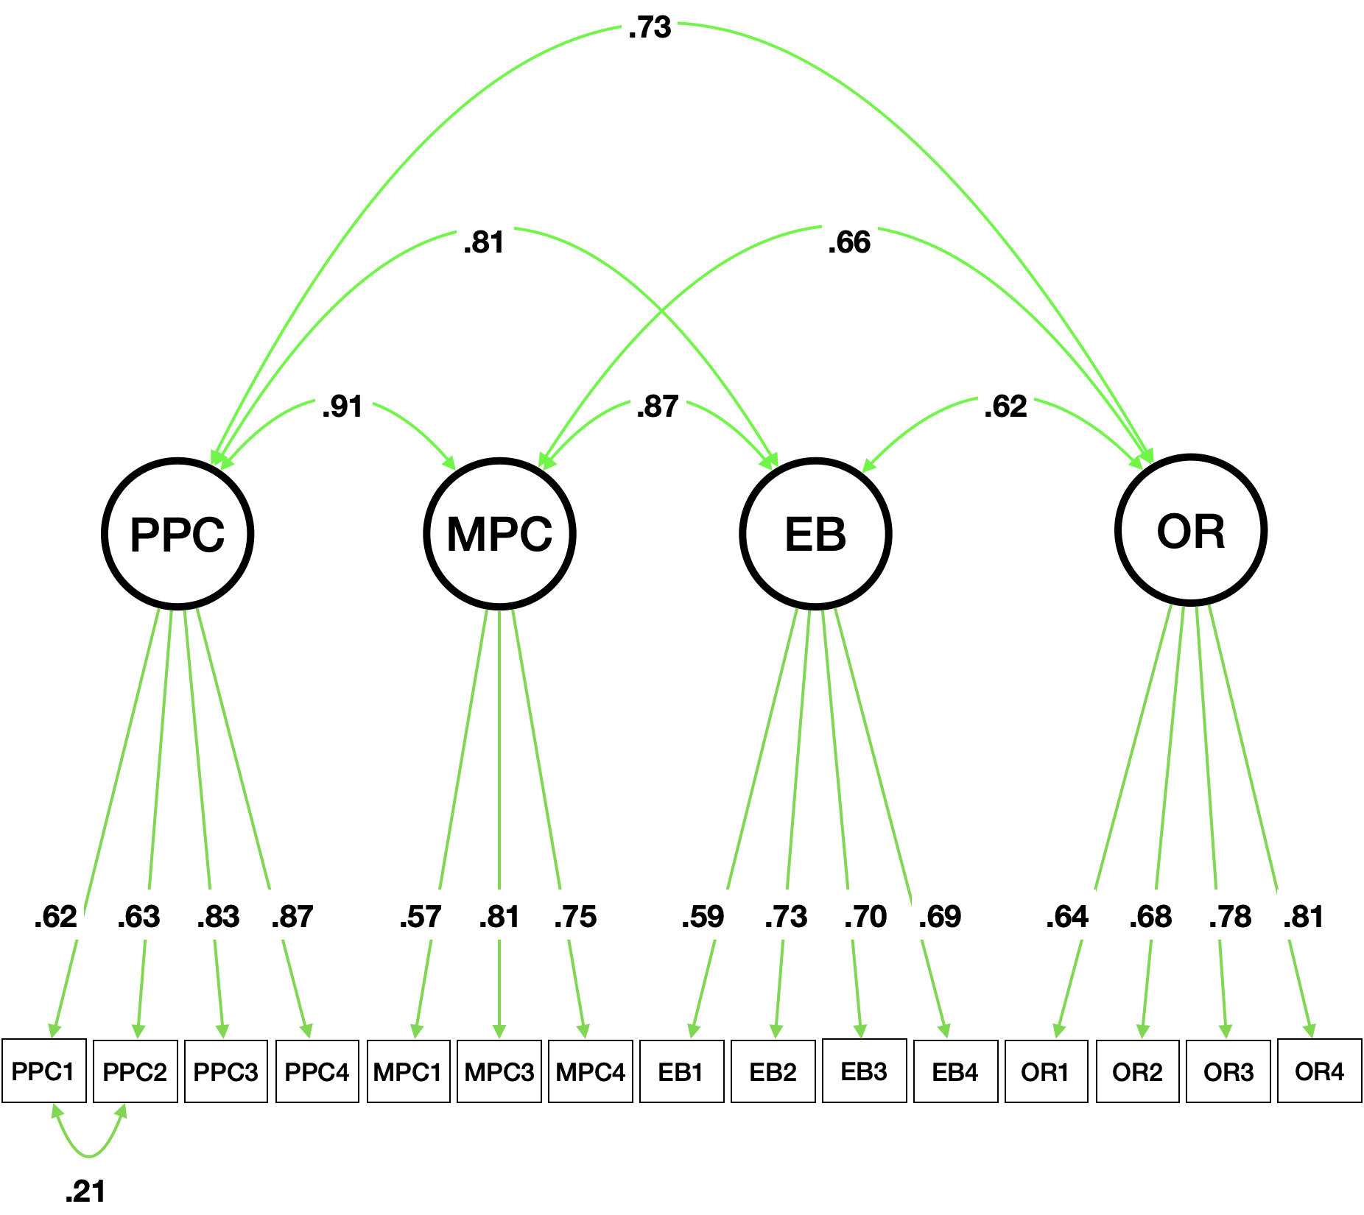
B
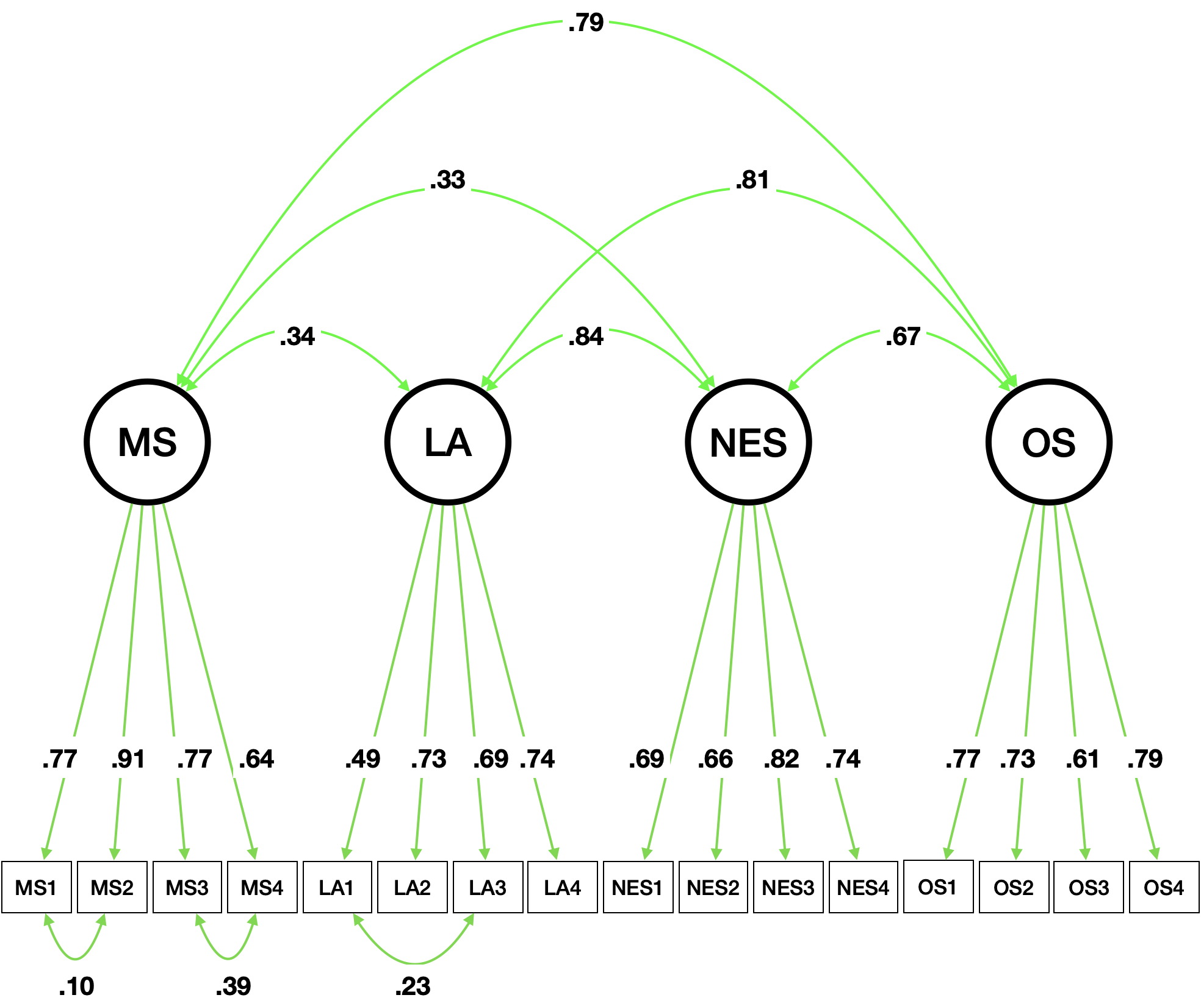
Figure 1. Final measurement models for the Recovery dimension (a) and the Stress dimension (b) of the ARSS as developed by CFA. Note: ARSS = Acute Recovery and Stress Scale; PPC = Physical Performance Capability; MPC = Mental Performance Capability; EB = Emotional Balance; OR = Overall Recovery; MS = Muscular Stress; LA = Lack of Activation; NES = Negative Emotional State; OS = Overall Stress.

