Systematic review and meta-analysis
Title: The Bitter Taste Of COI (ffee): A Systematic Review and Meta-Analysis On CYP1A2 Genotypes, Timing, And Dose Of Caffeine On Exercise Performance
Gabriel Barreto¹, Gabriel P. Esteves¹, Felipe Marticorena¹, Tamires N. Oliveira¹, Jozo Grgic², Bryan Saunders^{1, 3}
1 – Applied Physiology and Nutrition Research Group, School of Physical Education and Sport; Rheumatology Division; Faculty of Medicine FMUSP, University of São Paulo, São Paulo, Brazil.
2 – Institute for Health and Sport, Victoria University, Melbourne, VIC, Australia
3 – Institute of Orthopaedics and Traumatology, Faculty of Medicine FMUSP, University of São Paulo, Brazil.

Please cite as: Barreto et al. (2023). The Bitter Taste Of COI (ffee): A Systematic Review and Meta-Analysis On CYP1A2 Genotypes, Timing, And Dose Of Caffeine On Exercise Performance. SportRχiv. Doi:

Corresponding Author: Bryan Saunders
Email: drbryansaunders@outlook.com
Correspondence:
Applied Physiology & Nutrition Research Group, Rheumatology Division, Faculty of Medicine FMUSP
Av. Dr. Arnaldo, 455 - Cerqueira César - CEP: 01246903 - University of São Paulo,
São Paulo, SP, Brazil. Phone: +55 11 3061-8789

NOTE: This preprint reports new research that has not been certified by peer review and should not be used to guide clinical practice.

Abstract
Introduction: The CYP1A2 -164 A>C single nucleotide polymorphism (SNP) has been identified as a possible factor influencing the exercise responses to caffeine.
Methods: Six databases were searched for studies determining the effect of caffeine (except mouth rinsing) on exercise between CYP1A2 genotypes. Three-level meta-analyses were performed using standardized mean differences (SMD; Hedge’s g) to determine the effect of caffeine on exercise outcomes within and between CYP1A2 genotypes (AA, AC, CC). Meta-regressions were performed for dose, timing, and for the presence of conflict of interests (COI).
Results: Thirteen studies, totalling 119 outcomes and 440 participants were included (233 AA, 175 AC, 34 CC). Caffeine improved performance for AAs (SMD=0.30, 95%CI: 0.21; 0.39, p<.0001) and ACs (SMD=0.16, 95%CI: 0.06; 0.25, p=0.022), but was ergolytic for CCs (SMD=-0.22, 95%CI: -0.44; -0.01, p<.0001). Dose affected only CCs, with greater doses generating larger responses (CC*dose: +0.19/1 mg/kg BM, 95%CI: 0.04; 0.33, p = 0.01). Timing influenced only CCs, with larger SMDs with later onset of exercise after supplementation (CC*timing: +0.01/minute, 95%CI: 0.00; 0.02, p = 0.02). COI only affected CCs (CC*COI: -0.57, 95%CI: -1.02; -0.12, p=0.01), and after excluding studies with COI, no influence of CYP1A2 genotype was seen (all p≥0.19).
Conclusion: Caffeine improved performance for AAs and ACs, worsening performance for CCs. Dose and timing moderated the efficacy of caffeine for CCs alone. Caution is advised since studies with COI appear to heavily influence these results.

Key points
- Caffeine may differently affect exercise performance according to an individual’s CYP1A2 genotype.
- Dose and timing seem to moderate these differences, particularly for slow caffeine metabolisers.
- Conflict of interest has an influence on the results of studies in the area meaning caution is advised with these results.

- Introduction
Caffeine ingestion is ergogenic for sport and exercise performance across a wide array of modalities and intensities. A large number of meta-analyses showed positive effects for nearly all exercise modalities [1], with effect sizes varying from very small (standardized mean differences, SMD = 0.16, 95% CI: = 0.06; 0.26), for outcomes such as muscular strength [2], to moderate effects (SMD = 0.68, 95% CI: 0.53; 0.84) for endurance exercise [3]. Caffeine’s ergogenic effects are thought to be due to its effects on the central nervous system (CNS). Specifically, due to their similar molecular structure, caffeine binds to adenosine receptors, with specific emphasis on the A2A subtype [4]. After binding to these receptors, caffeine reduces the perception of pain and fatigue and increases excitability (volition) [5, 6]. Despite caffeine’s effectiveness as an ergogenic supplement, unexplained sources of variability in the acute exercise responses to caffeine are apparent, as not all individuals respond positively to caffeine [7, 8]. Hypotheses have been formulated to explain the factors for such variability, some relating to study methodology and others to physiology. For instance, inadequate dietary controls [9], placebo effects [10], and habitual caffeine consumption [11] have all been touted as possible factors that may influence the ergogenic effects of caffeine. In recent years, the influence of genetics on these responses has received increasing attention [12-14].
A single nucleotide polymorphism (SNP) on the gene responsible for expressing the cytochrome p450 1A2 enzyme (CYP1A2) has been identified as one of the possible factors that may influence the exercise response to caffeine ingestion. In humans, this enzyme is responsible for metabolizing ~95% of all ingested caffeine into its more excretable metabolites, namely, paraxanthine, theophylline, and theobromine [15]. An exchange from an A base to a C base in the first intron of the gene (CYP1A2 -164 A>C) has been shown to negatively impact the expression of the enzyme, leading to reduced caffeine metabolization rates, generating three allele combinations, namely AAs (“fast metabolizers”), ACs (“intermediate metabolizers”) and CCs (“slow metabolizers”) [16]. Faster metabolization of caffeine into paraxanthine, which has a higher affinity to adenosine receptors, could lead to a faster and more intense response to supplementation [4]. Several studies presented evidence that shows a greater performance benefit of caffeine for fast metabolizers (i.e., AA homozygous) in comparison to slow metabolizers (i.e., C-allele carriers) [17-20]. However, the findings in the literature on this topic are contrasting as differences between genotypes were not apparent in several other studies [21-27], while some even showed an advantage for C-allele carriers compared to AA homozygous individuals [28, 29]. Two published articles (stemming from the same project with the same participants) showed a negative effect of caffeine which was exclusive to CC homozygotes [18, 19]. Typically, studies in this area group AC and CC carriers together (“ACCC”), mainly due to the low frequency of CC carriers in the population (around 10% [16]). In these group of studies, however, specific analysis of a CC homozygote group was possible due to their large sample size (~100 individuals). This project, alongside one more study [22], are the only published data to date that had sufficient sample sizes to do this. The remaining studies presented ACCC groups, which may have masked the effects of genetic differences since responses may also differ between these two genotypes.
Key differences between studies, such as supplementation dose and the time between supplementation and exercise, may influence the effects of genotype on the effectiveness of caffeine. Dose, for instance, has an influence on enzyme kinetics, since the greater the concentration of a substrate, the higher the metabolization rates (REFERENCE). However, this occurs only up until the point of enzyme saturation, with metabolization rates reaching a plateau. Since both metabolization rates and enzyme saturation are influenced by enzyme availability, there is likely an interaction between CYP1A2 genotypes and caffeine dosage [12]. Also, considering the differences in metabolization rates between genotypes, it is conceivable that slow metabolizers will, over time, reach similar levels of circulating caffeine and paraxanthine, resulting in comparable effects to those of fast metabolizers [for a review, see Barreto et al. [12]]. Thus, both supplement dose and timing might play an important role in the genotype modulation of caffeine’s acute effects on exercise performance and might underpin different results between studies. However, the influence of dose and timing has not been directly investigated.
The aim of this study was to: (a) systematically summarize and meta-analyse all existing evidence examining the impact of CYP1A2 -164 A>C SNP on the acute effects of caffeine on exercise performance separately for each genotype; and (b) determine the influence of caffeine timing and dose using a meta-analysis with additional meta regressions.

- Methods
  - Study eligibility
Only English-language, peer-reviewed studies including human participants were considered in this review. Inclusion criteria were defined according to the PICOS process (population, intervention, comparison group, outcomes, and study design). Specifically, the following PICOS criteria were utilized:
- Population – healthy males and females of all ages and training status, from untrained individuals to professional athletes.
- Intervention – acute caffeine supplementation in any dose and form of administration (except mouth rinsing) prior to performing an exercise task.
- Comparison – placebo.
- Outcomes – exercise performance, capacity, or strength tests (e.g., total work done, mean power output, and total weight lifted) were included.
- Study design – randomized, single or double-blind, crossover or parallel group design.
The study protocol was prepared in accordance with PRISMA guidelines [30] (Figure 1 and supplementary table 1) and preregistered in Open Science Framework [https://osf.io/8rwv7].

  - Search Strategy
To identify relevant articles, an electronic literature search was conducted independently by J.G. and F.M. in six bibliographic databases (PubMed/MEDLINE, Scopus, Embase, SPORTDiscus, Web of Science, and Open Access Theses and Dissertations). Relevant search terms were used the following terms and Boolean operators: “(CYP1A2 OR genotype OR genetics OR polymorphism) AND (caffeine) AND (exercise OR sports OR strength OR endurance OR power OR physical)”. Search output was uploaded to the Rayyan app for systematic reviews [31], and following removal of duplicates, a two-stage search strategy applying the PICOS criteria was performed. In stage 1, the suitability of the title and abstract of each article was assessed. In stage 2, the full texts were retrieved and assessed against the eligibility criteria. Disagreements about the eligibility of studies were resolved through discussion. The original searches were conducted in December 2021 and updated in February 2023. The search was not limited to a specific date.

  - Data extraction
Data extraction was performed by G.P.E. and T.N. using a standardized Microsoft Excel spreadsheet. Extracted information included author names, location and year of publication, digital object identifier number (DOI), population characteristics (age, sex, genotype, and training status), supplementation protocol (dose, timing, and form of administration), exercise protocol and type (exercise capacity or performance), outcome data and conflicts of interest (COI) as reported by the authors. All extracted data are available in the supplementary file 1. To avoid duplication, only one outcome was extracted from each exercise protocol, based on a hierarchy agreed to a priori by all authors to ensure consistency of data extraction. Data were extracted according to availability, with priority given to exercise measurements over physiological measurements according to the following hierarchical profile [32]:
- Total work done
- Mean output throughout the test (i.e., mean power output, mean velocity, mean height)
- Time to completion (performance test)/time to exhaustion (capacity test)
Data from selected studies were extracted for AA, AC and CC genotypes separately, including total sample size (n), means and standard deviations (SDs). When standard error (SE) was reported instead of SDs, these were converted by multiplying the SE by the square root of the respective group sample size. When data was not available in text or tables, it was extracted from figures with the digitize package in RStudio Software (RStudio 1.4.1103, PBC, USA) [18, 33, 34]. Additional information, such as absolute and relative caffeine dose, form of consumption, exercise protocols, exercise type, and measurement units were also manually extracted. Time between the intervention and exercise tasks (i.e., supplementation timing), was also extracted. Authors typically report the supplementation timing as the time elapse between intaking the supplement, and the first test executed in a specific study. In many cases, however, participants took part in many successive tests in the same data collection day, and the specific timing for each test was seldom reported. In such cases, supplementation timing for the successive tests was estimated considering the expected duration of prior tests. Whenever data were not available either in text or in figures, a request for providing the data was sent to corresponding authors via email. Studies from which data could not be obtained were excluded from the analysis [29, 35, 36]. Due to the small number of CC homozygotes in the general population, some studies reported AC and CC individuals combined into a single group (AC/CC). In these cases, participant data separated according to respective genotype were also requested from the corresponding authors via email. In the case of studies consisting of only 1 CC individual [23, 34, 37], the data point was excluded due to the impossibility of calculating standardized mean differences (SMD). Whenever separate AC and CC data could not be obtained via email, the combined outcome (C-allele carriers) was excluded [17, 27, 33].

  - Certainty of evidence
For the assessment of certainty in evidence, the Grading of Recommendations, Assessment, Development and Evaluations (GRADE) framework [38] was utilized. Outcomes were evaluated across 5 categories: 1) risk of bias, 2) imprecision, 3) inconsistency, 4) indirectness, and 5) publication bias. Each of these categories could cause an outcome to be downgraded (-1 degree of certainty). After complete assessment, outcomes could be classified as providing high” (0 downgrades), “moderate” (1 downgrade), “low” (2 downgrades), or “very low” (3 downgrades) certainty.
Risk of bias was assessed with the Risk of Bias 2 Tool (Cochrane RoB 2) [39]. G.B. and F.M., individually and blinded to each other’s responses, manually assessed risk of bias through searching individual studies for biases arising from 5 domains: 1) the randomization process, 2) deviations from intended intervention, 3) missing outcome data, 4) measurements of the outcome, 5) selection of the reported results. Each of the domains would be graded as producing “low bias”, “some concerns” or “high risk of bias”. An item regarding the absence of familiarization with the exercise protocol was also added to domain 4, which automatically rated studies as having “high risk of bias”. Any disagreements were discussed, and a final decision was made when both evaluators agreed on the classification. Overall risk was classed as “low” if all domains were considered low risk; “some concerns” when at least one domain produced “some concerns”, and “high risk of bias” if at least one domain produced high risk or more than 3 domains were rated as ‘some concerns’ [39].
Imprecision was deemed to be present if the decision to recommend the supplement would be affected when the lower and upper bounds of the 95% confidence intervals (95% CIs) were considered as the real effect, or if outcomes were calculated from only up to 5 studies with small sample sizes. Inconsistency was determined according to heterogeneity measures (I² and tau²). If participants from the included studies differed substantially from the target population (trained individuals), then certainty was downgraded due to indirectness. Funnel plots were used to assess publication bias (further detailed below). Outcomes were upgraded in the presence of either: 1) a large magnitude of effect, 2) a dose-response gradient or 3) an indication that confounding factors would likely reduce rather than increase magnitude of the effect.

  - Statistical Analysis
Obtained means and standard deviations for each genotype (AAs, ACs and CCs) were transformed into SMDs (Hedge’s g, paired comparisons) and SEs with the esc_mean_sd function from the esc package. Since variances were expected to be homogenous between conditions, only pre (placebo condition) SDs were considered for the SMDs calculations. Three-level meta-analyses with meta-regression were then performed (rma.mv function from the metafor package) including genotype as a fixed factor, using restricted maximum-likelihood estimator (REML) for the obtention of variance estimates tau and tau-squared. Random effects estimates were adjusted with the Hartung-Knapp method. 95% CIs for these estimates were calculated with the Profile-likelihood method for three-level meta-analyses. For the overall SMD of each genotype, adjusted effects were calculated using the fitted model using the emmprep and the emmeans functions. To avoid pseudoreplication, three studies [18-20] were considered as the same study within the three-level structure (i.e., were given the same study ID code), as they reported results from a single experiment using data collected among the same participants. In one study where a repeated measures design was utilized [33], SMDs were calculated individually for each measure and then combined utilizing a correlation of 0.7 as described by Borenstein et al. [40].

To evaluate the influence of dose, timing and COI on the effects of caffeine across genotypes, different meta-regressions were performed. In all occasions, the main factor, either 1) acute dose,2) timing of ingestion, or 3) COI (computed dichotomously as either Yes/No), was input as a fixed factor in combination with genotype (interaction). Adjusted effects for each genotype under the presence or absence of COI were estimated using emmprep and emmeans, and plotted alongside their respective 95% CIs. For each meta-regression, statistics for their respective moderator’s test are reported (such as F value and p-value), alongside regression coefficients and 95% CIs.
Outlier detection was performed manually through an inspection of study CIs. A study was considered to be an outlier and excluded when its SMD’s confidence limits did not cross the confidence limits of the adjusted overall SMD for the respective genotype. Effect sizes were rated according to Sawilowsky’s [41] classification of 0.1 to < 0.2 (very small), 0.2 to < 0.5 (small), 0.5 to < 0.8 (moderate), 0.8 to <1.2 (large), 1.2 to < 2.0 (very large), and ≥ 2.0 (huge).
Potential publication bias was assessed through an evaluation of the funnel plot and, if any asymmetry was evident, specific tests were performed (Copas’ test for publication bias or Egger’s test for small-study bias). All analyses were performed with R (R Foundation for Statistical Computing, Vienna, Austria) and Rstudio software (Rstudio 1.4.1103, PBC, USA). Statistical significance was previously set at p < 0.05.

- Results
  - Search results
In the initial search across the databases, there were 1430 hits. Rayyan was used as an automation tool to detect 845 duplicates that were excluded. In stage 1, 579 studies were removed based upon the suitability of the title and abstract of each article. In stage 2, the full texts were retrieved and assessed for the eligibility criteria and 9 further reports were removed. One doctorate dissertation was excluded due to the author’s impossibility to provide the data, leaving 16 studies that were included in the analyses. A further 111 were found in the 2023 search update, but all were eliminated after title screening. Detailed search and inclusion/exclusion are described in Figure 1.
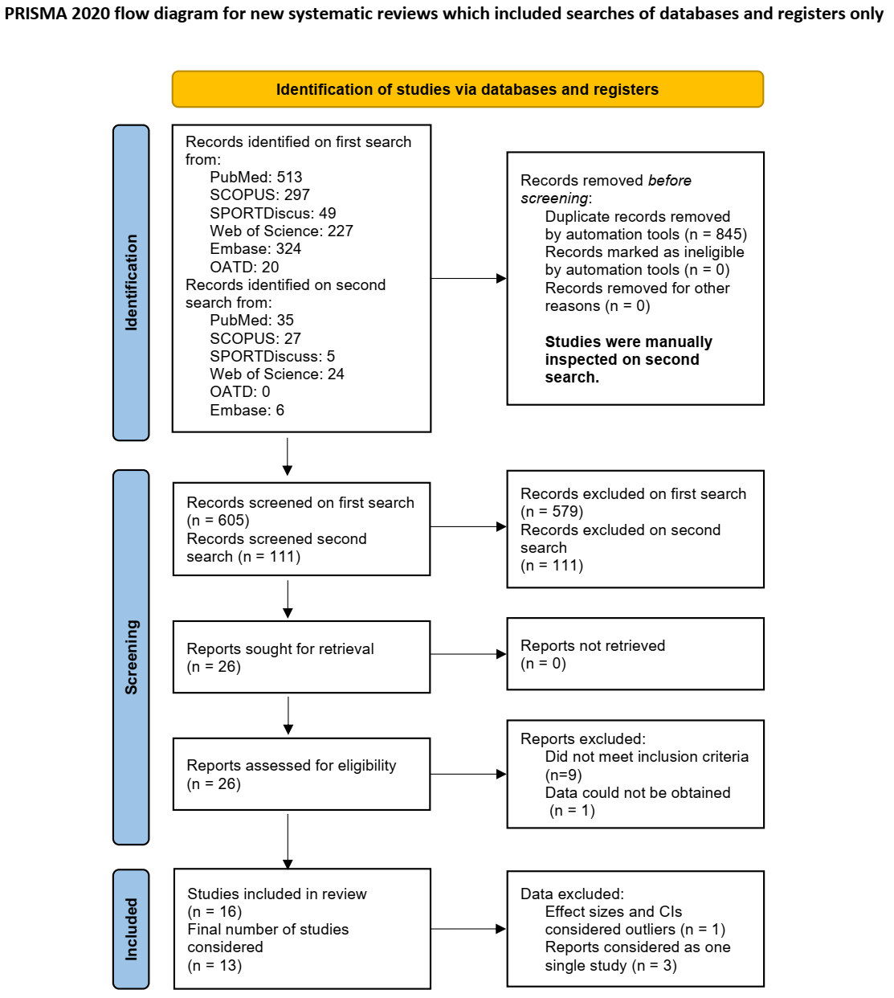
Figure 1. PRISMA 2020 flow diagram. From: Page MJ, McKenzie JE, Bossuyt PM, Boutron I, Hoffmann TC, Mulrow CD, et al. The PRISMA 2020 statement: an updated guideline for reporting systematic reviews. BMJ 2021;372:n71. doi: 10.1136/bmj.n71

  - Summary of studies
While 16 published papers were included in this meta-analysis, this represents 14 studies due to the fusion of three publications derived from the same study design and sample [18-20]. Within the 14 included studies, 123 outcomes were available, although 4 from the same study [33] were excluded due to outlying effect sizes and CIs. Therefore, a final total of 13 studies and 119 outcomes remained accounting for all genotypes (44 for AAs, 41 for ACs, and 34 for CCs). Out of 440 individuals, 233 (53.0%) were AA genotypes, 175 (39.8 %) were ACs, and 32 (7.2%) were CCs.

  - Meta-analysis
    - Overall effects of caffeine according to genotype
Caffeine had a small significant ergogenic effect on exercise performance for AA homozygotes (adjusted SMD = 0.30, 95% CI: 0.21; 0.39, coefficient p-value < 0.0001; Figure 2, Panel A), a very small significant ergogenic effect for AC homozygotes (adjusted SMD = 0.16, 95% CI: 0.06; 0.25, coefficient p-value = 0.022; Figure 2, Panel B) and a small, significant, ergolytic effect for CC homozygotes (adjusted SMD = -0.22, 95% CI: -0.44; -0.01, coefficient p-value < 0.0001; Figure 2, Panel C). No asymmetry was seen in the funnel plot (Supplementary Figure 1); therefore, publication bias was discarded. Detailed results for the GRADE assessment are described in Supplementary Table 3.

    - Caffeine dose
Meta-regressions showed a significant interaction between genotype and dose (F_{(df1,df2)} = 5.99_{(5,113)}; p < 0.0001, Table 1). In this model, there was an overall negative effect of caffeine for ACs (SMD: -0.41, 95% CI: -0.75; -0.07, p = 0.017) and CCs (SMD: -1.30, 95% CI: -1.96; -0.66, p = 0.0001) compared to AAs (Intercept = 0.46, 95% CI: 0.18, 0.73, p = 0.002). Dose affected CC homozygotes, with increased doses leading to greater performance effects (CC*dose: 0.19, 95% CI: 0.04; 0.33, p = 0.01, Figure 3); this relationship was not seen in the AC heterozygotes (AC*dose: 0.07, 95% CI: -0.01; 0.15, p = 0.1) or AA homozygotes (Intercept*dose: -0.04, 95% CI: -0.10; 0.03, p = 0.26).

    - Caffeine timing
Meta-regressions showed a significant interaction between genotype and supplement timing (Table 1) (F_{(df1,df2)} = 6.79_{(5,113),} p < 0.0001, Figure 3). No significant influence of carrying one C-allele (ACs: -0.31, 95% CI: -0.67; 0.05, p = 0.09) was found, while a significant reduction in performance was shown for carrying two C-alleles compared to AAs (CCs: -1.30, 95% CI: -1.97; -0.63, p = 0.0002). Timing of supplementation significantly affected CCs, with improved responses as the time between supplementation and exercise increases (CC*timing: 0.01, 95% CI: 0.002; 0.02, p = 0.015). Timing of supplementation was not a significant factor for AA or AC individuals (all p ≥ 0.17, see Table 1).

    - Conflict of interest
Under this model, the test of moderators was significant (F_{(df1,df2)} = 6.57_{(5,113)}; , p < 0.0001), and having either one C-allele (ACs: -0.11, 95% CI: -0.27; 0.06, p = 0.20) or two (CCs: -0.25, 95% CI: -0.56; 0.06, p = 0.12) did not modify the ergogenicity of caffeine. COI (vs. no COI, Figure 4) had no impact on ergogenicity for individuals with AA genotype (Intercept*COI: -0.05, 95% CI: -0.22; 0.12, p = 0.56), or AC genotype (AC*COI: -0.07, 95% CI: -0.32; 0.17, p = 0.53), but negatively influenced the estimate of CC genotypes (CC*COI: -0.57, 95% CI: -1.02; -0.12, p = 0.01). After the exclusion of all studies declaring COI, no effect was seen in any comparisons (all p ≥ 0.19).

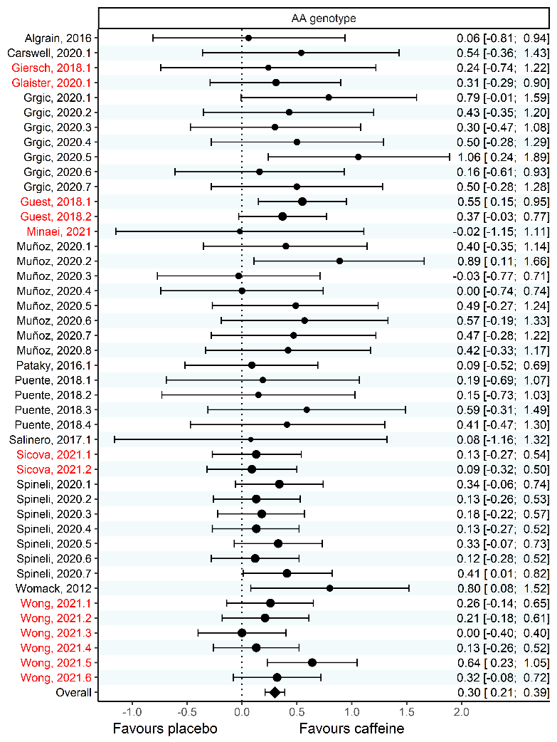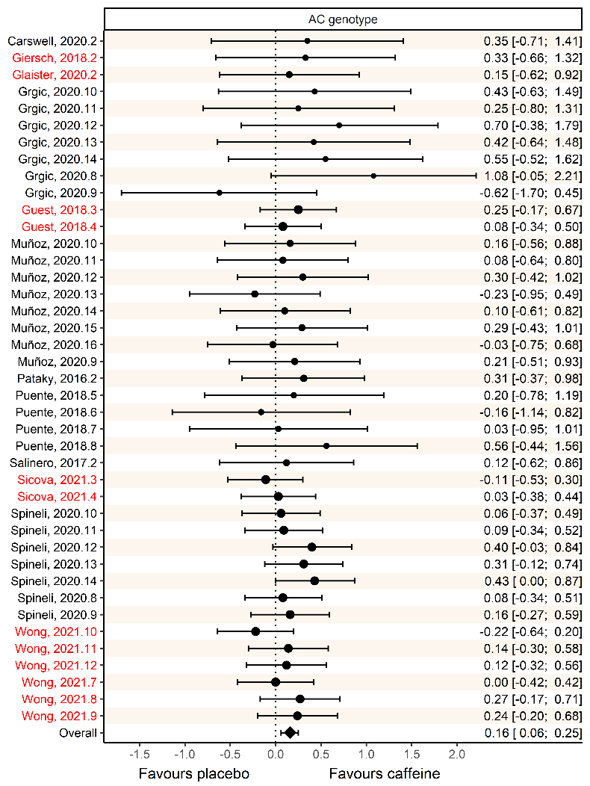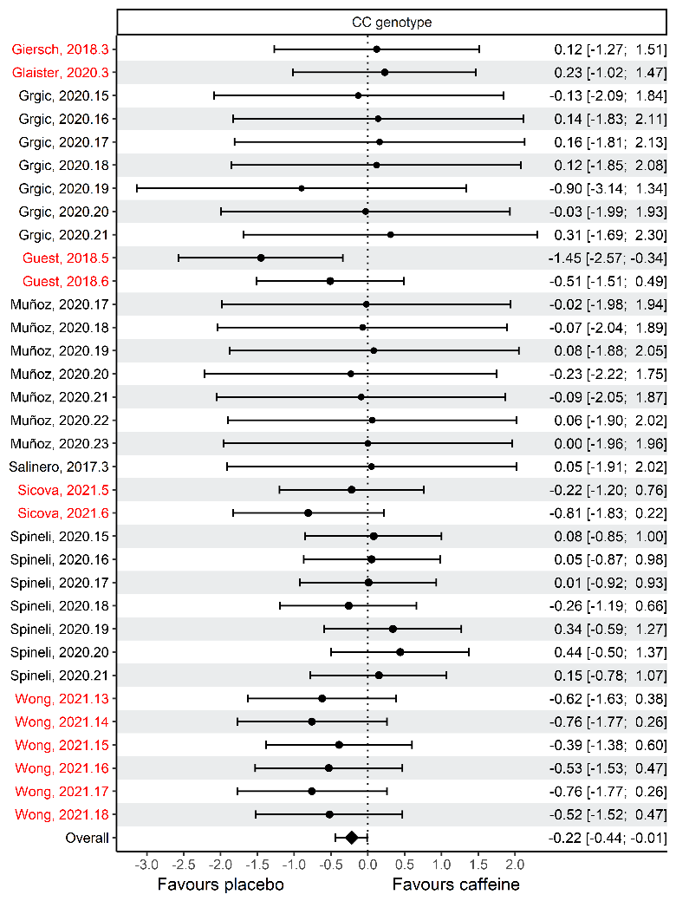
Figure 2. Forest plots of the main meta-analysis with meta-regression for genotype comparing the effects of placebo vs. caffeine on exercise performance. Outcomes are separated according to genotype, namely AA homozygous individuals (Panel A); AC heterozygous individuals (Panel B); and CC homozygous individuals (Panel C). Study names are followed by year of publication and the outcome number when more than one outcome was extracted from the same study. Dot size varies according to the weight attributed to each outcome in the model. The overall SMD represents the adjusted effect predicted by the fitted model. Studies with reported conflict of interest are highlighted in red.

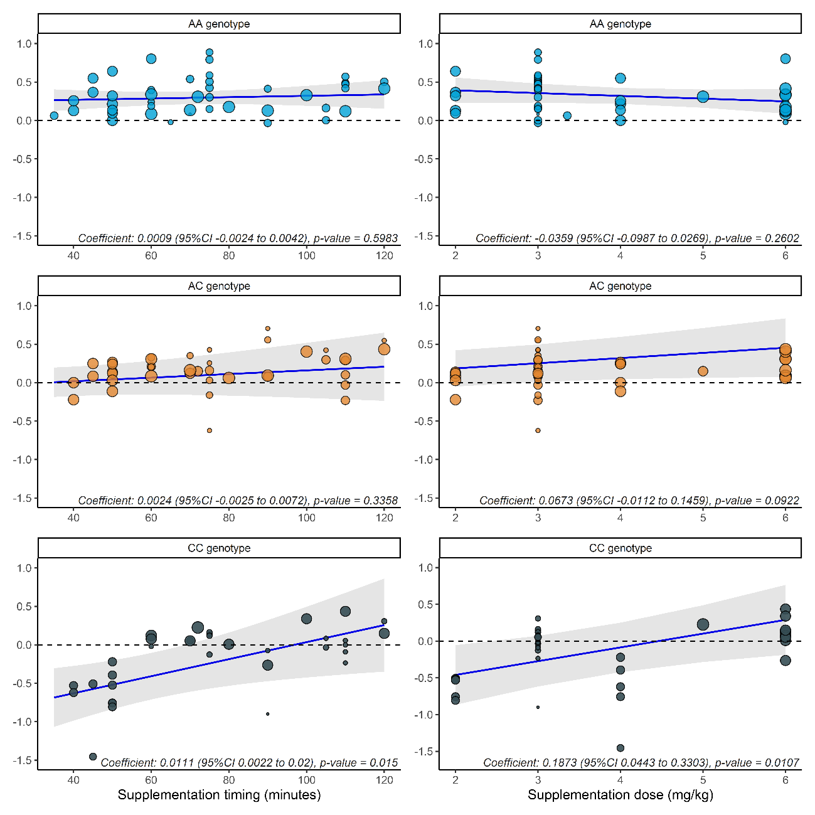
Figure 3. Left side: Scatter plots of the relationship between effect size and supplementation timing in each genotype, and their fitted linear regression line, alongside confidence interval bands (dot size varies according to weight in the meta-analysis). Right side: Scatter plots of the relationship between effect size and supplementation dose (mg/kg BM) in each genotype, and their fitted linear regression line, alongside confidence interval band (dot size varies according to weight in the meta-analysis).

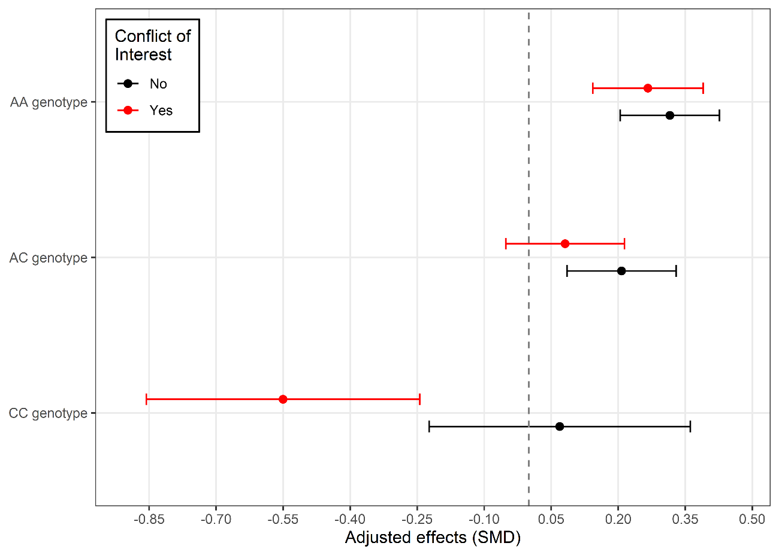
Figure 4. Estimated adjusted effects for each genotype under the presence or absence of conflict of interest alongside 95% confidence intervals.

Table 1. Meta-analytic models’ statistics and GRADE Quality Assessment.
Meta-analysis | Parameter estimate (95% CI) | p-value (estimate) | F_{df1,df2} | p-value (moderator test) | Between study variance (95% CI) | Between outcome variance (95% CI) | QE_{df} | p-value (heterogeneity test) | GRADE Quality Assessment
Initial model
(~ genotype)
Intercept (AA genotype) | 0.298 (0.206; 0.391) | <.0001 | 11.05_{2,116} | <.0001 | 0.0028 (0.0000; 0.0314) | 0.0000 (0.0000; 0.0083) | 62.91₁₁₆ | 1 | ⊕⊕⊕⊕ = high quality
AC genotype | -0.143 (-0.265; -0.02) | 0.022 |  |  |  |  |  |  | ⊕⊕⊕Ο = moderate quality
CC genotype | -0.52 (-0.747; -0.293) | <.0001 |  |  |  |  |  |  | ⊕⊕⊕Ο = moderate quality
Meta-regression 1
(~ genotype * dose)
Intercept (AA genotype) | 0.463 (0.188; 0.739) | 0.002 | 5.99_{5,113} | <.0001 | 0.0046 (0.0000; 0.0416) | 0.0000 (0.0000; 0.0078) | 54.23₁₁₃ | 1 | ⊕⊕⊕⊕ = high quality
AC genotype | -0.413 (-0.752; -0.074) | 0.017
CC genotype | -1.299 (-1.937; -0.66) | 0.0001
Dose | -0.036 (-0.099; 0.027) | 0.260
AC genotype * dose | 0.067 (-0.011; 0.146) | 0.092
CC genotype * dose | 0.187 (0.044; 0.33) | 0.010
Meta-regression 2
(~ genotype * timing)
Intercept (AA genotype) | 0.232 (-0.012; 0.477) | 0.062 | 6.79_{5,113} | < .0001 | 0.0000 (0.0000 0.0220) | 0.0000 (0.0000 0.0077) | 51.11₁₁₀ | 1 | ⊕⊕⊕Ο = moderate quality
AC genotype | -0.31 (-0.669; 0.05) | 0.090
CC genotype | -1.306 (-1.974; -0.638) | 0.0002
Timing | 0.001 (-0.002; 0.004) | 0.598
AC genotype * timing | 0.002 (-0.002; 0.007) | 0.335
CC genotype * timing | 0.011 (0.002; 0.02) | 0.015
Meta-regression 2
(~ genotype * conflict of interest)
Intercept (AA genotype) | 0.316(0.204; 0.427) | <.0001 | 6.60_{5,113} | <.0001 | 0.000 (0.000; 0.028) | 0.000 (0.000; 0.008) | 52.24₁₁₃ | 1 | ⊕⊕⊕Ο = moderate quality
AC genotype | -0.108 (-0.273; 0.0.057) | 0.197
CC genotype | -0.247 (-0.559; 0.066) | 0.121
Conflict of interest | -0.049 (-0.215; 0.117) | 0.559
AC genotype * Conflict. | -0.077 (-0.322; 0.168) | 0.535
CC genotype * Conflict | -0.570 (-1.025; -0.115) | 0.014
F_{df1,df2}: omnibus moderator test statistic; QE_{df}: residual heterogeneity test statistic. In all models, the AA genotype was chosen as the intercept (reference level), with coefficients representing the average difference between the intercept and each specific term.

    - Risk of bias
A visual representation of overall risk of bias is presented in Supplementary Figure 2. The overall risk was rated as “high” for 5 out of 16 studies, mostly due to a lack of familiarization. The remaining 9 were classified as “some concerns”. Most concerns were caused by issues in domain 1 (randomization process, 12 out of 16) and domain 5 (selection of outcomes, 13 out of 16 studies). Most of these arose from failures in proper reporting of the randomization method, and from lack of preregistration.

- Discussion
There are several major findings arising from this first systematic review with meta-analysis showing that genotype may affect the acute performance responses to caffeine. We found that caffeine ingestion before exercise has a small ergogenic effect in the AA genotype (GRADE: high certainty) and a very small ergogenic effect in the AC genotype (GRADE: moderate certainty). However, for the CC genotype, caffeine ingestion produced a small ergolytic effect (GRADE: moderate certainty). While an ergolytic effect was observed in this population, meta-regressions suggested that ingesting caffeine in larger doses (~6mg/kg, GRADE: high certainty) or increasing the time between supplementation and exercise (~100-120 minutes before exercise, GRADE: moderate certainty) may enhance performance even among individuals with the CC genotype. Still, exploratory analyses indicated that the presence of a COI influenced the findings for the CC genotype (GRADE: moderate certainty). Specifically, after excluding studies with a COI, caffeine was no longer ergolytic and both the dose and timing of ingestion were no longer significant moderators. Thus, caution is warranted when interpreting these data.
Our findings suggest that AA homozygotes likely benefit most from caffeine supplementation, while AC heterozygotes obtain a significant, albeit smaller, ergogenic effect. In contrast, the effect of caffeine for CC homozygotes was ergolytic, with a worsening in performance. As shown by previous studies, AA homozygotes may metabolize caffeine faster than C-allele carriers [16], which seems to be in line with the results shown here. We believe that the rationale behind an increased response for fast metabolizers is the faster transformation of caffeine into its higher affinity metabolites (mainly paraxanthine) [4], leading to faster and more intense effects for these individuals. However, it has been suggested that the metabolic and physiological responses to caffeine are similar between ACs and CCs [16], which justified grouping both genotypes into a single group. The low frequency of CCs in the general population (10%) makes it convenient to cluster individuals as AAs and C-allele carriers, since a large sample would be necessary to obtain a substantial amount of CC homozygotes. However, based upon our findings, the differences between ACs and CCs seem to be substantial, therefore requiring future studies to divide C-allele carriers into two separate groups.
Analyzing the effects of caffeine separately across all three groups would require a much large sample size (likely n ≥ 100), however, even studies with such large samples obtained contrasting results. For example, Guest et al. [18] and Wong et al. [19] (both derived from the same experiment) reported that CCs had an ergolytic response after consuming caffeine before endurance, power, and strength tasks. With a sample of 100 athletes from different modalities, 8 of them being CC homozygotes, it was one of the largest studies published on the topic, though the validity of some of their results has been questioned [42]. As their results suggested, heterozygotes would not benefit from caffeine, while AA homozygotes would be the only ones to experience ergogenic effects. The only publication with a comparable sample size (n = 100 adolescent athletes of soccer, volleyball, or athletics; 9 of them were CCs) [22], in contrast, showed no significant interaction between caffeine and genotype on aerobic endurance, power, or muscular endurance. Important differences between these studies may explain divergent results. Firstly, the studies by Guest et al. [18] and Wong et al. [19] had a heterogeneous sample, with individuals from different sports (e.g., powerlifters, marathonists, cyclists, boxers, swimmers, etc.), none of whom were familiarized with the exercise protocols. In contrast, Spinelli et al. [22] studied a similarly large sample of adolescent athletes, with participants being submitted to one familiarization session prior to the main trials. Familiarization sessions are usually included in experimental designs to reduce the effect of learning. This is especially important when including individuals unfamiliar with the chosen exercise protocol, since the effect of the intervention could be masked by any changes in performance due to a learning effect [43]. Timing and dosage were also different between protocols. In the three studies published from the same dataset [18-20], testing started 30 minutes after the ingestion of 2 and 4 mg/kg of caffeine. In other words, the performance of the last test began approximately 50-60 minutes after the ingestion of caffeine. In contrast, Spinelli et al. [22] waited at least 60 minutes after their participants consumed a dose of 6 mg/kg before starting the first exercise test. Given their large number, performance of the last test in the sequence (i.e., Yo-Yo test) was approximately 120 minutes following caffeine ingestion.
Indeed, our results show that the estimates of slow metabolizers are significantly affected by timing and dose, while these factors do not affect AAs or ACs. This could mean that the standard recommendation of ingesting 3-6 mg/kg BM of caffeine ~60 minutes prior to exercise [44] may not be the optimal strategy for all individuals. Specifically, meta-regressions suggest that CC individuals might benefit more when consuming caffeine earlier than their A-allele counterparts (i.e., ~100 to 120 minutes prior to exercise), and in higher doses (closer to 6 mg/kg BM). Timing between supplementation and exercise tests varied significantly between protocols. The majority of studies started the first battery of exercise ~60 minutes after supplementation [17, 22, 25, 29, 34, 37, 45], and/or included more than one exercise test [22, 24, 37, 45], increasing the waiting time up to 100~120 minutes for some outcomes. Notably, Guest et al. [18], Wong et al. [19] and Sicova et al. [20] were the only studies that administered caffeine to participants in capsules earlier than 60 minutes before exercise (between 30 to 45 minutes) and in lower to moderate doses (2 and 4 mg/kg BM), resulting in an ergolytic response with caffeine in CC homozygotes. Despite our results suggesting an effect of dose and timing on the relationship between caffeine and CYP1A2 genetics for exercise, studies specifically aimed at investigating the influence of different timings and dosages across CYP1A2 genotypes are necessary to confirm these findings.
Studies that have been partially or totally funded by private companies have a higher chance of showing results and conclusions aligned with the interests of stakeholders [46]. Corroborating this, when the dichotomous factor “COI” was included in the meta-regression interacting with genotype, the ergolytic response for the CC genotype was no longer statistically significant. A specific interaction between COI and CC individuals was seen, with studies that reported a COI showing a worse outcome for these individuals on average, while no other genotype was impacted. Six of the included studies declared COIs, five [18-21, 25] of which researchers were either employees or shareholders of genetic profiling companies, and the remaining declared one of the authors was an advisor for a supplement company [34]. Nonetheless, only 2 out of these 6 studies [18, 19] reported significant results. These two studies comprised a large number of outcomes (k = 10) and the second largest number of CC individuals (n = 8), with the total weight of all outcomes accounting for 42.6% of the total estimate, meaning it strongly influenced the results. A final exploratory analysis in which all studies with a COI were excluded showed no influence of genotype or any other factors detected by meta-regressions (Supplementary Table 2). Thus, our results suggest that studies with a COI had a strong influence on the results. Although there is no evidence to suggest that these COIs influenced the results of these studies, further studies without any perceived COIs are warranted to clarify the true impact of the CYP1A2 polymorphism related to caffeine's ergogenic effect.
This systematic review and meta-analysis has some limitations. For example, only 32 out of the 440 participants were CC homozygotes. While this sample size did not necessarily limit statistical power in some of the analyses (e.g., statistically significant ergolytic effects were found in the main analysis), future research on this population is undoubtedly required. Due to the small number of studies, it was also not possible to observe whether there is a differential effect of genotype between exercise types. In general, the literature suggests that the average effect of caffeine is similar between all exercise types [1, 47-50], although it is unclear whether this holds true for individuals of different genotypes. Thus, new studies should be performed to investigate whether caffeine affects individuals differently according to genotype in all types of sports. While a recent meta-analysis showed that habitual caffeine consumption might not dampen the effects of acute caffeine ingestion [11], we cannot provide evidence to support that this is consistent across CYP1A2 genotypes. It has been shown that high habitual consumption may increase CYP1A2 enzyme expression in AA homozygotes, but not C-allele carriers [51]. If this is the case, it could be hypothesized that fast metabolizers with high caffeine consumption might experience even greater effects than their counterparts due to even faster rises in plasma paraxanthine. Therefore, we propose more studies should be performed investigating the impact of habitual caffeine consumption on the relationship between CYP1A2 genotype and caffeine in sports. In addition, we cannot discard placebo/nocebo effects on the observed effects since placebo effects may represent as much as ~59% of the total effects of caffeine [10]. Although most of the studies assessed for treatment blinding, reporting was not done separately by genotype. In more sensitive individuals, e.g., those who feel more intense feelings of anxiety after consuming caffeine, treatment order could be more difficult to conceal. This would be the case for T-allele homozygotes for the ADORA2A 1976 C>T polymorphism [52], which seem to be more easily identified based on their negative expectations and symptoms related to caffeine [53]. Thus, reporting should be performed based on genotype in future studies, as correct supplement identification may influence the outcome of an exercise test and lead to bias in the results.

- Conclusions
The results herein suggest that the overall effects of caffeine in sports might be different between individuals of different CYP1A2 genotype. A dose-response of carrying the C-allele is expected, with AAs obtaining a small effect, followed by a very small effect for ACs, and a small negative effect for CC homozygotes. Dose and timing appear to differentially affect individuals according to genotype. Specifically, fast (AAs) and intermediate (ACs) metabolizers were unaffected by either, while slow metabolizers (CCs) were significantly affected by both. Thus, slow metabolizers may benefit from supplementation when consuming higher doses (~6mg/kg) earlier (~100-120 minutes before exercise) than moderate or fast metabolizers. However, the results are impacted by the presence of COI in some studies, which raises concerns about the interpretation of the data.

- Declarations
  - Funding
No specific funding was received for writing this review. GB (2020/12036-3; 2021/12116-0), BS (2021/06836-0), TN (2022/07327-4), GE (2020/07860-9), and FM (2021/05847-8) have been financially supported by Fundação de Amparo à Pesquisa do Estado de São Paulo.
  - Competing interests
GB, BS, TN, and FM have previously received caffeine supplements at no cost from a national supplement company (Farmácia Analítica, Rio de Janeiro, Brazil) for work unrelated to the current article. Farmácia Analítica have not had any input (financial, intellectual, or otherwise) into this review.
  - Data and Code Availability Statements
Extracted data is available as a supplementary file and analysis codes are available upon reasonable request.
  - Author contributions
GB is responsible for the conception of work. GE and JG performed database searches and study selection. Data extraction was done by FM and TN. GB and GE jointly performed data analysis. GB, BS, GE and JG were involved in writing and editing of the manuscript. All authors approved a final version of the manuscript.
  - Ethics approval, consent to participate and consent for publication
Not applicable.
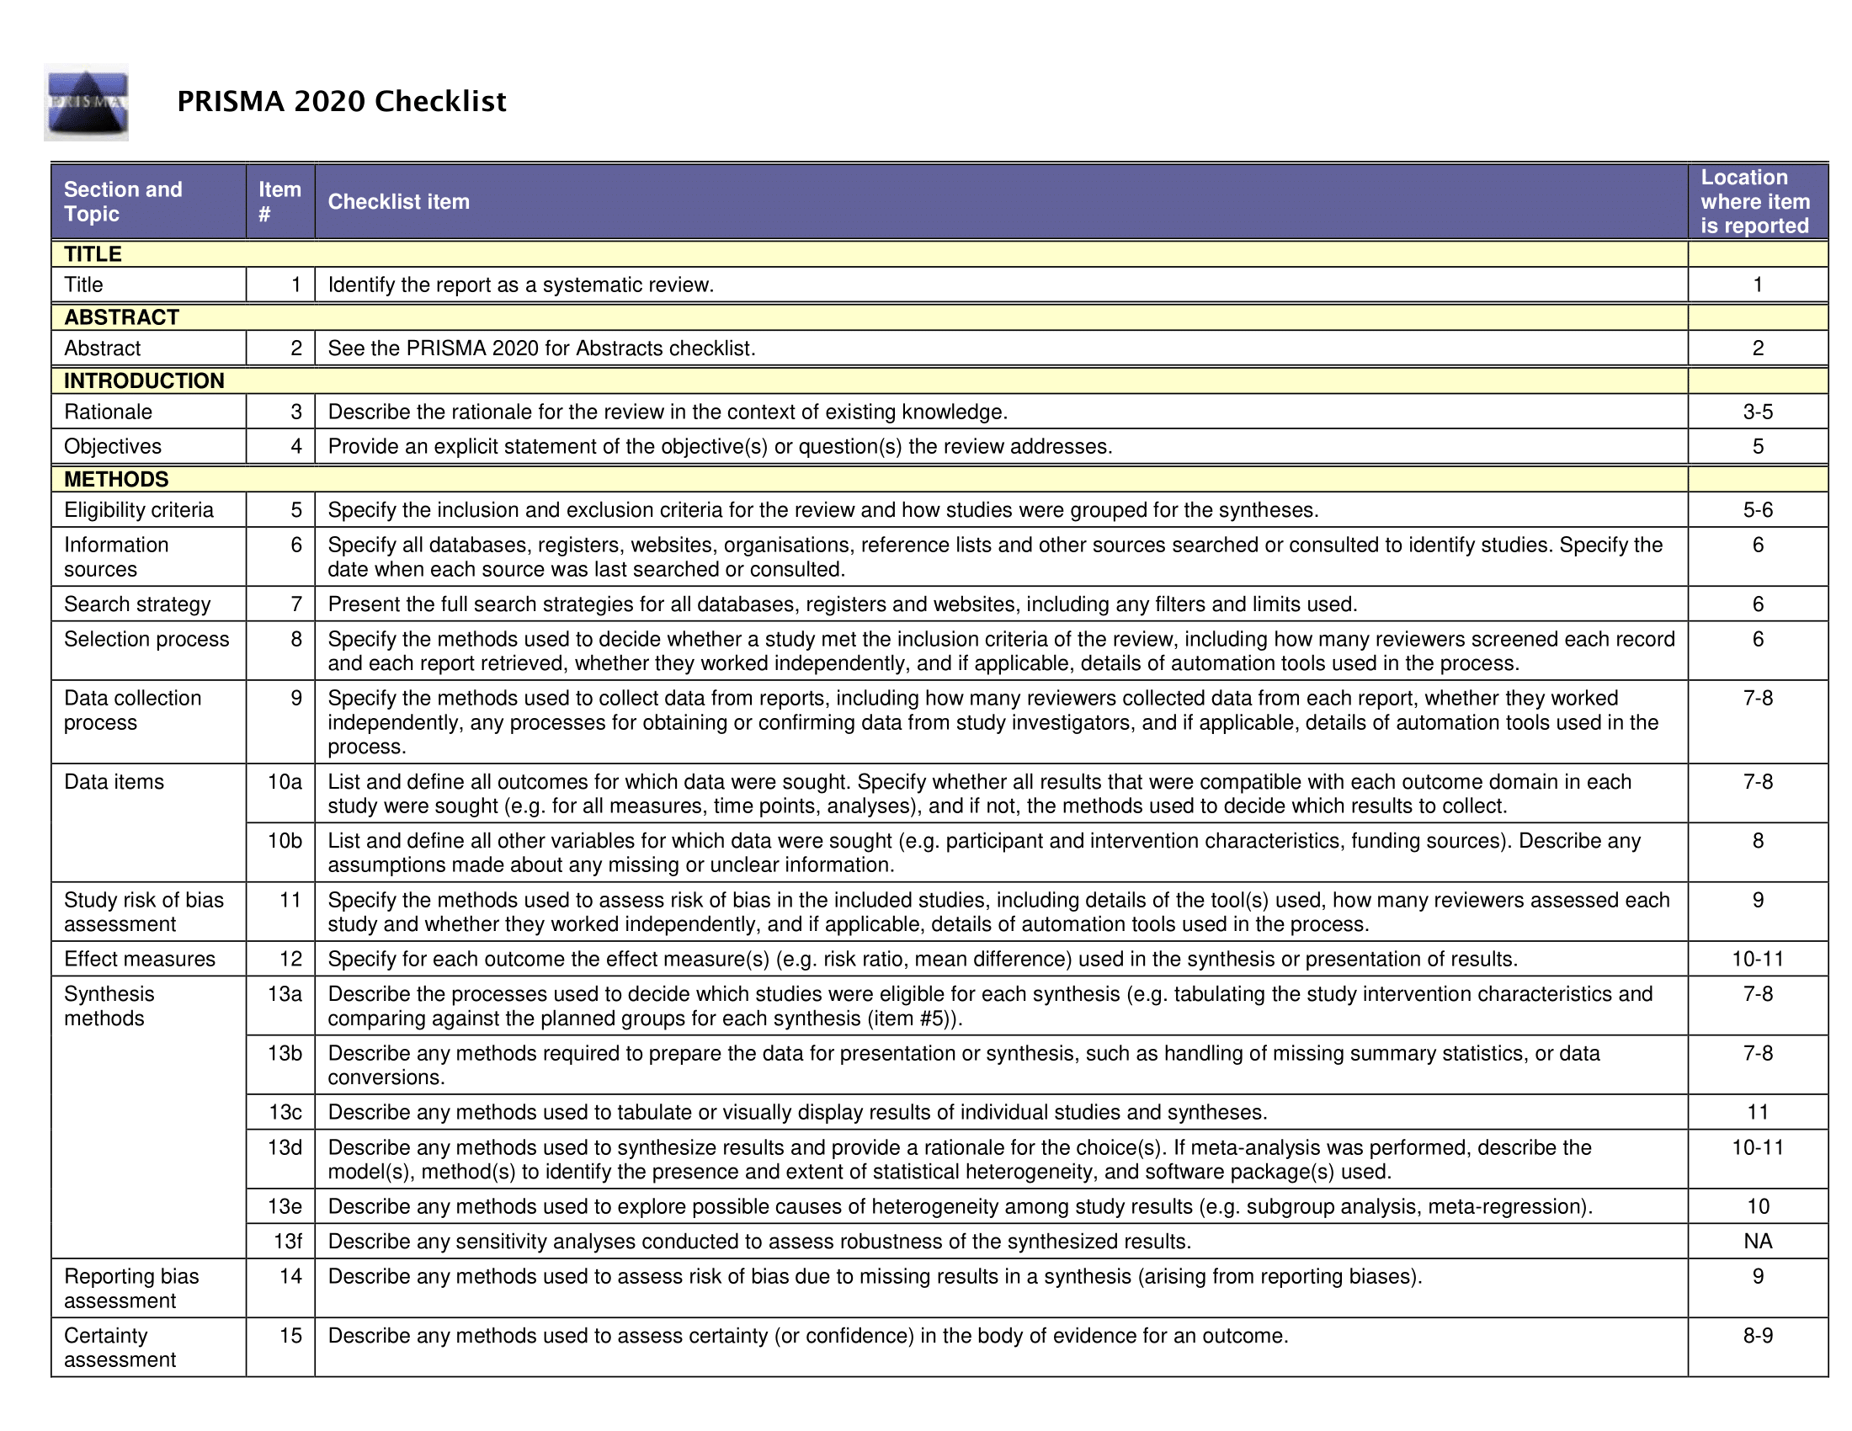
Supplementary Table 1. PRISMA 2020 Checklist
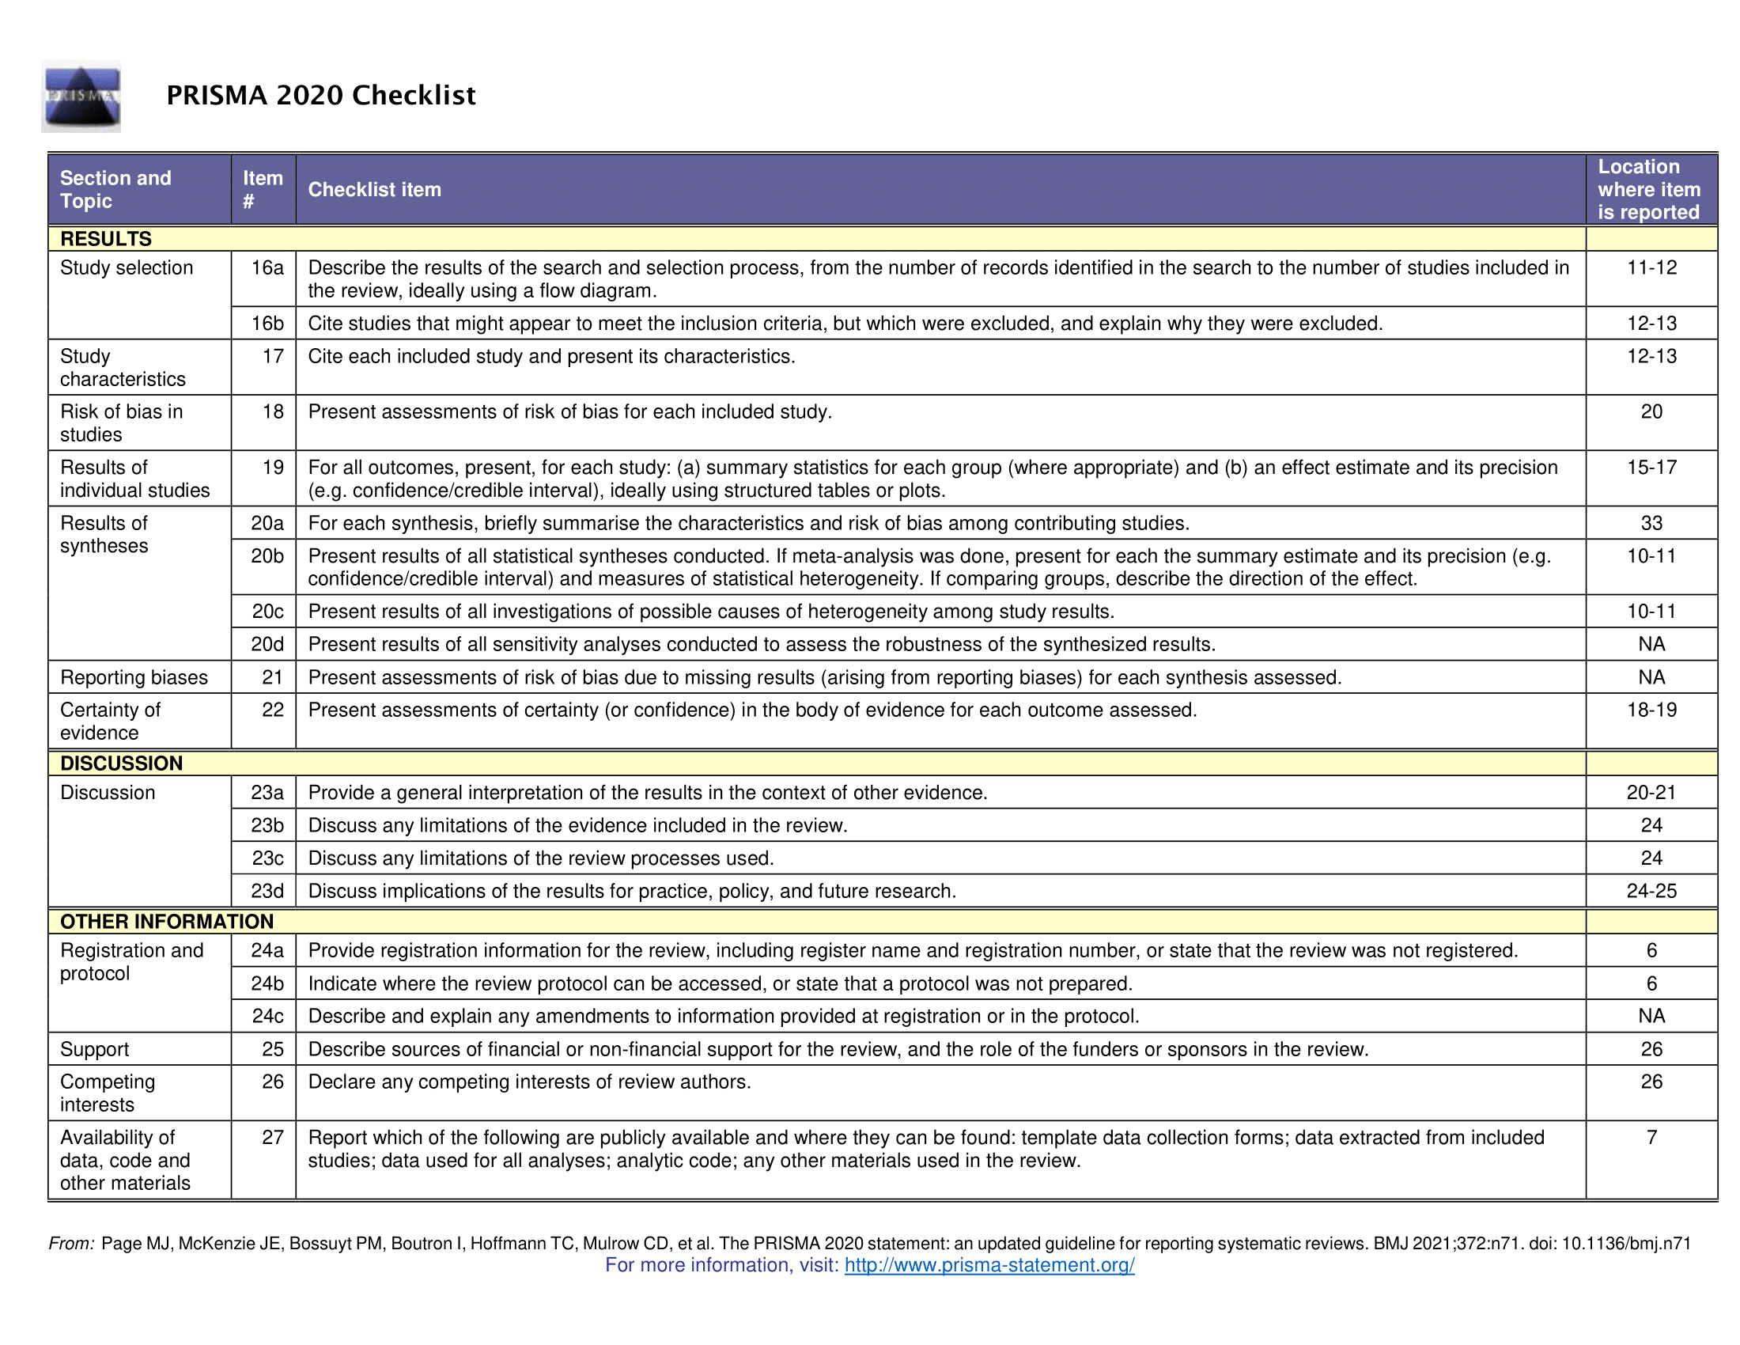

Supplementary Table 2. Meta-analytic models’ statistics after the exclusion of studies declaring any conflict of interest.
Meta-analysis | Parameter estimate (95% CI) | p-value (estimate) | F_{df1,df2} | p-value (moderator test) | Between study variance (95% CI) | Between outcome variance (95% CI) | QE_{df} | p-value (heterogeneity test)
Initial model
(~genotype)
Intercept (AA genotype) | 0.316 (0.204; 0.427) | <.0001 | 1.67_{2,79} | 0.19 | 0.0000 (0.0000; 0.0394) | 0.0000 (0.0000; 0.0125) | 31.88₇₉ | 1
AC genotype | -0.108 (-0.274; 0.058) | 0.198
CC genotype | -0.247 (-0.561; 0.068) | 0.122
Meta-regression 1
(~genotype * dose)
Intercept (AA genotype) | 0.586 (0.205; 0.966) | 0.003 | 1.16_{5,76} | 0.33 | 0.0000 (0.0000; 0.0639) | 0.0000 (0.0000; 0.0122) | 29.41₇₆ | 1
AC genotype | -0.442 (-1.004; 0.120) | 0.12
CC genotype | -0.746 (-1.909; 0.418) | 0.21
Dose | -0.056 (-0.133; 0.020) | 0.13
AC genotype * dose | 0.070 (-0.043; 0.183) | 0.22
CC genotype * dose | 0.102 (-0.122; 0.325) | 0.37
Meta-regression 2
(~genotype * timing)
Intercept (AA genotype) | 0.278 (-0.201; 0.756) | 0.25 | 0.89_{5,76} | 0.49 | 0.0000 (0.0000; 0.0447) | 0.0000 (0.0000; 0.0128) | 30.78₇₆ | 1
AC genotype | -0.331 (-1.069; 0.407) | 0.37
CC genotype | -0.495 (-1.965; 0.976) | 0.50
Timing | 0.004 (-0.005; 0.006) | 0.87
AC genotype * timing | 0.003 (-0.006; 0.011) | 0.54
CC genotype * timing | 0.003 (-0.013; 0.019) | 0.73

Supplementary Table 3. Results of Grading of Recommendations Assessment, Development and Evaluation (GRADE)
Analysis | GRADE items for downgrading quality of evidence |  |  |  |  | Downgraded evidence | GRADE items for upgrading the quality of evidence |  |  | Overall evidence*
 | Risk of bias | Inconsistency | Indirectness | Imprecision | Publication bias |  | Large effect | Dose-response | Confounding
AA genotype | Serious | Not serious | Not serious | Not serious | Not present | ⊕⊕⊕Ο | No upgrade | No upgrade | Upgrade | ⊕⊕⊕⊕ = high quality
AC genotype | Serious | Not serious | Not serious | Serious limitation | Not present | ⊕⊕ΟΟ | No upgrade | No upgrade | Upgrade | ⊕⊕⊕Ο = moderate quality
CC genotype | Serious | Not serious | Not serious | Serious limitation | Not present | ⊕⊕ΟΟ | No upgrade | No upgrade | Upgrade | ⊕⊕⊕Ο = moderate quality
Regression for dose | Serious | Not serious | Not serious | Serious limitation | Not present | ⊕⊕ΟΟ | No upgrade | Upgrade | Upgrade | ⊕⊕⊕⊕ = high quality
Regression for timing | Serious | Not serious | Not serious | Serious limitation | Not present | ⊕⊕ΟΟ | No upgrade | No upgrade | Upgrade | ⊕⊕⊕Ο = moderate quality
Regression for commercial interest | Serious | Not serious | Not serious | Serious limitation | Not present | ⊕⊕ΟΟ | No upgrade | No upgrade | Upgrade | ⊕⊕⊕Ο = moderate quality
* classification based on the GRADE Handbook as:
⊕⊕⊕⊕ = high quality
⊕⊕⊕Ο = moderate quality
⊕⊕ΟΟ = low quality
⊕ΟΟΟ = very low quality

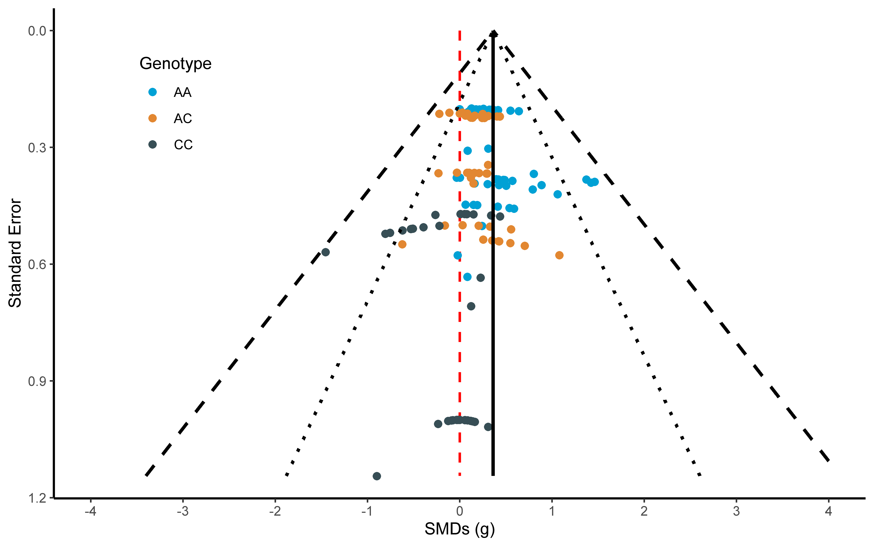
Supplementary figure 1. A funnel plot with the representation of SMDs in relation to the inverted variance. The red dashed line represents a value of zero SMD, while the black solid, dotted, and dashed lines represent the overall SMD, the 95% and the 98% confidence intervals. Coloured dots represent single study SMDs.

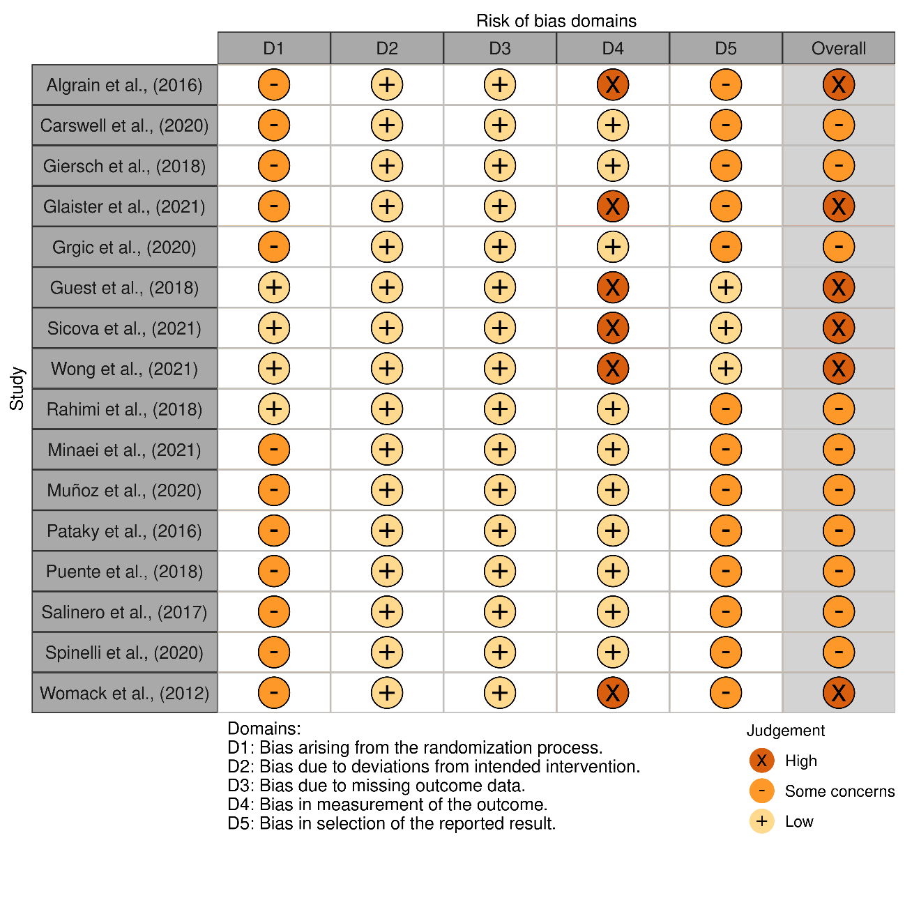
Supplementary Figure 2. A visual representation of the ROB2 tool with single studies classification by Domain and Overall (made with the robvis visualization tool available on https://mcguinlu.shinyapps.io/robvis/).

References
1. Grgic, J., et al., Wake up and smell the coffee: caffeine supplementation and exercise performance-an umbrella review of 21 published meta-analyses. Br J Sports Med, 2020. 54(11): p. 681-688 DOI: 10.1136/bjsports-2018-100278.
2. Grgic, J. and C. Pickering, The effects of caffeine ingestion on isokinetic muscular strength: A meta-analysis. J Sci Med Sport, 2019. 22(3): p. 353-360 DOI: 10.1016/j.jsams.2018.08.016.
3. Doherty, M. and P.M. Smith, Effects of caffeine ingestion on exercise testing: a meta-analysis. Int J Sport Nutr Exerc Metab, 2004. 14(6): p. 626-46 DOI: 10.1123/ijsnem.14.6.626.
4. Daly, J.W., P. Butts-Lamb, and W. Padgett, Subclasses of adenosine receptors in the central nervous system: interaction with caffeine and related methylxanthines. Cell Mol Neurobiol, 1983. 3(1): p. 69-80 DOI: 10.1007/BF00734999.
5. Salamone, J.D., et al., The role of adenosine in the ventral striatal circuits regulating behavioral activation and effort-related decision making: importance for normal and pathological aspects of motivation, in Adenosine. 2013, Springer. p. 493-512.
6. Davis, J.M., et al., Central nervous system effects of caffeine and adenosine on fatigue. Am J Physiol Regul Integr Comp Physiol, 2003. 284(2): p. R399-404 DOI: 10.1152/ajpregu.00386.2002.
7. Southward, K., et al., The Role of Genetics in Moderating the Inter-Individual Differences in the Ergogenicity of Caffeine. Nutrients, 2018. 10(10) DOI: 10.3390/nu10101352.
8. Pickering, C. and J. Grgic, Caffeine and Exercise: What Next? Sports Med, 2019. 49(7): p. 1007-1030 DOI: 10.1007/s40279-019-01101-0.
9. Reis, C.E.G., B. Saunders, and T.H.M. da Costa, Absence of dietary control precludes solid conclusions for sport nutrition trials. J Sci Med Sport, 2021. 24(6): p. 518-519 DOI: 10.1016/j.jsams.2020.11.017.
10. Marticorena, F.M., et al., Nonplacebo Controls to Determine the Magnitude of Ergogenic Interventions: A Systematic Review and Meta-analysis. Med Sci Sports Exerc, 2021. 53(8): p. 1766-1777 DOI: 10.1249/MSS.0000000000002635.
11. Carvalho, A., et al., Can I Have My Coffee and Drink It? A Systematic Review and Meta-analysis to Determine Whether Habitual Caffeine Consumption Affects the Ergogenic Effect of Caffeine. Sports Med, 2022. 52(9): p. 2209-2220 DOI: 10.1007/s40279-022-01685-0.
12. Barreto, G., et al., Novel insights on caffeine supplementation, CYP1A2 genotype, physiological responses and exercise performance. Eur J Appl Physiol, 2021. 121(3): p. 749-769 DOI: 10.1007/s00421-020-04571-7.
13. Grgic, J., et al., CYP1A2 genotype and acute ergogenic effects of caffeine intake on exercise performance: a systematic review. Eur J Nutr, 2021. 60(3): p. 1181-1195 DOI: 10.1007/s00394-020-02427-6.
14. Southward, K., et al., The role of genetics in moderating the inter-individual differences in the ergogenicity of caffeine. Nutrients, 2018. 10(10): p. 1352.
15. Gu, L., et al., Biotransformation of caffeine, paraxanthine, theobromine and theophylline by cDNA-expressed human CYP1A2 and CYP2E1. Pharmacogenetics, 1992. 2(2): p. 73-7 DOI: 10.1097/00008571-199204000-00004.
16. Sachse, C., et al., Functional significance of a C-->A polymorphism in intron 1 of the cytochrome P450 CYP1A2 gene tested with caffeine. Br J Clin Pharmacol, 1999. 47(4): p. 445-9 DOI: 10.1046/j.1365-2125.1999.00898.x.
17. Womack, C.J., et al., The influence of a CYP1A2 polymorphism on the ergogenic effects of caffeine. J Int Soc Sports Nutr, 2012. 9(1): p. 7 DOI: 10.1186/1550-2783-9-7.
18. Guest, N., et al., Caffeine, CYP1A2 Genotype, and Endurance Performance in Athletes. Med Sci Sports Exerc, 2018. 50(8): p. 1570-1578 DOI: 10.1249/MSS.0000000000001596.
19. Wong, O., et al., CYP1A2 Genotype Modifies the Effects of Caffeine Compared With Placebo on Muscle Strength in Competitive Male Athletes. Int J Sport Nutr Exerc Metab, 2021. 31(5): p. 420-426 DOI: 10.1123/ijsnem.2020-0395.
20. Sicova, M., et al., Caffeine, genetic variation and anaerobic performance in male athletes: a randomized controlled trial. Eur J Appl Physiol, 2021. 121(12): p. 3499-3513 DOI: 10.1007/s00421-021-04799-x.
21. Glaister, M., et al., Caffeine, exercise physiology, and time-trial performance: no effect of ADORA2A or CYP1A2 genotypes. Appl Physiol Nutr Metab, 2021. 46(6): p. 541-551 DOI: 10.1139/apnm-2020-0551.
22. Spineli, H., et al., Caffeine improves various aspects of athletic performance in adolescents independent of their 163 C> A CYP1A2 genotypes. Scandinavian journal of medicine & science in sports, 2020. 30(10): p. 1869-1877.
23. Carswell, A.T., et al., The effect of caffeine on cognitive performance is influenced by CYP1A2 but not ADORA2A genotype, yet neither genotype affects exercise performance in healthy adults. Eur J Appl Physiol, 2020. 120(7): p. 1495-1508 DOI: 10.1007/s00421-020-04384-8.
24. Grgic, J., et al., CYP1A2 genotype and acute effects of caffeine on resistance exercise, jumping, and sprinting performance. Journal of the International Society of Sports Nutrition, 2020. 17(1): p. 1-11.
25. Giersch, G.E., et al., The Effect of the CYP1A2− 163 C> a polymorphism on caffeine metabolism and subsequent cycling performance. Journal of Caffeine and Adenosine Research, 2018. 8(2): p. 65-70.
26. Klein, C.S., et al., The effect of caffeine on performance in collegiate tennis players. Journal of caffeine research, 2012. 2(3): p. 111-116.
27. Algrain, H.A., et al., The effects of a polymorphism in the cytochrome P450 CYP1A2 gene on performance enhancement with caffeine in recreational cyclists. Journal of Caffeine Research, 2016. 6(1): p. 34-39.
28. Salinero, J.J., et al., CYP1A2 Genotype Variations Do Not Modify the Benefits and Drawbacks of Caffeine during Exercise: A Pilot Study. Nutrients, 2017. 9(3) DOI: 10.3390/nu9030269.
29. Pataky, M.W., et al., Caffeine and 3-km cycling performance: Effects of mouth rinsing, genotype, and time of day. Scand J Med Sci Sports, 2016. 26(6): p. 613-9 DOI: 10.1111/sms.12501.
30. Page, M.J., et al., The PRISMA 2020 statement: an updated guideline for reporting systematic reviews. BMJ, 2021. 372: p. n71 DOI: 10.1136/bmj.n71.
31. Ouzzani, M., et al., Rayyan-a web and mobile app for systematic reviews. Syst Rev, 2016. 5(1): p. 210 DOI: 10.1186/s13643-016-0384-4.
32. Saunders, B., et al., beta-alanine supplementation to improve exercise capacity and performance: a systematic review and meta-analysis. Br J Sports Med, 2017. 51(8): p. 658-669 DOI: 10.1136/bjsports-2016-096396.
33. Rahimi, R., The effect of CYP1A2 genotype on the ergogenic properties of caffeine during resistance exercise: a randomized, double-blind, placebo-controlled, crossover study. Ir J Med Sci, 2019. 188(1): p. 337-345 DOI: 10.1007/s11845-018-1780-7.
34. Minaei, S., et al., CYP1A2 Genotype Polymorphism Influences the Effect of Caffeine on Anaerobic Performance in Trained Males. Int J Sport Nutr Exerc Metab, 2022. 32(1): p. 16-21 DOI: 10.1123/ijsnem.2021-0090.
35. Potgieter, S., The effect of caffeine supplementation on Olympic-distance triathletes and triathlon performance in the Western Cape, South Africa. 2013, Stellenbosch: Stellenbosch University.
36. McGrath, M.C., The significance of CYP1A2 genotype on caffeine metabolism and exercise performance: a thesis presented in partial fulfilment of the requirements for the degree of Master of Science in Human Nutrition at Massey University, Manawatu, New Zealand. 2015, Massey University.
37. Puente, C., et al., The CYP1A2 -163C>A polymorphism does not alter the effects of caffeine on basketball performance. PLoS One, 2018. 13(4): p. e0195943 DOI: 10.1371/journal.pone.0195943.
38. Zhang, Y., et al., GRADE Guidelines: 19. Assessing the certainty of evidence in the importance of outcomes or values and preferences-Risk of bias and indirectness. J Clin Epidemiol, 2019. 111: p. 94-104 DOI: 10.1016/j.jclinepi.2018.01.013.
39. Sterne, J.A.C., et al., RoB 2: a revised tool for assessing risk of bias in randomised trials. BMJ, 2019. 366: p. l4898 DOI: 10.1136/bmj.l4898.
40. Borenstein, M., et al., Multiple outcomes or time-points within a study. Introduction to meta-analysis, 2009: p. 225-238.
41. Sawilowsky, S.S., New effect size rules of thumb. Journal of modern applied statistical methods, 2009. 8(2): p. 26.
42. Barreto, G., et al., Comment on "CYP1A2 Genotype Modifies the Effects of Caffeine Compared With Placebo on Muscle Strength in Competitive Male Athletes". Int J Sport Nutr Exerc Metab, 2022. 32(1): p. 62-63 DOI: 10.1123/ijsnem.2021-0239.
43. Stevens, C.J. and B.J. Dascombe, The reliability and validity of protocols for the assessment of endurance sports performance: an updated review. Measurement in Physical Education and Exercise Science, 2015. 19(4): p. 177-185.
44. Maughan, R.J., et al., IOC Consensus Statement: Dietary Supplements and the High-Performance Athlete. Int J Sport Nutr Exerc Metab, 2018. 28(2): p. 104-125 DOI: 10.1123/ijsnem.2018-0020.
45. Munoz, A., et al., Effects of CYP1A2 and ADORA2A Genotypes on the Ergogenic Response to Caffeine in Professional Handball Players. Genes (Basel), 2020. 11(8) DOI: 10.3390/genes11080933.
46. Lesser, L.I., et al., Relationship between funding source and conclusion among nutrition-related scientific articles. PLoS Med, 2007. 4(1): p. e5 DOI: 10.1371/journal.pmed.0040005.
47. Grgic, J., Caffeine ingestion enhances Wingate performance: a meta-analysis. Eur J Sport Sci, 2018. 18(2): p. 219-225 DOI: 10.1080/17461391.2017.1394371.
48. Southward, K., K.J. Rutherfurd-Markwick, and A. Ali, Correction to: The Effect of Acute Caffeine Ingestion on Endurance Performance: A Systematic Review and Meta-Analysis. Sports Med, 2018. 48(10): p. 2425-2441 DOI: 10.1007/s40279-018-0967-4.
49. Salinero, J.J., B. Lara, and J. Del Coso, Effects of acute ingestion of caffeine on team sports performance: a systematic review and meta-analysis. Res Sports Med, 2019. 27(2): p. 238-256 DOI: 10.1080/15438627.2018.1552146.
50. Ferreira, T.T., J.V.F. da Silva, and N.B. Bueno, Effects of caffeine supplementation on muscle endurance, maximum strength, and perceived exertion in adults submitted to strength training: a systematic review and meta-analyses. Crit Rev Food Sci Nutr, 2021. 61(15): p. 2587-2600 DOI: 10.1080/10408398.2020.1781051.
51. Djordjevic, N., et al., Induction of CYP1A2 by heavy coffee consumption is associated with the CYP1A2 -163C>A polymorphism. Eur J Clin Pharmacol, 2010. 66(7): p. 697-703 DOI: 10.1007/s00228-010-0823-4.
52. Childs, E., et al., Association between ADORA2A and DRD2 polymorphisms and caffeine-induced anxiety. Neuropsychopharmacology, 2008. 33(12): p. 2791-800 DOI: 10.1038/npp.2008.17.
53. Mendes, G.F., et al., Can the Brazilian Caffeine Expectancy Questionnaires Differentiate the CYP1A2 and ADORA2A Gene Polymorphisms?-An Exploratory Study with Brazilian Athletes. Nutrients, 2022. 14(16) DOI: 10.3390/nu14163355.

