Materials and Methods – additional information

Data processing and statistical analysis

Sample descriptives additional information
Variable | Mean | SD | Min | Max
Age (years) | 20.21 | 1.02 | 19 | 23
Height (cm) | 175.73 | 9.37 | 152.1 | 202
Weight (kg) | 71.83 | 10.09 | 43.5 | 91.8
Table 1 – Sample descriptives

Concordance and correlation of dependent variables
Kendall's coefficient of concordance showed high conformity between the tree evaluators for both AQV (W = 0.75 [0.749, 0.780], p < 0.001) and E-score (W = 0.79 [0.761, 0.984], p < 0.001) above our predefined threshold of W = 0.70. Based on these results we therefore assumed sufficient concordance between all three evaluators and for subsequent analyses, we calculated mean values of E-score and mode values of AQV for each participant.

Exploratory data analysis
Normality of the continuous variables (i.e., UQYBT Right, UYBT Left, UQYBT Total, CKCUEST and E-score) is highlighted in Table 1. All variables are normally distributed except for E-score.
 | All participants (N = 111)
variable | W | p | normality
UQYBT Right | 0.99 | 0.94 | Yes
UQYBT Left | 0.99 | 0.39 | Yes
UQYBT Total | 0.99 | 0.90 | Yes
CKCUEST | 0.99 | 0.46 | Yes
Table 1 - Assumptions of normality of continuous variables included in data analysis.

The assumptions of variance equality of continuous variables was met between UQYBT Total & E-score and between CKCUEST & E-score. We highlight detailed results in Table 2.
variables | Test | Result | p | variance equality
UQYBTT ~ E-score | Fligner-Killeen's test | chi-squared = 23.09 | 0.28 | Yes
CKCUEST ~ E-score | Fligner-Killeen's test | chi-squared = 27.78 | 0.11 | Yes
Table 2 - Assumptions of variance equality between all continuous variables

Within association between variables, UQYBT Right and UQYBT Left were highly and positively correlated (r₁₁₁ = 0.78 [0.70, 0.84], p < 0.001), and both were highly and positively correlated with UQYBT Total score (r₁₁₁ = 0.94 [0.92, 0.96], p < 0.001 and r₁₁₁ = 0.94 [0.92, 0.96], p < 0.001 for left and right arm, respectively). The association between UQYBT Total and CKCUEST was negligible negative (r₁₁₁ = -0.05 [-0.24, 0.14], p = 0.583). Results of correlation between The AQV and E-score were statistically significantly negatively associated (τ₁₁₁ = -0.68[-0.772, -0.581], p < 0.001), see on Figure 1.

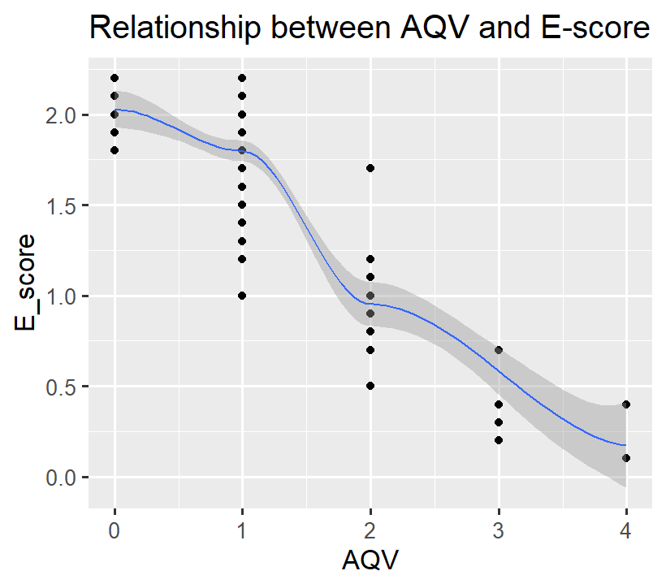
Figure 1 – Relationship between AQV and E-score within all participants.

Relationship between quality of handstand and stability and flexibility tests
The VIF values for all three predictors were below the threshold, with UQYBT Total = 1.00, and CKCUEST = 1.00, thus we can reject multicollinearity between predictors and entre them into the considered model (Figure 2).

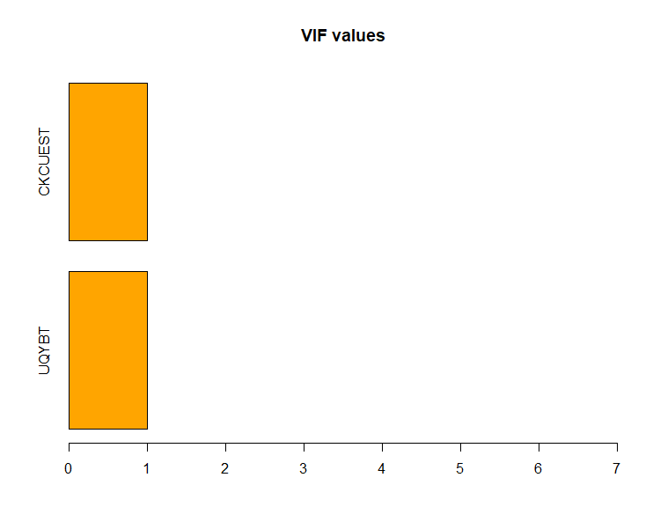
Figure 2 - Assumptions for ordinal logistic model – VIF values of the independent variables.

