|  |  |  |
| --- | --- | --- |
| **Reliability of a maximum effort inertia flywheel squat protocol** |  | For correspondence: [Keegan.Hall@mymail.unisa.edu.au](mailto:Keegan.Hall@mymail.unisa.edu.au) |

Keegan B. Hall1,2, Maarten A. Immink1,3, David T. Martin4, Hunter Bennett1,2, Robert G. Crowther1,2

1UniSA: Allied Health and Human Performance, University of South Australia, 5001 Adelaide, South Australia,

2Alliance for Research in Exercise, Nutrition and Activity (ARENA), University of South Australia, Adelaide, South Australia,

3Sport, Health, Activity, Performance and Exercise Research Centre, Flinders University, 5042 Adelaide, South Australia,

4School of Behavioural and Health Sciences, Australian Catholic University, 3065 Melbourne, Australia

*Please cite as*: Hall, K.B., Immink, M.A., Martin, D.T., Bennett, H & Crowther, R.G. (2022). Reliability of a maximum effort inertia flywheel squat protocol. *SportRχiv*.

# ABSTRACT

The purpose of this study was to determine the inter-day test-retest reliability of a multi-repetition maximum effort inertia flywheel (IFw) squat test, and to identify the association between maximal performance in an IFw squat test and a 6-repetition maximum (RM) back-squat. Twelve subjects completed three sessions of squat testing: one session to determine back-squat 6RM and two sessions on the IFw. Reflective markers were attached to landmarks of the lower body to calculate repetition velocity, and the activation of lower body musculature was captured with eight electromyography (EMG) electrodes. IFw squat test load and velocity variables showed moderate-excellent test-retest reliability (ICC = 0.69 – 0.95). EMG variables between the two IFw sessions showed a negative poor-moderate positive reliability (ICC = -0.27 – 0.66). Significance for all statistical testing was set at p < 0.05. There was no significant association for maximal loads between the two testing modalities (IFw vs. 6RM; p = 0.137 – 0.192), however a significant relationship was identified between back-squat 6RM load and IFw in mean concentric velocity in session 2 (p = 0.011, r = 0.705) and final repetition velocity in both IFw sessions (p = 0.023, r = 0.648 vs p = 0.026, r = 0.635). The IFw squat test showed moderate-excellent reliability. The poor correlations between IFw and back-squat 6RM performance variables indicate that IFw specific performance tests should be used to guide IFw load prescription in training settings.

# INTRODUCTION

Inertia flywheel (IFw) training is an emerging mode of resistance training (RT). An IFw is a portable, disc-loaded resistance training device that can be used to replicate a variety of exercises at a high intensity with inertial loading (Beato et al. 2019; Piqueras-Sanchiz et al. 2020). The primary difference between IFw and traditional RT is how the load is applied, as the IFw load is not constantly influenced by gravitational resistance (Beato et al. 2020a; Norrbrand, Pozzo & Tesch 2010). As such, when high forces are applied during the concentric phase of a movement (i.e., squat), the rotational acceleration of the IFw disc develops inertial torque, which accumulates and is returned during the eccentric phase (Beato et al. 2020a; Vicens-Bordas et al. 2018), where an athlete must then generate a large braking force to decelerate the disc. This generates a greater eccentric load (when braking action is delayed in the early eccentric phase) that cannot easily be achieved with traditional RT (Beato & Dello Iacono 2020). Given the propensity for eccentric contractions to aid development of chronic strength, power and hypertrophy, the combined accentuated eccentric load and concentric loading of the IFw may be a more effective modality for attaining these training outcomes (Beato et al. 2019; Cormie, McGuigan & Newton 2011; Douglas et al. 2017). Recent literature has supported this theory, where IFw training has shown to be effective at developing strength, power, and hypertrophy, with potential benefits for injury prevention and rehabilitation (Colliander & Tesch 1990; de Hoyo et al. 2015b; Gonzalo-Skok et al. 2017; Norrbrand et al. 2008)

However, prescribing loads for specific training outcomes on the IFw is difficult, due to the unique challenges associated with maximal and near-maximal testing. To achieve specific training adaptations, specific loading parameters are required. These loading parameters are often based upon a percentage of an individual maximum performance (i.e., maximum load an individual can lift), but there currently exists no protocol to reliably determine maximal performance on an IFw. Testing maximal performance is challenging, as the load applied during the eccentric phase is dependent on the force applied in the concentric phase. Given this reliance on athlete effort, it is difficult to discern whether a decrease in velocity is due to an increase in IFw load, or a decrease in effort. Recent research has investigated the conformity of IFw performance to a force-velocity (F-v) curve across a series of submaximal loads to predict theoretical maximal loads (i.e., max power, max velocity & max force loads; Carroll et al. 2019; Spudić, Cvitkovič & Šarabon 2021). Research has identified a significant decrease in concentric velocity as IFw load increases, and found a linear relationship between the two variables (Carroll et al. 2019). A prediction of maximal force and velocity loads in the IFw squat can be determined from athlete performance at four pre-determined loads (0.025, 0.075, 0.225 & 0.25 kg.m2) for six repetitions (Spudić, Cvitkovič & Šarabon 2021). F-v profiling can be useful as it allows the prediction of maximal performance without the severe fatigue associated with maximal testing. However, as F-v profiling creates a prediction of maximal performance, it is uncertain whether these predictions align with an athlete’s true maximal performance. Therefore, a reliable protocol to determine an athlete’s true maximal performance can be used to validate F-v profiles.

In barbell back-squat (BBS) studies, a relationship has been identified between mean concentric velocity (µVelCon) and failure at progressive loads, set at a percentage of 1-repetition maximum (RM; Rodríguez-Rosell et al. 2020). It was discovered that, on average, the µVelCon decreased below ~0.3 m/s (0.21 – 0.34 m/s) as an athlete approached failure (Rodríguez-Rosell et al. 2020). While both emulating a squat pattern, there are key differences between the BBS and IFw squat that may lead to a different failure velocity on the IFw. Despite these differences, we can conclude that the highest load used in the F-v profile investigated by Spudic et al. (2020; 0.25 kg.m2), was not a maximal load given the µVelCon reported (0.43 ± 0.06 m/s). To date, there currently exists no repeatable protocol for testing maximal performance on the IFw, so it is unclear how accurate current prediction models are at determining maximal load. To further understand and optimize load prescription for the IFw, a reliable method of determining athlete failure is necessary, both with subjective and objective measures, during an IFw squat.

Consequently, the aim of this study was to determine the test-retest reliability of a multi-repetition maximal effort squat test on the IFw, and to identify the association between maximal performance in the IFw squat test and a 6RM back-squat. It was hypothesised that the reliability of the IFw squat test would be high (ICC > 0.8) for the performance variables assessed, that there would not be a significant difference in performance variables between sessions (p > 0.05) and that there would be a significant correlation between the performance outcome variables of the back squat 6RM and IFw squat test.

# METHOD

**Experimental approach to the problem**

The study design consisted of a test-retest reliability protocol involving a multi-repetition maximal squat test on an IFw (kBox4, Exxentric, Stockholm, Sweden). Each participant attended the laboratory on three separate occasions. In the first testing session, participants completed a 6RM barbell back-squat test for the purpose of a baseline strength assessment. A prediction equation (Estimated 1RM in lbs = [1 + 0.333 × no. of reps] × load in lbs) was used to estimate 1RM back-squat performance from the 6RM back-squat (LeSuer et al. 1997). Following completion of the 6RM barbell back-squat, participants underwent a familiarisation protocol on the IFw. In the subsequent two sessions, participants completed a multi-repetition maximal testing protocol on the IFw. All testing sessions were conducted in the biomechanics laboratory at the University of South Australia at a similar time of day to control for diurnal effect (Teo, Newton & McGuigan 2011). Electromyography (EMG) data was collected from specified lower body muscles during all physical tests was and used to support and provide deeper context to the primary findings of the research. EMG results were used to support the main findings of the research and determine whether any potential differences in the IFw squat test variables can be explained by changes in the neuromuscular demands of the movement that may indicate a learning effect. A standardised, dynamic warm-up and cool down was conducted at the beginning and end of each session, and participants were asked to maintain normal physical activity throughout the testing period.

## **Participants**

Twelve healthy resistance trained athletes volunteered for this study (8 males, 4 females; age: 21.8 ± 2.1 yrs; height: 178.8 ± 11.7 cm; mass: 74.2 ± 14.0 kg). Participants were required to meet the following inclusion criteria to be eligible for participation in the study; aged 18 - 35 yrs.; have a minimum of six months of resistance training experience; capable of passing a functional movement screen for the squat (Myer et al. 2014); currently competing in an elite sporting league (i.e., state league equivalent or above); participate in an explosive sport (i.e., basketball, volleyball, football); and pass stage 1 of the Exercise and Sport Science Australia (ESSA) pre-exercise screening questionnaire (ESSA 2019; Appendix E). Participants were excluded from participation in the study if they had a pre-existing injury that inhibited their ability to squat maximally. All participants were informed about the potential risks and benefits associated with participation and signed an informed consent form (Appendix C). Additionally, participants completed a questionnaire regarding their resistance training and sporting history to provide greater information on the participant demographics (Appendix G). The Human Research Ethics Committee at the University of South Australia approved this study (Protocol number: 203302). All procedures were conducted according to the Declaration of Helsinki for studies involving human participants.

## **Procedures**

Height (cm) and body mass (kg) were measured using a wall-mounted stadiometer (SECA 216, Seca, NY, USA) and scales (TANITA DR-953 Inner Scan, Tanita, Tokyo, Japan), respectively. Eight electromyography (EMG) surface electrodes (Trigno AvantiTM, Delsys, Massachusetts, USA) were applied to muscles of the lower body on both left and right legs (lateral gastrocnemius [GL], vastus medialis [VM], rectus femoris [RF] and semitendinosus [ST]). EMG was applied in accordance with industry standards (SENIAM 2020), where electrode sites were shaved and cleaned with alcohol wipes, before the EMG was applied over the muscle belly. Ten reflective markers were applied to anatomical landmarks of the lower body (1st, 2nd and 3rd metatarsal head, calcaneus, lateral & medial malleolus, lateral and medial femoral epicondyles, greater trochanter, and posterior superior iliac spine). Marker trajectories during all physical tests were captured and recorded by VICON Nexus (v2.10, VICON, Oxford, UK) to allow for the calculation of repetition velocity. EMG activity was captured by VICON Nexus via the Delsys control unit during all physical tests. A standardised warm-up was conducted prior to any physical testing. The warm-up included a series of dynamic lower body activation and mobility exercises (Kraska et al. 2009; Mizuguchi 2012), followed by a task-specific warm-up comprised of 10 quarter squats at a low load on the inertia flywheel (~0.025 kg.m2), or 10 back-squats at a low load (~50% of predicted 6RM; Burkett, Phillips & Ziuraitis 2005).

##### Barbell back-squat 6RM

The 6RM back-squat was determined following the American College of Sports Medicine (ASCM) guidelines (Ratamess 2011). Six repetitions were completed for each attempt, and at the end of each attempt, participants reported their perceived number of repetitions in reserve (RIR; Appendix I) before failure and rating of perceived exertion (RPE, CR10; Appendix H; Borg 1982). Loading started at 50% of the participants self-estimated predicted 6RM and was increased by 10-20% for each successful attempt. Smaller loading increments were made as the participant approached their 6RM (2 - 5%). If successful, load was increased by a further 2 - 5% based on participant feedback. If the attempt was unsuccessful, load was decreased by 2 - 5% and the next successful load was declared their 6RM. This process was repeated until failure was reached (participant could not complete another successful repetition) and the participant reported a maximal RPE (i.e., >9 RPE). A 3 - 5 min rest interval was allowed between each attempt, and the final 6RM load was established within 3 - 5 attempts. The participants were instructed to end the eccentric phase of the squat once they had reached a parallel position (inguinal fold was aligned below the patella), to adhere with best practice for BBS RM testing (Ratamess 2011). Strong verbal encouragement was given throughout all attempts and the chief investigator acted as a spotter, positioned behind the participant to assist in lifting the barbell if the participant was unable to complete a repetition independently (Sands, Wurth & Hewit 2012).

##### *Inertia flywheel set up*

Participants were positioned in the middle of the IFw (harness attached; Figure 3.1), so that the pulley was aligned between the heel and midfoot. Participants were instructed to assume their normal squat stance, where foot placement was standardised using a custom tape grid on the IFw platform. During the squat movement, participants were permitted to hold their arms out in front as a counterbalance. Participant squat depth was controlled to a partial squat, as this has been shown to be beneficial for a variety of IFw based training outcomes (Beato et al. 2021b). Depth was controlled using two portable squat racks, positioned adjacent to the IFw, supporting a plastic pipe between them. The height of this system was adjusted so that during the squat, the participant would contact the plastic pipe when a 45-degree relative knee angle was produced (measured with a goniometer). This procedure provided kinesthetic feedback during the eccentric phase of the squat, allowing the participant to maintain consistent squat depth. The chief investigator acted as a spotter, located in front of the IFw with a tether attached to the safety release latch on the harness, ready to detach the participant from the flywheel in the event of a failed repetition. A safety mat was located behind the IFw for the participant to safely land on in the event of the safety release latch being pulled, as a supramaximal load would cause the participant to fall backwards.

##### *Inertia flywheel multi-repetition velocity-controlled squat test*

For all attempts, eight repetitions were completed, with the first two repetitions required to charge the IFw device, as the full inertial load is not applied until the flywheel is in motion (six working repetitions, two pre-repetitions; Beato et al. 2021a). After all attempts, RIR and RPE was recorded. The starting load in the IFw squat test was determined based off participant comfort and performance with the warm-up load (0.025 kg.m2), between 0.05 – 0.075 kg.m2. If the participant successfully completed an attempt, an additional disc was added to the IFw based on the participant RPE and performance at the previous load (between 0.025 – 0.05 kg.m2). Load was progressively increased with each successful attempt, until the participant reached their perceived max (RPE >9), they could not complete all repetitions or no more load could be added to the IFw (only four discs can be fitted to the Exxentric kBox4). A 3 – 5 min rest interval was permitted between each attempt, and the final IFw load was achieved within 3 – 5 attempts.

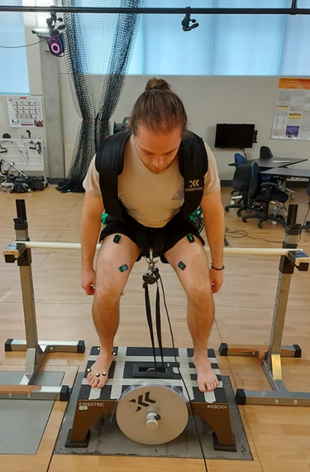

Figure 3.31 Inertia flywheel test set-up.

Strong verbal encouragement was given throughout all attempts to maintain maximal effort, with direction to maximise velocity during the concentric phase of the squat. Movement velocity was calculated through the VICON Nexus motion capture system and reviewed after each trial. Participants were instructed to delay voluntary resistance of the load for the initial third of the eccentric phase, and to apply a braking force rapidly to finish the range of motion of the squat when contact was made with the plastic pipe to optimise eccentric loading (Carroll et al. 2019; Suchomel et al. 2019). Additional instruction was given to keep both feet securely planted on the IFw throughout the squat, and to avoid locking the knees at the top of a movement.

## **Data Analysis**

Marker trajectories were captured by VICON Nexus (v2.10, VICON, Oxford, UK) and imported to Visual3D (v6.0, c-motion, Mayland, USA) to be processed, where a low-pass Butterworth filter at 6 Hz was performed. Processed kinematic data was exported to Microsoft Excel 2018 (Microsoft Corporation, Redmond, Washington, USA) and ran through a custom MatLab (MatLab R2020a v9.8.0, Natick, Massachusetts, USA) script to calculate final repetition velocity (VelFinal; linear velocity between calcaneus and posterior iliac spin markers) and µVelCon (m/s) across the six repetitions for the BBS 6RM and IFw squat test. Velocity was calculated using the difference in the z-coordinates between the calcaneus and greater trochanter markers.

Raw EMG (mV) data from the selected muscles (GL, VM, RF & ST) were captured with eight Trigno Avanti EMGs via Vicon Nexus and imported into a custom MatLab script, where a linear envelope process (high-pass filter at 50 Hz for DC-offset, full-wave rectification and low-pass filter at 3 Hz) was performed. EMG data was normalised for each session by the maximum EMG signal obtained in each session (i.e., back squat or IFw) for each participant (Konrad 2005). Peak EMG amplitude (% of intra-session peak) was calculated for the final six repetitions of the maximum load reached in each IFw squat testing session.

## **Statistical analysis**

All statistical analyses were conducted in SPSS statistical software (v27, IBM Corp, New York, NY, USA). Descriptive statistics (mean & standard deviation [SD]) were generated for each variable. Boxplots were used to identify any outliers in the data and the Shapiro-Wilk test of normality was used to assess the normal distribution of the data. If a true outlier was identified following the data check (> 3 × IQR away from mean), it would be considered for removal for future analyses. No outliers were removed from the analysis. Relative test-retest reliability was assessed using an intraclass correlation coefficient (ICC3,1; <0.5, poor; 0.5 - 0.75, moderate; 0.75 - 0.9, good; > 0.9 excellent) and presented with 95% confidence intervals (CI; Portney & Watkins 2009). Absolute reliability was assessed by standard error of measurement (SEM), coefficient of variation (%CV) and typical error (TE). SEM was calculated as SD√(1-ICC), %CV was calculated as SD/mean and expressed as a percentage (Hopkins 2000, 2006). TE was calculated as (SD×√2) and, to aid interpretation, is reported as raw units (m/s or kg.m2). A paired samples t-test was used to compare session data (1 vs. 2) and Pearson’s correlation coefficient was used to assess the correlation between the back-squat 6RM (load & velocity) and IFw test results (velocity). Pearson correlation values were interpreted following Hopkin’s (2006) recommendations (0.0 - 0.1, trivial; 0.1 - 0.3, small; 0.3 - 0.5, moderate; 0.5 - 0.7, large; 0.7 - 0.9, very large; 0.9 - 1.0, nearly perfect). The significance level for all hypothesis testing was set at p < 0.05. Cohen’s d effect size statistics are reported and interpreted as recommended by Hopkin’s (2006; small 0.2, moderate 0.6, large 1.2, very large 2.0 and nearly perfect 4.0).

# Results

All participants completed the full testing protocol. Descriptive statistics of participant performance variables are presented in Table 1.1. The average barbell back squat 6RM was 101.9 ± 33.9 kg, with a mean concentric velocity (µVelCon) of 0.221 ± 0.035 m/s and a final repetition velocity (VelFinal) of 0.199 ± 0.040 m/s, while the average performance in the IFw squat test was 0.212 ± 0.039 kg.m2, with an µVelCon of 0.196 ± .024 m/s and a VelFinal of 0.201 ± 0.040 m/s. Due to the technical limitations of wireless EMG electrodes and their tendency to disconnect mid-session, complete EMG data were only available for nine participants.

##### *Reliability*

Reliability statistics are presented in Table 1.2 and Table 1.3. ICCs for the objective variables assessed, showed moderate-excellent reliability (ICC = 0.69 - 0.95), while subjective variables showed poor-moderate reliability (ICC = 0.41 – 0.73). EMG ICC data was highly variable and showed a negative poor to positive moderate reliability (ICC = -0.27 – 0.66), with a difference identified for the left RF muscle (p = 0.045). T-tests revealed no difference between any performance variables between sessions (p > 0.05). Effect sizes for all performance variables were small-moderate (ES = -0.61 – 0.31).

##### *Comparison*

There were no significant associations observed for maximal load between the two strength testing protocols (BBS 6RM vs. IFw squat test) across both session 1 (r = 0.456, p = 0.137) and session 2 (r = 0.405, p = 0.192). A very large association was identified between BBS 6RM performance (load) and µVelCon in the IFw session 2 (r = 0.705, p = 0.011). No significant association was identified for µVelCon between the two test modalities (Table 1.4; r = -0.007, p = 0.984 vs. r = 0.199, p = 0.535), however a large association was identified between the VelFinal for the BBS 6RM and IFw squat session 2 (r = 0.674, p = 0.016).

**Table 1. Barbell back-squat & inertia flywheel squat test performance outcome measures.**

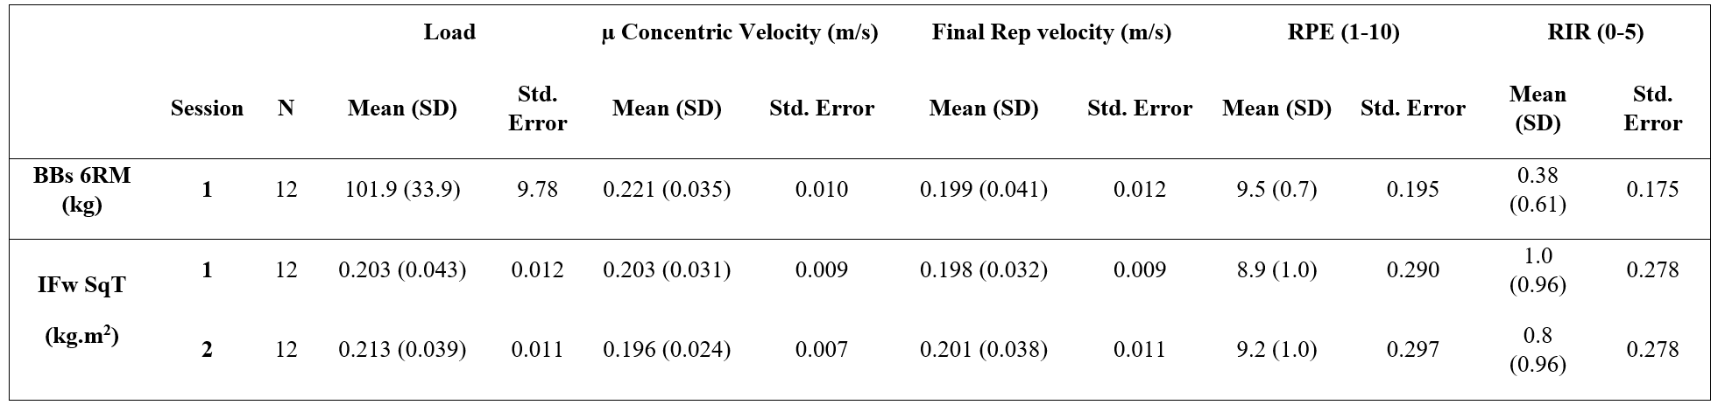

BBs6RM = Barbell back-squat 6 repetition maximum, IFwSqT = Inertia flywheel squat test, RPE = Rating of perceived exertion, RIR = Repetitions in reserve, SD = Standard deviation

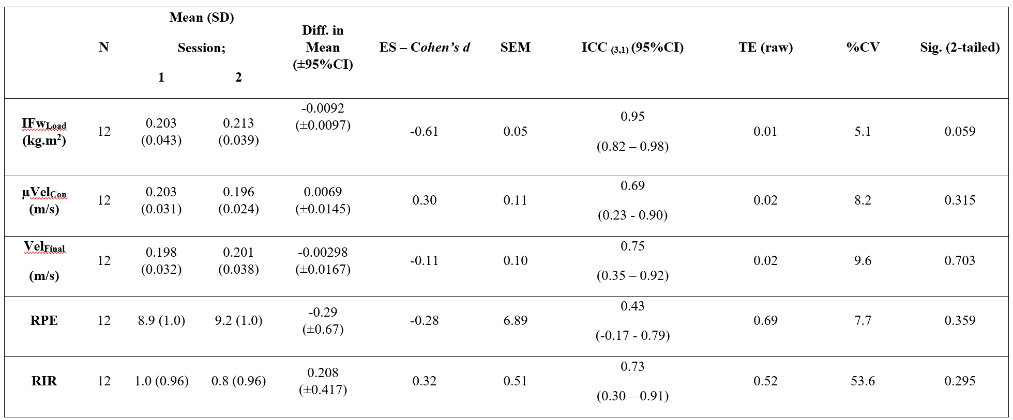**Table 2. Reliability of performance variables for the inertia flywheel multi-repetition squat test**

IFwLoad = Inertia Flywheel Load, **µ**Velcon = mean concentric velocity, VelFinal = final repetition velocity; RPE = rating of perceived exertion, RIR = repetitions in reserve, SD = standard deviation, CI = confidence interval, ES = effect size, SEM = standard error of measurement, ICC = intraclass correlation coefficient, TE = typical error, %CV = coefficient of variation.

**Table 3. Reliability of EMG activity for the IFw multi-repetition test.**

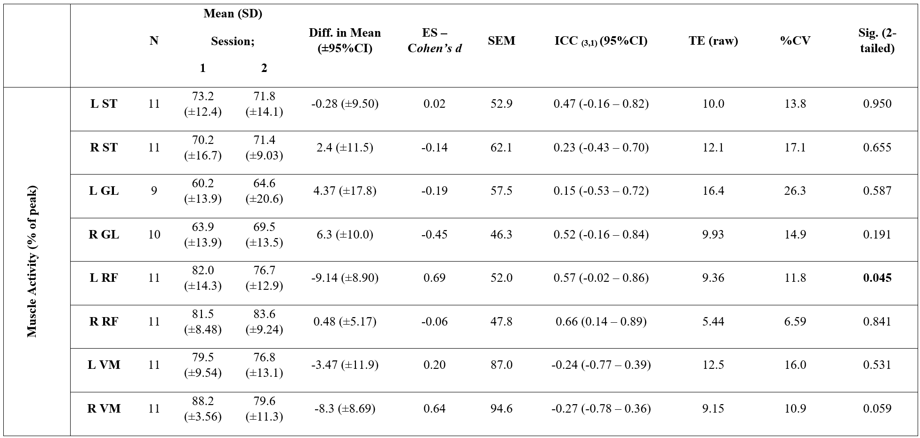L = Left side limb; R = Right side limb; ST = semitendinosus; GL = lateral gastrocnemius; RF = rectus femoris; VM = vastus medialis; SD = standard deviation; CI= confidence interval; ES = effect size; SEM = standard error of measurement; ICC = intraclass correlation coefficient; TE = typical error; %CV = coefficient of variation.

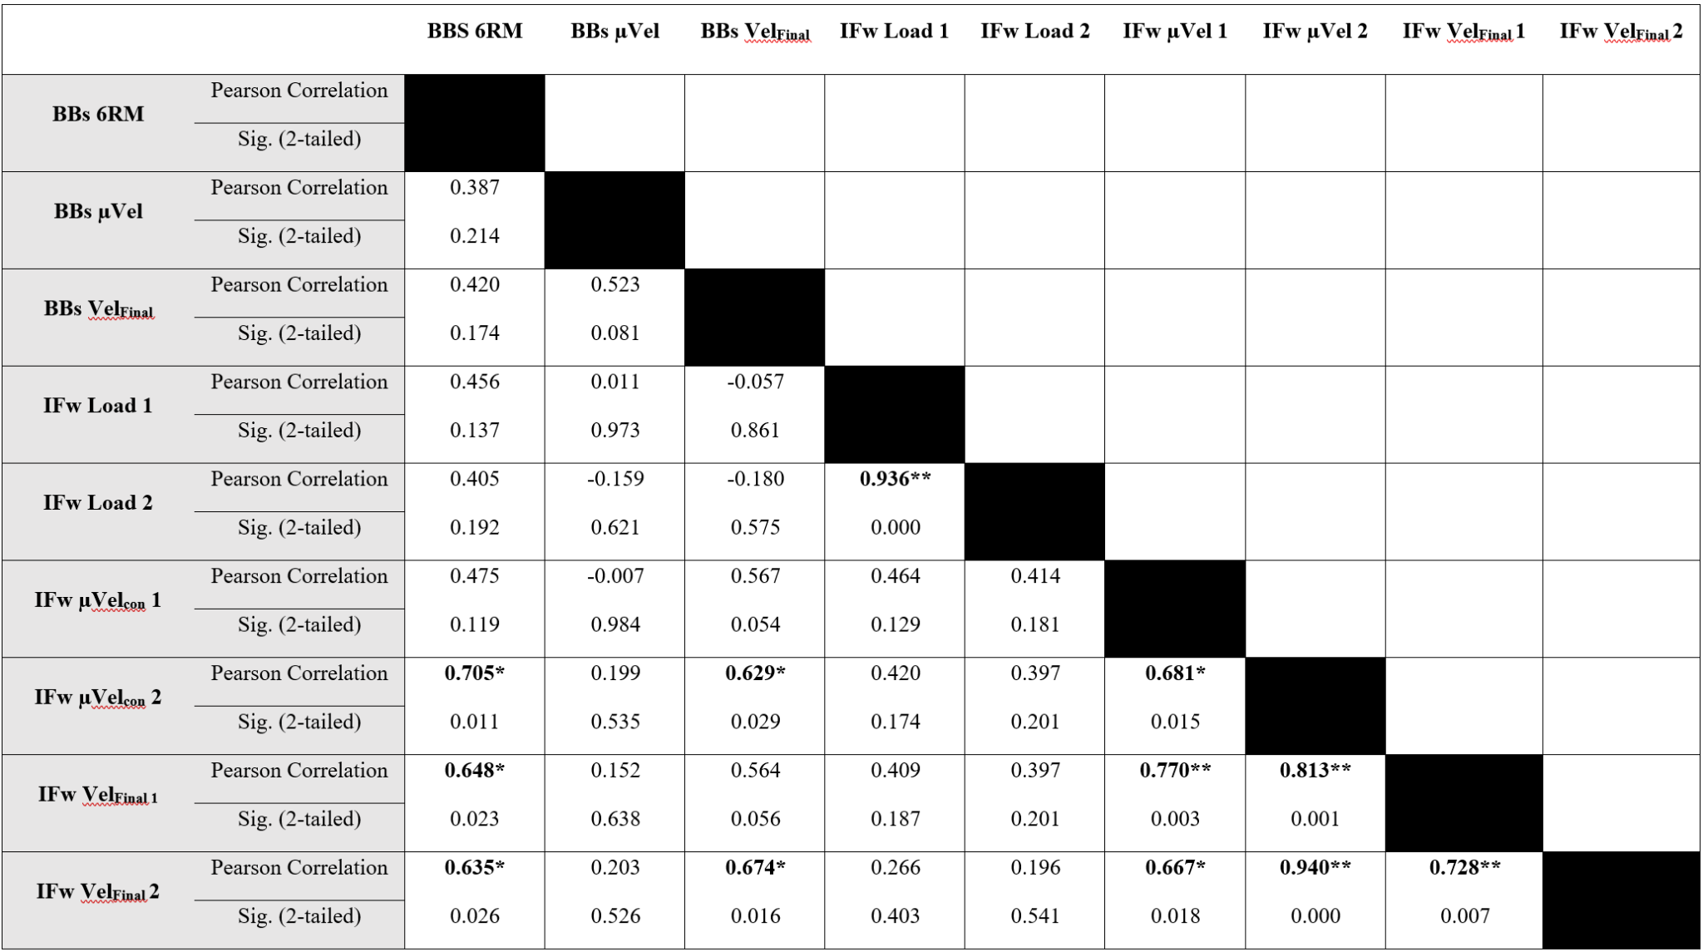**Table 4. Pearson Correlation statistics for barbell back-squat and inertia flywheel squat tests variables**

BBS6RM = Barbell back-squat 6 repetition maximum; IFw = inertia flywheel; µVelcon­ = mean concentric velocity; VelFinal = final repetition velocity; * p < 0.05; ** p < 0.01.

# Discussion

This study aimed to determine the test-retest reliability of a novel IFw multi-repetition maximal effort squat test in terms of the absolute load, movement velocity and subjective measures of RPE and RIR. A secondary aim of this study was to identify the relationship between the back-squat 6RM and performance in the IFw squat test. Given the potential benefits of IFw in resistance training, it is important to formulate a repeatable method of testing maximal IFw performance for the purpose of training load prescription. The IFw multi-repetition max effort squat test showed moderate-excellent test-retest reliability across two sessions for the objective performance variables assessed, but showed a lower poor-moderate test-retest reliability for subjective measures (i.e., RPE & RIR) and EMG data.

Objective measures of absolute load and μVelCon for the IFw multi-repetition squat test showed moderate-excellent test-retest reliability (ICC = 0.69 – 0.95). To the authors knowledge, this is the first study to assess the test-retest repeatability of an IFw squat test that seeks to maximise inertial load. Recent literature on IFw reliability testing has primarily focused on the reliability of performance production measures, such as power, force, and work, when inertial load is standardised (Beato et al. 2021b; Bollinger et al. 2020; Piqueras-Sanchiz et al. 2020; Spudić, Cvitkovič & Šarabon 2021). Of these, only two studies investigated performance at IFw loads greater than 0.2 kg.m2 (Piqueras-Sanchiz et al. 2020; Spudić, Cvitkovič & Šarabon 2021), and even so, it is unknown whether these loads were representative of maximal or near-maximal performance in the populations assessed. Unlike traditional weight training, there exists no protocol of assessing maximal performance on the IFw, and while F-v profiling can be used to predict maximal force and load, it is unknown whether such loads can be objectively or subjectively defined as maximal.

The current study demonstrated that a maximal IFw squat testing protocol has moderate-excellent test-retest reliability for absolute load and mean concentric velocity (ICCs: IFwLoad = 0.95; Velcon = 0.69). As such, the IFw squat test described can be used to reliably assess 6RM performance on the IFw. Subjective measures were more inconsistent and showed poor-moderate test-retest reliability (ICCs: RPE = 0.41; RIR = 0.73). Subjective measures are expected to be more variable due to variation in individual interpretation of the measure and the range of different factors that may influence the values reported (Robertson & Noble 1997). Additionally, a poor ICC for RPE could be explained by a single score difference (Borg CR-10 RPE), representing a disproportionately large variation (~10%) in RPE compared to other measures. While there was no difference in RPE scores between sessions, a low ICC may suggest that one familiarisation was insufficient in this population and may support the emphasis on extensive familiarization prior to testing on the IFw (Sabido, Hernández-Davó & Pereyra-Gerber 2018). EMG activity showed poor-moderate reliability (ICC = 0.15 – 0.66), with both VM muscles presenting a negative ICC (ICC = -0.27 – -0.24). This may suggest that participants have a higher variability of process (EMG activity) to produce a similar outcome (IFw load) or may be due to the inherent variability of EMG measures.

Another notable finding from this research is the relationship between the BBS 6RM and IFw squat test performance variables. Despite both tests emulating a squat pattern, there were no significant associations observed between maximal loads determined in each test (r = 0.456 p = 0.137 vs. r = 0.405, p = 0.192). The very large association identified between the maximum load achieved in the BBS 6RM and the μVelCon in the IFw squat test (r = 0.705, p = 0.011), suggests that stronger individuals (i.e., higher 6RM) can move with a faster repetition velocity on the IFw. Recent evidence suggests that stronger athletes can better utilise the stretch shortening cycle than their weaker counterparts (Jarvis et al. 2022). As such, stronger athletes may be more equipped to absorb the eccentric load of the IFw and use this load to aid concentric force production, which may explain this finding.

No significant association was identified for μVelCon between the two testing modalities (IFw 1: r = -0.007, p = 0.984 vs. IFw 2: r = 0.199, p = 0.535). This highlights potential differences between the two tests and supports the justification for maximal testing on the IFw prior to its use in training regimes, as performance variables (i.e., velocity) in BBS RM testing will not carry over to the IFw. The difference in mean concentric velocity may be due to the differences in how load is applied between the tests. As the BBS is loaded axially, it may allow for a brief elastic period at the bottom of the repetition as the barbell rebounds slightly. This may allow for the reutilization of elastic energy as the squatter transitions from the eccentric to concentric phases, which may aid velocity development. Such a pattern would not occur on the external disc-loaded IFw and may explain the velocity differences between the tests.

The VelFinal in the BBS 6RM performed in this study (0.19 ± 0.04 m/s) was below previously observed values in research by Rodriguez-Rossell et al. (2020; 0.27 ± 0.04 m/s). However, a large association was identified between VelFinal in BBS 6RM and both IFw squat session 1 (r = 0.564, p = 0.056) and 2 (r = 0.674, p = 0.016), although only session 2 reached statistical significance. This would suggest that despite the inherent differences in the two tests, participants tend to reach failure at a similar movement velocity. Additionally, this significant association with BBS VelFinal and the second IFw session, may indicate that further exposure to and familiarisation with the IFw allowed the participant to push themselves closer to true failure than in the first IFw session. This study is the first to record VelFinal at subjective failure at maximal loads on the IFw, further research may allow for more informative IFw training zones based on concentric velocity.

A limitation to this study is that only a maximum of four IFw discs could be safely mounted on the IFw during the squat test, meaning the maximum inertial load achievable was limited to 0.24 kg.m2 (2 × 0.07 kg.m2 + 2 × 0.05 kg.m2 discs). Two participants reached this maximum IFw load without reporting a maximal RPE (RPE 10) and may have a higher maximal IFw load than what was observed. As two of the recorded participants did not achieve a subjective maximal IFw load, this may affect the interpretation of the results of this study, as the observed increase in μVelCon in the IFw squat test for stronger participants, may be due to the participant not attaining a true maximal load. Additionally, due to the way load is applied on the IFw (eccentric load highly dependent on concentric applied force), the load resisted by the participant may have varied slightly between repetitions. Despite maximal encouragement being given during all squat tests, the inertial load experienced by the participant may have varied between attempts at the same load. Further differences between the BBS 6RM procedure and the IFw squat test make a direct comparison between the two tests difficult. Squat depth was controlled for the IFw (quarter squat), in accordance with previous recommendations for IFw training (Beato et al. 2020b), however the BBS was performed to full depth. While best practice was followed for either condition, there are still inherent differences in the movement patterns that may complicate direct comparison of the two tests. Finally, this study only assessed test-retest reliability across two sessions, with an additional familiarisation session. Based on previous research into statistical measures of reliability (Hopkins 2000), a third IFw testing session is warranted and may yield a more accurate reliability measure, given the varying degrees of familiarity with IFw training prior to the study. Despite the potential influence of limitations, acceptable measures of reliability were found for the variables assessed, however further investigation with these limitations considered may improve the quality of reported data.

# Conclusion

The IFw multi-repetition squat testing protocol has moderate-excellent test-retest reliability for objective measures suggesting its suitability for maximal testing to improve IFw training prescription. While the test demonstrated adequate reliability, given the mechanical limitations of the IFw device (maximum of four discs, max load of 0.24 kg.m2), it is unclear whether such reliability will be recorded in stronger populations. Despite its novelty, and the anticipated difficulty with maximal testing using inertial resistance, athletes were able to complete the maximal IFw protocol without any complications. This IFw squat test is a practical method for assessing maximal performance without high equipment costs, however, should be used with athletes that are well trained, and with adequate familiarisation with IFw training.

# Contributions

Contributed to conception and design: KBH, DTM, MAI and RGC

Contributed to acquisition of data: KBH

Contributed to analysis and interpretation of data: KBH and RGC

Drafted and/or revised the article: KBH, DTM, HB, MAI and RGC

Approved the submitted version for publication: KBH, DTM, HB, MAI and RGC

# 

# Acknowledgements

People who contributed to the work but do not fit our author criteria should be listed in the acknowledgments, along with their contributions. You must ensure that anyone named in the acknowledgments agrees to being so named.

Funding sources should not be included in the acknowledgments, but in the section below.

# Funding information

No sources of funding were used to assist in the preparation of this article.

# Data and Supplementary Material Accessibility

Not applicable.

# REFERENCES

Allen, WJC, De Keijzer, KL, Raya-González, J, Castillo, D, Coratella, G & Beato, M 2021, 'Chronic effects of flywheel training on physical capacities in soccer players: a systematic review', *Research in Sports Medicine*, pp. 1-21. https://doi.org/10.1080/15438627.2021.1958813

Beato, M, De Keijzer, KL, Leskauskas, Z, Allen, WJ, Dello Iacono, A & McErlain-Naylor, SA 2021a, 'Effect of postactivation potentiation after medium vs. high inertia eccentric overload exercise on standing long jump, countermovement jump, and change of direction performance', *The Journal of Strength & Conditioning Research,* vol*.* 35, no. 9, pp. 2616-21. https://doi.org/10.1519/jsc.0000000000003214

Beato, M & Dello Iacono, A 2020, 'Implementing flywheel (isoinertial) exercise in strength training: current evidence, practical recommendations, and future directions', *Frontiers in Physiology,* vol*.* 11, no. 569, pp. 1-6. https://doi.org/10.3389/fphys.2020.00569

Beato, M, Fleming, A, Coates, A & Dello Iacono, A 2021b, 'Validity and reliability of a flywheel squat test in sport', *Journal of Sports Sciences,* vol*.* 39, no. 5, pp. 482-88. https://doi.org/10.1080/02640414.2020.1827530

Beato, M, McErlain-Naylor, SA, Halperin, I & Dello Iacono, A 2020b, 'Current evidence and practical applications of flywheel eccentric overload exercises as postactivation potentiation protocols: a brief review', *International Journal of Sports Physiology and Performance* vol*.* 15, no. 2, pp. 154-61. https://doi.org/10.1123/ijspp.2019-0476

Bollinger, LM, Brantley, JT, Tarlton, JK, Baker, PA, Seay, RF & Abel, MG 2020, 'Construct validity, test-retest reliability, and repeatability of performance variables using a flywheel resistance training device', *The Journal of Strength & Conditioning Research,* vol*.* 34, no. 11, pp. 3149-56. https://doi.org/10.1519/jsc.0000000000002647

Borg, GA 1982, 'Psychophysical bases of perceived exertion', *Medicine & Science in Sports & Exercise* vol*.* 14, no. 5, pp. 377-81.

Burkett, LN, Phillips, WT & Ziuraitis, J 2005, 'The best warm-up for the vertical jump in college-age athletic men', *The Journal of Strength & Conditioning Research,* vol*.* 19, no. 3, pp. 673-76. https://doi.org/10.1519/15204.1

Carroll, KM, Wagle, JP, Sato, K, Taber, CB, Yoshida, N, Bingham, GE & Stone, MH 2019, 'Characterising overload in inertial flywheel devices for use in exercise training', *Sports Biomechechanics,* vol*.* 18, no. 4, pp. 390-401. https://doi.org/10.1080/14763141.2018.1433715

Colliander, EB & Tesch, PA 1990, 'Effects of eccentric and concentric muscle actions in resistance training', *Acta Physiologica Scandinavica,* vol*.* 140, no. 1, pp. 31-39. https://doi.org/10.1111/j.1748-1716.1990.tb08973.x

Cormie, P, McGuigan, MR & Newton, RU 2011, 'Developing maximal neuromuscular power: Part 1-biological basis of maximal power production', *Sports Medicine,* vol*.* 41, no. 1, pp. 17-38. https://doi.org/10.2165/11537690-000000000-00000

de Hoyo, M, de la Torre, A, Pradas, F, Sañudo, B, Carrasco, L, Mateo-Cortes, J, Domínguez-Cobo, S, Fernandes, O & Gonzalo-Skok, O 2015a, 'Effects of eccentric overload bout on change of direction and performance in soccer players', *International Journal of Sports Medicine,* vol*.* 36, no. 4, pp. 308-14. http://dx.doi.org/10.1055/s-0034-1395521

Douglas, J, Pearson, S, Ross, A & McGuigan, M 2017, 'Chronic adaptations to eccentric training: A systematic review', *Sports Medicine,* vol*.* 47, no. 5, pp. 917-41. https://doi.org/10.1007/s40279-016-0628-4

ESSA 2019, *Adult Pre-Exercise Screening System (APSS)*, <https://www.essa.org.au/Public/ABOUT_ESSA/Pre-Exercise_Screening_Systems.aspx>.

Gonzalo-Skok, O, Tous-Fajardo, J, Valero-Campo, C, Berzosa, C, Bataller, AV, Arjol-Serrano, JL, Moras, G & Mendez-Villanueva, A 2017, 'Eccentric-overload training in team-sport functional performance: constant bilateral vertical versus variable unilateral multidirectional movements', *International Journal of Sports Physiology and Performance* vol*.* 12, no. 7, pp. 951-58. https://doi.org/10.1123/ijspp.2016-0251

Hopkins, WG 2000, 'Measures of reliability in sports medicine and science', *Sports Medicine,* vol*.* 30, no. 1, pp. 1-15. https://doi.org/10.2165/00007256-200030010-00001

Hopkins, WG 2006, *A New View of Statistics*, viewed October, <http://www.sportsci.org/resource/stats/effectmag.html>.

Jarvis, P, Turner, A, Read, P & Bishop, C 2022, 'Reactive strength index and its associations to measures of physical and sports performance: A systematic review with meta-analysis', *Sports Medicine,* vol*.* 52, pp. 301-30. https://doi.org/10.1007/s40279-021-01566-y

Konrad, P 2005, *The ABC of EMG: A practical introduction to kinesiological electromyography*, vol. 1.

Kraska, JM, Ramsey, MW, Haff, GG, Fethke, N, Sands, WA, Stone, ME & Stone, MH 2009, 'Relationship between strength characteristics and unweighted and weighted vertical jump height', *International Journal of Sports Physiology and Performance* vol*.* 4, no. 4, pp. 461-73. https://doi.org/10.1123/ijspp.4.4.461

LeSuer, DA, McCormick, JH, Mayhew, JL, Wasserstein, RL & Arnold, MD 1997, 'The accuracy of prediction equations for estimating 1-RM performance in the bench press, squat, and deadlift', *The Journal of Strength & Conditioning Research,* vol*.* 11, no. 4, pp. 211-13. https://doi.org/10.1519/1533-4287%281997%29011%3C0211%3ATAOPEF%3E2.3.CO%3B2

Mizuguchi, S 2012, 'Net impulse and net impulse characteristics in vertical jumping', Department of Kinesiology, Leisure, and Sport Sciences, East Tennessee State University.

Myer, GD, Kushner, AM, Brent, JL, Schoenfeld, BJ, Hugentobler, J, Lloyd, RS, Vermeil, A, Chu, DA, Harbin, J & McGill, SM 2014, 'The back squat: A proposed assessment of functional deficits and technical factors that limit performance', *Strength & Conditioning Journal,* vol*.* 36, no. 6, pp. 4-27. https://doi.org/10.1519/SSC.0000000000000103

Norrbrand, L, Fluckey, JD, Pozzo, M & Tesch, PA 2008, 'Resistance training using eccentric overload induces early adaptations in skeletal muscle size', *European Journal of Applied Physiology,* vol*.* 102, no. 3, pp. 271-81.

Norrbrand, L, Pozzo, M & Tesch, PA 2010, 'Flywheel resistance training calls for greater eccentric muscle activation than weight training', *European Journal of Applied Physiology,* vol*.* 110, no. 5, pp. 997-1005. https://doi.org/10.1007/s00421-010-1575-7

Piqueras-Sanchiz, F, Sabido, R, Raya-González, J, Madruga-Parera, M, Romero-Rodríguez, D, Beato, M, Hoyo, Md, Nakamura, FY & Hernández-Davó, JL 2020, 'Effects of different inertial load settings on power output using a flywheel leg curl exercise and its inter-session reliability', *Journal of Human Kinetics,* vol*.* 74, no. 1, pp. 215-26. https://doi.org/10.2478%2Fhukin-2020-0029

Portney, LG & Watkins, M, P 2009, *Foundations of Clinical Research: Applications to Practice*, 3rd edn, Pearson/Prentice Hall, Upper Saddle River, NJ.

Ratamess, N 2011, *ACSM's foundations of strength and conditioning*, 1st edn, Lippincott Williams & Wilkins, 401 W. Michigan St. Indianapolis, IN.

Robertson, RJ & Noble, BJ 1997, 'Perception of physical exertion: methods, mediators, and applications', *Exercise and Sport Sciences Reviews,* vol*.* 25, pp. 407-52.

Rodríguez-Rosell, D, Yáñez-García, JM, Sánchez-Medina, L, Mora-Custodio, R & González-Badillo, JJ 2020, 'Relationship between velocity loss and repetitions in reserve in the bench press and back squat exercises', *The Journal of Strength & Conditioning Research,* vol*.* 34, no. 9, pp. 2537-47. https://doi.org/10.1519/jsc.0000000000002881

Sabido, R, Hernández-Davó, JL & Pereyra-Gerber, GT 2018, 'Influence of different inertial loads on basic training variables during the flywheel squat exercise', *International Journal of Sports Physiology and Performance* vol*.* 13, no. 4, pp. 482-89. https://doi.org/10.1123/ijspp.2017-0282

Sagelv, EH, Pedersen, S, Nilsen, LPR, Casolo, A, Welde, B, Randers, MB & Pettersen, SA 2020, 'Flywheel squats versus free weight high load squats for improving high velocity movements in football. A randomized controlled trial', *BMC Sports Science, Medicine and Rehabilitation,* vol*.* 12, no. 61, pp. 1-13. https://doi.org/10.1186/s13102-020-00210-y

Sands, WA, Wurth, JJ & Hewit, JK 2012, *The National strength and conditioning association's (NSCA) basics of strength and conditioning manual*, NCSA, Colorado Springs.

SENIAM 2020, *Sensor Locations*, Surface Electromyography for the Non-Invasive Assessment of Muscles (SENIAM), viewed 4 June 2020, <http://seniam.org>.

Spudić, D, Smajla, D & Šarabon, N 2020, 'Validity and reliability of force–velocity outcome parameters in flywheel squats', *Journal of Biomechanics,* vol*.* 107, no. 109824, pp. 1-8. https://doi.org/10.1016/j.jbiomech.2020.109824

Suchomel, TJ, Wagle, JP, Douglas, J, Taber, CB, Harden, M, Haff, GG & Stone, MH 2019, 'Implementing eccentric resistance training-part 1: A brief review of existing methods', *Journal of Functional Morphology and Kinesiology,* vol*.* 4, no. 2, pp. 1-25. https://doi.org/10.3390/jfmk4020038

Teo, W, Newton, MJ & McGuigan, MR 2011, 'Circadian rhythms in exercise performance: implications for hormonal and muscular adaptation', *Journal of Sports Science & Medicine,* vol*.* 10, no. 4, pp. 600-06.

Vicens-Bordas, J, Esteve, E, Fort-Vanmeerhaeghe, A, Bandholm, T & Thorborg, K 2018a, 'Is inertial flywheel resistance training superior to gravity-dependent resistance training in improving muscle strength? A systematic review with meta-analyses', *Journal of Science and Medicine in Sport,* vol*.* 21, no. 1, pp. 75-83. https://doi.org/10.1016/j.jsams.2017.10.006

Vicens-Bordas J, Esteve E, Fort-Vanmeerhaeghe A, Bandholm T, & Thorborg K, 2018b, ‘Skeletal muscle functional and structural adaptations after eccentric overload flywheel resistance training: a systematic review and meta-analysis’, *Journal of Science and Medicine in Sport*, vol. 21, no. 1, pp. 2-3. https://doi.org/10.1016/j.jsams.2017.09.001