Supplemental figure 1 – Training Feeling (TF) scale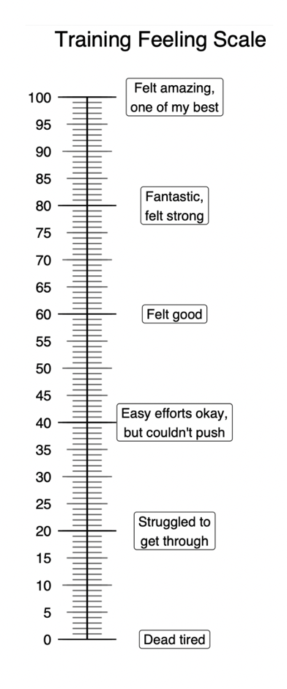

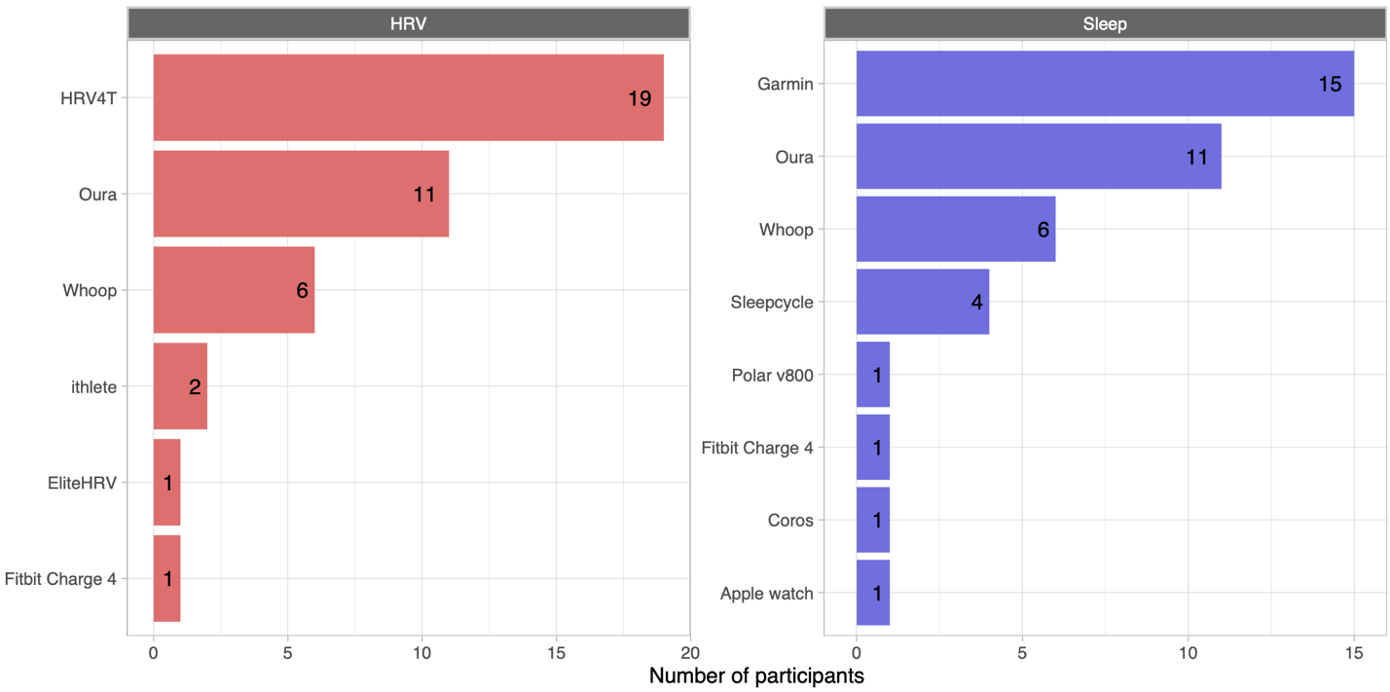

Supplemental figure 2. Participant devices used for sleep and HRV tracking.

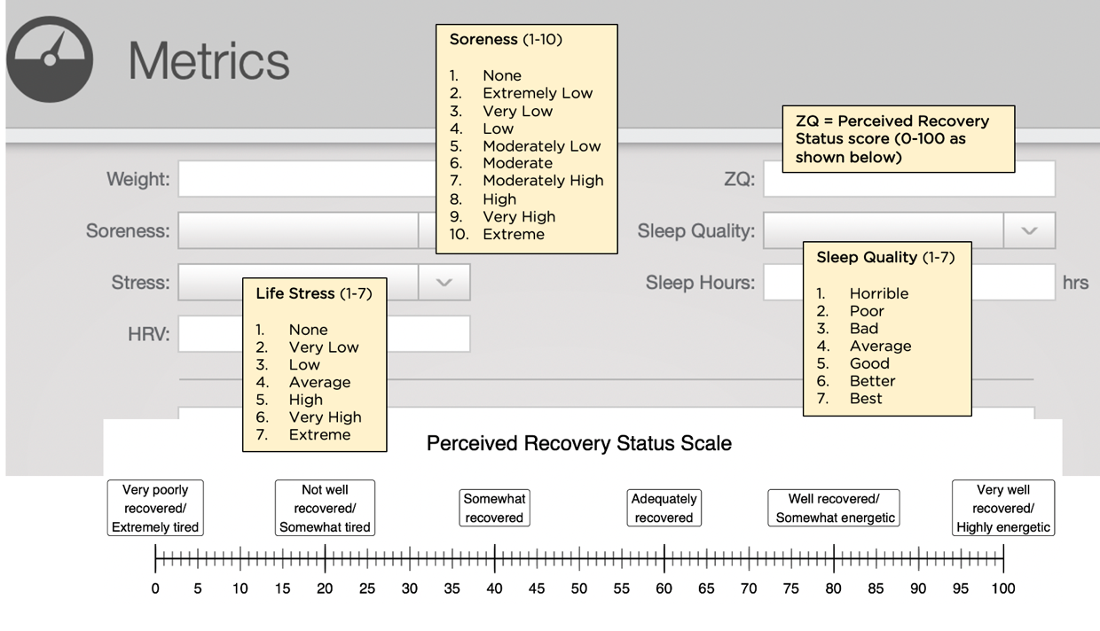
Supplemental figure 3 – 100-pt PRS scale and scale for other subjective measures

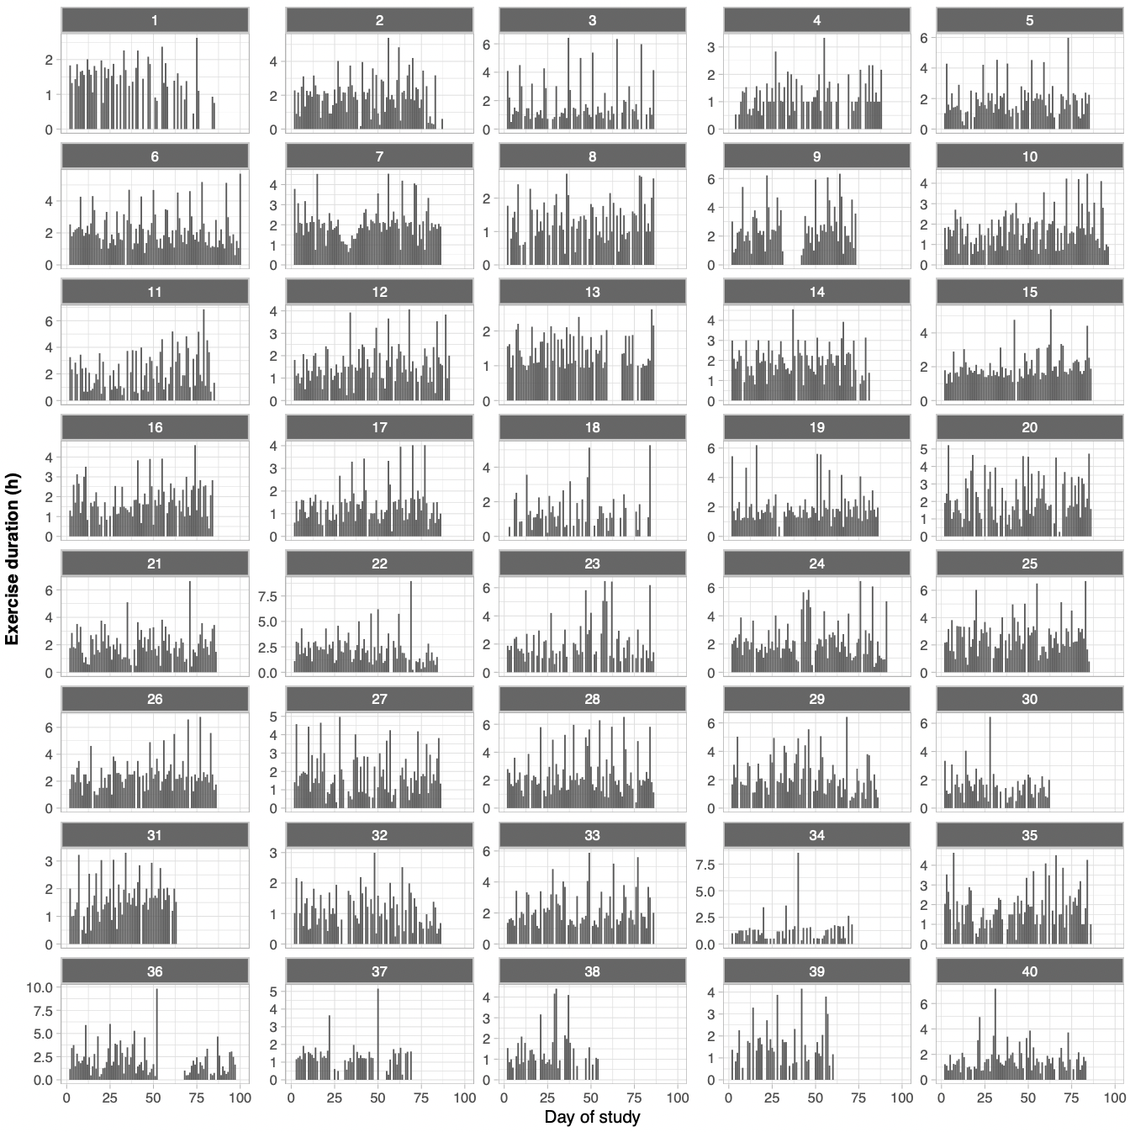
Supplemental figure 4 – Daily training volume (hours per day) for each participant for each day of the study.

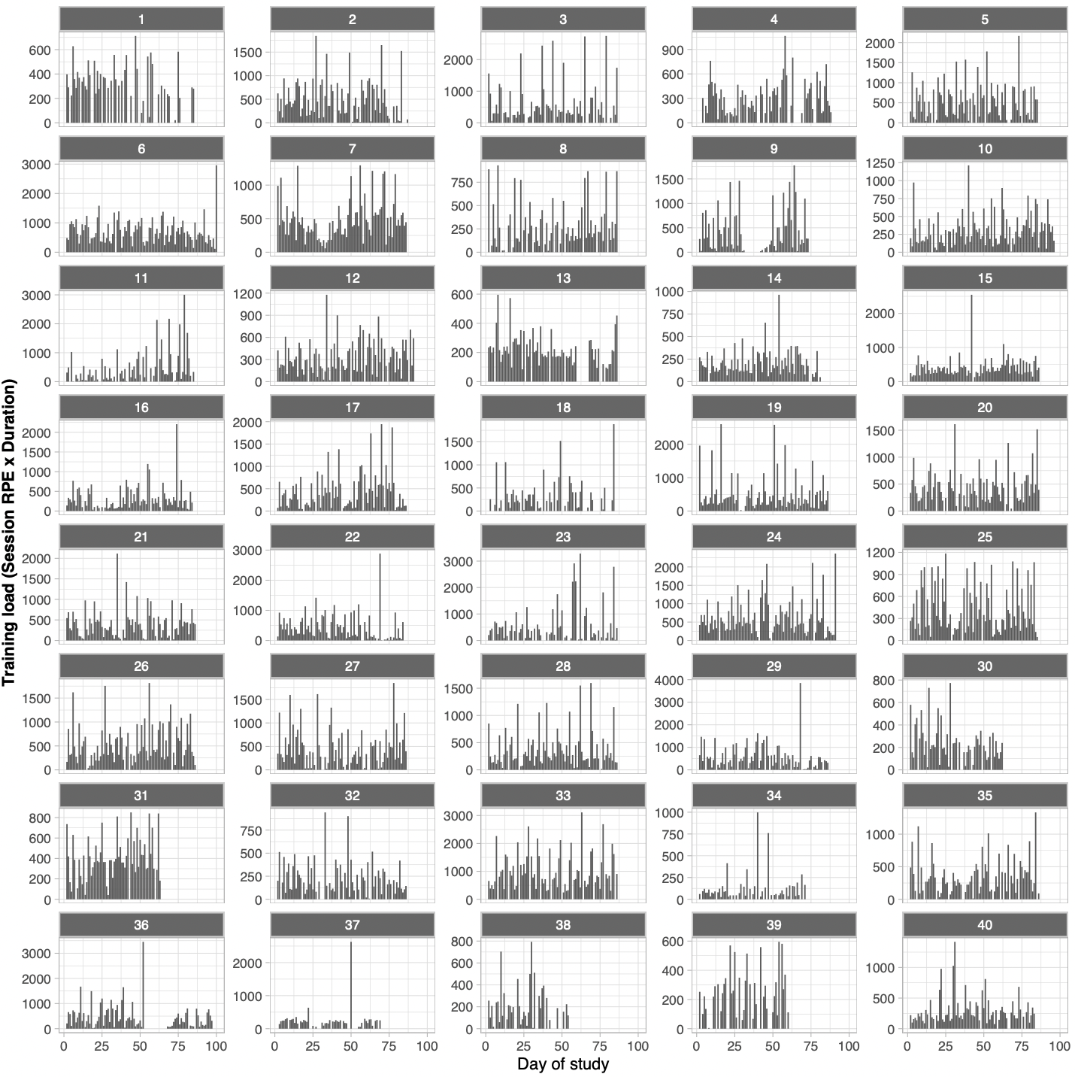
Supplemental figure 5 – Daily training load (product of session RPE and exercise duration in minutes) for each participant for each day of the study.

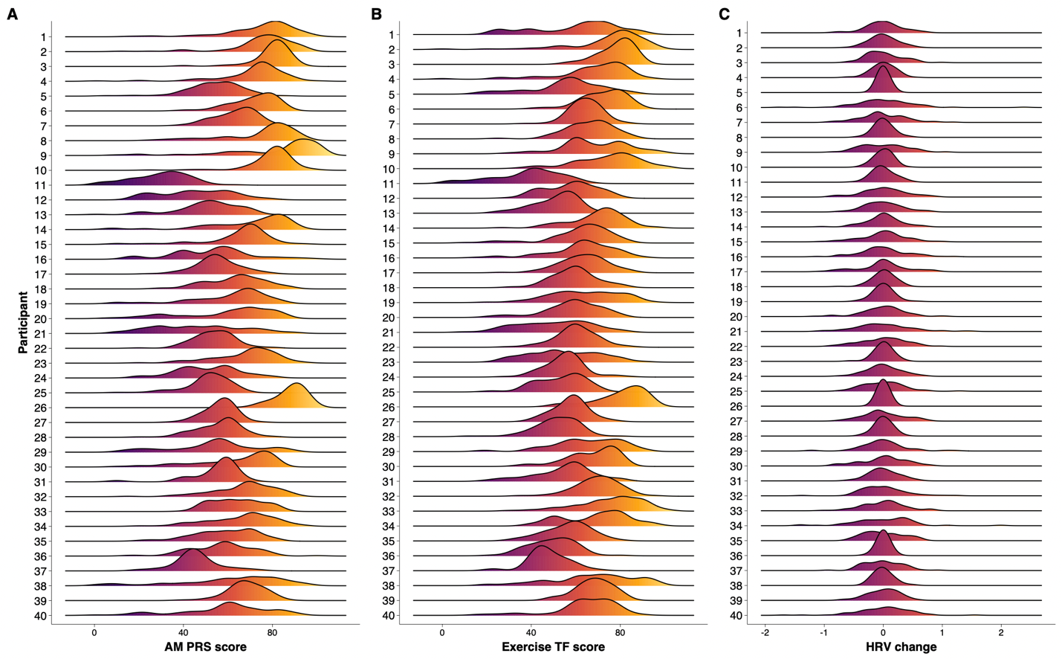
Supplemental figure 6 – Density plot showing the distribution of the three main outcome variables for each participant.

