A clarification of the (mis)use of the term ‘load’ in sport and exercise science: why it is appropriate and scientific |  | For correspondence: franco.impellizzeri@uts.edu.au
Franco M. Impellizzeri¹, Annie C. Jeffries¹, Asaf Weisman², Aaron J. Coutts¹, Alan McCall^{1,3}, Shaun J. McLaren^{4,5} Judd T. Kalkhoven¹
¹ School of Sport, Exercise and Rehabilitation, Faculty of Health, University of Technology Sydney, NSW, Australia, ² Spinal Research Laboratory, Department of Physical Therapy, Stanley Steyer School of Health Professions, Sackler Faculty of Medicine, Tel Aviv University, Israel, ³ Arsenal Performance and Research Team, Arsenal Football Club, London, United Kingdom, ⁴ Newcastle Falcons Rugby Club, Newcastle upon Tyne, United Kingdom, ⁵ Department of Sport and Exercise Sciences, Durham University, Durham, United Kingdom
Please cite as: Impellizzeri, F. M., Jeffries, A. C., Weisman, A., Coutts, A. C., McCall, A., McLaren, S. J., & Kalkhoven, J. T. (2021). A clarification of the (mis)use of the term ‘load’ in sport and exercise science: why it is appropriate and scientific. SportRxiv. Doi:

ABSTRACT
A recent paper called for the ﻿abandonment of the term load (and training load) when used outside its mechanical meaning, claiming it is “unscientific” and “breaches scientific principles.” In this article, we explain why its use does not breach any scientific principles and we clarify the process of labelling, conceptualising and operationalising a construct. Training load is simply a label attributed to a higher-order construct overarching other interrelated sub-dimensions. This multi-level structure provides a framework (nomological network) to support the research process and also practical applications. Load is a word, and therefore cannot be “unscientific”. The “use” or “misuse” of words and terms entirely depends upon definitions that should be based on current understanding. Misuse occurs when a term is decontextualised or interpreted according to a unilateral perspective. The field of mechanics does not have a monopoly on the term load (or other common terms such as work, stress and fatigue), which are legitimately used in many scientific areas and with various meanings. The ‘obligation’ to rely on terms abiding by the Système International d’Unités (SI) when describing a construct is inappropriate. The SI relates to how we can measure, not describe training load; i.e., SI is relevant to its operational and not its constitutive (descriptive) definition. Discussions regarding shared and standardised descriptions and definitions are more relevant than discussions about discarding terms in sport and exercise science. Researchers (and practitioners) can continue to use the term training load as it does not breach any scientific principles.
INTRODUCTION
Staunton and colleagues¹ recently published an opinion piece in the Journal of Science and Medicine in Sport which suggested dismissing the use of the term load (and hence training load), claiming it is “unscientific” and “breaches principles of science”; essentially because it is used outside of a mechanical context. Whilst Staunton and colleagues’¹ call for better use of definitions is a welcome one, it is our opinion that they failed to provide sound and valid arguments that justify the abandonment of the term load (and training load) from the sport and exercise science vernacular. Although we directly refer to the opinion piece of Staunton and colleagues,¹ we preface this by saying that we have simply used the article from these authors as a means to clarify some fundamental concepts and inconsistencies that can generate misunderstandings and potentially misleading or confusing interpretations. The contents of this article can be extended to other terminological debates and our intent is to offer the reader notions that can help with addressing theoretical and conceptual issues more scientifically (i.e., focusing on the process and not on purely semantic ‘battles’) to advance the field of exercise science and medicine. Finally, we explain why the term load, and specifically the construct of training load, does meet scientific principles, and can be used in both practice and research.

Is the use of load “unscientific”?

Staunton and colleagues¹ wrote that “﻿the term ‘training load’ is unscientific and must therefore be abandoned.” However, words or terms by themselves cannot be unscientific. For example, the word spiritualism depicts a construct, which at first glance may appear to be “unscientific”. Nevertheless, this word can be defined and conceptualised in a way that it meets the requirements to be considered a scientific construct and investigated using the scientific method.² Without entering too deeply into a philosophical debate concerning the demarcation of science and non-science,³ we can posit that something can be considered unscientific when it cannot be investigated following the scientific method. Scientific relates to the process of acquiring knowledge and is not simply a semantic property of a term. This is coherent with the definition of science provided by the Science Council (https://sciencecouncil.org/):

“Science is the pursuit and application of knowledge and understanding of the natural and social world following a systematic methodology based on evidence.”

Whilst the misuse of words and terms is not necessarily unscientific, it can be classified as poor practice because it confounds mutual understanding, thus impairing scientific progress. Similarly, it is poor practice to extrapolate, decontextualise or reinterpret arguments and definitions provided in previous articles to support personal perspective. For example, Staunton and colleagues¹ referred to an article by Knuttgen and Kraemer⁴ to highlight that in sport and exercise science, several terms have historically been misused. However, this reference⁴ showed the opposite of what they intended to communicate, and their use¹ did not reflect the contents of the original paper. In reality, Knuttgen and Kraemer⁴ provided a prime example of why descriptive definitions and contextualisation are essential to avoid confusion, and also offered an appropriate solution.

Context matters
In their first paragraph, Staunton and colleagues¹ wrote:
“For example, Knuttgen and Kraemer reminded sport and exercise scientists that an isometric muscle ‘contraction’ is not possible. The term ‘contraction’ means to shorten and in isometric activity there is no movement. Hence the term isometric muscle action is preferred.”
However, such a statement misinterprets the work of Knuttgen and Kraemer,⁴ who did not call for the abandonment of terms, unlike Staunton and colleagues.¹ Indeed, the goal of Knuttgen and Kraemer⁴ was not to “remind[ed] sport and exercise scientists that an isometric muscle ‘contraction’ is not possible”,¹ so that this term can be replaced. Rather, Knuttgen and Kraemer⁴ accepted that physiologists had used the term contraction outside of its dictionary meaning, acknowledging that “the term contraction would appear to be firmly entrenched by history and tradition as referring to activated muscle.”, and opted to retain it. Whilst they made it clear that adopting the dictionary definition of contraction (i.e., shortening or shortening and thickening) would create a contradiction when combined with the terms concentric, eccentric, and isometric, their ‘solution to the dilemma’ was exemplary and merits dissection. They proposed to “define muscle contraction as, ‘the active state of muscle tissue; the attempt of muscle to shorten’”, and that “no directionality is to be inferred”.⁴ Accordingly, Knuttgen and Kraemer⁴ did not suggest abandoning the term contraction, rather, they adopted an adaptive strategy, opting to retain and redefine the term contraction to better fit the context within which it was commonly used. In doing so, Knuttgen and Kraemer⁴ respected the widespread use by physiologists of the non-dictionary meaning and retained the term, providing a new and more contextualised definition of muscle contraction. Such an approach was similarly adopted by Faulkner,⁵ who proposed that “contraction be redefined as “to undergo activation and generate force” to avoid contradiction within the term ‘isometric contraction.’
Of additional interest, various suggestions within these articles^{4,5} also exemplify that proposing to dismiss terms at variance with current and common understanding within a field and without a shared solution is unsuccessful. Indeed, their proposal to substitute eccentric and concentric with lengthening and shortening has not been widely adopted and these terms (concentric and eccentric) are now consolidated within muscle physiology. We do not believe it can be said, according to the authors’ logic,¹ that the entire community of physiologists are using unscientific terms. Instead, it should be said that this community has adapted terms, and their use is appropriate when contextualised.
Staunton and colleagues¹ aptly described how load is commonly used within sport and exercise science and other disciplines according to different meanings, beyond its mechanical definition. However, instead of trying to build upon, or adapt and improve existing uses of the term,⁶ they dismissed this practice as confusing and unscientific, calling for this term to be discarded. In our view, their suggested solution is radical, unnecessary, and an expression of their personal interpretation of what they believe to be scientific.

Construct labelling, conceptualisation and operationalisation: from constructs to variables

Another fundamental conceptual error that is evident in the first paragraph (and recurring throughout the text) of Staunton and colleagues¹ article is the argument that “terms and nomenclature used to describe exercise should abide by the Système International d’Unités (SI)”.¹ Here, the authors erroneously used the verb “to describe,” and in doing so, have made a common error. This misunderstanding provides an opportunity for us to clarify some concepts: the difference between the label, descriptive and operational definitions of a construct. Use of the SI relates only to the way constructs such as load can be measured, not how they can be described. In other words, the authors have confused the descriptive (constitutive) definition of a construct with its operational definition. ﻿

An essential component of the scientific process is to determine a clear description of a construct and how it can be measured.^{7, 8} A construct, according to the American Physiological Association dictionary (https://dictionary.apa.org/) is “a complex idea or concept formed from a synthesis of simpler ideas”. A construct is a mental construction that is differentiated with concepts primarily by the level of abstraction, which is lower for concepts, or in terms of generalisability.^{9, 10} Stenner et al.¹¹ defined a construct as the means by which science orders observations. To be considered scientific (i.e., to be investigated using the scientific method), a construct would need to possess at least three characteristics: a construct label, a constitutive definition, and operational definitions (Figure 1).

- The construct label

Any mental construction of a phenomenon should be identifiable and communicable. For this reason, we must assign a name to this construct: a label. Training load is the label assigned to a construct that has been created by observing a phenomenon (training). Although labelling is the process of assigning a descriptive word or phrase to a construct, labels are usually not self-explicative and can be ambiguous. Accordingly, it is essential to clarify what we mean when we use a label by providing a constitutive definition.

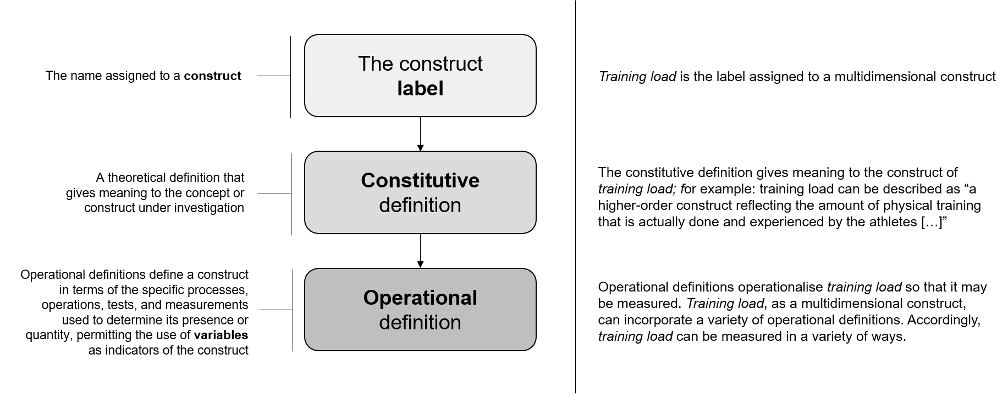

Figure 1. From construct to variables: process.

- Constitutive definition

A constitutive (also called theoretical, conceptual or descriptive) definition is a description that uses other concepts^{7, 8, 12, 13} and gives meaning to the construct or concept under investigation. The conceptualisation of a construct is needed to explain to others the construct identified by the label. Conceptualisation refers to the mental process by which constructs, and their constituent components, are defined in precise terms. Conceptualisation is an inductive process based on background knowledge. Definitions should be clear and unambiguous, meaning they should allow individuals to identify the main concepts, which are the ones that will be operationalised.

Descriptions should reflect current understanding
We agree with Staunton and colleagues¹ that some definitions are unclear and may be misinterpreted. However, a definition of a higher-order construct should be precise but cannot be too specific because it should allow for the inclusion of many subdimensions. It is therefore important not to conflate the necessity of generic definitions with vagueness. Finding a balance is often challenging. A constitutive definition should reflect current conceptions of the construct and related concepts. Conceptual engineering involves not only the development of new concepts but also the revision and adaptation of old concepts to a given task and context (concept re-engineering).^{6, 14, 15} In this regard, valid reservations of a definition should only include issues regarding ambiguity, inconsistencies or errors in the description. However, the authors¹ have rejected the current understanding and interpretation of the term load despite implicitly demonstrating through their examples that the current interpretation of the term load among sport and exercise scientists is often not mechanical (as contraction is not commonly interpreted by its dictionary meaning). Staunton and colleagues¹ also stated that load could be confused with definitions in the structural and electrical fields. It is unreasonable to believe that the majority of sport scientists and practitioners are confused by the term training load because of its mechanical, structural or electrical meanings. Again, context is key. Respectfully, we think that the inability of peers to adopt a suggested definition just because they hold rigid opinions is a problem that should be acknowledged. Ideally, the act of defining concepts should be devoid of false consensus, biases and agendas.

The field of mechanics does not have a monopoly on the term load in science
Staunton and colleagues’¹ arguments exclusively revolve around the ‘improper’ use of single terms, and they suggested their own imposed interpretation as a solution. This occurred without them taking into consideration the current understanding and use of those terms. Indeed, the authors wrote that “﻿a ‘load’ is a mechanical variable that, when used appropriately,
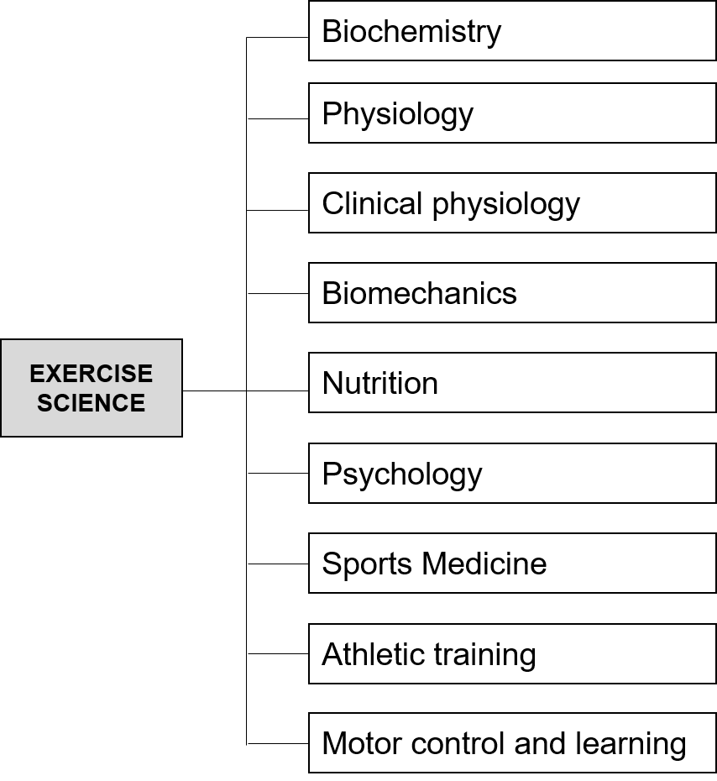

Figure 2. Subdisciplines of sport and exercise science. Adapted from Potteiger.²²

describes a force and therefore should be accompanied with the SI-derived unit of the newton, which has the symbol N. A ‘load’ presented in any other unit, including arbitrary units, is incorrect and does not abide by the principles of science and the SI.” Other constructs use load outside of its mechanical meaning such as allostatic load,¹⁶ cognitive load,¹⁷ mental load,¹⁸ glycemic load,¹⁹ hemodynamic load,²⁰ or the now frequently used viral load.²¹ These are just some examples where load has other, legitimate, contextual connotations. The majority of these contexts are relevant to exercise science which is an interdisciplinary field including several sub-disciplines (Figure 2), of which biomechanics is just one.²² It is therefore not clear from their arguments what principles of science have been broken? Has the term load limited the investigation of these constructs from a scientific point of view? While the authors¹ considered this use (also in other disciplines) confusing, we believe there is no confusion as these terms are used in science, are defined, describe specific constructs and concepts, are measurable, and have been investigated. The argument of the authors that if the term load does not refer to a quantity that can be measured in N, it is therefore unscientific and cannot be used in a scientific context, is not a valid argument because the conclusion is false even when assuming that the premise is true. The aforementioned terms using load and relevant fields of investigation such as perceptual load theory²³ or cognitive load theory²⁴ are just examples invalidating their conclusion.

As aforementioned, we agree that some definitions in sports and exercise science are probably imprecise, ambiguous, and confusing. Nevertheless, although some definitions lack clarity, it cannot be implied that one specific definition or context should prevail by default or according to personal and unilateral preferences. Accepting such a biased approach may ingenerate semantic disputes that have nothing to do with scientific discussion and that will not help advance science. For example, similar arguments could be made for other terms commonly used in sport and exercise science such as stress, strain and fatigue, which also have a mechanical, psychological and physiological meaning. However, such semantics are unnecessary, with the apparent misguided approach appearing to be propelled by another fundamental conceptual error, which is the mixing of constitutive and descriptive definitions with operational definitions.

- Operational definition

Operational definitions are fundamental to the scientific process. They outline a construct in terms of the specific processes, tests and measurements used to determine its presence or quantity, permitting the use of measurements as indicators of the construct. Accordingly, by operationalising the concepts used to describe the construct we create variables reflecting the construct. This notion is well-established in science.^{25, 26} In a seminal paper published almost 90 years ago entitled “the operational basis of psychology”, S. Stevens explained: “We must first define an operation; and, if we are to be consistent, we must define it operationally. An operation is a performance which we execute in order to make known a concept.”²⁷ The American Psychological Association (https://dictionary.apa.org/) defines an operational definition as “a description of something in terms of the operations (procedures, actions, or processes) by which it could be observed and measured”.

In other words, once a label has been assigned to a construct, and once a constitutive or descriptive definition is provided, operational definitions are needed to obtain indicators that reflect the construct. It is at this point that the SI is relevant. Therefore, stating that “terms and nomenclature used to describe exercise should abide by the SI” is conceptually incorrect. Terms to ‘describe exercise’ should only be conceptualised and defined. Afterward, the concepts used in the description can be operationalised to obtain measures reflecting the concepts, eventually using the SI. A problem may arise if a concept used in the description cannot be operationalised; this would not be scientific. For example, if we would define load or training load as the ‘living energy generated by the soul’, there is no reasonable operationalisation that would allow us to connect the concept of ‘living energy of the soul’ to a measure. Clearly, this is not the case for load. All the examples provided by the authors from previous studies actually confirm there are various operationalisations that have allowed scientific investigation. However, operationalising so that the SI can be used is not even an obligation as the authors have claimed¹, and it is not a requirement of science. For example, psychological and perceptual aspects of exercise can be measured without the use of the SI; unless it is to be considered that the fields of psychology, psychophysics and sociology are unscientific. Based on the reasoning presented, it appears evident by the majority of the arguments raised by the authors¹ that they have simply conflated how the construct can be measured with how it should be described.

Uni and multidimensional constructs

An important aspect when conceptualising constructs is understanding whether they are unidimensional or multidimensional. Unidimensional constructs are expected to have a single underlying dimension. They can be measured using a single measure or test, while multidimensional constructs consist of interrelated attributes or dimensions within a multidimensional domain.^{10, 28} According to this formulation, training load falls in the category of a multidimensional construct, acting as a higher-order construct whereby the subdimensions of external training load and internal training load are different forms manifested by the construct.²⁸ Considering the underlying dimensions of training load (which are also multidimensional constructs with their own description),¹⁰ a single operational definition (i.e., a single measure) cannot encapsulate all possible dimensions of the constructs of training load, external training load, or internal training load. It is the constitutive definition and not the operational definition that can describe a multidimensional construct and that can (conceptually) capture all of the dimensions of the construct. According to their multidimensional nature, various operational definitions may exist, with these definitions permitting the use of a variety of measures reflecting the constructs. These measures may differ in terms of the information that they provide regarding the constructs.¹⁰

Staunton and colleagues¹ admitted that they ﻿“are not aware of any other field of science where different constructs are combined into a meta-construct, like ‘training load’.” The authors have overlooked that similar (and much more complex) multi-level structures and higher-order constructs are common in other disciplines such as psychology, clinimetrics and social sciences. For example, the construct of wellbeing can include various dimensions such as standard of living, social relationships, and health. Social relations can have two sub-dimensions such as community and personal, and health has other sub-dimensions such as physical and psychological health, and so on.²⁹ Even in sport and exercise science examples of other multidimensional constructs exist, such as musculoskeletal fitness, which includes the sub-dimensions of muscle strength, muscle endurance and muscle power.^{30, 31} Similarly to training load, each of these sub-dimensions can also have other lower-level dimensions, and all can be operationalised in a variety of ways, resulting in a number of different variables.

The misunderstandings of the authors¹ are further illustrated in this excerpt: “these metrics are the product of an intensity factor (RPE or HR [weighted based on value]) and an exercise duration factor (minutes). In these instances, it appears that ‘training load’ represents the construct of exercise volume. ﻿But to add confusion, other researchers have quantified ‘training load’ by simultaneously reporting measures of both volume and intensity.” Here, the authors¹ attributed the confusion to the researchers using different measures of training load. The implicit question is whether training load is the volume or the intensity. The authors¹ have again overlooked the multi-level structure, where training load is the higher-level construct underlying two dimensions (internal and external load), each of which can be quantified in terms of volume and intensity, and intensity can be measured using absolute or relative measures. This is also consistent with the classifications of intensity measures provided by the authors. There is nothing particularly confusing about considering both volume and intensity as dimensions under training load. It is the sentence of the authors (“training load represents the construct of exercise volume”)¹ that appears confusing because it should be the other way around: “exercise volume represents the construct training load.”

As explained in a seminal article by Cronbach & Meehl in 1955,³² the multi-level structures of multidimensional constructs help to define a nomological network. This framework can be used for designing validation studies and supports the research process. The validity of the structure of the multidimensional construct of training load, along with its sub-dimensions, to date, can only be inferred by studies demonstrating that measures of internal and external training load are related. For example, the strength of the associations reported in the literature and the possibility to dissociate internal and external load, support that the sub-dimensions are indeed interrelated but different constructs coherent with the proposed hierarchy and structure (Figure 3).³³

Logical inconsistencies and double standards

Intensity
In scientific reasoning and communication, logic and coherence are important,³⁴ but Staunton and colleagues¹ proposed solution (framework) is illogical and does not even fit within their own main criterion for considering a term as scientific (i.e., abiding by the SI). For example, they provided a solution to use only intensity and volume while acknowledging that intensity also has another meaning (luminous intensity) which is measured using candela (cd) as the SI unit. However, in addition to this, other definitions can also be found even within physics (e.g., radiant intensity and photon intensity, which uses other SI units).³⁵ Nevertheless, they considered this acceptable because intensity is not a “universally defined term,” and ﻿exercise intensity is not defined in the base SI (but this is also actually the case for training load). How can a term that is “not universally defined” help resolve the problems of ambiguity that Staunton and colleagues¹ themselves identified? By criticising and providing several dictionary definitions of load, together with examples of ‘inappropriate’ use of load in other scientific areas, the authors actually demonstrated that load has no accepted universal meaning (like intensity). It therefore follows that the mechanical connotation of load is certainly not universal. Remarkably, the authors have decided that for intensity this situation is acceptable, but for load it is not; which is a double standard.

When Staunton and colleagues¹ provided their ‘solution’, they made the same errors they ascribed to other researchers. They defined intensity in the text as

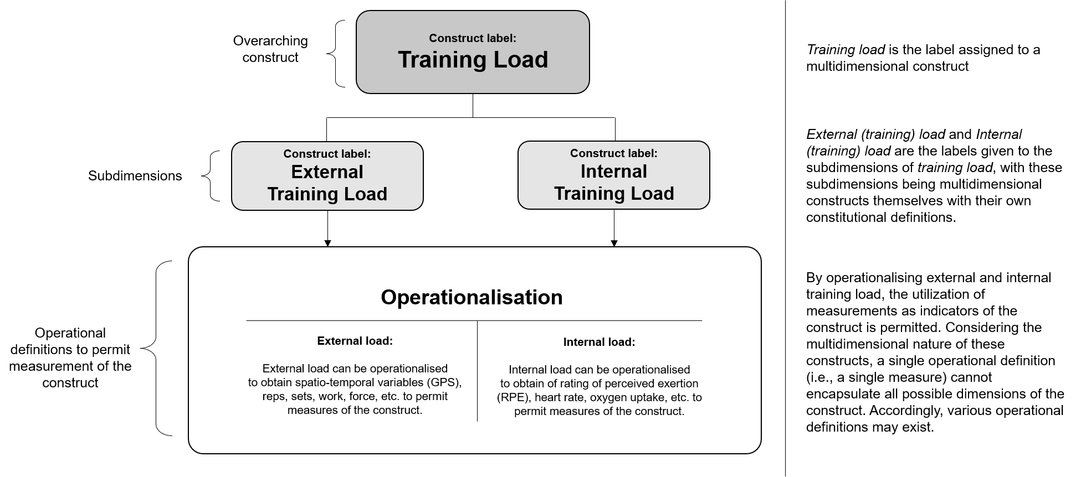

Figure 3. Multidimensional structure of the training load construct.

“how hard somebody is exercising.” ‘How hard’ cannot be measured using the SI and if “terms and nomenclature used to describe exercise should abide by the Système International d’Unités”, hard is not what the authors consider a ‘scientific’ term, according to their own standards. Furthermore, the majority of examples of objective measures of intensity do not fit the description because ‘how hard’ is strictly connected to perception (i.e., psychophysics instruments), otherwise it would not be possible to classify something as more or less ‘hard’. In reality, as load can be measured in different ways, so intensity can also be measured in different ways through specific operationalisation and validation processes. This requires intensity to be connected to a measure reflecting “how hard” an exercise is. To add to the inconsistency, hard(ness) also has a mechanical meaning, referring to the resistance of a material to localised plastic deformation, which would abide by the SI. However, it is clear that the authors¹ have not used the term ‘hard’ as per its mechanical meaning, and unfortunately, according to the ‘logic’ of the authors, if it is not measured in N/mm², its use would not be scientific. As a further inconsistency, the authors¹ also provided (in their Table 1) a second and different definition of intensity, which is as confusing as having different definitions of training load, as they allege: “﻿The specific level of muscular activity that can be quantified in terms of power (rate of energy expenditure), force, or velocity.” Not only is this a second definition provided within the same article, but muscle activity is not a well-defined term because a physiologist may interpret this as muscle activation, which is unlikely to be measured using power, force or velocity. If terms and nomenclature used to describe exercise should abide by the SI, then muscle activity does not meet this criterion. However, this definition is actually acceptable but only if the same criteria used for load and training load are also accepted. Indeed, the link between the level of muscular activity and measures such as power, velocity and force can be supported by operationalisations that connect these measures to levels of muscle ‘activity’.

Volume and frequency
Regarding the use of volume, again, the authors¹ wrote that it is possible to use non-SI units or dimensionless units…carefully. However, this is again in contradiction to their criteria (abiding by the SI). Furthermore, volume is the quantity/amount of three-dimensional space (i.e., m³ according to SI).³⁵ Yet, the definition of the term volume has been adapted outside of its physics meaning to fit into the context of exercise. The same inconsistency can be found for frequency, which is measured in Hz (1/T) according to the SI, but it is used by the authors in a more generic way that does not abide by the SI. Accordingly, they have granted themselves licence to overcome their own criteria, but this apparent luxury was not permitted for training load and its lower-level constructs.

Additionally, the authors presented the volume formula from the ACSM, reminding us that “﻿the world’s largest sport and exercise science professional organisation, suggests the use of the terms frequency (F), intensity (I), time (T), and type (T) for exercise monitoring and prescription (known as the FITT principle).”³⁶ However, that was not the formula for exercise monitoring and prescription, but the formula proposed for aerobic exercise prescription [“﻿Aerobic (Cardiorespiratory Endurance) Exercise”]. Indeed, for resistance exercise, ACSM quantifies volume using sets and repetitions and uses total duration for flexibility. Evidently, the concept volume, and consequently its operationalisation, was adapted by ACSM to the context, as with load. ﻿The authors also stated that “inconsistencies and variations in the terms used by the ACSM are problematic” because of the use of the term load. We add that the ACSM³⁶ also uses the terms work and workload and even “physical work performance” that the authors considered unscientific and confusing. So, it is not clear whether the ACSM is a reference organisation for definitions that meet the expectations of the authors only. Furthermore, similarly to ACSM, terms such as work and workload have also been used in the last 2018 Physical Activity Guidelines Advisory Committee Scientific Report.³⁷ These examples do not confirm confusion in the field but rather confirm that terms do not have a unique meaning and that these meanings may legitimately change depending on the context. This is neither problematic nor unscientific and common practice in science.

In addition to the above points, volume and intensity are not two separate constructs, as the authors reported in their conclusion. If the authors operationalised volume so that it is calculated from intensity, then volume cannot be a ‘separate’ construct since volume is calculated from intensity, duration and frequency under a formative model: i.e., volume incorporates intensity. Volume and intensity are concepts related to the operationalisation of training load. This is not the case for external and internal training load because these two constructs are related, with the internal load being induced by the external load and not calculated from the external load, and neither external nor internal include the other in their operationalisation. To clarify, we are not suggesting that intensity and volume are not appropriate; instead, we are highlighting that the proposed solution by Staunton and colleagues¹ is illogical. It is illogical because in order to be taken into consideration, the authors should accept all of the ‘flaws’ they attributed to the use of the terms load and training load.

Conclusion

In sport and exercise science, as in other sciences, clarity and accuracy of the relevant specialised language are crucial for the dissemination of knowledge, for the reproducibility of results of experiments, and for meaningful discourses between researchers.³⁸ Staunton and colleagues¹ have properly identified an unjustified proliferation of the use of various terms and definitions in sport and exercise science. However, our dissection of their arguments and suggested solutions for dealing with this situation have demonstrated that their framework is illogical and unnecessary because they have missed fundamental aspects pertaining to construct labelling, conceptualisation and operationalisation. Awareness of those fundamental issues may aid in reducing currently overlapping and competing constructs and definitions and consequently lessen confusion and misunderstanding. Researchers and practitioners can continue to use the terms load and training load as they do not and cannot breach any scientific principles. Ultimately, it is up to the sport and exercise science community to provide consistent definitions of its shared constructs. This should be achieved via ontological and epistemological discussions, which in our opinion, are currently needed and more beneficial than mere semantic discussions.
9-
References
1. Staunton CA, Abt G, Weaving D, Wundersitz DWT. Misuse of the term ‘load’ in sport and exercise science. J Sci Med Sport 2021 ﻿https://doi.org/10.1016/j.jsams.2021.08.013
2. MacDonald DA, Friedman HL, Brewczynski J, et al. Spirituality as a scientific construct: testing its universality across cultures and languages. PLoS One. 2015; 10(3):e0117701.
3. Sven Ove H. "Science and Pseudo-Science". In: Zalta EN, ed. The Stanford Encyclopedia of Philosophy Fall edition 2021.
4. Knuttgen HG, Kraemer WJ. Terminology and Measurement in Exercise Performance. J Strength Cond Res 1987; 1(1):1-10.
5. Faulkner JA. Terminology for contractions of muscles during shortening, while isometric, and during lengthening. J Appl Physiol 2003; 95(2):455-459.
6. Vessonen E. Conceptual engineering and operationalism in psychology. Synthese 2021. https://doi.org/10.1007/s11229-021-03261-x
7. Hoy WK. Concepts, variables, and research problems. Quantitative Research in Education: A Primer. Thousand Oaks, California: SAGE Publications, Inc.; 2010.
8. Reznick JS. Defining Constructs and Variables, in The Developmental Scientist's Companion: Improving Research Methodology and Achieving Professional Success. Reznick JS, ed^eds. Cambridge, Cambridge University Press, 2017.
9. Markus KA. Constructs, Concepts and the Worlds of Possibility: Connecting the Measurement, Manipulation, and Meaning of Variables. Measurement 2008; 6(1-2):54-77.
10. Bhattacherjee. Social Science Research: Principles, Methods and Practices, 2012.
11. Stenner AJ, Smith M, Burdick DS. Toward a Theory of Construct Definition. J Educ Meas 1983; 20(4):305-316.
12. Middendorp CP. On the conceptualization of theoretical constructs. Qual Quant 1991; 25(3):235-252.
13. Willer D, Webster M. Theoretical Concepts and Observables. Am Sociol Rev 1970; 35(4):748-757.
14. Chalmers DJ. What is conceptual engineering and what should it be? Inquiry 2020:1-18.
15. Cappelen H. Fixing Language. An Essay on Conceptual Engineering. Oxford: Oxford University Press 2018.
16. D'Amico D, Amestoy ME, Fiocco AJ. The association between allostatic load and cognitive function: A systematic and meta-analytic review. Psychoneuroendocrinology 2020; 121:104849.
17. Naismith LM, Cavalcanti RB. Validity of Cognitive Load Measures in Simulation-Based Training: A Systematic Review. Acad Med 2015; 90(11 Suppl):S24-35.
18. Adamczyk AK, Ligeza TS, Wyczesany M. The dynamics of pain reappraisal: the joint contribution of cognitive change and mental load. Cogn Affect Behav Neurosci 2020; 20(2):276-293.
19. Jenkins DJA, Dehghan M, Mente A, et al. Glycemic Index, Glycemic Load, and Cardiovascular Disease and Mortality. N Engl J Med 2021; 384(14):1312-1322.
20. Cooper LL, Rong J, Benjamin EJ, et al. Components of hemodynamic load and cardiovascular events: the Framingham Heart Study. Circulation 2015; 131(4):354-361; discussion 361.
21. Lopman BA, McQuade ETR. Using viral load to model disease dynamics. Science 2021; 373(6552):280-281.
22. Potteiger JA. American College of Sports Medicine’s introduction to exercise science, Third edition ed, Philadelphia, Wolters Kluwer Health; 2018.
23. Murphy G, Groeger JA, Greene CM. Twenty years of load theory—Where are we now, and where should we go next? Psychon Bull Rev 2016; 23(5):1316-1340.
24. Sweller J. CHAPTER TWO - Cognitive Load Theory, in Psychology of Learning and Motivation. Mestre JP, Ross BH, ed^eds, Academic Press, 2011.
25. Boring EG. The use of operational definitions in science. Psychol Rev 1945; 52(5):243-245.
26. Slife BD, Wright CD, Yanchar SC. Using Operational Definitions in Research: A Best-Practices Approach. J Mind Behav 2016; 37(2):119-139.
27. Stevens SS. The Operational Basis of Psychology. Am J Psychol 1935; 47(2):323-330.
28. Law KS, Wong C-S, Mobley WH. Toward a Taxonomy of Multidimensional Constructs. Acad Manage Rev 1998; 23(4):741-755.
29. Olsen JA, Misajon R. A conceptual map of health-related quality of life dimensions: key lessons for a new instrument. Qual Life Res 2020; 29(3):733-743.
30. Lang JJ, Smith JJ, Tomkinson GR. Global Surveillance of Cardiorespiratory and Musculoskeletal Fitness. In: Brusseau TA, Fairclough SJ, Lubans DR, eds. The Routledge Handbook of Youth Physical Activity. Abingdon: Routledge; 2020.
31. Committee on Fitness Measures and Health Outcomes in Youth, Food and Nutrition Board, Institute of Medicine. Health-Related Fitness Measures for Youth: Musculoskeletal Fitness. In: Pate R, Oria M, Pillsbury L, eds. Fitness Measures and Health Outcomes in Youth. Washington (DC): National Academies Press (US); 2012.
32. Cronbach LJ, Meehl PE. Construct validity in psychological tests. Psychol Bull 1955; 52(4):281-302.
33. McLaren SJ, Macpherson TW, Coutts AJ, Hurst C, Spears IR, Weston M. The Relationships Between Internal and External Measures of Training Load and Intensity in Team Sports: A Meta-Analysis. Sports Med 2018; 48(3):641-658.
34. Giere RN. Understanding Scientific Reasoning, Holt, Rinehart, and Winston; 1991.
35. Cohen ER, Cvitas T, Frey J, et al. Quantities, Units and Symbols in Physical Chemistry, IUPAC Green Book, 2007.
36. Liguori G, Medicine ACoS. ACSM's guidelines for exercise testing and prescription, Lippincott Williams & Wilkins; 2020.
37. Committee PAGA. 2018 Physical Activity Guidelines Advisory Committee Scientific Report: Washington, DC; 2018.
38. Plavén-Sigray P, Matheson GJ, Schiffler BC, Thompson WH. The readability of scientific texts is decreasing over time. Elife 2017; 6:e27725.

