Reciprocal effects of esport participation and mental fatigue among Chinese undergraduate students using dynamic structural equation modeling
Yan Luoª*, Jasmin C. Hutchinson^{b}, Colleen S. O’Connellª, Yanru Sha^{c}
ªDepartment of Physical Education and Health Education, Springfield College, Springfield, MA, USA, 01109;
^{b}Department of Exercise Science and Athletic Training, Springfield College, Springfield, MA, USA, 01109;
^{c}Institute of Physical Education, Ningxia University, Yinchuan, Ningxia, China, 750021;
Email address:
Yan Luo: yluo2@springfieldcollege.edu
Jasmin C. Hutchinson: jhutchinson@springfieldcollege.edu
Colleen S. O’Connell: coconnell3@springfieldcollege.edu
Yanru Sha: 123592032@qq.com
*Corresponding author
Correspondence concerning this article should be addressed to Yan Luo, Department of Physical Education and Health Education, 263 Alden Street, Springfield College, Springfield, MA, USA, 01109. E-mail: yluo2@springfieldcollege.edu.
This is a preprint
Please cite as: Luo, Y., Hutchinson, J. C., O’Connell, C. S., Sha, Y. (2022). Reciprocal effects of esport participation and mental fatigue among Chinese undergraduate students using dynamic structural equation modeling. SportRxiv.

Reciprocal effects of esport participation and mental fatigue among Chinese undergraduate students using dynamic structural equation modeling

Introduction
Electronic sport, often known as esport or competitive gaming, has increased in popularity in recent years. Presently, there is no universal agreement on whether esport should be considered a legitimate sport (Cunningham et al., 2018; Funk et al., 2018). However, a recent review article encouraged incorporating esport in the study of sport psychology, defining esport as a causal or organized competitive activity in which players play video games through electronic platforms that have ranking systems and competitions governed by official leagues at the professional or amateur level (Pedraza-Ramirez et al., 2020). By this definition, esport should be regarded a genuine sport (competitive activity), in contrast to other video games that are mainly recreational in nature.
China surpassed the US as the world’s largest market for digital gaming in 2016 (Zhao & Lin, 2021). Esport is highly popular among Chinese college students. According to the 2017 Report on the Development of Chinese Esport, 87% of Chinese college students have participated in esport before (Report on the Development of Chinese Esport, n.d.). The most popular esport genre for this population is multiplayer online battle arena (MOBA) games such as League of Legends (LOL) played on PC and Honor of Kings (HOK) played on mobile devices.
Participating in esport can be a pleasant and relaxing pastime and may sometimes serve as a way to escape from the hectic college life. However, because playing esport frequently requires a high level of cognitive engagement, excessive participation may result in a high level of mental fatigue (MF), a factor that has been shown to have a detrimental effect on students’ psychological well-being and academic performance (Smith, 2018). Hence, it is critical to understand the relationship between esport participation (EP) and MF to provide evidence for the formulation of intervention programs that might positively impact quality of life and academic achievement for college esport players.
MF is a psychobiological state that can be caused by extended participation in cognitively demanding activities (Marcora et al., 2009). MF is associated with feelings of tiredness, exhaustion, and task aversion, as well as impaired cognitive and behavioral performance (Boksem et al., 2005). Participating in esport is an example of a cognitively demanding activity that can result in MF (Andre et al., 2020). Likewise, problematic gaming behavior (also known as gaming disorder) has been associated with increased levels of MF (Mannikko et al., 2015). Fortes et al., (2020) confirmed the positive effect of gaming on MF in their experimental study, where playing a 30-minute video game induced higher level of MF than watching a 30-minute advertisement video. However, other experimental studies have not found a substantial increase in MF after playing video games (Gundogdu et al., 2021). These contradictory findings may be explained by the use of various video game genres, game durations, MF assessments, and time gaps between game play and MF assessment.
While most research has found a positive correlation between video gaming and MF, many limitations remain. First, none of the previous studies have accounted for the effect of time gap between game play and MF assessment. It is reasonable to speculate that the level of MF right after gameplay would be different from MF after a period of time following gameplay. Second, although video gaming is likely to cause MF, nothing is known about whether greater game participation leads to a higher degree of MF. Third, previous studies have focused only on the unidirectional effect of video gaming on MF without consideration that MF may also have a negative impact on future game participation. In their systematic review, Peracchia and Curcio (2018) reported that a high amount of video gaming may negatively impact cognitively demanding activities the following day, which may be caused by after-game MF. Fourth, previous research has omitted the notion that MF and video gaming are unstable rather than stable variables (i.e., they tend to vary within a short time interval). Examining the relationship between video gaming and MF while considering their instability over time may reveal additional insight into how they relate to each other. Lastly, it is still unclear if participating in esport has an impact on MF, since Aliyari et al. (2020) discovered that different game genres may have different effects on MF. Therefore, it is critical to distinguish esport from regular video games due to its unique characteristics; for example, problematic gaming behavior is assumed to be more prevalent among esport players than traditional online gamers (Chung et al., 2019).
In light of previous limitations in this area of research, this study used an event-contingent ambulatory assessment protocol to assess EP and MF. Specifically, participants were instructed to record their EP time and level of MF right after playing esport (esport as a randomly occurring event for each participant). This method addressed the disadvantage of the uncontrolled time gap between EP and MF assessment in previous studies. As the research on the relationship between esport and MF is still in its infancy, it is important to examine the direct effect of EP on MF, rather than having a time lag between EP and MF assessment. This approach also outperforms laboratory and retrospective assessments in terms of capturing naturalistic experience and minimizing memory recall biases (Fahrenberg et al., 2007; Stone & Broderick, 2007).
To evaluate the data generated by the event-contingent ambulatory assessment, we used the dynamic structural equation modeling (DSEM) framework, which combines the benefits of time series analysis, multilevel modeling, and structural equation modeling (Asparouhov et al., 2018). DSEM models data with intensive time points while allowing for cross-individual variation and path analysis of between-individual effects. This statistical paradigm divides the variation associated with each variable into within-person and between-person parts (Asparouhov et al., 2018). In the present context, at the within level, the mean values for EP and MF can be estimated to reflect the typical EP and MF for each individual. The cross-lagged parameters can also be estimated to describe the bidirectional effects of EP and MF over time. This framework allows for the assessment of lagged or autoregressive effects (also known as inertia, carry-over, or lingering effects) for each variable on itself. Examining this lagged effect is beneficial in that a positive autoregression coefficient would indicate a consistent pattern of EP and MF (previous EP and MF positively impact themselves at present). In contrast, a negative autoregression coefficient suggests a back-and-forth pattern of EP and MF (previous EP and MF negatively impact themselves at present). If the autoregressive coefficient is close to zero, then this demonstrates that EP and MF in the previous moment are not predictive of themselves for the current moment. At the between level, these within-level parameters (means, lagged, and cross-lagged effects) are allowed to vary across individuals and thus can be correlated with each other. While correlating these within-person parameters is exploratory, it may offer further information into the interplay between EP and MF.
The purpose of this study was to examine the reciprocal relationship between EP and MF among Chinese undergraduate students. Specifically, this study aimed to: (a) investigate the effect of EP on after-game MF and vice versa; (b) investigate the inertia of EP and MF; (c) examine the relationship between the aforementioned effects across individuals; (d) examine whether background information (i.e. player characteristics) could predict aforementioned effects. Based on the findings of previous literature, we hypothesized that EP would positively predict after-game MF, and that MF would negatively predict future EP. No hypotheses were made for other effects due to their exploratory nature.

Materials and methods

Participants
198 undergraduate college students from a public university in China were invited to participate in this study. Students completed a background survey to screen for eligibility based on the following criteria: (a) full-time undergraduate student; (b) aged between 18 to 24 years old; (c) play only esport, not other video games; (d) play esport at least five times per week. 110 students were eligible and participated in the following longitudinal study (see Figure 1).
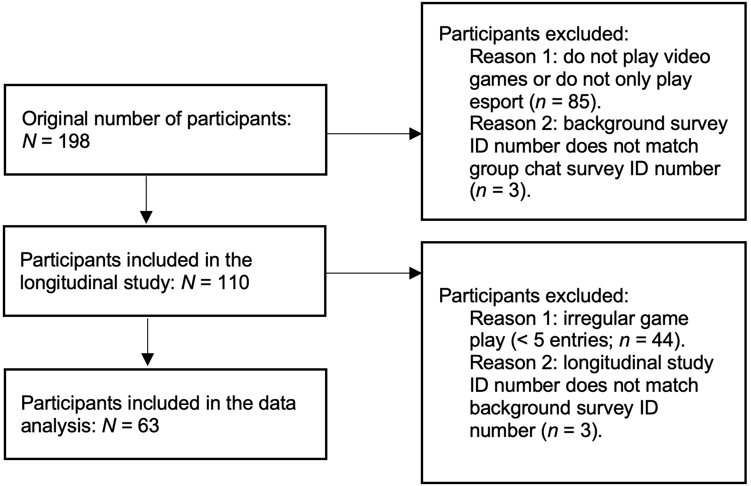
Fig. 1. The screening process of participants.

Measures

Background survey

Background and demographic information were collected using an electronic survey. The survey included questions to determine eligibility (i.e., age, esport genres played, and EP frequency) as well as background information used to describe the sample and to explore the influence of personal characteristics on observed effects. Demographic information included college year, gender, number of years playing esport, and playing preference (playing with friends in person; or playing with friends online). Participants rated the two playing preference questions on a four-point Likert scale (1 = never, 2= sometimes, 3 = most of the time, and 4 = always).

Esport participation
Students were asked to report their EP time (in hours; reported to half an hour; etc., 0.5, 1.0, 1.5, 2.0) immediately after completing each esport session for 15 consecutive days.

Mental fatigue
The Rating of Fatigue scale (Micklewright et al., 2017) was used to assess MF. Immediately after each esport session, participants rated their current state of fatigue by responding to the question “how mentally fatigued do you feel right now?” from “0” (not fatigued at all) to “10” (total fatigue & exhaustion). Micklewright et al. (2017) demonstrated that the Rating of Fatigue Scale has high face validity, as well as strong convergent validity and divergent validity with various physiological and psychophysical measures of fatigue. Single item scales have been used previously to measure MF level among esport college students (Andre et al., 2020; Rhoden et al., 2021). The Rating of Fatigue scale was translated into Chinese following recommendations for cross-cultural adaptation of self-report measures (Beaton et al., 2000). Due to frequent MF assessment, employing a single item for measurement was advantageous so that participants were not overwhelmed by taking the same measure for an extended period of time.

Procedures
The first author received the institutional review board (IRB) approval for the study. A collaborating college professor in China disseminated study questionnaires to students by inviting them and the primary researcher to a group chat on Wechat.
The primary researcher first sent an implied consent form and demographic questionnaire (created using Wen Juan Xing, an online questionnaire management software) to the group chat. Students were asked to fill out these questionnaires, with reminders sent to the group after three and five days. After seven days, any student who did not complete the questionnaires were presumed to be unwilling to participate and were removed from the group chat (students also had the option to remove themselves from the group chat prior to this if they did not wish to participate, although none did so). The primary researcher assessed the participant eligibility and privately messaged those who did not meet the inclusion criteria (n = 85) to inform them and then removed them from the group chat.
Next, the primary researcher sent the online link for EP and MF questions to the group chat. Students were asked to fill out this questionnaire every time they finished playing esport for 15 consecutive days. To ensure a high response rate, the principal investigator sent a group chat message each day at around 9 a.m. reminding participants to complete the questionnaire. To enable tracking of individual data, participants entered their student ID number each time they completed the questionnaire, with completion time taking approximately one minute. Completed questionnaires were automatically stored on Wen Juan Xing and were only accessible to the primary researcher. The primary researcher assigned each participant a non-identifying identification number upon data download and the original ID number was removed.

Statistical analysis
R (R Core Team, 2021) was used for data preparation and Mplus (Muthen & Muthen, 2017) was used for data analysis. The relationship between EP and MF over time was modeled using a bivariate DSEM approach. To align the data from all participants onto a single time spectrum, the time stamp for the first data entry was set to zero, and the timestamps for subsequent data entries were set to the difference between the first and subsequent data entries. The unequal spacing of assessments caused by varying time of playing esport within and across participants was resolved by utilizing the TINTERVAL option in Mplus with a time window of 12 hours. Since the number of available data points accounted for 16.67% of the total number of time windows for participants with the lowest response rate (five responses), the parameter estimate was unlikely to be biased (Asparouhov et al., 2018).
The DSEM decomposed the variance of EP and MF into within-person and between-person parts based on a latent mean approach (Asparouhov et al., 2018). At the within-person level, the means for EP and MF were calculated separately for each individual. Two autoregressive parameters (ranging from -1 to 1) were calculated by regressing present EP(t) and MF(t) on their preceding assessments (t-1). In addition, present MF(t) was regressed on present EP(t) to represent the impact of EP on post-game MF while present EP(t) was regressed on preceding MF(t-1) to represent the impact of MF on EP, serving as two cross-lagged paths. At the between-person level, the six within-person parameters were allowed to vary across individuals (random effects) and were allowed to correlate with each other. Participant characteristics of gender, playing preference (playing with friends in person; or playing with friends online), and number of years playing esport were used as covariates to predict all random effects. Figure 2 showed the graphical representation of the model.
The Bayes full information estimator was used to estimate the model parameters based on non-informative priors. Two Markov chain Monte Carlo (MCMC) chains were used with 50000 each, and a thinning of 10. The 95% credible interval (95%CI) was used to examine statistical significance of effects. If the 95%CI did not contain zero, the corresponding effect was deemed statistically significant. The individually standardized parameters provided by Mplus were used in the results.
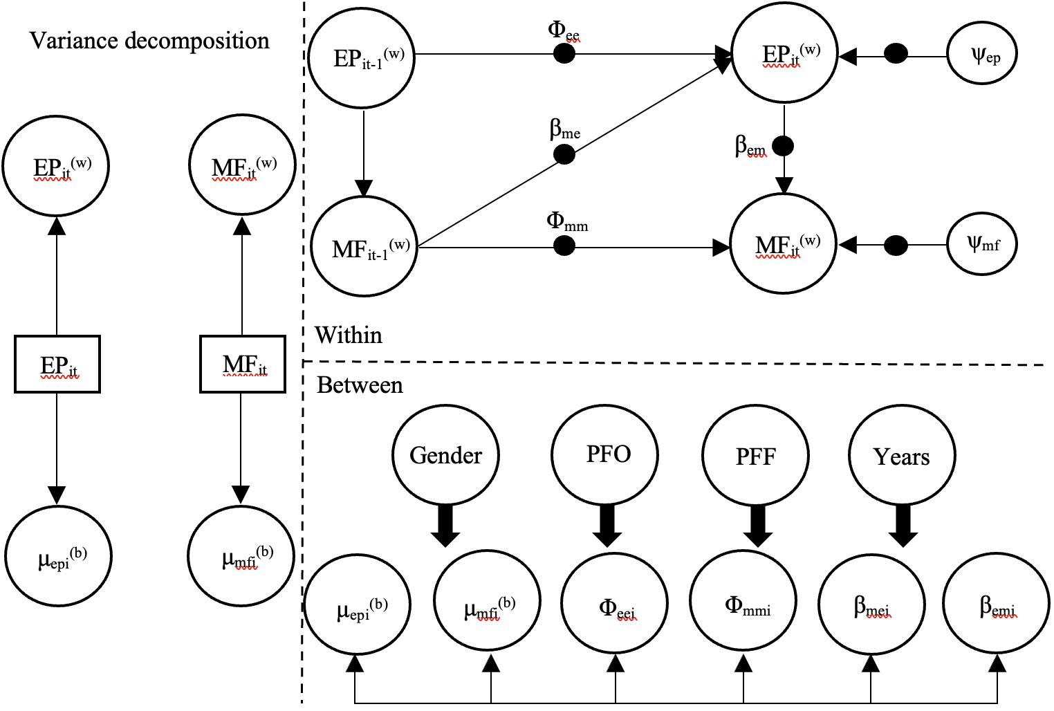
Fig. 2. Graphical representation of the dynamic structural equation model. (w) = within-person effect; (b) = between-person effect; EP = esport participation; MF = mental fatigue; i = individual; t = time point; μ = mean; Φ_{mm} = inertia of mental fatigue; β_{em} = cross-lagged effect of esport participation on mental fatigue; β_{me} = cross-lagged effect of mental fatigue on esport participation; Φ_{ee} = inertia of esport participation; ψ = residual variance; PFO = playing with friends online; PFF = playing with friends in person; Years = number of years playing esport; solid black circles indicate random effects; indicates random effects; indicates all random effects regressed on each covariate.

Results

Data screening and participant characteristics
At the conclusion of the longitudinal survey, participants reported 802 data entries. 85 data entries that occurred within 12 hours of preceding entries stratified by participants were discarded to prepare the dataset for the treatment of unequal spacing issues detailed in the statistical analysis section. Participants (n = 44) with fewer than five data entries over the 15-day data collection period were excluded from the dataset because at least 83% (25 missing responses divided by 30 time windows) of missing data would have been created for those participants, which would bias the individual parameter estimates (Asparouhov et al., 2018). Three individuals were excluded because their longitudinal study ID number did not match their background survey ID number. The data analysis included 63 participants. Descriptive statistics for participants are summarized in table 1. The mean response rate was 9.49 (SD = 3.36).

Table 1
Descriptive statistics of participants’ background information (N = 63).
Variable |  | Frequency | Percentage
Gender | Men | 46 | 73.02%
 | Women | 17 | 26.98%
School year | Sophomore | 62 | 98.41%
 | Freshmen | 1 | 1.59%
Player type | Recreational | 62 | 98.41%
 | Semi-professional | 1 | 1.59%
Esport genre | Honor of Kings | 51 | 80.95%
 | League of Legends | 21 | 33.33%
 | Game for Peace | 5 | 7.94%
 | CS Go | 2 | 3.17%
 | Cross Fire | 1 | 1.59%
 | Battle Field 5 | 1 | 1.59%
 | Call of Duty | 1 | 1.59%
 | Brawl Stars | 1 | 1.59%
 |  | Mean | SD
Age (years) |  | 19.65 | 1.05
Playing online with friends |  | 2.94 | 0.47
Playing face-to-face with friends |  | 2.81 | 0.47
Number of years playing esport |  | 3.65 | 2.46
Esport participation (hours) |  | 2.02 | 1.48
Mental fatigue |  | 4.61 | 2.69

Within-person effects (lagged and cross-lagged effects)
The results of the lagged and cross-lagged effects are presented in table 2. The average autoregressive effect of MF was significantly different from 0 (Φ_{mm} = 0.118, 95%CI = 0.001-0.238). 6.35% of participants had a statistically significant estimate on this effect. The average cross-lagged effect from EP to MF was significantly different from 0 (β_{em} = 0.782, 95%CI = 0.680-0.882), 80.95% of participants had a statistically significant estimate on this effect. The average cross-lagged effect from MF to EP was significantly different from 0 (β_{me} = -0.382, 95%CI = -0.572–0.203). 25.40% of participants had a statistically significant estimate on this effect.

Table 2
Individually standardized estimate of lagged and cross-lagged effects (N = 63).
 |  |  |  |  | 95%CI
Predictor | Outcome | Notation | Estimate | PSD | Lower | Upper | Percentage
MF(t-1) | MF(t) | Φ_{mm} | 0.118* | 0.061 | 0.001 | 0.238 | 6.35%
EP(t) |  | β_{em} | 0.782*** | 0.051 | 0.680 | 0.882 | 80.95%
EP(t-1) | EP(t) | Φ_{ee} | 0.182 | 0.099 | -0.021 | 0.361 | 3.17%
MF(t-1) |  | β_{me} | -0.382*** | 0.091 | -0.572 | -0.203 | 25.40%
Note. * p < 0.05, *** p < 0.001; MF = mental fatigue; EP = esport participation; PSD = posterior standard deviation; CI = credible interval.

Between-person effects

Correlation between random effects
The results of the correlation between random effects are presented in table 3. The mean EP was positively associated with mean MF (r = 0.379, 95%CI = 0.045-0.628), inertia of MF (r = 0.582, 95%CI = 0.201-0.810), and negatively associated with the cross-lagged effect from MF to EP (r = -0.862, 95%CI = -0.972–0.608). The inertia of MF was negatively associated with the cross-lagged effect from MF to EP (r = -0.538, 95%CI = -0.792–0.136) and inertia of EP (r = -0.430, 95%CI = -0.732–0.009).

Table 3
Correlation between random effects (N = 63).
Variable | 1 | 2 | 3 | 4 | 5 | 6
1 μ_{epi} | -
2 μ_{mfi} | 0.379* | -
3 β_{em} | -0.190 | 0.281 | -
4 Φ_{mm} | 0.582** | 0.105 | 0.022 | -
5 β_{me} | -0.862*** | -0.293 | 0.178 | -0.538** | -
6 Φ_{ee} | 0.244 | 0.106 | -0.174 | -0.430* | -0.409 | -
Note. * p < 0.05, ** p < 0.01, *** p < 0.001; μ_{epi} = mean esport participation; μ_{mfi} = mean mental fatigue; β_{em} = cross-lagged effect of esport participation on mental fatigue; Φ_{mm} = inertia of mental fatigue; β_{me} = cross-lagged effect of mental fatigue on esport participation; Φ_{ee} = inertia of esport participation.

Random effects regressed on covariates
The results of the random effects regressed on covariates are presented in table 4. None of the covariates significantly predicted the random effects.

Table 4
Random effects regressed on covariates (N = 63).
 |  |  |  | 95%CI
Predictor | Outcome | Estimate | PSD | Lower | Upper
Gender | μ_{epi} | -0.083 | 0.145 | -0.361 | 0.207
 | μ_{mfi} | -0.147 | 0.147 | -0.421 | 0.155
 | Φ_{mm} | -0.193 | 0.164 | -0.477 | 0.157
 | β_{em} | -0.124 | 0.168 | -0.426 | 0.226
 | Φ_{ee} | -0.013 | 0.220 | -0.457 | 0.398
 | β_{me} | 0.104 | 0.165 | -0.211 | 0.418
Playing with friends online | μ_{epi} | 0.062 | 0.145 | -0.225 | 0.346
 | μ_{mfi} | 0.072 | 0.147 | -0.224 | 0.352
 | Φ_{mm} | 0.105 | 0.168 | -0.233 | 0.415
 | β_{em} | 0.099 | 0.162 | -0.238 | 0.396
 | Φ_{ee} | -0.015 | 0.223 | -0.419 | 0.436
 | β_{me} | -0.086 | 0.172 | -0.419 | 0.251
Playing with friends face-to-face | μ_{epi} | 0.189 | 0.139 | -0.096 | 0.447
 | μ_{mfi} | -0.021 | 0.144 | -0.297 | 0.263
 | Φ_{mm} | -0.033 | 0.160 | -0.343 | 0.286
 | β_{em} | -0.101 | 0.161 | -0.405 | 0.226
 | Φ_{ee} | 0.178 | 0.214 | -0.265 | 0.556
 | β_{me} | -0.294 | 0.161 | -0.583 | 0.036
Number of years playing esport | μ_{epi} | 0.107 | 0.145 | -0.180 | 0.383
 | μ_{mfi} | 0.015 | 0.146 | -0.264 | 0.303
 | Φ_{mm} | -0.223 | 0.168 | -0.520 | 0.133
 | β_{em} | -0.293 | 0.159 | -0.570 | 0.051
 | Φ_{ee} | 0.047 | 0.201 | -0.343 | 0.441
 | β_{me} | -0.068 | 0.166 | -0.390 | 0.260
Note. μ_{epi} = mean esport participation; μ_{mfi} = mean mental fatigue; β_{em} = cross-lagged effect of esport participation on mental fatigue; Φ_{mm} = inertia of mental fatigue; β_{me} = cross-lagged effect of mental fatigue on esport participation; Φ_{ee} = inertia of esport participation. PSD = posterior standard deviation; CI = credible interval.

Discussion
The purpose of this study was to investigate the reciprocal relationship between EP and MF. The results showed that increased amount of EP resulted in a greater level of MF for the majority of students (80.95%) immediately after gameplay. Increased MF resulted in a lower amount of EP for around a quarter of participants (25.4%) after 12 hours of gameplay. A small number of students (6.35%) experienced inertia of MF (i.e. carry-over effects) after 12 hours of gameplay. Greater mean EP was linked with increased mean MF, increased MF inertia, and a stronger negative influence of MF on later EP. Increased MF inertia was related with a stronger negative effect of MF on later EP and a decreased EP inertia.

Inertia
The standardized autoregressive coefficient of MF indicated a relatively low inertia from one assessment to the next, indicating that if students experience an increase or reduction in MF relative to their baseline level at one point in time, there is a good chance that this change will be partially carried over 12 hours later. However, the lower boundary of the 95%CI for this effect was close to zero and this relationship was only applicable to 6.35% of the participants. This implies that the majority of participants may return to their normal level of MF within 12 hours of playing esport. This finding aligns with the work of Jacquet et al. (2021), in that the MF level gradually decreased for 20 minutes after a cognitively demanding activity, although notably it did not return to pre-task levels. The autoregressive coefficient for EP was insignificant, showing that participants tended to spend an arbitrary rather than a certain amount of time on playing esport on a daily basis.

Cross-lagged effects
The study was particularly interested in the two cross-lagged effects of EP and MF. Consistent with prior research (Fortes et al., 2020), the current study revealed that increased EP resulted in an increased level of post-game MF for the majority of students. In comparison to earlier research, this study established more robust evidence for this effect by exhibiting four merits: (1) recall bias was minimized by measuring EP and MF immediately following gameplay; (2) the time interval between gameplay and MF assessment was controlled; (3) the evidence of causal effect of EP on MF is stronger as the latter was measured after the former (though not true causality). (4) the confounding effect of different genres of video games was eliminated since participants only engaged in esports. Consistent with the definition of MF (Marcora et al., 2009), these findings suggest that EP should be regarded as a highly cognitively demanding activity that can lead to increased level of MF. Nonetheless, this association does not hold true for approximately 19% of students, as when the duration of their EP varied, there was not a significant variation in their MF level. Two possible explanations for this finding are: (1) those students were not as cognitively engaged in esport as others and (2) certain varieties of esport may not require as much cognitive engagement as others.
To our knowledge, this is the first study to investigate the possible causal influence of MF on EP. For around a quarter of the participants, a higher degree of MF predicted a lower level of EP 12 hours later. Due to low carryover effect of MF, a drop in EP as a direct result of past MF is unlikely. Rather, this link may indicate that students prefer to play less esport the next time to avoid experiencing the feeling of MF immediately after gameplay. Additionally, the negative repercussions (e.g., reduced well-being and lower academic performance) caused by high degree of MF may motivate students to adapt their esport time in the future (Smith, 2018). Approximately 75% of participants continued to participate in esport for a significant amount of time 12 hours after experiencing increased MF. This shows that a 12-hour time period may be adequate for those students to recover their typical level of MF, allowing them to participate in esport without being affected by past MF. However, this finding also suggests that the majority of students continue to play esport for an extended period of time despite the mentally exhausted feeling that occurs when they play high amount of esport.
Due to the fact that both EP and MF can be used to forecast one another in the future, a reciprocal relationship was established. This predictive effect is termed Granger causality, where systems in which the variable “x” forecasts the future values of the variable “y” in time series analysis and serves as the closest evidence of the causal relationship in an observational study (Granger, 1969). Although approximately 81% of students reported feeling more fatigued after participating in more esport, only approximately 25% of participants indicated that they would reduce their EP the next time. This reveals that that EP is a somewhat compelling activity for the majority of students, as the presence of an unpleasant psychological outcome (MF) immediately following playing does not incentivize them to reduce their participation duration the next time.

Relationship between random effects
The results indicated that the mean EP was positively linked with mean MF. This finding implies that playing more esport is associated with a higher level of MF in general, regardless of time. Mean EP is also positively linked with the inertia of MF, which may imply that students who play a lot of esport in general are more likely to be trapped in a state of high MF. Given the effect of mean EP on both the mean and inertia of MF, intervention programs and policies should be implemented to prevent students from participating in excessive esport on a routine basis. Additionally, students with high mean EP spent less time in esport following MF than students with low mean EP. A possible explanation for this finding is that students who spend more time playing esport in general have a greater MF inertia. This prolonged uncomfortable feeling of MF perhaps aids them in reducing esport time next time.
The inertia of MF moderates the negative effect of MF on EP, indicating that students who are more likely to remain in a high MF state will also be more likely to spend less time in esport after experiencing MF when compared to individuals who are less likely to remain in a high MF state. This finding demonstrates that highly involved esport gamers might adapt their playing time to maintain their MF level within a certain range. In other words, although students who spend more time participating in esport are more likely to have high MF inertia in general, they are also more likely to bring down their esport time than those who have low MF inertia, which helps them experience less MF next time they play esport. The inertia of MF was found to be negatively associated with the inertia of EP, revealing that when the EP time becomes more stable (consistently high or low), their MF tends to move up and down relative to their typical MF level. This relationship is difficult to be explained by our knowledge.

Limitations and future directions
The present study has several limitations. To begin, the event-contingent ambulatory assessment method required participants to freely report their EP and MF level following gameplay. It is possible that students forgot to or were unwilling to report if they were experiencing significant MF following gameplay. Future research may circumvent this disadvantage by examining the game servers’ log files to confirm whether participants report their data after gameplay. Second, the present study examined the effect of EP on MF immediately after gameplay. It is still unclear how long this effect lasts. Future studies should examine how this effect varies based on different time lags after gameplay to understand the constancy or fade-away of this effect. Third, because most students in this study played Honor of Kings and League of Legends, both of which are classified as MOBA games, the findings of this study may be generalizable solely to this genre of esport. Future studies may recruit students who participate in a variety of esports, such as first-person shooters, real-time strategy, racing, and sports games. Fourth, although this study established a reciprocal Granger-causal relationship between EP and MF, more experimental investigations should be undertaken in the future to further our understanding of this relationship.
As esport has rapidly emerged as a global phenomenon, further research on the association between EP and MF is urgently needed. Persistent MF can lead to burnout (Demerouti et al., 2001), decreased motivation (Boksem et al., 2006), decreased likelihood of choosing to exercise (Harris & Bray, 2019), and increased distractibility (Boksem et al., 2005). Among college students in particular, increased MF is associated with reduced well-being and decreased academic performance (Smith et al., 2018). There are also physical health concerns associated with MF and EP that warrant further exploration (Nicholson et al., 2020). It has been shown that interrupting prolonged EP with a short bout of exercise helped reduce MF (Harris & Bray, 2019). Future research should explore ways to alleviate esport-related MF utilizing various kinds of exercise.

Conclusions
Our findings suggest that higher EP not only results in an increase in MF immediately following gameplay, but also that a sustained high level of EP is connected with a persistent high level of MF and a prolonged feeling of MF. Given the negative associations between MF, wellbeing, and academic performance (Smith 2018), health promotion professionals and policymakers should explore implementing measures to promote healthier esport behaviors among college students.

Acknowledgments
None.
Funding sources
This research did not receive any specific grant from funding agencies in the public, commercial, or not-for-profit sectors.

References
Aliyari, H., Sahraei, H., Erfani, M., Mohammadi, M., Kazemi, M., Daliri, M. R., Minaei-Bidgoli, B., Agaei, H., Sahraei, M., Hosseini, S. M. A. S., Tekieh, E., Salehi, M., & Farajdokht, F. (2020). Changes in cognitive functions following violent and football video games in young male volunteers by studying brain waves. Basic and Clinical Neuroscience, 11(3), 279–288. https://doi.org/10.32598/bcn.9.10.335
Andre, T. L., Walsh, S. M., Valladao, S., & Cox, D. (2020). Physiological and perceptual response to a live collegiate esports tournament. International Journal of Exercise Science, 13(6), 1418–1429. https://www.ncbi.nlm.nih.gov/pmc/articles/PMC7523907/
Asparouhov, T., Hamaker, E. L., & Muthén, B. (2018). Dynamic structural equation models. Structural Equation Modeling: A Multidisciplinary Journal, 25(3), 359–388. https://doi.org/10.1080/10705511.2017.1406803
Beaton, D. E., Bombardier, C., Guillemin, F., & Ferraz, M. B. (2000). Guidelines for the Process of Cross-Cultural Adaptation of Self-Report Measures. Spine, 25(24), 3186–3191. https://doi.org/10.1097/00007632-200012150-00014
Boksem, M. A. S., Meijman, T. F., & Lorist, M. M. (2006). Mental fatigue, motivation and action monitoring. Biological Psychology, 72(2), 123–132. https://doi.org/10.1016/j.biopsycho.2005.08.007
Boksem, M. A. S., Meijman, T. F., & Lorist, M. M. (2005). Effects of mental fatigue on attention: An ERP study. Cognitive Brain Research, 25(1), 107–116. https://doi.org/10.1016/j.cogbrainres.2005.04.011
Chung, T., Sum, S., Chan, M., Lai, E., & Cheng, N. (2019). Will esports result in a higher prevalence of problematic gaming? A review of the global situation. Journal of Behavioral Addictions, 8(3), 384–394. https://doi.org/10.1556/2006.8.2019.46
Cunningham, G. B., Fairley, S., Ferkins, L., Kerwin, S., Lock, D., Shaw, S., & Wicker, P. (2018). Esport: Construct specifications and implications for sport management. Sport Management Review, 21(1), 1–6. https://doi.org/10.1016/j.smr.2017.11.002
Demerouti, E., Bakker, A. B., Nachreiner, F., & Schaufeli, W. B. (2001). The job demands-resources model of burnout. Journal of Applied Psychology, 86(3), 499–512. https://doi.org/10.1037/0021-9010.86.3.499
Fahrenberg, J., Myrtek, M., Pawlik, K., & Perrez, M. (2007). Ambulatory assessment - monitoring behavior in daily life settings. European Journal of Psychological Assessment, 23(4), 206–213. https://doi.org/10.1027/1015-5759.23.4.206
Fortes, L. S., De Lima-Junior, D., Fiorese, L., Nascimento-Júnior, J. R. A., Mortatti, A. L., & Ferreira, M. E. C. (2020). The effect of smartphones and playing video games on decision-making in soccer players: A crossover and randomised study. Journal of Sports Sciences, 38(5), 552–558. https://doi.org/10.1080/02640414.2020.1715181
Funk, D. C., Pizzo, A. D., & Baker, B. J. (2018). Esport management: Embracing esport education and research opportunities. Sport Management Review, 21(1), 7–13. https://doi.org/10.1016/j.smr.2017.07.008
Granger, C. W. J. (1969). Investigating causal relations by econometric models and cross-spectral methods. Econometrica, 37(3), 424–438. https://doi.org/10.2307/1912791
Gundogdu, S., Colak, O. H., Dogan, E. A., Gulbetekin, E., & Polat, O. (2021). Assessment of mental fatigue and stress on electronic sport players with data fusion. Medical & Biological Engineering & Computing, 59(9), 1691–1707. https://doi.org/10.1007/s11517-021-02389-9
Harris, S., & Bray, S. R. (2019). Effects of mental fatigue on exercise decision-making. Psychology of Sport and Exercise, 44, 1–8. https://doi.org/10.1016/j.psychsport.2019.04.005
Jacquet, T., Poulin-Charronnat, B., Bard, P., & Lepers, R. (2021). Persistence of mental fatigue on motor control. Frontiers in Psychology, 11, 3679. https://doi.org/10.3389/fpsyg.2020.588253
Mannikko, N., Billieux, J., & Kaariainen, M. (2015). Problematic digital gaming behavior and its relation to the psychological, social and physical health of Finnish adolescents and young adults. Journal of Behavioral Addictions, 4(4), 281–288. https://doi.org/10.1556/2006.4.2015.040
Marcora, S. M., Staiano, W., & Manning, V. (2009). Mental fatigue impairs physical performance in humans. Journal of Applied Physiology, 106(3), 857–864. https://doi.org/10.1152/japplphysiol.91324.2008
Micklewright, D., St Clair Gibson, A., Gladwell, V., & Al Salman, A. (2017). Development and validity of the Rating-of-Fatigue Scale. Sports Medicine, 47(11), 2375–2393. https://doi.org/10.1007/s40279-017-0711-5
Muthen, L. K., & Muthen, B. (2017). Mplus user’s guide: statistical analysis with latent variables.
Nicholson, M., Poulus, D., & McNulty, C. (2020). Letter in response to review: More physiological research is needed in Esports. International Journal of Esports, 1(1), Article number: 311-6.
Pedraza-Ramirez, I., Musculus, L., Raab, M., & Laborde, S. (2020). Setting the scientific stage for esports psychology: A systematic review. International Review of Sport and Exercise Psychology, 13(1), 319–352. https://doi.org/10.1080/1750984X.2020.1723122
Peracchia, S., & Curcio, G. (2018). Exposure to video games: effects on sleep and on post-sleep cognitive abilities. A systematic review of experimental evidences. Sleep Science, 11(4), 302–314. https://doi.org/10.5935/1984-0063.20180046
R Core Team. (2021). R: A language and environment for statistical computing [Manual]. https://www.R-project.org/
Report on the development of Chinese esport. (n.d.). Retrieved August 31, 2021, from http://nxkc.com.cn/a/xinwen/jiuhetiyuzhuce/2021/0826/794.html
Rhoden, G., Nelson, H., Valladao, S., & Andre, T. (2021). Blood glucose levels in response to 1 hour of esports training: A pilot study. International Journal of Esports, 1(1), Article 1. https://www.ijesports.org/article/47/html
Smith, A. P. (2018). Cognitive fatigue and the well-being and academic attainment of university students. Journal of Education, Society and Behavioral Science. https://doi.org/10.9734/JESBS/2018/39529
Stone, A. A., & Broderick, J. E. (2007). Real-time data collection for pain: Appraisal and current status. Pain Medicine, 8(s3), S85–S93. https://doi.org/10.1111/j.1526-4637.2007.00372.x
Zhao, Y., & Lin, Z. (2021). Umbrella platform of Tencent eSports industry in China. Journal of Cultural Economy, 14(1), 9–25. https://doi.org/10.1080/17530350.2020.1788625

